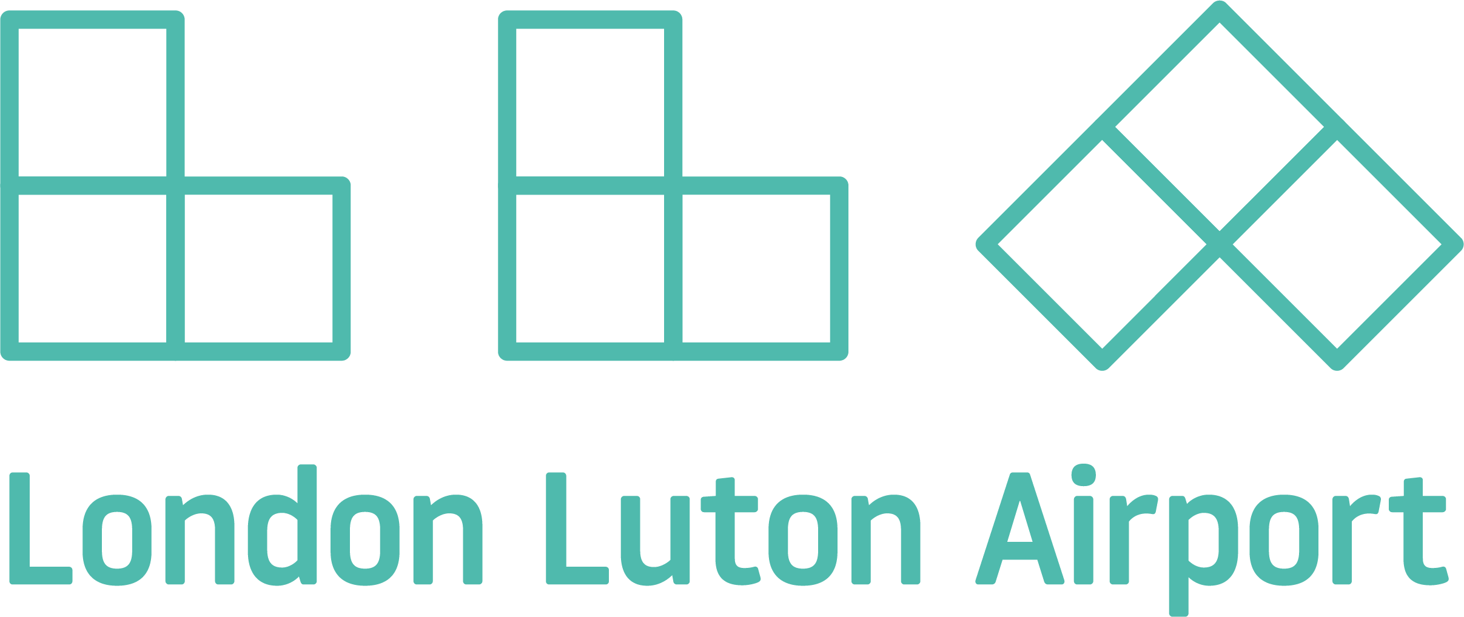 |  | Notice of Proposed Crane Lift Within 6km Safety Zone |  | Failure To Provide All Requested Information May Delay The Processing of Your Notice
1. Sponsor (person, company, etc. proposing this action) :  Name:  Address:  Post Code:  Telephone:  2. Sponsor's Representative (if other than #1) :  Name:  Address:  City/Town:  Post Code:  Telephone:  3. Notice of New Construction Alteration Existing  4. Work Schedule: Beginning: End:  5. Crane Type: Tower Mobile Other  6. Marking/Painting and/or Lighting Preferred:  Continuous Red Light Other  7. Crane Operator or Site contact number Tel, ------------------------------------ |  |  | 8. Easting:  9. Northing:  10. Site Elevation (AOD):  11. Max Jib Height (AGL):  12. Overall height (#10. + #11.) (AOD): -  13. Previous LLAOL Aeronautical Study Number (if applicable):  14. Description of Location: (Attach an Ordnance Survey 1:1250 scale plan)
15. Complete Description of Proposal:

I hereby certify that all of the above statements made by me are true, complete, and correct to the best of my knowledge. In addition, I agree to mark and/or light the structure in accordance with established marking and lighting standards as necessary.
Date | Typed or Printed name and Title of Person Filing Notice |  |  | Signature
Please email the completed form to ltnsafeguarding@ltn.aero.
If any assistance is required in completing the application then please contact the above address.

