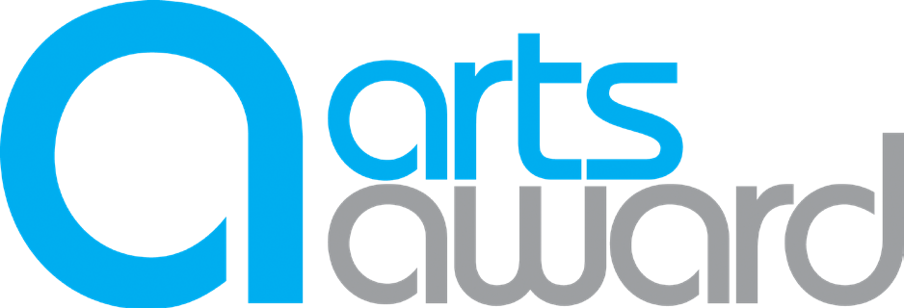

Plan

Gold Arts Award
Unit 1 Part A: extend own arts practice

The purpose of this worksheet is to help you identify your main art form, and create a plan to extend this through working with a new art form.

What is your main art form / practice? What skills would you like to develop?

What is the new art form / practice that you want to develop and why?

How will you develop your skills in the new art form / practice (think about who you will work with, timescales and review points that you will set)
You can continue on the next page

Notes continued

What new work / material will you produce?

What other practitioner will you work with and why?

How will you incorporate your new art form/practice into your original art form/practice to create a new piece of work?

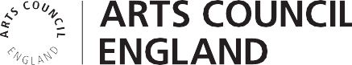
How will you collect and record evidence of the new work created and the process used?
Tip: this could be photos, video / audio recordings, or notes from sessions

How will you share the new work with others and gather feedback from a range of people? Remember to include the feedback you collect in your portfolio.

Adviser note: young people do not have to organise their public sharing themselves

