Review

Gold Arts Award Unit 1 Part C: research practitioners and review arts events

The purpose of this worksheet is to help you to review arts events.

Tip: Take this sheet with you when you attend your arts event so that you can make notes. Remember to include evidence of the event(s) you attended eg programme, ticket, photos, URL.
What event did you attend?
What did you see/do?
When did it take place?

Describe what happened at the arts event

Describe which art forms were involved: (include information about genres and tech- niques involved)

What was the context of the event? (eg was it part of large tour/ a temporary exhibition/ part of a film festival/an online event etc.)

Was there anything unexpected about what you saw/experienced?

What did you think was good, and why?

Was there anything about the arts event you didn’t like? Why?

Who do you think the intended audience was for this event?
What was the creative impact of the event?

Did the event develop your knowledge and understanding of the art form(s)?

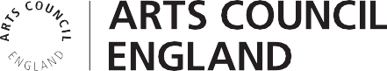
How did this event relate to your research into more advanced practitioners?
How did you present your reviews of the arts events?

How did these experiences influence your own arts practice and/or plans and how might you develop your arts practice in the future?

