The following information will help us profile your company in our Service Management Analysis. We reserve the right to publish all answers returned in print and on our Web site. If your company has additional material in the way of research, white papers and demonstrations that you feel would be helpful, please include it. If your have questions contact Bruce Boardman via email bboardman@nwc.com. Companies that decline to answer questionnaire may still be included in the article, at the author’s discretion.
Please RSVP by March 27

June 22 Service Management Survey

1. Please provide at least two reference customer contacts for interview.
- Interviews will take place between NWC and the customer without the vendor.
- The interview will be used to understand Service Management issues, challenges and strategies
- We can shield the contact’s identity by saying, for example, “an IT manager for a 10,000 employee manufacturing firm.”

2. Describe your Service Management features architecture regarding:
- Automation
- Integration
- Processing

Automation
Automation is a key function of Proxima Technology’s Business Service Management or BSM product, Centauri Business Service Manager™ (Centauri). Centauri automates:
- Service level reporting
- ITIL Service Delivery processes
- Automated notification of issues based on business impact
- Six Sigma techniques
Service Level Reporting: Centauri automatically generates and distributes service level reports to appropriate user groups (IT and business users) via email. This enables service managers and operational staff to increase accuracy of reports and increase staff productivity by eliminating the manual service level reporting task. Moreover, this ensures that reports are sent to the right people, at the right time. This is critical where penalty payments are involved when reports are not provided on time. Centauri also provides a full audit trail feature for any changes to the data to promote contractual transparency. In addition, this information and the business impact of poor service quality is available in real-time through the dashboards.
ITIL Service Delivery: Centauri helps support the automation of ITIL Service Delivery processes. More specifically, Centauri automates the calculation of service level compliance statistics in Service Level Management ranging from simple availability measures (e.g. Availability for peak operating hours must be greater than 99.7% to meet the SLA) to complex formulas that combine availability, performance, and service desk data (e.g. Availability must be greater than or equal to 99.7% and 90% of response time must be less than 3 seconds and maximum time to resolve problems is less than 6 hours—to meet the SLA). Centauri also automates the creation of the Centauri Service Model through the integration with Configuration Management Databases (see processing section below).
Alert notification based on business impact: Centauri automates the notification of IT issues using correlated business impact data. Centauri takes into account staff schedules and escalates alerts until problem is acknowledged. Management and business users can also be notified simultaneously of problems and of impact on the business. This is done through pagers, emails, and is highlighted on the real-time dashboard automatically. As a result, IT support staff immediately take corrective action to restore service and business users are better informed of problems impacting their critical business processes or business unit.
Six Sigma Techniques: Proxima Technology was the first service management vendor to adopt the Six Sigma quality improvement process. Today, Centauri automates techniques such as Control Charts, Pareto Charts, Process Sigma Calculation, Risk Priority Number in Failure Modes and Effects Analysis and so on. By doing so, this saves IT and business staff significant time in service quality improvement projects.

Integration
Centauri integrates easily with other products, it uses adaptors to collect data from disparate data sources in different locations. The Centauri Connection Manager consolidates the disparate data into a standard format to be processed by Centauri’s Service Model, which is a real-time, hierarchical model of the business services and the IT infrastructure supporting them. Common data types used by Centauri include:
- Business Data – This data is used to highlight the business impact of any IT issue. It is typically transaction data that can be collected either from Enterprise Messaging systems or queried from a database.
- Service Desk Data – These interfaces are bi-directional, enabling Centauri to query metrics from service desk systems such as response time data, and also raise incident requests based on business impact.
- Configuration Data – In order to automatically generate the Centauri Service Model using Service Templates, Centauri needs a source of configuration data. This is often provided by Configuration Management Database (CMDB), the Service Desk system, network discovery engines or infrastructure management tools that maintain a repository of configuration data.
- Response Times – Data that highlights the end-user experience is commonly used with Centauri to help highlight the performance, availability and business impact of IT services from a user’s perspective.
- Infrastructure Metrics – Infrastructure metrics can be correlated with response time metrics to show a complete picture of an IT service. Infrastructure metrics are collected from the enterprise monitoring tools such as BMC Patrol or IBM Tivoli, as well as through standards such as SNMP.
Centauri provides a set of standard adaptors to collect the above data types. In addition, a series of ‘Toolkit’ adaptors are provided to allow data to be quickly collected without the need to write new adaptors. Moreover, Proxima Technology publishes an API specification for creating custom adaptors. This enables partners of the On Centauri Program and customers to create add-on products or solutions based On Centauri. Examples of partner created adaptors include Microsoft Operations Manager and WMI adaptors. Solutions include BSM for Capacity and Performance Management products, and BSM for Job Scheduling products.

Processing
The processing capabilities of Centauri are handled by the Centauri Service Model. The Centauri Service Model enables users to define business rules against real-time and historical data, and correlate disparate data sources. This enables IT and business users to understand how IT infrastructure components support the critical business services, processes and functions.

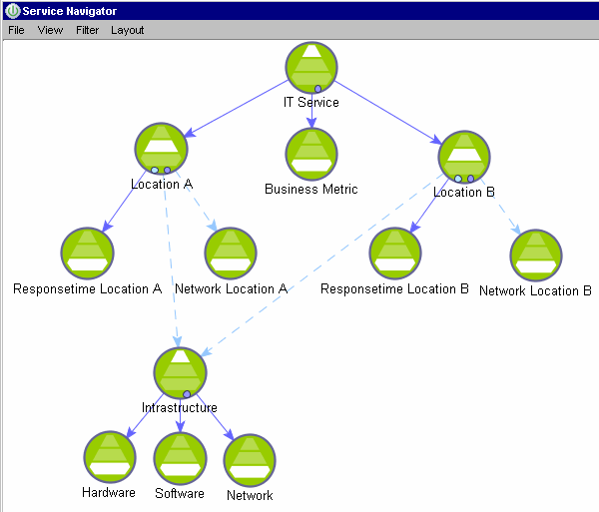
Centauri Service Model example

The Service Model transforms incoming data into meaningful information that is presented to the right audience in real-time allowing rapid decision-making. The foundation of the Service Model is the combination of service objects and the relationships between those objects that represent the business rules.

The Model works by matching incoming data against user defined rules. This data is then combined together in the Service Model rules (the relationships). The rules range from simple rules (best, worst or average status) to complex rules that automatically apply weightings to the data. In addition, advanced Centauri users create free-form expressions to extend the flexibility of the Model.

Underlying the Service Model is the status model; enabling users to define the status
levels that are represented in the model and the associated thresholds that define the availability of the object. For example in an IT Service Management application, levels that represent IT events are defined in the Model, and a threshold
used to highlight downtime. In a risk management environment the Model highlights exposure levels and thresholds are used to trigger notifications or items that require disclosure.

The Service Model works with real world data feeds as it processes a combination of real-time, batch and delayed data. In addition to highlighting the status of the objects in the Model, other Key Performance Indicators are illustrated and used in the standard statistics that are available from the Service Model.

The Service Model provides other capabilities such as root cause analysis—where status thresholds are breached the root cause of the issue is immediately emphasized—this root cause range from a full disk on a file server, to a financial trader being over his/her daily limit to a situation where customer complaints were up 10% over the average.

3. Please provide an annotated architectural diagram in jpeg or bitmap format.
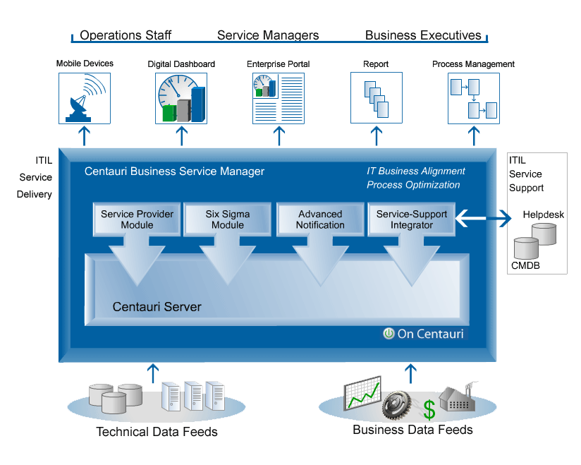
Also attached.

4. Please provide Service Management metrics reported/measured by product, categorized by the following:
- Technical IT infrastructure, i.e. CPU, IO, MTTR
- Financial impact of service
Centauri reports both IT and business metrics in real-time. The Centauri Service Model is used in various ways from IT Service Management to business risk management reporting.
As standard, Centauri calculates a number of statistical measures, and this capability can be extended when required. Metrics include:
  - Business impact: critical business processes, functions, locations
  - Cost of poor service quality expressed in financial terms (e.g. cost of outage in monetary terms)
  - User impact: number of users affected, user-minute downtime
  - Business activity metrics (e.g. number portability activities for telecommunications)
  - Mean time between failures
  - Maximum time to restore
  - Number of outages and their duration
  - SLA compliance based on formulas that use the statistics as input data
  - Process Sigma Calculation
  - Risk Priority Number from the Failure Mode and Effects Analysis
  - And more
Critically, these metrics are calculated with consideration for the business calendar – every Centauri service has a schedule associated with the business critical time periods defined. For example availability during peak periods can be compared with overall availability inside scheduled hours.
5. Please provide figures on units sold, delivered, customers serviced, etc.
Proxima Technology Centauri is implemented in 150 client sites globally.

6.Product pricing: Contact Proxima Technology
- High and low ranges
- Average initial purchase

7. Please provide project implementation planning guidelines.

Centauri Method
The Centauri Method is a key differentiator between Proxima Technology and other vendors because it provides a structured methodology for implementing business service management solutions.
The Centauri Method is an amalgamation of best practices, including:
- ITIL Service Delivery
- Six Sigma’s Process Improvement Model: DMAIC (Define, Measure, Analyze, Improve and Control)
- Proxima Technology’s field experience working with some of the world’s largest enterprises and service providers
Centauri Method is designed to define what has to be implemented, provide structure around that implementation and to feed into the process improvement capabilities that Centauri provides. It uses the approach of taking on manageable projects one by one until all projects are complete. Not only does this allow for value to be added in the least possible time, it keeps the complexity of the products to a minimum and helps to ensure their success.
The methodology consists of five stages:
- Service Catalog
- Process Analysis
- Preparation
- Implementation
- Control
Each of the stages has a defined end and sign off to ensure that all tasks are completed and the overall project is a success. Centauri Method uses a top down approach to ensure that all aspects of the business that are analyzed and tracked using Centauri are critical to the business. The aim of the methodology is to align IT operations with business priorities, define the critical services, measure the quality of service and understand the impact IT has on business success.
8. Describe your Service Management product roadmaps – including market segmentation and underlying assumptions like required customer process maturity – for the next 2 years.
Product Roadmap
The latest version of Centauri, version 4.0 (GA by summer 2006) provides significant improvement to existing features as well as adding new functionality. In line with allowing rapid business decision making, Centauri provides additional flexibility in its modeling capabilities, now allowing the user to define a service quality model to best represent the requirements of the organization. In addition, the ability to query historical business impact and root cause information is now improved so Fault and Impact maps are now available for every outage.
A considerable strength of Centauri is its ability to provide a real-time and historical dashboard to match the specific needs of each customer. This has been further improved allowing for these dashboards to be created through a ‘point and click’ user interface from a library of standard dashboard elements such as charts, service statistics, root cause, and other relevant information.
Further extending Centauri’s ability to collect data from disparate systems is a web services client adaptor which can be used with any standard web service. This capability is further enhancement with the Adaptor Software Development Kit, which allows for the quick construction of custom integrations to remote data sources.

- Benefits of your Service Management solutions to IT and to the business.
Benefits to the Business: Increase customer satisfaction and reduce costs
- Increase customer satisfaction by improving IT-dependant critical business services.
- Minimize financial impact on the business bottom line by proactively measuring and reporting on critical business services.
- Reduce latency in business decision making by having real-time information on how IT service quality impacts the business.
- Increase business operational efficiency by prioritizing IT resources to meet business needs.
- Cost avoidance in penalty payments through comprehensive service level management.
Benefits to IT: Prove the Business Value of IT
- Gain understanding of how IT services support critical business processes.
- Increase business availability and client/user satisfaction by improving problem resolution time.
- Reduce operational costs through automation of reporting, notification and root cause analysis.
- Increase communication with the business by sharing real-time service quality information.
Centauri helps IT dependent organizations align IT services with the Business Processes they support. It does this by correlating and consolidating both business and IT metrics collected from multiple sources into a logical model which maps the IT components and business Key Performance Indicator (KPI) data against the business processes and other areas of business impact. The data is available in real-time to show the current impact of IT on the business, or historically so that past service level compliance can be tracked and analyzed.
A key goal of using such a model is facilitating rapid business decision making by providing the necessary information to the right audience. For example, Centauri is able to highlight that a particular funds trading system is not accessible to its main user community due to a network issue, and highlight the potential cost and number of users affected by it. This ensures that resources can be prioritized to restore the system, as the root cause of the issue has been immediately pinpointed by Centauri. Later on, more detailed analysis of the statistical data can take place and the historical root causes of IT incidents can be analyzed to start quality improvement projects, which are tracked by Centauri through its support for the Six Sigma process improvement methodology.
Centauri has been particularly optimized for use in environments with service providers, or where the internal IT supplier has a formalized IT governance strategy and requires comprehensive service level management capabilities. Not only can complex SLAs can be modeled and tracked in the system (for example a composite SLA that combines both system availability data and service desk response time metrics) but the availability numbers an be reviewed and adjusted using the fully audited reconciliation capability ensuring that the system fits in with the overall ‘outsourcer’ workflow.
Centauri helps realize significant cost savings through its ability to automate Service level reporting, as well as its ability to measure and report on the business impact of IT issues and ensure that problem resolution is prioritized.
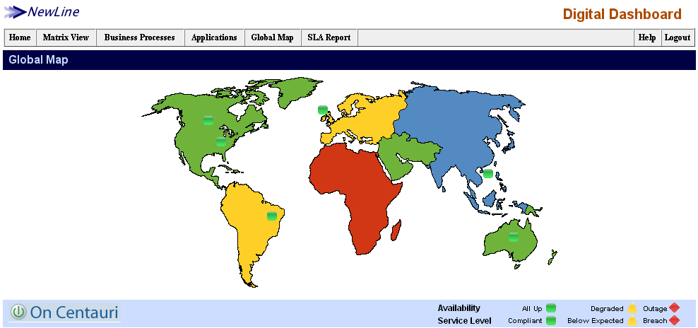
1. Centauri dashboard example: showing global business locations affected by business services.

- Organizational profiles of businesses that will best be able to take advantage of your Service Management offering(s). Include factors such as size of business by gross revenue, market, industry, technology deployed, and processes implemented.
  - Proxima Technology customers include Global Fortune 1000 enterprises and service providers/system integrators. Centauri users include Qualcomm, T-Mobile UK, National City Corporation, Mutual of Omaha, EDS, Sun Microsystems, Capgemini, SAIC, iPSL (Unisys), Carlson Companies among many others. Centauri is broadly applicable to a variety of markets and industries. Current customer markets include IT outsourcing, financial services, manufacturing, telecommunications and government. Proxima Technology customers typically have a mature IT management infrastructure but have a need to apply that data to business services.
  - In terms of processes implemented, our customers have often adopted ITIL, CobiT and/or Six Sigma, although these are not a requirement in order to use Centauri.
9. Describe your company’s market presence, including the following:
- Number of customers: 150 customers globally
- Service management revenue for fiscal year 2005: N/A

- Recent acquisitions, partnerships and technology developments related to service management

Partnerships: Proxima Technology has always had a partner-friendly culture and a flexible product. Today partners range from Fortune 100 Service Providers and Systems Integrators to small-and medium-sized organizations. Most partners develop solutions based On Centauri through the On Centauri Partner Program. To name a few: EDS, Sun Microsystems, SAIC, among others already leverage the flexibility and maturity of Centauri to bring innovative solutions to market. More info on the program: www.oncentauri.com

EDS: Proxima Technology is a partner of EDS’ Global Insight initiative.

Sun Microsystems: Proxima Technology Centauri is embedded in Sun Services, including their managed storage service. Others include Sun’s N1 Grid Computing initiative and their Mainframe Re-hosting practice. Centauri offers Sun Services a service level management and business service management capability. Additionally, Centauri provides a real-time provisioning visualization for Sun N1.
- Sun Storage release
- Sun N1 Grid release
Dave Uhlir, Senior Director, Sun Management Services Product Management, Sun Microsystems said, "The flexibility of Centauri is key for Sun Managed Operations. The ability to leverage the numerous capabilities of the Centauri platform in new ways as our business grows is extremely important, ensuring that we remain competitive and responsive to the market."
SAIC: SAIC launched a service quality reporting solution based on Centauri. Through this relationship, Centauri offers SAIC's Integrated Services Management Center (ISMC) a business service management solution - providing business insight into IT service performance. ISMC is SAIC's service delivery capability for managing communications, computing, and application infrastructures including mainframes, servers, desktops, databases, middleware, local and wide area networks, and enterprise applications. See newsrelease.
Oracle: Proxima Technology is a member of the Oracle Partner Network. Centauri was the first solution successfully deployed on Oracle Database 10g and Real Application Clusters by a joint customer, Qualcomm. This enabled Qualcomm to automate many management tasks and reduce their operation costs. See newsrelease.
- Third-party indicators of market leadership (for instance, analyst rankings or awards)
Industry Analysts
Proxima Technology is mentioned in analyst reports and presentations on business service management and service level management. Sample analyst reports include:
Gartner:
- Hype Cycle for IT Operations Management 2005: Proxima Technology was selected among many Business Service Management vendors as one of 5 mentioned in the report. Additionally, Proxima Technology was also one of 6 Service Level Management vendors mentioned in the same report.
- Polls from Gartner’s 2005 Data Center Conference results (April 2006): Proxima Technology is included as one of 3 third-party Business Service Management Vendors.
- Business Service Management, SLA monitoring and reporting tools likely to merge 2005: Proxima Technology is included as one of the selected vendors for Business Service Management.
- Six Sigma: Strategy for Quality and Customer Satisfaction: Proxima Technology is the only service management vendor included in this report. Proxima Technology is the first service management vendor to adopt the quality improvement method, Six Sigma.
- Apply IT Operations Tools for Business Activity Monitoring: Proxima Technology is one of the vendors listed as one that is best positioned for business activity monitoring.

Forrester:
- Point Solutions for Enterprise Infrastructure Management (2005): Proxima Technology is listed as one of the top Business Service Management and Service Level Management vendors.
- Best Practice for Business Service Management: Proxima Technology is listed along side major vendors as a leading vendor in this space.
- Market Update: SLM/BSM Technologies: Proxima Technology is said to be “a proven product with good success”.
- Market Overview: SLM/BSM Technologies 2003: “Proxima Technology’s Six Sigma capability is a key differentiator and a powerful combination for continuous service improvement.”
- IT Trends: Enterprise Infrastructure Management: Proxima Technology is listed as an innovative vendor in Business Service Management.
- Best Practices in Implementing Infrastructure Service-Level Management: “Proxima Technology: An SLM product that is close to the Holy Grail.”

Awards

2005 DM Review World Class Solution Award: Category: High Availability, Performance and Systems Management.

Mutual of Omaha and Proxima Technology Won the 2005 award for achieving business value of IT through Business Service Management.

In 2004, Mutual of Omaha realized tangible results from completing the project:
- Cost savings of $1.5 million in 2004 by avoiding lost productivity;
- Reduced customer impact hours by 51% as compared to 2002;
- Reduced systems downtime: distributed systems availability reached 99.99% for the first time.
Paul Nelsen, Mutual of Omaha First Vice President, Information Services, said, "In 2004, Mutual of Omaha achieved 99.99% availability in distributed systems for the first time. Moreover, we reduced customer impact hours - the number of hours customers were impacted by IT outages - by 51% compared to 2002. The results are reduced outages, improved business productivity, and increased customer satisfaction."

"Mutual of Omaha has an impressive understanding of IT business alignment-particularly with Mutual of Omaha's ability to translate its IT business alignment vision using Centauri together with Peregrine's asset and change management capabilities. The resulting solution is a statement of Mutual of Omaha's IT maturity and shows leadership on the part of all three companies." said Lisa Erickson-Harris, Research Director with Enterprise Management Associates.

"Proxima Technology's contribution to improving application availability is significant. Proxima Technology has always been helpful and very responsive to our needs. As a result, we plan to continue our partnership with Proxima Technology and look forward to exploiting more of Centauri's capabilities. We are very pleased to have won this award; it provides us with an opportunity to highlight our successes and the excellent collaborative effort between Mutual of Omaha and Proxima Technology." said William Puskas, First Vice President of I/S Technical Services, Mutual of Omaha.

Full story at: http://www.dmreview.com/awards/wcs/2005/mutualofomaha.cfm

2004 DM Review World Class Solution Award: Category: High Availability, Performance and Systems Management.

T-Mobile and Proxima Technology won the 2004 award for realizing value from Business Activity Monitoring and Business Service Management.

Centauri provides T-Mobile with an understanding of how IT service performance affects the critical business processes in real-time. Business activity performance metrics include service activation time, wireless number portability rate and associated SLAs, billing systems, and resellers activities, among others. Through the use of the Centauri dashboard and automated reports, T-Mobile improved the quality of IT service performance delivered to the business groups.

"The key value that we get from using Centauri is the ability to have, in real-time, business performance information that helps our decision makers," says Kevin Giles, Service Delivery Team Leader, T-Mobile (UK). "This enables our business managers to improve business operations, and it enables us to keep our competitive edge with new technology."

"Centauri has provided us with a reporting tool on business critical information, helped automate the reporting process and improve our operational effectiveness," said Giles.

Jean Schauer, Editor-in-Chief of DM Review said “Our World Class Solution Award judges determined that T-Mobile UK’s implementation of Proxima Technology’s Centauri is exceptional in this category. T-Mobile has a proven success story of improving service availability and performance, efficiency of IT-dependent business processes, and business activity reporting.”

Full Story at: http://www.dmreview.com/awards/wcs/2004/wcs_2004.cfm#T-Mobile

