The following information will help us profile your company in our Service Management Analysis. We reserve the right to publish all answers returned in print and on our Web site. If your company has additional material in the way of research, white papers and demonstrations that you feel would be helpful, please include it. If your have questions contact Bruce Boardman via email bboardman@nwc.com. Companies that decline to answer questionnaire may still be included in the article, at the author’s discretion.
Please RSVP by March 27

June 22 Service Management Survey

1. Please provide at least two reference customer contacts for interview.
- Interviews will take place between NWC and the customer without the vendor.
- The interview will be used to understand Service Management issues, challenges and strategies
- We can shield the contact’s identity by saying, for example, “an IT manager for a 10,000 employee manufacturing firm.”

2. Describe your Service Management features architecture regarding:
- Automation
  - OpTier’s CoreFirst is unique in offering automated service level assurance features based on its business priority driven dynamic transaction resource allocation. This allows CoreFirst to not only track business transactions across IT infrastructure, thus identifying SLA compliance issues as they develop but to eliminate SLA compliance issues by enforcing in real-time a policy assigning more resources to higher priority business transactions that must meet SLAs.
Late last year Forrester Research provided an explanation of the value of this capability, “The first generation of tools to identify end-to-end components and dependencies of complex services that span multiple systems and network elements became available this year. In addition to identifying all the components of a multi-tier transaction (such as Java and database components), startup OpTier’s CoreFirst product can alter CPU priorities in real time to optimize execution of selected transactions against service-level goals. Forrester believes that this real-time optimization is an industry first. Inline transaction optimization and SLA enforcement will help firms build successful high-end SOA environments.”
  - CoreFirst also offers a completely automated process of transaction flow discovery and monitoring, 24X7 in production. This automation not only provides visibility not possible with other solutions – but eliminates most of the customization and modeling efforts that lengthen time to value and decrease ROI of other solutions.
- Integration
  - CoreFirst integrates with many of the leading web, application server, database, messaging and EAI platforms supporting offering transaction management as a critical components of SLM, out of the box, for applications that run in those environments.
  - CoreFirst integrates with main identity management schemes for identifying the user context of transaction instances
  - CoreFirst integrates with other Service management frameworks by allowing transaction service level alerts and data to be passed, and by being open to accept service level threshold policies.
  - CoreFirst can integrate with capacity planning offerings by taking the guesswork away from understanding the mapping of resource consumption metrics to business activities. Thus managing service by planning architecture and resource allocation for changing business demands can transforms from an art to a science.
  - In essence CoreFirst creates and automatically populates a CMDB for the transaction layer of service management. This is a strong integration point for many other service management practices.
- Processing
  - The way CoreFirst processes “service behavior” provides the foundation for its unique capability to manage service from a transactional perspective. CoreFirst agents actively track transactions as they move through the IT infrastructure with a low overhead lightweight mechanism that allows it to offer production grade visibility into business transaction performance.
  - CoreFirst architecture processes this transaction activity profile information in a highly distributed architecture that provides for the scalability and reliability required of a service management offering that needs to provide an everyday solution for assuring service levels.
  - Real time processing of transaction priorities defined by high level business policies allows CoreFirst agents to effectively accelerate the flow of transactions through the IT infrastructure and thus protect the service levels for core business processes and users.
3. Please provide an annotated architectural diagram in jpeg or bitmap format. (Image also attached to email).
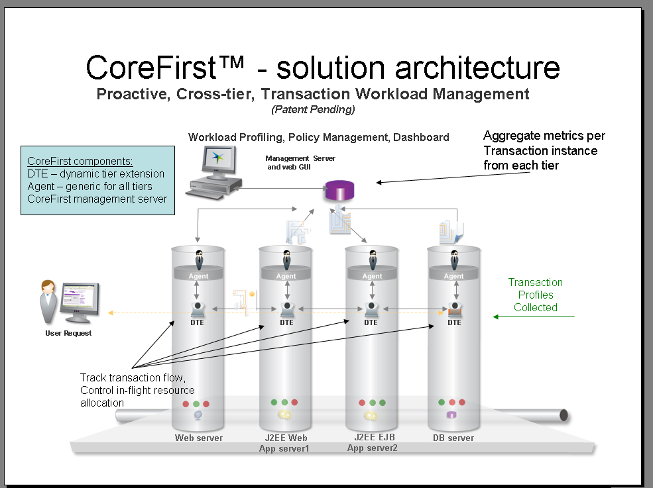
4. Please provide Service Management metrics reported/measured by product, categorized by the following:
- Technical IT infrastructure, i.e. CPU, IO, MTTR
  - Metrics are provided per transaction instance and aggregated over time/user/transaction type and origin.
  - For all platforms metrics include: response times and service times.
  - For platforms where CoreFirst agents reside additional metrics are available including: CPU times, I/O and memory usage, cache parameters, locking parameters and many other platform specific metrics.
  - Based on these parameters baselines comparison metrics are created to compute SLA compliance metrics.
- Financial impact of service
  - Financial impact of service issues at the infrastructure can be computed based on the accurate analysis of the exact business transaction types and users that are impacted when failures occur.
5. Please provide figures on units sold, delivered, customers serviced, etc.
- CoreFirst has been sold to about 10 customers most of which are global Fortune 100 organizations. It has further serviced around 20 additional organizations that are at different stages of piloting/purchasing the solution.
6.Product pricing:
- High and low ranges
  - Product licenses start at the $1,500 per CPU in test environments ranging to $15,000 per CPU in certain production architectures.
- Average initial purchase
  - Average initial purchases range $70,000 to $250,000.
7. Please provide project implementation planning guidelines.
  - CoreFirst project implementation follows these good practice steps (for supporting an environment with several applications):
    - Install in acceptance testing environment.
    - Run main application tests to generate transaction activity (CoreFirst automatically discovers all transactions, their flow and resource consumption profile).
    - Get application support and operations teams familiar with product capabilities and use case scenarios (training).
    - Decide and implement basic alerting rules based on suggested thresholds as recorded by product and create labels and grouping for periodic service level reporting on transaction.
    - Deploy agents in production.
    - Tune threshold baselines.
    - At this stage product is fully usable to monitor all transactional activity and diagnose and fix any issues.
    - Define transaction priorities based on business policies. CoreFirst enforces these automatically.
    - Compare effectiveness of policies by using time based an control group reports to measure SLA compliance improvements and resource utilization improvements.

8. Describe your Service Management product roadmaps – including market segmentation and underlying assumptions like required customer process maturity – for the next 2 years.
- OpTier will further increase the out of the box coverage CoreFirst offers to cover additional infrastructure elements such as networks.
OpTier will further expand the concept of a transaction management approach to ITSM by integrating with:
Service modeling and business process modeling
Configuration management
Change management
Resource Provisioning and platform level workload management
The adoption of service management takes time and organizations are slowly moving through the maturity curve. OpTier can help accelerate this process by making it extremely easy to bring the different management silos together around the business transaction concept. This helps organizations adopt the processes that make them more service management mature.
- Benefits of your Service Management solutions to IT and to the business.
  - CoreFirst enables organizations to capture more business and retain more customers, better utilize employee’s time and spend less to the deliver required services. With CoreFirst, companies:
- Reduce service problem impact.
- Reduce time to resolve issues.
- Reduce roll out risks of new or changed applications.
- Improve capacity planning effectiveness.
- Enable IT consolidation and large-scale deployment of multi-tier architectures and SOAs.
CoreFirst delivers value to customers the minute the software is installed. Once setup, the software can map the topology of a network in great detail. For many companies, this is the first time they have been able to visually understand the relationship of all the elements of their infrastructure. As a result, they are able to pinpoint performance issues and provide quick resolution.
For example, after installing CoreFirst in the Private Banking division of a global Fortune 50 bank, the product demonstrated how transactions were going to the wrong application server because of server mis-configuration. The transactions were completing successfully, so end-users were not complaining, but in fact the transactions were pulling data out of the wrong database. This type of information is instantly visible when looking at the tier topology diagram that CoreFirst auto-discovers by tracking business transactions across the environment and showing their execution paths.
During the summary of a successful proof of concept done with CoreFirst in a global financial company, the VP in charge announced that "in just five days, [OpTier] showed us information we've been trying to get for two years." He was referring to the basic view of transactions in the CoreFirst Profiler, showing how much time each business transaction was spending in each one of the tiers.
  - The IT benefits
CoreFirst provides an innovative and unique approach to service management by assuring application performance and availability at the transaction level.
With CoreFirst, an enterprise can:
- Auto-discover, track & profile all transactions across all tiers
- Maintain a fair share of transaction resources
- Prioritize transactions based on business policies
- Consolidate and deploy large-scale multi-tier architectures
- Fill the gap left by existing monitoring, diagnostic and tuning tools
OpTier is unique for its Dynamic prioritization and Contextual transaction tracking:
Dynamic prioritization
CoreFirst lets organizations preempt performance issues by controlling resource allocation, at the cross-tier transaction level, based on business prioritization policies. For example, a higher priority - resulting in faster cross-tier processing - would be assigned to a transaction such as an ATM cash withdrawal, and a lower priority to an internal query that is not particularly time-sensitive. This unique approach helps organizations to maintain service levels by preventing negative business impact and optimizing IT resources which results in improved and consistent quality of service.
Contextual transaction tracking
CoreFirst automatically discovers, tracks and profiles every transaction - across all tiers - to clearly map IT business service topology. This contextual tracking ability pinpoints problem areas, reducing the time to fix underlying performance problems and making architecture and capacity planning more effective.
- Organizational profiles of businesses that will best be able to take advantage of your Service Management offering(s). Include factors such as size of business by gross revenue, market, industry, technology deployed, and processes implemented.
  - All enterprises share the need to assure service levels of IT services while optimizing the cost of service delivery. To date, OpTier has focused on large, Fortune Global 100 organizations with complex IT infrastructures.
Often times these are the types of organizations that have patched together new and legacy applications, are trying to incorporate homegrown solutions into their IT stack and integrate systems from various vendors. These companies have at least one thing in common: they do not have clear visibility into their entire IT infrastructure, making service level management nearly impossible.
OpTier is experiencing significant success in financial services, retail, telecom and manufacturing as well as initial penetration in government, transportation and MSPs. OpTier – any others we should include?
Within these organizations, OpTier's solution provides significant and distinct value specifically to:
- Line of Business Application owners – OpTier enables IT application owners to identify the transactions and user groups that are most important and to prioritize them accordingly.
- Line of Business Managers - OpTier's end-to-end, business-focused views and performance policies enable management to align IT performance with business priorities.
- Operations Management & Application Support - OpTier provides deep visibility into multi-tier application workloads and allows for real-time control of applications.
- Service Level Managers - OpTier's cross tier transaction tracking allows service level managers to clearly map of IT services to infrastructure components.
- Infrastructure engineering - OpTier's auto-discovery and topology mapping is ideally suited to development, testing and production environments.
9. Describe your company’s market presence, including the following:
- Number of customers
  - About 10 paying customers.
- Service management revenue for fiscal year 2005
  - Cannot disclose.
- Recent acquisitions, partnerships and technology developments related to service management
- Third-party indicators of market leadership (for instance, analyst rankings or awards)
  - In the short amount of time since its product debut in 2005, OpTier has been acknowledged for its unique approach to transaction workload management with the following analyst recognition and industry awards:
- CODie Awards: CoreFirst chosen as a 2006 Software and Information Industry Association CODiE Awards Finalist in the Best Software Testing Solution category
- Datamation: In February 2006, the company received the Datamation.com Product of the Year 2006 Award in the Network & Systems Management category.
- InfoWorld: three of OpTier’s co-founders, Amir Alon, CTO; Yori Lavi, CEO; and Israel Mazin, Chairman, were named “2005 Innovators” for the development of the company’s flagship product, CoreFirst.
- Network World: OpTier named one of Network World’s “Top 10 Start-Ups to Watch” for 2005.
- Gartner: OpTier named to the list of “Cool Vendors in IT Operations Management, 2006,” by Gartner, Inc. in the report published on March 9, 2006 by Cameron Haight, Milind Govekar and Donna Scott of Gartner, Inc.
- Forrester: the research firm calls OpTier’s real time optimization “An Industry First.” The Forrester report titled “In-Flight Transaction Optimization Arrives: OpTier’s CoreFirst Represents the First of A New Class of Management Tools” also recognizes OpTier as the first vendor to bring to market a single solution for dependency analysis, monitoring and optimization, “three functions required by a modern service-oriented architecture.”

