


Request for Information (RFI)
On
Mobile E-mail

RFI Deadline: August 22, 2007
Publication Date: October, 2007

Drafted by Sean Ginevan
Contributing Technology Editor, Network Computing
E-mail: SGinevan@nwc.com

Introduction 3
Instructions 3
A. Business Overview 4
Objectives 5
Mobile E-mail Vendors Questions 6
Nokia Intellisync Mobile Suite Support 16

Introduction

This RFI (Request for Information) is proprietary to Network Computing, Information Week and CMP Media, LLC. It is drafted and disseminated for the sole purpose of generating information on Mobile E-mail for publication in Network Computing.com and/or InformationWeek in October, 2007.

Participating vendors must agree that any information returned to Network Computing in response to this RFI may be published in print and electronic form on our Web site, www.networkcomputing.com. Information obtained for this RFI may also be reprinted in whole or in part within InformationWeek or on the InformationWeek website at www.informationweek.com

Instructions
The following questions are designed to provide direct comparisons among major vendors within the mobile e-mail space. We have endeavored to provide as much detail about our proposed scenario below in “Business Overview.” However, if you feel that any points need clarification, please contact the author, Sean Ginevan, via e-mail at SGinevan@nwc.com. If points are clarified we will send those clarifications to all participating vendors to ensure that everyone is operating with the same information. The answers obtained from this RFI, in addition to previous completed testing, will be used to provide all analysis for this article.

If you respond to the RFI, please note that all responses must be received by August 22, 2007 for inclusion in this review. We suggest you read through the entire RFI before answering questions. You can reference answers to other questions in the RFI using the section title. Please do not reference materials outside the RFI; incorporate them into your answers.

Essay-type questions include word-count limits. Any submission beyond the limit may be ignored.

Business Overview

NWC Inc. is a medium sized company specializing in the development and manufacturer of specialty Widgets and Sprockets. The company has three major offices; a headquarters in suburban Washington, DC and branch offices in Syracuse, NY and Kansas City, MO. The company also has just opened a European sales office in Dublin, Ireland.

NWC Inc.’s mobile strategy has been limited thus far. Cellular phones and plans have been subsidized for executives, sales staff and critical operations (on call) staff. However the company has been slow to move into any other mobile service beyond voice. Executives at NWC Inc. have read numerous articles on the benefits of mobile e-mail but have been concerned about costs as well as complexity for supporting a new mobile e-mail initiative.

NWC Inc. has decided to start with a 100 user deployment, focusing on executives, top-tier sales staff and select operations employees in each of our worldwide offices. The company has standardized on Microsoft Exchange and has recently completed an upgrade to Exchange 2007. NWC Inc. has its e-mail servers distributed between Washington, DC; Syracuse, NY; and Kansas City, MO for increased scale and reliability.

While our focus is on an initial 100 user deployment, NWC Inc. wants to eventually scale to include the entire IT operations, sales and management staffs for a total of about 1000 people. The ability to scale up to larger deployments, particularly as the company grows, is important.
NWC Inc is also interested in applications beyond mobile e-mail. Our CIO has read numerous articles about how enterprises are creating applications beyond mobile e-mail. The company is thus curious with how our mobile e-mail software provider can also help us mobilize applications or whether we would have to partner with another vendor. Our CIO is also very security conscious, so we want to understand what the device management and security posture is for the vendors

Objectives

NWC Inc's initial goal is to provision select staff across our worldwide offices with a mobile e-mail solution to more effectively communicate with our more nomadic employees. While our initial goal is to focus on mobile e-mail, we want to ensure that whatever solution we choose has a robust enough security and device management framework in place. We also want to make sure that we can expand into other types of applications. Our goal is to be strategic, rather than tactical, in developing our mobility strategy. We are flexible in device platform selection and we're looking to vendors to provide us with insight as to pros and cons with our available selections (Windows Mobile, BlackBerry, Symbian, etc).

Targets:
- Initial deployment date is: Sept 5th, 2007
  - Mobile e-mail gateway installed in all locations
  - Handsets configured and loaded with software
  - 2 weeks troubleshooting
  - Employee training if needed
- Live on Sept 24th, 2007

Selection Criteria
During our analysis period, we will be reviewing all the RFI’s looking for the best solutions that fit our needs. We will most likely have additional clarifying questions that will need to be answered. We will be using the following list of items (in alphabetical order) to perform our assessment.

- Client software cost (if any)
- Depth of client support
- Depth of management features
- Depth of security features
- Mobile e-mail client features
- Mobile e-mail client ease of use
- Geographical Coverage (i.e. Where service(s) can be used)
- Middleware software cost (if any)
- Service contract cost

Mobile E-mail Vendors Questions

Server Support

Please define what e-mail platform(s) your mobile e-mal platform supports. Examples would include Microsoft Exchange, Lotus Notes, etc.
Answer Guidance
Reason for Question
While NWC Inc uses an Exchange environment, we want to understand if the vendor supports platforms outside of Microsoft Exchange.

Nokia Response

Nokia Intellisync Wireless Email provides a range of benefits to your organization:
- Saves money by leveraging current device investment
- Reduces IT Help Desk costs
- Increases business efficiency, employee productivity, responsiveness, and enables faster/more informed decision-making
- Extends employee flexibility regarding when and where to do business
- Improves collaboration with customers and partners

Nokia Intellisync Mobile Suite provides full support for the highly diverse range and versions of email systems in use today. By deploying Nokia Intellisync Mobile Suite, NWC will have the flexibility to not only be able to use your existing email systems, but also a full range of mobile device platform choices...

Email Servers and Data Sources
- Microsoft Exchange
- Lotus Domino
- Novell GroupWise
- IMAP4, POP3, Cybozu, XML data sources

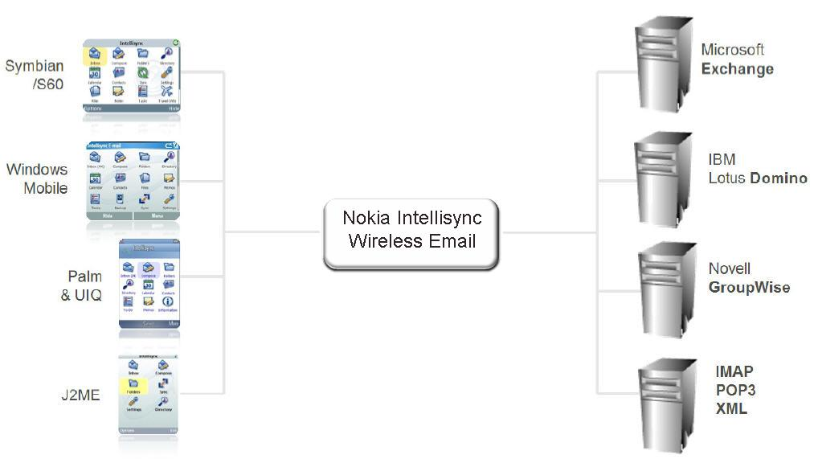
Client Support

Please define what client platform(s) your product supports. Examples would include Microsoft Windows Mobile, Symbian, etc. If your product supports non smartphone platforms (e.g. J2ME or BREW), please note this. Please note if your product uses its own e-mail client or integrates with the handheld’s native e-mail client.
If possible, please provide screenshots of the e-mail client on each platform supported by your product.

Answer Guidance
Reason for Question
NWC Inc has office locations around the globe. Windows Mobile is the most popular within the United States however our European counterparts prefer Symbian, so we are curious to know what we can support. Screenshots help us to get a feeling for the look & feel of your product and if there are major differences in the user experience between handset platforms.

Nokia Response

Nokia Intellisync Wireless Email provides full support for the highly diverse range and versions of mobile devices you may use at NWC today. By deploying Nokia Intellisync Wireless Email, NWC’s mobility strategy is not tied to a particular mobile operating system. Different roles in your organization often require different devices. Thus, your users should be able to choose the device that best supports their particular productivity needs, whether a Nokia, Motorola, Palm, Windows Mobile, or other popular platform. Nokia Intellisync Wireless Email provides a familiar interface with the highest degree of functionality across a range of device platforms.

Broad Device Support
Nokia Intellisync Wireless Email gives users access to their email and PIM data from a broad array of devices (100+), taking advantage of the breadth of device characteristics and capabilities.

The following mobile devices are supported for full synchronization to the native email and PIM applications:
- Symbian
- Windows Mobile (Pocket PC and SmartPhone)
- Palm
- J2ME
- BREW
- Windows PCs
- Alert Devices
- SyncML Devices
- Browser Devices

Client Features

Please detail the features available from your client (e.g. send/receive e-mail, create calendar appointments, synchronize Outlook contacts, corporate directory lookup, etc.). If necessary, please reference screenshots from the previous section to provide better detail of the available features.

Answer Guidance
Reason for Question
The breadth and depth of client features available for each product is one of the grading criteria. We are thus looking for detail in this category.

Nokia Response

Nokia Intellisync Wireless Email significantly raises the bar for server-based email access solutions by focusing on delivering excellence and addressing both the business and human challenges of increasing work group and work force mobility in these key areas:

Benefits of Nokia Intellisync Wireless Email for your organization:
- Mobilizes email and PIM for more employees
- Works with the mobile devices you already have
- Streamlines client installation/updates via over-the-air (OTA) distribution
- Supports multiple encryption and authentication options
- Web-based, self-service administration helps end-users reduce reliance on Help Desk support
- Cost-effective, needs-based pricing structure with a Base and Professional Client
- Supports 21 languages to enable global usage
- Offers a complete email experience – full attachments send and receive, travel itineraries, customizable views, and more

Key Features for End-User
- Two-way, wireless email, calendar, contacts, tasks, and notes synchronization
- Full inbox subfolder access and synchronization
- Attachment downloading, viewing, and editing
- Support for multiple email accounts
- Meeting request management
- Recurring meetings support
- Global Address List (GAL) and Active Directory sync
- Personal travel information
- Unlimited number of devices (including laptops) supported per user
- Bi-directional push technology
- A great end-user experience

Key Features for Business and IT Managers
- The broadest device support
- Enterprise-grade security
- Powerful administration and management tools
- Class-leading, integrated device management
- Top-notch synchronization quality
- Scalability and communications efficiency
- A great admin user experience
- Common user interface across different device platforms

Top-notch Synchronization Quality
Providing high quality synchronization is a fundamental requirement for a great user experience. NWC’s users should be able to rely on a synchronization solution that will preserve and make their data available without distortion or omissions. Nokia’s attention to detail here is the key.

The data synchronized includes:
- Email (Inbox, Inbox subfolders, Drafts, Sent Items)
- Contacts (including Microsoft Outlook and Domino iNotes contact sync)
- Calendar
- Tasks or to-do list
- Memos (or Notes)

Detailed Features of Wireless Email:

Meeting Requests - Your users may need to be able to handle meeting requests, as well as to create, receive, accept, deny, and tentatively accept meeting requests on their handheld device. They also may need the capability to view requests in their calendar, and send meeting-related updates or notices. Nokia Intellisync Wireless Email offers full support for all of this functionality, with some device-specific limitations inherent in particular platforms.

Global Address List Delivery - Nokia Intellisync Wireless Email provides the ability to deliver the entire Global Address List (GAL), or to easily select subsets based on distribution lists. Individual users or user groups can be designated by your IT administrator to receive the GAL just for individuals on distribution lists relevant to their work. Users may also opt to receive particular distribution lists, and to download a fresh copy of their portions of the GAL as needed. GAL lookup is also available for users who choose to not carry the entire corporate address list on their devices.

Device Merge – Nokia Intellisync Wireless Email can keep multiple devices and email clients in sync for the same user. A single user might sync their mobile phone, PDA, or Microsoft Outlook at home and at the office. As they add or substitute devices over time, it is important to be able to “merge” each device and any data on it with the others. Our unique technology enables the Nokia Intellisync solution to readily accomplish the complex tasks of managing duplicates and combining records without losing data.

Recurring Entries Including Exceptions – Nokia Intellisync Wireless Email handles the highly detailed task of synchronizing complex recurrence rules from sophisticated groupware servers to a wide range of device calendar implementations.

Filter Management Options - With Nokia Intellisync Wireless Email, your administrators can set filter option defaults for select users or user groups, and by application. Your administrators also can turn on and turn off the end-users’ ability to change their defaults. For instance, the administrator may decide to conserve bandwidth by choosing to globally prevent AutoCAD attachments from being synchronized.

A Great User Experience
Nokia Intellisync Wireless Email offers an excellent user experience, making it easy for your users to be productive. Basic settings can be controlled from the device with, while more advanced settings such as email filters are controlled from the Web interface.

Inbox on the Road – Nokia Intellisync Wireless Email provides your users with the same functionality they enjoy on their desktop, even when they are on the road. Changes made while out of the office are synced on the server, so your workforce can seamlessly transition between the road and the office. A small sample of what your users can accomplish:
- Read, forward, reply to/reply to all, delete, and mark their emails read/unread
- Accept, reject, or tentatively answer meeting requests
- Create meeting requests, including recurring meetings (on certain devices)
- Manage folders, including creation and deletion

Email Sync Settings - Email tends to drive the bulk of data traffic to and from your users’ devices, compared to the other PIM applications. Nokia Intellisync Wireless Email allows email to be filtered based on specific email addresses (from and to), subject line contents, priority/importance, read vs. unread, and age of the message. Email can also be automatically truncated if the message body exceeds a specified length. Email that reaches the configurable age limit is automatically cleared off the device.

Email Attachments - With Nokia Intellisync Wireless Email, email attachments can be turned off and on, and attachments delivered can be filtered by size and by file format. Users are informed of attachments that have been filtered out, and can choose to override the filters for specific attachments they need to view. Attachments delivered to devices can be viewed or edited using viewers or editors available on the device. Attachments can be added to outgoing email as well.

Calendar and Task Sync Settings – Calendar and task data does not typically consume much bandwidth; however, initial calendar loads on a device can take time if unfiltered. Nokia
Intellisync Wireless Email allows calendar and task entries to be filtered for a set number of days.

Ease of Installation – The Nokia Intellisync Wireless Email client software installation process is quite simple, involving just a click on your mobile device or Intranet site. After the install routine finishes, your users only need to enter a password to begin receiving email and PIM data. This ‘self-service’ approach greatly reduces your support requirements.

No Configuration Effort Required – Our Nokia Intellisync Wireless Email solution spares the end-user from having to participate in configuring their device for synchronization. Default Profile settings are controlled by the administrator and can be individualized or standardized depending on the desired degree of administrative control. Administrators set user profiles at the server, package initial user configurations into the client install, and set-up default profiles for new users. This process keeps your users productive and eliminates many calls to the Help Desk, to help protect your ROI during deployment.

Multiple Connection Modes – As your mobile worker logs more and more time away from office LAN connections, you need to support multiple device connection modes. This not only has an impact on the usability of the client (i.e., a Wi-Fi connection enables users to download larger files), but also increases your opportunities for achieving and maintaining lower costs. Your users can use your wireless LAN rather than a public network or Wi-Fi hotspot, enabling them to benefit from virtually global access to their business mobility solution. Nokia Intellisync Wireless Email supports each of the following methods:
- Mobile networks (GSM, GPRS, CDPD, TDMA, CDMA, etc.)
- Wireless LAN (i.e., 802.11, Wi-Fi)
- PC cradle (leveraging the PC network connection)
- Wireless infrared

Easy Sync Configuration – With the Nokia Intellisync Wireless Email Web PIM application, your user can set a range of configurations to tell the server what type of information should be automatically synced with the device. In addition to picking specific PIM applications, the user can also specify the days of the week and hourly range for synchronization. For instance, one might choose to receive just email and calendar updates on weekdays between 6 a.m. and 6 p.m.

‘Smarter’ PIM Sync – Nokia Intellisync Wireless Email expands the definition of PIM sync to include additional highly personal and contextually relevant information. Your user works as they would normally would in their groupware client without any extra effort, and information is automatically gathered and delivered. This Nokia Intellisync Wireless Email functionality helps take mobile user acceptance and productivity to a new level.

Appointments – By allowing your users to link appointments in their calendar to contacts in their address book, and create meeting requests and recurring appointments, Nokia Intellisync Wireless Email extends the functionality of Lotus Notes and Microsoft Outlook. These special appointments signal the server to gather additional contextually relevant information and make it available to all of the user’s devices.

Trips – Nokia Intellisync Wireless Email has an optional, licensed Personal Travel Information capability. The server also monitors your user’s inbox for incoming travel itineraries from the travel agency, and parses these out into car, hotel, and airline reservations. The itinerary information is then automatically synchronized to the calendar across the user’s devices, independent of any user effort. Trips also can be manually created from within Lotus Notes, Microsoft Outlook, or the Nokia Intellisync Wireless Email Web application.

Alerts – The server-based alert capability also sends users timely alerts along with their trip and appointment data. For example, the user can receive email alerts on their phone with flight times, seat assignments, and confirmation numbers on the morning of a trip. They can also automatically receive a phone alert with the name, timing, and contact information of the person with whom they are meeting at the destination. This added level of convenience helps your workforce stay productive despite the unpredictability of business travel.

Maps and Directions – Using the optional Personal Travel Information capability, instead of the typical time-consuming advance preparation, NWC’s personnel can rely on Nokia Intellisync Wireless Email to steer them right. By looking at the user’s scheduled trips and appointments, Nokia Intellisync Wireless Email can provide driving directions and maps to help them get from point A to point B. For example, if a user is flying in to an unfamiliar city, staying overnight at a nearby hotel, and then driving to a meeting the next morning, Nokia Intellisync Wireless Email can provide driving maps and directions from the airport to the hotel and from the hotel to the appointment. And when multiple appointments are scheduled, directions can be provided from each appointment to the next without any additional effort on the traveler’s part.

Weather – As an added convenience, Nokia Intellisync Wireless Email retrieves weather information for your user’s hometown and travel destination cities. This helps users avoid unexpected travel complications and be prepared for contingencies.

ReadySync Interval Sync – For specialty devices that are not network addressable, Nokia Intellisync Wireless Email offers an alternative automatic update mechanism called ReadySync. This interval-based sync periodically wakes-up the device, initiates a network connection and then a synchronization session, and finally closes the connection. Although the device is not technically always connected, the user experience mimics that of an always-connected device. The user doesn’t need to do anything to receive updates and email.

The following screenshots provide additional insight into the overall look and feel of Nokia Intellisync Wireless Email. Nokia can provide a high-resolution screenshot if needed for publication.

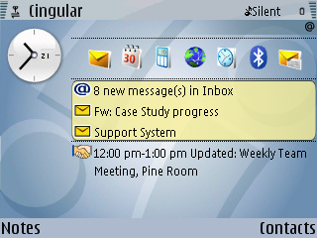
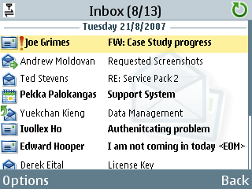
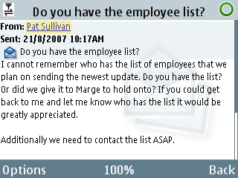

Main Menu
Inbox View
Email View

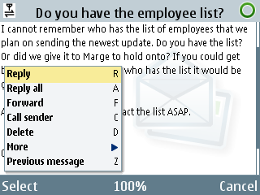
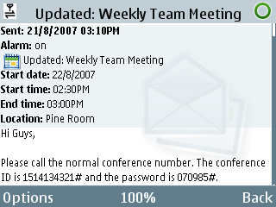

Email Menu
Calendar Invite
Launch Screen

Compose Email Screens

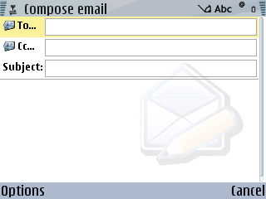
Pricing

Please define server and/or client pricing for your product for both our initial deployment (100 users) and final deployment (1000 users) based on any volume discounts available.
Answer Guidance
Reason for Question
Price is a grading criterion and we have asked vendors to submit information for this area accordingly.

Nokia Response

Nokia is changing the economies of mobile email with the introduction of Nokia Intellisync Wireless Email 8.0, giving companies like NWC a cost-effective solution for extending wireless email beyond the executive suite. Nokia Intellisync Wireless Email is designed to lower the barriers to mobile email adoption by reducing the total costs associated with wireless email. The solution leverages the broad availability of standard mobile phones and provides a two-tier licensing model.

The Nokia Intellisync Wireless Email Professional client is a full-featured wireless email platform that lets your users easily and rapidly access their email, calendar, contacts, notes and task lists on almost any mobile phone they chose. They can download attachments, respond to meeting requests and manage subfolders while on the road. Everything—including read/unread/sent emails, drafts, deletions and attachments—is fully synchronized with the email server, whether Exchange, Domino, IMAP, POP3 or XML.

The optional Nokia Intellisync Wireless Email Base client can be licensed for up to 1,000 users on each Nokia Intellisync enterprise server. This client offers the ability to compose, read and delete email and manage local folders, in addition to robust security.

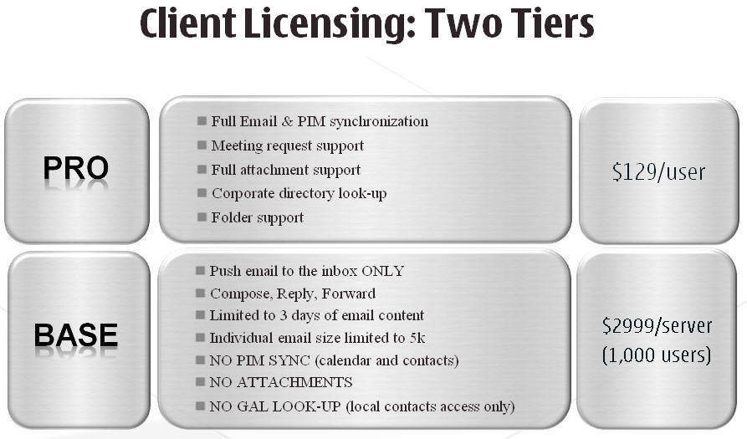
Total cost of ownership includes mobile email software, mobile devices, data plans, IT administration, and end-user support. Nokia Intellisync provides a suite approach to mobilizing and remotely managing email, PIM, files, and business applications, to drive down the total cost of ownership. For most organizations, Nokia Intellisync Wireless Email also works with the mobile devices they already own, eliminating the need for across-the-board mobile device replacement.

The following pricing pertains to Nokia Intellisync Wireless Email software.

Nokia Intellisync Device Management, Nokia Intellisync File Sync and Nokia Intellisync Application Sync are separately licensable components of Nokia Intellisync Mobile Suite.

Nokia Intellisync Wireless Email PRO Pricing – 100 and 1000 Users
Nokia Intellisync Wireless Email PRO (Pricing per user for handheld devices) | Total SW License Cost (perpetual license)
MSRP for Quantity 100 | $12,255
MSRP for Quantity 1000 | $103,200

The server fee in the table below applies to customers wishing to deploy the base client, which provides a very cost-effective way to compose, read and delete email, and manage local folders.
This server fee does not apply to customers deploying only the professional clients.

Nokia Intellisync Wireless Email BASE Pricing – 1000 Users
Nokia Intellisync Wireless Email Base (Pricing per server) | Total SW License Cost (perpetual license)
MSRP for up to 1000 users | $2,999

Support Costs

Please define service contract costs for your product for both our initial deployment (100 users) and final deployment (1000 users) based on any volume discounts available.

Answer Guidance
Reason for Question
Price is a grading criterion and we have asked vendors to submit information for this area accordingly.

Nokia Response

Nokia Intellisync Mobile Suite Support
Nokia Intellisync Wireless Email PRO - Annual Support | Essential Support Annual Price
MSRP Quantity 100 (Support) | $2,484
MSRP Quantity 1000 (Support) | $18,372

Nokia Intellisync Wireless Email Base - Support (per server) | Essential Support Annual Price
MSRP Support for up to 1000 users | $600

Nokia Technical Support Services (7x24): Nokia provides access to telephone and Web-based assistance upon purchase of Support Offerings. Service includes:
- Global Technical Support: Customers can submit cases related to problems. Calls are answered by a customer service professional who will gather and route key information to the appropriate Technical Support Engineer. To enter the same information, customers may also use the self-service Nokia Support Web 24 hours a day.
- Software Maintenance (Software Updates and Technical Support): Nokia provides ongoing software maintenance and version upgrades as part of support plans. Customers will receive updates to ensure their software is current and trouble-free. This includes software fixes as needed, periodic software maintenance releases, new version upgrade releases (except for features for which Nokia charges extra) and technical support (English only).
Authorized Customer Representatives: Customers may authorize named representatives to contact Nokia Technical Support when necessary. These authorized support contacts are established to protect the customer’s software and to facilitate speedy problem resolution. Customers may authorize additional technical contacts to access Nokia Technical Support for an additional fee.

Secure Access to Support Web Resources and Electronic Support
Nokia offers customers secure password access to Nokia Support Web resources and electronic case management. The Support Web includes these facilities:
- Product Documentation, Technical Bulletins and Searchable Ask Nokia Knowledgebase: Our information resources supply instant answers to technical questions through a sophisticated, yet easy to use search-and-retrieval system. Nokia also offers proactive email notification of new releases and technical notices.

- Electronic Case Management: A Web-based facility allows customers to log new incidents directly into the Technical Support database 24 hours a day. The incident is automatically queued to be processed according to the problem priority and target response time.

- Shared Support Technologies: Depending on the type of Support Agreement, customers receive a variety of technologies (as used by Nokia Technical Support), enabling customers’ technical contacts to resolve their own support issues. Online technologies allow customers to build their own expertise and proactively solve problems as they occur.

Support Offering Structure

- Nokia Intellisync Mobile Suite Support – Required – One per enterprise customer

- Software License Support – Required – License quantity required corresponds directly to the number of Nokia Intellisync Mobile Suite individual software product licenses purchased on a per user, device or server basis

Data Plans
We understand that some vendors require special data plans for their mobile e-mail product. With so many data plans available, please detail which data plan (if any) is required for your product from the following carriers: AT&T, Sprint, Verizon Wireless, Vodafone, T-Mobile (Europe)

Answer Guidance
Reason for Question
Data plans are a major point of confusion for NWC Inc.’s CEO. Some carriers charge differently if a particular mobile e-mail product is used than if another is used. We are looking for guidance from our vendors to determine which data plan(s) we will need to ensure that our mobile e-mail solution works.

Nokia Response

Simply put, anyone with a data-enabled mobile device and a data plan from a carrier can use Nokia Intellisync Wireless Email. Unlike many mobile email solutions, Nokia Intellisync Wireless Email allows NWC to choose the carrier and data plan that best suit your company’s needs.

Since the Nokia Intellisync solution does not require a NOC, there is no embedded cost premium in the data plan to cover the costs of an external NOC.

Unlike some “free” solutions with extremely high data requirements, Nokia Intellisync Wireless Email provides an efficient solution that lets you chose the most appropriate data plan for your users.

Communications Model

Please detail how messages are relayed from our corporate e-mail servers to a client handheld (i.e. via a NOC, direct connection to the handheld, etc). Please explain why this model is best compared to your competitors (i.e. if a direct connection is used, explain why this is better than a NOC relay).

Answer Guidance
Reason for Question
We are curious as to what the technical differences are between each product; these differences may sway our overall impression for each product.

Nokia Response

NOC-less Design
The communications model used by Nokia Intellisync Wireless Email drives email and PIM synchronization directly between corporate servers and connected devices, without requiring a NOC. Given that most companies do not allow inbound connections for security reasons, Nokia includes (at no additional cost) an optional Secure Gateway software component that can be deployed in NWC’s DMZ to securely bridge the connections between the Nokia Intellisync Mobile Suite server and devices. This architecture allows for the greatest control and flexibility for your company, while also ensuring that sensitive corporate data is never stored in any unauthorized place. Companies may also choose to deploy their own reverse proxy alternative to the Secure Gateway. Most companies choose to deploy a Secure Gateway to enhance security and minimize firewall rules, but it is not required.

Standard Internet Protocols
All Nokia Intellisync Mobile Suite communications use standard Internet protocols. Thus, any communications link that can support IP communication can connect devices to the server. No special carrier APNs are required, just a standard data plan. Wi-Fi is a first-class protocol as well for device communication. Wi-Fi can be an effective alternative to WAN connectivity, offering higher bandwidth and lower cost service.

Efficient Protocol
Because the amount of data transferred between the server and the device directly impacts both cost and responsiveness, Nokia Intellisync Mobile Suite includes features designed to minimize data transfer:

Sync Resume – Mobile communications can be unreliable with frequent line drops. Nokia Intellisync Wireless Email keeps track of the last acknowledged packet and resumes transmission where it left off. For example, dropping a slow wireless connection after 90 percent of an email attachment has been transmitted does not require re-transmission of the entire file. Our sync resume feature can have significant time-saving and cost-efficiency implications for NWC’s communications.

Compression – Communications between the server and client are compressed to protect bandwidth and minimize connect times. For email, both the message body and any attachments are compressed. However, because compression of very small units of information may actually decrease communication efficiency, Nokia Intellisync Wireless Email selectively compresses based on the size of the communication. In addition, information is precompressed at a high level instead of breaking it up into packets and then compressing. This results in a much more bandwidth-efficient communication.

Smart Attachment Filtering – Nokia Intellisync Wireless Email allows the administrator to restrict the size of email attachments. The individual NWC end-user has the option to further limit attachment size.

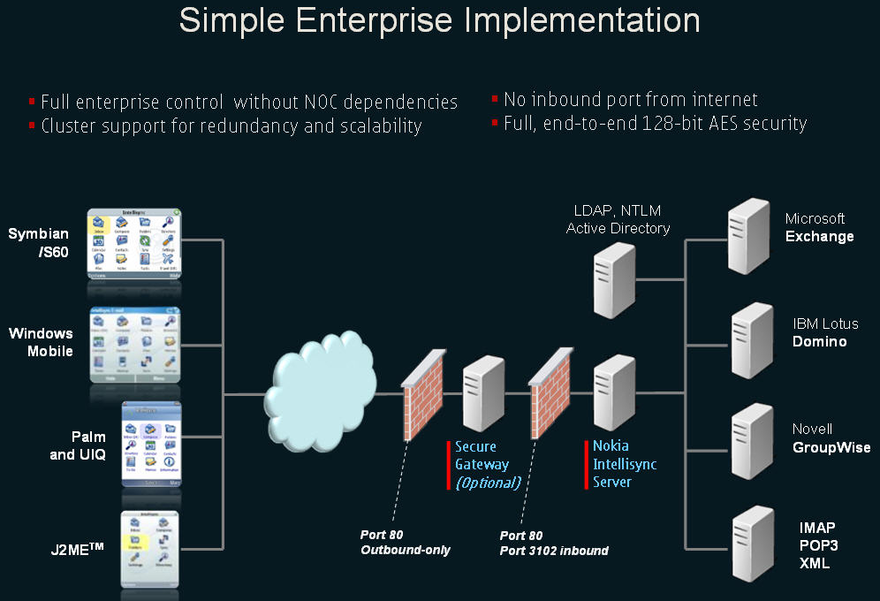

NOC Alternative
Nokia has partnered with several wireless carriers to offer a NOC-based service. Nokia Intellisync Wireless Email technology is flexible enough to be offered as a hosted, NOC-based solution for small to medium companies. This offering involves a lightweight component known as the Corporate Email Connector, or CEC, that can be installed inside your company. The CEC supports the connection of anywhere from one to 100-plus users to a hosted service based on Nokia Intellisync.

If this configuration is of interest to NWC, Inc., Nokia would be glad to provide a list of carriers that support this alternative.

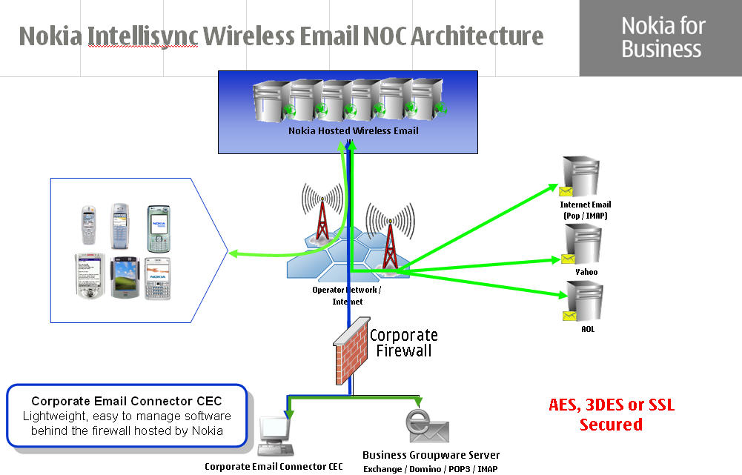

Security
Please detail how messages are secured during transport. Please detail how messages are secured on the client handheld.
Answer Guidance
Reason for Question
Security is a crucial concern not just for NWC Inc. but in many surveys is a leading concern for enterprises considering mobile deployments. We would thus like to determine the security features available for each product.

Nokia Response

Serious Security
Nokia recognizes that providing the highest level of security is essential when deploying strategic corporate information to mobile devices. Thus, Nokia Intellisync products are built from the ground up to protect your data.

Select Security Features
- User disablement
- Multiple encryption options (AES, 3DES, SSL, Certicom SSL Plus with EEC)
- Multiple user authentication options
- Theft/loss protection: lock-out, select and total device wipe
- End-user self service for lock/wipe functions resulting in quicker device locks and fewer Help Desk calls
- Session-based key exchange
- Credential expiration options
- Power-on password
- Server-sent security policy enforcement

Security and User Management
Nokia Intellisync offers security features that include advanced user management, encryption options, user disablement and more.

Advanced User Management – Administrators are able to import user lists and user group assignments from existing directory services. This prevents duplicate administrative effort and decreases error potential. Nokia Intellisync offers a variety of integration options for user list management, and enables multiple sources to be used simultaneously for:
- Microsoft Active Directory
- LDAP-compliant databases
- Windows NT domains
- Domino
- iPlanet
- Text and certain other database sources

User management is completely unified within the administration console regardless of the type or number of devices, or the directory services source from which the user comes. Features include:

Encryption Options – Nokia Intellisync allows administrators to select the transport protocol encryption options that best meet their needs for balancing the level of security with communication efficiency. Administrators may assign different encryption options to different profiles. The following standard options are available:
- AES (default setting)
- Triple DES
- SSL and Certicom SSL Plus with ECC
- No encryption

User Disablement – Your administrators are able to "turn-off" a specific user, user group, or device. For example, they may turn-off the account of a stolen device to prevent unauthorized persons from synchronizing with NWC’s company servers. Your administrators can also send a “hard reset” to wipe all data on the device and return it to factory default settings.

Session-Based Key Exchange – Each synchronization session generates new encryption keys to help ensure security. If a “malicious party” manages to eavesdrop and ascertains a session key, that key will be valid for only that session to minimize any risk exposure. Given the nature of synchronization sessions, i.e., typically short and frequent, this feature makes it difficult to compromise the encryption.

Credential Expiration Options – Your system administrators can prevent storage of network credentials on a user’s device by forcing users to enter a password each time they connect to the network to synchronize. To support more frequent synchronization, including automatic synchronization, an option allows credentials to be encrypted and stored for a configurable length of time. This provides a flexible method to balance usability needs with reliable security.

Staged Files Encrypted – As part of our end-to-end security approach, files are encrypted when stored at the server awaiting transmission.

Control of Hardware Elements – The optional Nokia Intellisync Device Management component allows your administrator to disable/enable selected hardware elements on end-user devices including camera, Bluetooth, WLAN, infrared and memory card. Your end-user will receive a pop-up screen notification that hardware functionality is disabled and they cannot override the setting. This capability gives the option to disable functions like the camera on a mobile device if a company’s security policy does not allow cameras on the premises.
Security – Part 2

NWC Inc’s Exchange server is located behind the corporate firewall. We are reluctant to open any holes into our firewall to allow for mobile clients to gain access. Please detail how your product can integrate into our DMZ (i.e. use of a proxy, via middleware server’s integration to Exchange via OWA, etc). Please also detail what firewall ports NWC Inc would need to open, if any, in order to facilitate communication between mobile clients, your mobile e-mail server and Exchange.

Answer Guidance
Reason for Question
Security is a crucial concern not just for NWC Inc. but in many surveys is a leading concern for enterprises considering mobile deployments. We would thus like to determine the security features available for each product.

Nokia Response

Flexible Access to Groupware Servers
Because deployment strategies and configuration options differ from company to company, Nokia Intellisync Wireless Email offers flexible methods for accessing Lotus Domino and Microsoft Exchange servers.

- Microsoft Exchange server access options
  - User domain account credentials
  - Courier account access
- Lotus Domino server access options
  - HTTP password
  - Courier account access

Secure Architecture – Nokia Intellisync Wireless Email uses secure deployment architectures, with only a single outbound port required to connect wireless email to the Nokia Intellisync Mobile Gateway in the DMZ. The mobile gateway can run on Linux, obviating the need for IIS in the DMZ.

NOC-less Option – With the included Nokia Intellisync Mobile Gateway, NWC has the option to avoid having email and other sensitive company information reside at a third-party network operating centre (NOC), which is commonly used by other wireless email providers. Nokia Intellisync Wireless Email essentially brings the NOC within the firewall and under the control of the NWC IT department. Nokia Intellisync also offers a hosted NOC if NWC prefers this option.

Nokia Secure Gateway, DMZ,
Port 80 Outbound and Port 80 and 3102 Inbound

Management

Please detail the handheld management features available from your product or from products available from your company. If no product is available, please detail if any products are available from partner vendors. If management features are available as a separate product, please detail the change in the price defined above, if any.
Answer Guidance
Reason for Question
When companies start to load corporate data (like e-mail) onto their handhelds, it’s imperative that these handhelds be able to be managed from the IT department. We are curious to know if we will need to implement a separate management solution or if we can leverage management features from our mobile e-mail investment.

Nokia Response

Nokia Intellisync Device Management is a flexible and cost-effective over-the-air device management solution for remotely managing mobile devices in enterprise environments.

Nokia Intellisync Device Management provides the following benefits:
- Provides opportunities to reduce IT support costs
- Increases operational efficiency
- Extends regulatory [e.g., SOX] compliance to devices to help manage risk associated with information technology
- Manages corporate risk
- Helps you realize faster ROI through rapid deployment of mobile applications and updates
- Improves employee retention and satisfaction by relieving burden of device management

The solution supports a broad range of mobile device platforms including Symbian OS, Windows Mobile, Palm OS, BlackBerry and Windows for personal computers.

Nokia Intellisync Device Management Feature Highlights
- Streamlines administration of mobile devices (including laptops and desktops), with over-the-air provisioning and corporate policy management
- Protects end-user productivity with remote management
- Comprehensive security policy enforcement
- Wide range of theft/loss protection features
- Comprehensive device settings enforcement
- Improves business planning via asset management
- Reduces burden on end-users of application distribution, configuration and management
- Disaster recovery via back-up and restore features
- Inherent support for standards (OMA)

Administrative Interface Options
- Microsoft Management Console (MMC) plug-in administration console
- Web-based administration for Help Desk multi-tenant functions
- Self-service end-user control of device lock/wipe and device administration

Management Solution Attributes
- Support for clustered servers with failover
- Dynamic load balancing
- Real-time monitors
- Inventory-based administrative alerts
- Flexible log viewing and reporting
- Configurable logging detail
- Wireless optimizations

Supported Device Operating Systems
- BlackBerry OS
- Palm OS
- Symbian OS
- Windows Mobile (Pocket PC and Smartphone)
- Windows PCs

Device Management
With Nokia Intellisync Device Management, NWC administrators will have the ability to filter a device update according to static and dynamic device characteristics. For example, they can specify that a software update can be sent only to Windows Mobile 6 devices running a specific OS version (i.e., Smartphone Edition) and with specific applications installed. This feature enables very flexible and targeted management of users and devices.

Nokia Intellisync Device Management delivers best-of-breed functionality for:
- Device configuration
- Asset collection
- Software distribution
- Troubleshooting and recovery
- Powerful security – Please see “Security” and “Security Part 2” sections above
- Communications efficiency
- Simplified user experience

The following section details our capabilities in each of these areas. Major features are identified with their significance and associated benefits as well as potential drawbacks of alternative approaches.

Device Configuration Features

Configuration Management – A key element in any effort to control total cost of ownership (TCO) is putting in place device policies. Configuration management provides a centralized way to manage device settings to minimize downtime and streamline support. NWC’s administrators will be able to control power management, security settings, auto-update mechanisms, dial-up and VPN settings, plus other key settings.

Configuration Reader – Often the simplest way to create a standard device configuration is to configure one prototypical device to your specifications. Nokia Intellisync Device Management can then read and extract configuration data from the device, create a standard profile, and push it out to all similar devices.

Configuration Wizard – Nokia Intellisync Device Management provides an administration console wizard to guide your administrator through the steps of building a configuration profile. This method ensures key settings are managed in a simple, straightforward manner.

Asset Collection
Hardware Asset Collection – Nokia Intellisync Device Management enables compiling hardware asset information on the server to facilitate troubleshooting and planning. During the occasional synchronization sessions, the Nokia Intellisync Mobile Suite client gathers the asset information and transmits it to the server. Device characteristics include memory usage, operating system (OS) version, device manufacturer, installed peripherals, serial number, mobile operator, phone number, and more.

Software Asset Collection – With Nokia Intellisync Device Management, NWC administrators can gather information about the software installed on your devices, including versions and application sizes.

Inventory Alerts – Once asset information is brought back to the server, it is analyzed for various administrative alert conditions. Your administrator will then be able to custom-tailor these conditions, and the alert mechanism itself, to meet NWC’s needs. Examples of alert conditions you can address include low free storage and/or excessive time lapses between client-server connections.

Configurable Asset Collection – Transmitting asset information incurs communications overhead. Nokia Intellisync Device Management gives NWC administrators the flexibility to choose the specific information they want brought back. For example, they might select data about the memory and OS of a device, but not its video characteristics.

Offline Asset Collection – Many devices allow the gathering of asset information in advance, so staged asset data can be transmitted more quickly during a synchronization session.

Scheduled Collections – Nokia Intellisync Device Management allows your administrator to set-up a schedule for asset collection at specified times of the day and/or days of the week.

Configurable Alert Delivery – Nokia Intellisync Device Management enables your administrators to control the frequency and delivery methods of administrative alerts. They can set threshold severity levels over the types of errors that trigger an alert. They also can choose the delivery mechanism, using SMTP email alerts to paging devices and mobile phones, SNMP to route alerts into the network operations center, as well as other network management tools.

Application Programming Interfaces (APIs) – The most detailed asset data available can be brought back to the server with Nokia Intellisync Device Management. For Windows, the Windows Management Instrumentation (WMI) standard is used. In general, for other handheld devices, standard OS APIs are used. For the most popular models, close Nokia cooperation with the device manufacturers enables usage of manufacturer-specific APIs that bring back more detailed data.

Software Distribution
Nokia Intellisync Device Management publish-and-subscribe model provides the ultimate in flexibility. The solution can be used to service a broad range of user communities, providing each NWC user with a personalized portfolio of relevant applications. Dynamic publication capability simplifies targeting updates to only the relevant devices and users.

Standard Install Publications – Nokia Intellisync Device Management can be used to push-out pre-packaged software installations to mobile devices. Many different packaged install types are supported including Microsoft cabinet (CAB) files, InstallShield executables, Microsoft installer (MSI) packages, Palm resource (PRC) files, Symbian installation system (SIS) files and Microsoft System Management Server (SMS) packages.

Custom Publication Definitions – Administrative tools to define custom publications are included in Nokia Intellisync Device Management. A publication is composed of a set of actions that execute in order, online and offline, on the client and server. A publication can be as simple as a single action to copy an executable file from the server to a mobile device, or as complex as multi-step processes with branching logic.

ActiveSync Settings – ActiveSync is the Microsoft protocol for email and PIM synchronization. Nokia Intellisync Device Management provides an interface for administrators to configure and distribute ActiveSync settings for a large number of users.

Subscriptions – Once either type of publication − standard install publication or custom publication definition − has been specified, NWC’s designated users or groups of users can be subscribed to a publication via the administration console. Note that a “group” of users does not necessarily have to relate to their network domain; it may be used more flexibly.

Publication Wizard – A powerful wizard is available to guide the process of creating new publications and subscribing users.

Standard Actions Library – Nokia Intellisync Device Management includes a library of over 30 standard actions for setting up publications. These include creating and removing directories; downloading files to a device; uploading files to the server; executing programs and scripts; copying, deleting, renaming and moving files; and referencing inventory attributes. One standard action may be used to run specified Visual Basic scripts, making it easy to extend the solution to handle NWC’s unique needs without requiring a proprietary scripting language.

Extensive Action Configurations – Each standard action has its own set of configurable properties. The flexibility afforded by the standard action lists and the action properties enables administrators to easily accomplish the vast majority of device management tasks without any custom scripting.

Non-Proprietary Visual Basic Script – The Nokia Intellisync Device Management library of standard actions can easily be extended with custom actions written in Visual Basic script. In contrast, some competitive products use a proprietary scripting method that can drive-up NWC’s costs of training and maintenance.

Availability Scheduling and Bandwidth Management – To control bandwidth consumption during peak hours; Nokia Intellisync Device Management enables administrators to schedule publications for delivery during specific off-peak windows. Users synchronizing outside the administrator-defined window will not receive updates to these publications. Alternatively, administrators can “trickle” large publications using increments of data size or time units. For example, a large software package can be sent in hundred-kilobyte chunks, or in five-minute data session increments, to avoid monopolizing usage of the device connection.

Dynamic Formulation of Groups – NWC’s IT administrator may already be organizing your users into groups via other tools such as Microsoft Active Directory or Lightweight Directory Access Protocol (LDAP) database. Nokia Intellisync Device Management can help your administrator take advantage of external data for user and group assignments, especially when assignments change frequently during the normal course of business.

API for Automating Subscriptions – Your IT administrator may have existing systems that dictate which software NWC users or devices are supposed to receive. NWC now can leverage the exceptional communications efficiency and reporting capabilities in Nokia Intellisync Device Management, while still utilizing the subscription API for building links to external systems.

Parameterized Publications – Nokia Intellisync Device Management publications can be parameterized for additional flexibility in bringing the right information to the right users. A single parameterized publication is created to deliver all application data in a particular directory, where the path name for the directory includes the NWC user’s network login user name. This allows for totally customized delivery without requiring extensive publication maintenance.

Publication Prioritization – Using the Nokia Intellisync Device Management publication prioritization feature, NWC administrators can ensure the most critical software is updated first during synchronization sessions. When your users experience unreliable connectivity or lack the time needed for full synchronization sessions, the most important application updates will be delivered first.

APIs for Client Components – Nokia Intellisync Device Management includes the Nokia Intellisync Mobile Suite client, an application for launching synchronization sessions. Nokia Intellisync also provides APIs that make it possible to embed the device management capabilities within other applications and processes, to effectively provide a “silent client” user experience.

Delayed Activation – Nokia Intellisync Device Management enables NWC to publish applications and data to devices in advance of a specific activation date. while preventing user access before that date. This feature simplifies roll-out of new applications and time-sensitive information.

Troubleshooting and Recovery Features

Remote Control – Nokia Intellisync Device Management enables NWC administrators to take control of devices over a wireless connection for easy troubleshooting and end-user training. The administrator initiates a connection by sending a connection request to the remote device, which then initiates a request displayed on the device: “Accept remote control connection?” If the NWC user selects the “Yes” response option, the viewer is launched on the administrator’s computer displaying a skin resembling the user's device. This skin allows the administrator to press keys similar to the actual device, including soft keys.

Device Backup – Nokia Intellisync Device Management allows the NWC administrator to create device backup publications that function almost like software installations in reverse. The publication is set-up to retrieve specific files and data from the device during device management connections, and to encrypt and store these on the server for use if device restore becomes necessary.

Software Healing – Nokia Intellisync Device Management will even repair damaged or accidentally deleted software components for NWC. At the next server connection, the required updates are noted and performed, so NWC users do not experience delays that may occur when the Help Desk must be contacted to identify and resolve such problems.

Single Integrated Administration Console
NWC can take advantage of the time-saving convenience of one integrated Nokia Intellisync Admin Console that manages all administrative aspects of controlling device management.

Single Nokia Intellisync Mobile Suite Client – All data sessions are managed through a single Nokia Intellisync Mobile Suite client on a device. The sync client can manage all types of updates in a single session. For example, the client can update email, application data, and software, and receive a security update, all in one session. Bandwidth is very efficiently used, updates are rapid, and prioritization can be managed across all device applications and functions.

Microsoft Management Console (MMC) Administration –Nokia Intellisync Mobile Suite features a MMC plug-in that allows NWC administrators to manage the core server attributes, the synchronization server software, and other common applications.

Web-Based Administration – Nokia Intellisync Device Management gives NWC access through a Web interface, so your Web administrator or Help Desk only needs Internet access from the remote location. Web-based administration enables the efficient management of multiple departments or sites, with separate groups of mobile devices or users. Multi-tenant support enables delegated NWC administrators to login and view only their respective objects, such as users, groups, devices and publications.

Viewing Staged Files – Nokia Intellisync Device Management gives NWC administrators a view into staged files so they can look at the queue to be sent to device users. Functionality includes the ability to inspect file update history to help with troubleshooting, and to manage bandwidth by understanding the effects of differencing on specific publications.

Comprehensive Logging Detail – The detailed logging feature in Nokia Intellisync Device Management enables NWC administrators to quickly and easily identify when a specific user is connected as well as the device used, connection type, volume of transferred data and any error messages. Logs are held in an open database connectivity-compliant (ODBC) data source and may easily be used for high-level aggregate reporting and departmental billing.

Flexible Logging Detail Level – Highly detailed logging is particularly beneficial during initial roll-out and when environmental factors might cause NWC users to experience a high frequency of problems. NWC administrators have the option to escalate the level of system logging detail to facilitate troubleshooting at such times, and then reduce the detail level during more routine periods.

Console-Based Log Views – To facilitate troubleshooting, Nokia Intellisync Device Management provides a wide variety of interactive log views from within the administration console for rapid drill-down into specific log data. Logs can be sorted or filtered by various factors including the specific user, device, type of event, or time period. Log views can also be exported to Microsoft Excel.

Real-Time Monitoring – The Nokia Intellisync Admin Console includes a real-time monitoring capability for watching server processor usage, database transactions, database connections, Web server throughput, message queue size, gateway transmission, and more. This functionality is complemented by historical reporting for daily, hourly, and other levels of detail.

Client Side Activity Logged at Server – During synchronization sessions, full client activity records are brought back to the server for central storage and viewing. This glimpse of client-side activity can be extremely helpful to NWC during troubleshooting and for supporting the Help Desk.

Configurable Alert Delivery – With Nokia Intellisync Device Management, NWC, administrators have control over the frequency and delivery methods of administrative alerts. In addition to setting threshold severity levels over the types of errors that trigger an alert, they also can choose the alert delivery mechanism, using SMTP email alerts and SNMP to route alerts into a network operations center.

Web Reports for Help Desk Staff – While some inventory data is very useful to NWC’s Help Desk staff, NWC may choose to not give these personnel access to the full administration console. Nokia Intellisync Device Management provides a variety of Web-based inventory reports to facilitate Help Desk troubleshooting and support without incurring the potential security risks posed by full access.

Integration with Microsoft Systems Management Server (SMS) – Nokia Intellisync Device Management integrates with Microsoft SMS, enabling NWC administrators to view device and log info and initiate packages destined for devices running the Nokia Intellisync Mobile Suite client. The integration extends the visibility to Symbian, Palm and Windows Mobile devices via Microsoft SMS administration console.

Application Support
Please detail how NWC Inc. can leverage your company to help us mobilize applications
Answer Guidance
Reason for Question
Mobile e-mail is a good way to get our foot in the door to create a larger mobile applications strategy. We are interested in ways we can create CRM, field force automation and other mobile applications for our company. We are thus interested in understanding how we can

Nokia Response

Mobilizing Line-of-Business Applications with Nokia Intellisync Mobile Suite
Nokia Intellisync Mobile Suite is a modular software infrastructure solution that helps companies like NWC quickly realize ROI on their mobile computing initiatives. NWC may choose to deploy specific components as a point solution to solve a specific business problem, or invest in the full suite for a strategic company-wide mobile infrastructure. Nokia Intellisync Mobile Suite includes a collection of integrated platform technologies, as well as the four main products that plug into the platform.
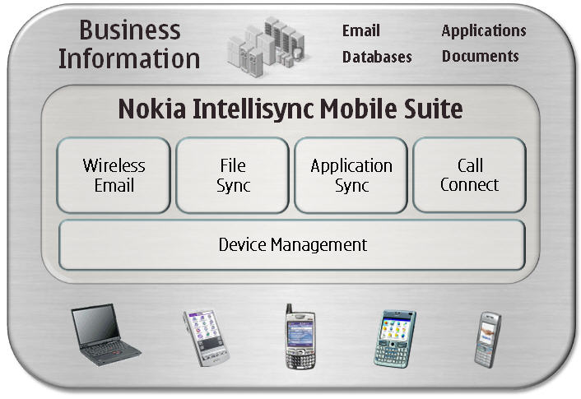

A wireless application requires data that must be available even when the device is off-line. Two components of Nokia Intellisync Mobile Suite enable NWC to mobilize line-of-business data. Nokia Intellisync File Sync focuses on applications that use file-based data on the client to store information, whether a form, picture, spreadsheet, xml data file or other type of data. Nokia Intellisync Application Sync focuses on applications that store data on the client in a relational database such as Microsoft SQL Server CE or IBM DB2e.

Nokia Intellisync File Sync
Nokia Intellisync File Sync is a highly automated information distribution, updating and retrieval tool that enables the entire NWC organization to have the most up-to-date business information and documents − including files, pictures, video, forms, documents, and intranet content − without burdening the NWC end-user. Beyond driving-down the typical delays and high costs of distributing business-critical information to your employees, Nokia Intellisync File Sync also provides reliable, traceable delivery of documentation to support NWC’s regulatory and legal compliance.

With Nokia Intellisync File Sync, virtually any type of file or data can be kept synchronized. Information stored in specified network locations can be automatically distributed to a wide range of devices. Additionally, information captured on remote devices can be automatically retrieved and stored centrally. Typical applications include custom application data, sales literature, standard contracts, parts catalogs, service manuals, human resources materials, company directories, and other company intranet content. System administrators set up publications, which are a sequence of file transport instructions, and then subscribe groups of users to these publications. When devices connect back to the server and authenticate, new materials and updates are transmitted, while missing or damaged files on the remote device are repaired. Connection to the server can be automatic or user-initiated. Once placed on the device, files are available through the device file system, and through convenient hyperlinks from the Nokia Intellisync File Sync client. When using the automated file retrieval features of Nokia Intellisync File Sync, files collected from the device can be processed following upload to the server or network storage location.

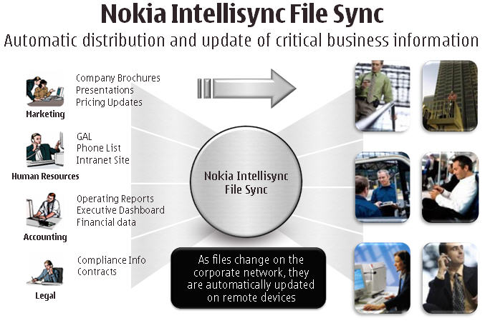

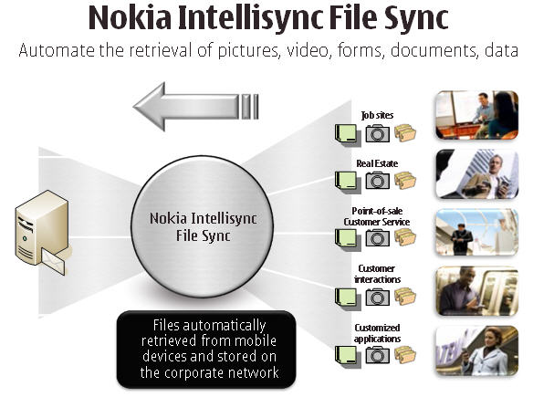

Photo Sync
Nokia Intellisync File Sync includes a Photo Sync feature that allows users to automatically upload photos automatically from their phone. Once photos are on the server, users can view and manage their images via the Web-based Nokia Intellisync client interface.

Nokia Intellisync Application Sync
The Nokia Intellisync Application Sync component of Nokia Intellisync Mobile Suite enables NWC to extend corporate information to your mobile workforce. The solution has been designed as a mobile framework that seamlessly integrates into corporate environments for managing, accessing, and synchronizing information to mobile users. Nokia Intellisync Application Sync provides an open, flexible, and scalable architecture ideal for NWC as you embark on mobile application deployments. Nokia Intellisync Application Sync can extend your data from your existing corporate applications to wireless and mobile environments, or deploy custom line-of-business applications to your mobile users.

Scalable to thousands of users, Nokia Intellisync Application Sync supports a wide variety of computing environments to bring NWC the industry’s most flexible and robust framework for mobile solutions. NWC will be able to mobilize information from virtually any corporate data source to any laptop, tablet, and handheld device. With support for heterogeneous database, device, and mobile operator models, you can leverage your existing infrastructure to minimize the costs of extending mobile information. Further, by utilizing business logic instead of code for defining data distribution and sharing rules, Nokia Intellisync Application Sync offers NWC the utmost flexibility for your dynamic business environment.

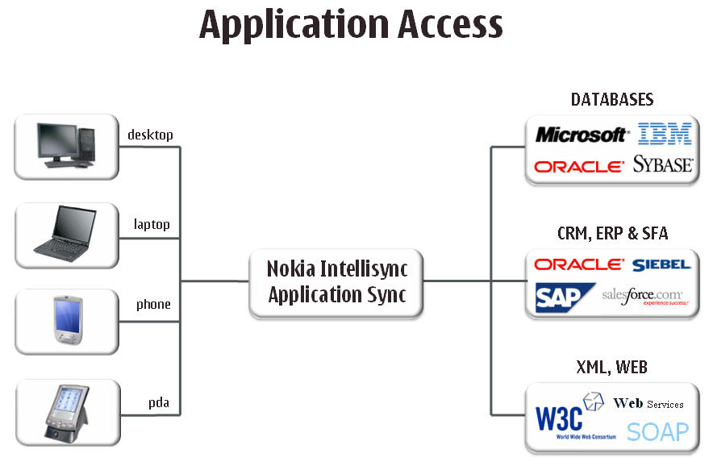

Powerful Database Replication Engine
Many business applications store data in a relational database management system. Replicating data to mobile clients is a challenge, as it is traditionally difficult to set-up and manage, is often unreliable, and does not scale. It also restricts the choice of mobile database. Nokia Intellisync Application Sync lets you "mix and match" database platforms on the client and server. This allows you to choose the right data store at either end without having to compromise to suit the middleware. It also provides maximum flexibility when extending an existing application out to mobile devices.

Nokia Intellisync Mobile Suite as a whole has proven to scale massively. Nokia Intellisync Application Sync offers a replication engine that scales effortlessly to thousands of users and makes use of techniques to ensure maximum performance. For example, Nokia Intellisync Application Sync applies change files offline, so that nothing happens during the sync session except passing the change files in each direction. Only after the transfer is complete are the changes “unpacked” into the databases on either end. This method reduces connection times significantly.

Nokia Intellisync Application Sync also offers a simple yet powerful environment for managing business rules that partition the data. Parameters can be defined to create rules whereby only matching clients are updated with specific data. For instance, service calls may be assigned to technicians based not only on their geographic territory, but also on their skill sets. When a technician is certified on a new product, there is no need to rewrite a lot of SQL conduit code. A simple parameter setting reflecting the change would affect the data transfer logic automatically.

Solutions for Service-Based CRM
Software as a service (SaaS) is a new trend whereby corporate applications reside on the Internet and organizations can then subscribe their users. Systems for CRM and salesforce are particularly popular in this model. Nokia Intellisync Application Sync provides a way for customers to access data from service-based systems on their mobile devices. Data is synchronized and stored on the device so it is available even without an Internet connection.

Mobile Applications Starter Kit
Nokia offers a Mobile Applications Starter Kit so new users can evaluate Nokia Intellisync Application Sync and Nokia Intellisync File Sync. With sample mobile applications, server-side applications and complete instructions to deploy and trial the solutions, the Starter Kit makes learning and trying Nokia Intellisync technology very easy for NWC.

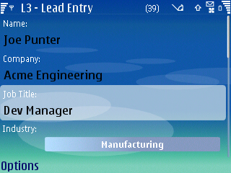

Collecting Leads with the Starter Kit L3 Sample Application and Nokia Intellisync File Sync

Extending Custom Applications
Some applications use proprietary APIs or are built on custom data stores. For such cases, Nokia offers NWC an extensive set of tools and SDKs to help you create the necessary connectors to custom applications. Once these are built, you can enjoy the benefits of Nokia Intellisync Mobile Suite, including the ability to manage and update the client application and monitor usage of the system.

Geographic Coverage
Please detail the countries your product works in. Answer Guidance
Reason for Question
As NWC Inc looks to expand globally, we want to understand where your mobile e-mail product will work.

Nokia Response

Nokia Intellisync Mobile Suite is ideal for NWC as you become truly global. Nokia Intellisync Mobile Suite is sold through operators and to companies worldwide.

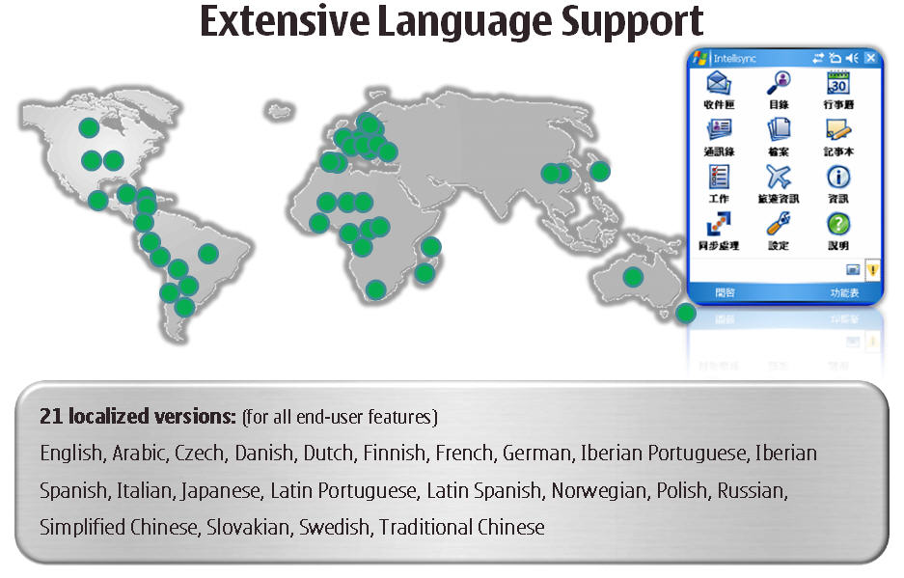

Competitive Analysis
Please detail how your product compares, and what advantages it has, against your competition. Consider competing companies to be those on the right hand side of Gartner’s mobile e-mail magic quadrant.

Answer Guidance
Reason for Question
We want to understand how vendors see themselves and how their product stacks up against competing products.

Nokia Response

Background: Basic Architecture Choices for NWC’s Mobile Email
NWC Inc's goal is to essentially pilot a mobile email solution, and then extend email and other applications as it deems appropriate. Nokia customers and industry analysts have overwhelming found that the ROI of mobile email has been reality-checked by real-world experience and is no longer in question.

Even more important, the expectation of real-time communication is becoming so pervasive that customer and partner expectations make it difficult for almost any company to resist adopting mobile email. With the capability of enabling wireless email as an included feature on the latest version of Microsoft Exchange, to which NWC has upgraded, workers’ ability to connect to up-to-date information have become the expectation rather than the exception.

NWC, or any company, needs to consider several basic architectural choices for mobilizing email. Some solutions use a Network Operations Center (NOC)-based architecture with a standalone server in the corporate network behind the firewall, which is linked to proprietary and mostly email-centric devices. NOC-based solutions generally carry a price premium because of limited device range, NOC fees, and licensing structures, which all drive-up total costs.

Companies can also choose a “white-label” mobile email product hosted by an operator. Such products rely on operator-hosted NOCs and have very limited device management. These alternatives are mainly appropriate for “prosumers” or consumers. All of these products rely heavily upon a third-party NOC for stability and security. Many companies are thus uncomfortable with this approach and unwilling to have their internal data reside outside their corporate walls.

A more suitable alternative for these organizations, as well as for those seeking more control in managing cross-carrier solutions, is the Nokia Intellisync Wireless Email “behind the firewall” solution. Compared to the limitations of NOC-based solutions as well as the limited device management, incomplete security features, and high administrative and Data Plan costs associated with many other solutions, Nokia Intellisync Mobile Suite is the alternative that leverages the real-world devices NWC’s workers already use today. NWC can easily expand capabilities with the fully functional Nokia Intellisync Mobile Suite to mobilize the applications and data that support your economic and global strategies. And NWC can add Nokia Intellisync components at the time and in the order that make the best business sense.

Choosing a Mobilization Strategy
Given the many available mobile email platforms, plus the rising demand for mobility by customers as well as workers, companies like NWC are challenged to create a full mobile strategy beyond a point solution that supports only key executives or sales groups. One of the critical mobile solution-purchasing considerations NWC faces involves the trade-offs implied by choosing a single-vendor offering.

At Nokia, we hear these trade-offs expressed in different ways by our customers: “Is it better for us to choose a mobile email point product that restricts choice to a few devices, or will this end up proving very costly, given our mix of user types and needs? Will all of our users accept an extremely limited device range or will they simply bring their own preferred personal mobile phones into the workplace, thus removing mobile devices from our IT’s awareness and control? Is the headache of implementing a first-release product a wise alternative? Will all email products work across the geographies our workforce covers? What’s next after mobile email and how do we evolve our workforce mobility over time?”

Nokia Intellisync Mobile Suite is a modularized, server-based solution that incorporates a wireless email suite, a systems and device management suite, a file sync suite for unstructured data and documents, and an application sync suite for custom data mobilization of back-end systems such as Oracle, SQL Server, DB2 and ODBC. All four components plug into the Nokia Intellisync Mobile Suite platform, which provides shared user and administration interfaces, a common communications layer and shared services for reporting and logging. With Nokia Intellisync, adding each set of capabilities requires only an additional license key—not a new software installation.

Nokia Intellisync Mobile Suite has a built-in roadmap of productivity solutions:
- Nokia Intellisync Wireless Email extends your email, calendar, and contacts to the device of your choice in a scalable, secure solution that works across messaging platforms and versions
- Nokia Intellisync File Sync automates the distribution and updating of documents and intranet content
- Nokia Intellisync Application Sync lets you extend important enterprise applications or data—such as a CRM application—to devices in the field
- Nokia Intellisync Device Management helps you keep your workforce connected, manage and control your mobile assets, and minimize your IT administrative costs
- Nokia Intellisync Call Connect extends the functionality of your PBX to the mobile phones deployed across your organization

Each of these modules brings the benefits you have come to expect from Nokia:
- A wide range of data collection and distribution capabilities
- The ability to use your handset as a primary phone
- The wide range of choice in the form factor or design you like best
- It is in this dramatically increased choice that Nokia Intellisync shines with its support of hundreds of devices from all manufacturers and all major messaging platforms.

In fact, Nokia Intellisync Mobile Suite supports not only all of the leading, high-end mobile devices, but also a broad range of more basic phones as well as laptop and tablet PCs. In other words, Nokia Intellisync Mobile Suite is designed to support the devices that are currently used in a company, while alternative solutions require purchasing additional, expensive devices.

Securing Your Mobile Workforce
NWC specifically mentioned security as a concern in choosing a mobile platform. Nokia Intellisync built an integrated management and security framework into its platform, from day one. As a result, Nokia Intellisync has proven and earned its leadership position in mobile security.

Nokia Intellisync Device Management and administration capabilities extend far beyond many alternative products. For example, role-based and group-based administrative capabilities are deeper in Nokia Intellisync Mobile Suite, including definable hierarchies of administrators and tiered administration capabilities that allow the creation of sub-groups with specified profiles.

Unlike other products that are limited to a high-end subset of mobile devices, Nokia Intellisync Wireless Email addresses broader device classes as well as device types: Windows Mobile, Symbian, BREW, Palm OS, and RIM devices.

Nokia Intellisync Mobile Suite also features deeper functionality in such critical areas as hardware and software asset collection; connection policy settings and enforcement; software distribution; and recovery/backup functions.

Summary
Nokia Intellisync Mobile Suite offers NWC a modularized roadmap to introducing point solutions such as email and IM in the broader context of a fully-functional, comprehensively managed corporate-wide solution.

For companies like NWC that are seeking a full-featured solution in order to begin integrating the mobile habits and devices of a broad set of employees, Nokia Intellisync Mobile Suite offers the broadest and deepest support. With Nokia Intellisync Wireless Email, you are not dependent upon a NOC-based architecture with a high cost structure, nor do you have to wait for the device management and additional capabilities you need, or restrict employees to only a few high-end devices.

Only Nokia Intellisync Mobile Suite combines all of the benefits across all major device and messaging platforms, while keeping costs down through architecture and licensing structure.

The Value of Nokia Intellisync to NWC
Nokia Intellisync Mobile Suite provides a complete mobility platform that will enable NWC to mobilize in the order that makes the most sense to you, cost-effectively and with a rapid ROI. Nokia customers have experienced increased productivity, reduced operational costs, and improved customer satisfaction through Nokia Intellisync Mobile Suite.

Nokia Intellisync Mobile Suite enables access to email, calendar information, instant messages, customer information, documentation, and business-critical information.

We believe the Nokia Intellisync Mobile Suite solution best meets the needs of NWC by providing:

- A scaleable mobile data architecture not shared with other companies
- Better control over security, redundancy, and failover settings
- Strong, proven data access tools to help you drive any information to your devices
- Rich device and systems management tools for managing your environment from a single, centralized console
- Broad choice of devices for your mobility implementation
- Proven Nokia Intellisync client software
- Support for all major email groupware platforms

We look forward to working with NWC to help you harness Nokia Intellisync Wireless Email and other Nokia Intellisync Mobile Suite components to implement your global strategy. Thank you for this opportunity to present our information to you.

