


Request for Information (RFI)
On
Mobile E-mail

RFI Deadline: August 22, 2007
Publication Date: October, 2007

Drafted by Sean Ginevan
Contributing Technology Editor, Network Computing
E-mail: SGinevan@nwc.com

Introduction 3
Instructions 3
A. Business Overview 4
Objectives 5
Mobile E-mail Vendors Questions 6

Introduction

This RFI (Request for Information) is proprietary to Network Computing, Information Week and CMP Media, LLC. It is drafted and disseminated for the sole purpose of generating information on Mobile E-mail for publication in Network Computing.com and/or InformationWeek in October, 2007. Participating vendors must agree that any information returned to Network Computing in response to this RFI may be published in print and electronic form on our Web site, www.networkcomputing.com. Information obtained for this RFI may also be reprinted in whole or in part within InformationWeek or on the InformationWeek website at www.informationweek.com

Instructions

The following questions are designed to provide direct comparisons among major vendors within the mobile e-mail space. We have endeavored to provide as much detail about our proposed scenario below in “Business Overview.” However, if you feel that any points need clarification, please contact the author, Sean Ginevan, via e-mail at SGinevan@nwc.com. If points are clarified we will send those clarifications to all participating vendors to ensure that everyone is operating with the same information. The answers obtained from this RFI, in addition to previous completed testing, will be used to provide all analysis for this article.

If you respond to the RFI, please note that all responses must be received by August 22, 2007 for inclusion in this review. We suggest you read through the entire RFI before answering questions. You can reference answers to other questions in the RFI using the section title. Please do not reference materials outside the RFI; incorporate them into your answers.

Essay-type questions include word-count limits. Any submission beyond the limit may be ignored.

Business Overview

NWC Inc. is a medium sized company specializing in the development and manufacturer of specialty Widgets and Sprockets. The company has three major offices; a headquarters in suburban Washington, DC and branch offices in Syracuse, NY and Kansas City, MO. The company also has just opened a European sales office in Dublin, Ireland.

NWC Inc.’s mobile strategy has been limited thus far. Cellular phones and plans have been subsidized for executives, sales staff and critical operations (on call) staff. However the company has been slow to move into any other mobile service beyond voice. Executives at NWC Inc. have read numerous articles on the benefits of mobile e-mail but have been concerned about costs as well as complexity for supporting a new mobile e-mail initiative.

NWC Inc. has decided to start with a 100 user deployment, focusing on executives, top-tier sales staff and select operations employees in each of our worldwide offices. The company has standardized on Microsoft Exchange and has recently completed an upgrade to Exchange 2007. NWC Inc. has its e-mail servers distributed between Washington, DC; Syracuse, NY; and Kansas City, MO for increased scale and reliability.

While our focus is on an initial 100 user deployment, NWC Inc. wants to eventually scale to include the entire IT operations, sales and management staffs for a total of about 1000 people. The ability to scale up to larger deployments, particularly as the company grows, is important.
NWC Inc is also interested in applications beyond mobile e-mail. Our CIO has read numerous articles about how enterprises are creating applications beyond mobile e-mail. The company is thus curious with how our mobile e-mail software provider can also help us mobilize applications or whether we would have to partner with another vendor. Our CIO is also very security conscious, so we want to understand what the device management and security posture is for the vendors

Objectives

NWC Inc's initial goal is to provision select staff across our worldwide offices with a mobile e-mail solution to more effectively communicate with our more nomadic employees. While our initial goal is to focus on mobile e-mail, we want to ensure that whatever solution we choose has a robust enough security and device management framework in place. We also want to make sure that we can expand into other types of applications. Our goal is to be strategic, rather than tactical, in developing our mobility strategy. We are flexible in device platform selection and we're looking to vendors to provide us with insight as to pros and cons with our available selections (Windows Mobile, BlackBerry, Symbian, etc).

Targets:
- Initial deployment date is: Sept 5th, 2007
  - Mobile e-mail gateway installed in all locations
  - Handsets configured and loaded with software
  - 2 weeks troubleshooting
  - Employee training if needed
- Live on Sept 24th, 2007

Selection Criteria
During our analysis period, we will be reviewing all the RFI’s looking for the best solutions that fit our needs. We will most likely have additional clarifying questions that will need to be answered. We will be using the following list of items (in alphabetical order) to perform our assessment.

- Client software cost (if any)
- Depth of client support
- Depth of management features
- Depth of security features
- Mobile e-mail client features
- Mobile e-mail client ease of use
- Geographical Coverage (i.e. Where service(s) can be used)
- Middleware software cost (if any)
- Service contract cost

Mobile E-mail Vendors Questions

Server Support
Please define what e-mail platform(s) your mobile e-mal platform supports. Examples would include Microsoft Exchange, Lotus Notes, etc.
Answer Guidance
Reason For Question
While NWC Inc uses an Exchange environment, we want to understand if the vendor supports platforms outside of Microsoft Exchange.

Mandatory Response Format:
Word count: Summary not exceeding one page

Server Support Response

To ensure the greatest flexibility as the CMP organization and its mobile messaging deployment expands, Good Mobile Messaging supports Microsoft Exchange Server 2000, 2003 and 2007 and Lotus Notes and Domino 6.x, 7.x and 8 servers.

The Good Messaging Server is optimized to work with these industry-leading messaging servers to offer enterprise-class security, exceptional reliability and centralized fleet management. Specifically designed to meet the needs of IT managers, it reduces costs of deployment and support via its zero-desktop software architecture. Good Messaging Server software monitors the user’s enterprise mailbox and synchronizes any mailbox activity with the Good NOC, which then passes the e-mail and data through the wireless network to the user’s handheld using a true-push architecture.

Changes made on the handheld are sent to the Good NOC via the handheld’s radio transmitter and the wireless network and return from the Good NOC to the enterprise messaging server via the Good Messaging Server. As a result, e-mail and data are available on both the user’s desktop and handheld, ready to be read and filed from either location.

Client Support
Please define what client platform(s) your product supports. Examples would include Microsoft Windows Mobile, Symbian, etc. If your product supports non smartphone platforms (e.g. J2ME or BREW), please note this. Please note if your product uses its own e-mail client or integrates with the handheld’s native e-mail client.
If possible, please provide screenshots of the e-mail client on each platform supported by your product.

Answer Guidance
Reason For Question
NWC Inc. has office locations around the globe. Windows Mobile is the most popular within the United States however our European counterparts prefer Symbian, so we are curious to know what we can support. Screenshots help us to get a feeling for the look & feel of your product and if there are major differences in the user experience between handset platforms.

Mandatory Response Format:
Word count: Summary not exceeding one page excluding screenshots.
Client Support Response

What good is the flexibility of mobility if your organization is locked in to a limited number of platforms? CMP can avoid vendor lock-in with the Good Mobile Messaging open-platform approach.

The complete Good Mobile Messaging 5 application is offered on multiple handhelds and carriers that run industry-standard operating systems, so that you have maximum flexibility and choice. Good Technology supports a variety of enterprise-class industry standard handhelds running the Palm® (Treo™ family) and Windows Mobile® 5 and 6 operating systems. The Good client UI is very consistent across each of these operating systems, minimizing the learning curve for end-users and saving training and support time for IT.

Palm OS
Seamlessly combining voice and data functionality with web browsing, Good Mobile Messaging 5 on the Palm OS lets mobile employees get work done faster and easier from anywhere. Good Mobile Messaging on supported Palm Treo devices integrates e-mail, calendar, contacts, and other corporate data along with voice and Web browsing on a single wireless handheld.

Windows Mobile
Good Mobile Messaging is optimized for certain Windows Mobile handhelds and supports many of the latest and hottest Windows Mobile 5 Pocket PC and Smartphone edition devices as well as and Windows Mobile 6 Professional and Standard edition devices. Good Mobile Messaging on Windows Mobile provides a highly efficient, enterprise-class solution that enhances the security and reliability of these sought after devices.

Compatible Handhelds
At Motorola Good Technology Group, we know that the right handheld can really round out your mobile experience. We select the best enterprise-class handhelds and engineer our software and service to run optimally on each handheld. With Good Mobile Messaging, CMP employees can choose from any of the following handsets to fit their personality and needs:

Motorola/Symbol
Motorola Q9/Q9h (coming soon!) (supported globally)
Motorola Q™ / Q8 (supported globally)
Symbol MC35 (coming soon!)
Symbol MC50
HTC
AT&T 8525
HTC 8100 Series (AT&T)
HTC 6800 (Sprint and Verizon)
Verizon xv6700
Palm
Treo 755p by Palm (Verizon and Sprint)
Treo 750 by Palm (AT&T, Telstra, O2)
Treo 700w|wx by Palm (Verizon, Sprint)
Treo 700p by Palm (Verizon and Sprint)
Treo 680 by Palm (AT&T)
Palm unannounced device (coming in Q4-07)
Palm unannounced device (coming in Q4-07)
Samsung
Samsung i601/i607 (Blackjack) (AT&T and Telstra)

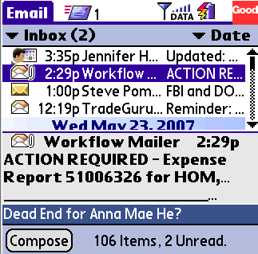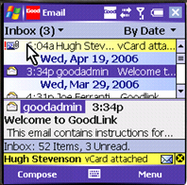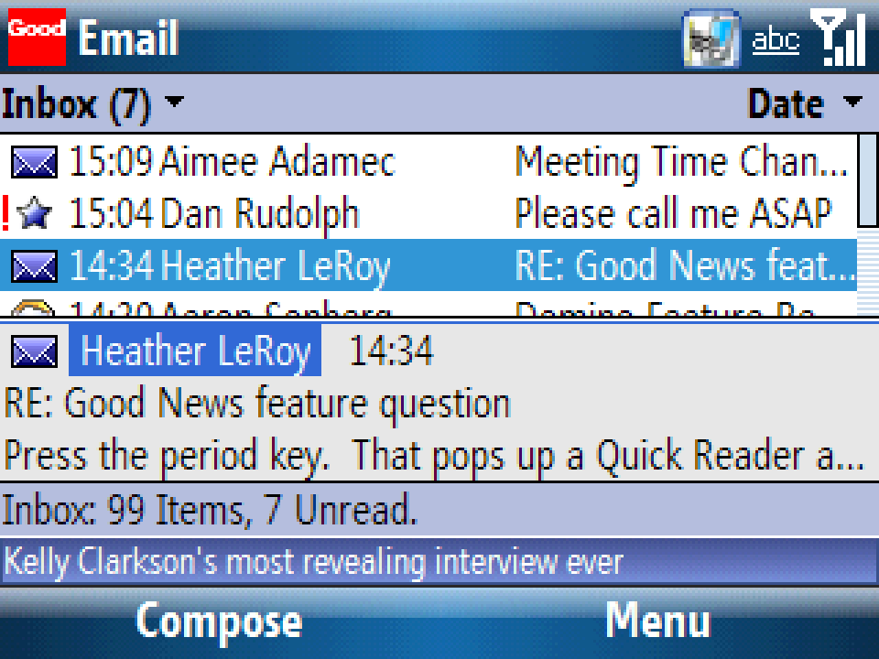

Good on Palm O/S Good on WM Professional Good on WM Standard / Smartphone
Client Features
Please detail the features available from your client (e.g. send/receive e-mail, create calendar appointments, synchronize Outlook contacts, corporate directory lookup, etc.). If necessary, please reference screenshots from the previous section to provide better detail of the available features.

Answer Guidance
Reason For Question
The breadth and depth of client features available for each product is one of the grading criteria. We are thus looking for detail in this category.

Mandatory Response Format:
Word count: Not to exceed three pages
Client Features Response (PAGE ONE)

Good Mobile Messaging is designed to be as intuitive and familiar as your desktop, and is optimized for use on supported handhelds and smartphones. Tasks such as composing e-mail or viewing rich attachments are just clicks away. And because Good Mobile Messaging 5 lets users run multiple applications at once, it’s as easy to multi-task as it would be on a laptop or desktop PC. Key user features include:

Highlights:
E-mail highlights
- Create, send, receive, delete, file, search and sort e-mail
- View e-mail via preview pane, single-line display or two-line display
- View rich attachments
- Edit and send attachments including streamlined photo sending
- Synchronize e-mail sub-folders including sent and deleted items
- Prioritize and filter e-mail according to user-defined parameters
- Conversation view allows rapid processing of complex threads
- Global Address List (GAL) or Domino Directory lookup to access your corporate directory
RSS and News Feeds
- Good Mobile News RSS reader is integrated with your Good e-mail and PIM interface so that you can stay up-to-date on the news and information you care about
Calendar highlights
- Check free/busy status of invitees
- Automatically find available rooms
- View and accept meeting invitations
- Daily, weekly and monthly viewing
Contacts highlights
- Search, edit, add and delete contacts
- Use phone without entering password
- Manage public, shared and personal contacts
- Category synchronization
- vCard (electronic business card) downloading and beaming
- Automatic phone caller ID integrated with contacts

Get Things Done – Easily
Good Mobile Messaging 5 makes it easy to get things done by enabling you to find what you need when you need it, by allowing you to finish tasks end-to-end, and by integrating seamlessly with your phone. Some of the key features include:
- Conversation view – Need to find all the messages related to a specific subject? With the ability display email grouped by conversation, you can easily see all the emails related to a conversation. Read, file or delete emails within an email thread.
- Group and find by sender – In the vast sea of email, it’s often difficult to find the particular information you need. Quickly manage your email with the view by sender option, which conveniently groups your email and allows you to search by sender.
- Complete calendaring – Easily schedule meetings from anywhere by inviting optional or required attendees. Get suggested times and conference rooms based on real-time attendee and room availability.
- Send attachments – No need to drop by the office to send an important document. With Good Mobile Messaging 5 you can send email attachments directly from your mobile device, improving responsiveness and efficiency.
- Dial without password – Good Mobile Messaging 5 integrates seamlessly with your mobile phone allowing easy access to your contacts and dialing without the hassle of entering a password – all while keeping your email and data secure.

Client Features Response (PAGE TWO)

Personalize the Way You Work
Messaging on your mobile phone can be as easy and personal as it is on your desktop. With Good Mobile Messaging 5, you can work (and play) the way you want by taking advantage of new features, including:
- Good Mobile News – Stay updated on the news that matters to you with integrated RSS feeds and rich subscription management capabilities. You can preview and read feeds all without having to leave your inbox, navigate a mobile browser or launch another application.
- Priority mail – Quickly identify messages that are important to you. With priority mail you can define and distinguish what’s meaningful by sender, distribution list, who’s in the “To:” or “Cc:” fields, and even meeting requests or updates.
- Outbox management – Want to catch an email and make an edit before it goes out? Robust outbox management capabilities allow you to edit, delete and reorder messages in the queue on the fly from your handheld device.

Shortcuts
The Good Mobile Messaging client features many shortcuts for commonly accessed features/functions, in order to simplify typing and enable greater productivity. Shortcuts include:

General
- Go to Good Launcher g
- Close notification x
- Open notification o
- Toggle Good News viewer . (period)
- Delete item d
- Go to bottom of list b
- Go to top of list t
- Go to next item in list n
- Go to previous item in list p
- Send/Receive now z
Email
- Reply r
- Reply to all a
- Forward message f
- Move message to folder m
- Mark message as unread u
- Open or close Preview Pane v
- Set flag l
- Change to Conversations view c
- Change to Senders view s
Calendar
- Open Agenda view a
- Open Day view d
- Open Month view m
- Open Week view w
- Jump to date j
- Go to current day y
Tasks/To Do
- Mark as Complete c

Pricing
Please define server and/or client pricing for your product for both our initial deployment (100 users) and final deployment (1000 users) based on any volume discounts available.

Answer Guidance
Reason For Question
Price is a grading criteria and we have asked vendors to submit information for this area accordingly.

Mandatory Response Format:
Word count: Summary not exceeding two pages. Pricing charts are allowed for submission to this question.

Pricing Response (PAGE ONE)

Pricing Component | 100 Users | 1000 Users
Good Starter Pack (server + 5 Client Access Licenses) – one-time license | $0 (free starter promotion is often available) | $0 (free starter promotion is often available)
Client Access License (CAL) – one-time license  $60 per user for 100users  $55 per user for 1000 users | $6,000 (note – Good frequently offers free CAL promotions with the purchase of certain devices) | $55,000 (note – Good frequently offers free CAL promotions with the purchase of certain devices)
Technical Support | 6 months included with initial purchase | 6 months included with initial purchase
Support Costs
Please define service contract costs for your product for both our initial deployment (100 users) and final deployment (1000 users) based on any volume discounts available.

Answer Guidance
Reason For Question
Price is a grading criteria and we have asked vendors to submit information for this area accordingly.

Mandatory Response Format:
Word count: Summary not exceeding two pages. Pricing charts are allowed for submission to this question.
Support Costs Response (PAGE ONE)

6 months of Basic Technical support is provided for new customers when purchasing through a Good reseller carrier. If customers want support directly from Good after their 6 month initial period, several direct support plans are available. Pricing for Basic Support is $19 per user per year for under 100 users.
Support Plan | 100 users | 1000 users
Basic Support | 6 months free | 6 months free
Basic Support (after 6 months) | $18 per user per year | $15 per user per year
Extended 24X7 | $23 per user per year | $20 per user per year
Data Plans
We understand that some vendors require special data plans for their mobile e-mail product. With so many data plans available, please detail which data plan (if any) is required for your product from the following carriers: AT&T, Sprint, Verizon Wireless, Vodafone, T-Mobile (Europe)

Answer Guidance
Reason For Question
Data plans are a major point of confusion for NWC Inc.’s CEO. Some carriers charge differently if a particular mobile e-mail product is used than if another is used. We are looking for guidance from our vendors to determine which data plan(s) we will need to ensure that our mobile e-mail solution works.

Mandatory Response Format:
Word count: Summary not exceeding two pages. Charts are allowed as a response to this question.
Data Plans Response (PAGE ONE)

AT&T, Sprint, Verizon Wireless, Vodafone, T-Mobile (Europe)

Carrier | Smartphone Data Plan | PDA / Unlimited Data Plan
AT&T / Cingular | $34.99 | $44.99
Sprint | NA | $39.99*
Verizon Wireless | $29.99* | $49.99*
Vodafone | Use any data plan, pay annual subscription to Good | Use any data plan, pay annual subscription to Good
T-Mobile (Europe) | Use any data plan, pay annual subscription to Good | Use any data plan, pay annual subscription to Good
* add on to voice plan
- Communications Model
Please detail how messages are relayed from our corporate e-mail servers to a client handheld (i.e. via a NOC, direct connection to the handheld, etc). Please explain why this model is best compared to your competitors (i.e. if a direct connection is used, explain why this is better than a NOC relay).

Answer Guidance
Reason For Question
We are curious as to what the technical differences are between each product; these differences may sway our overall impression for each product.

Mandatory Response Format:
Word count: Not to exceed three pages including a high level summary and a technical description. A maximum of two pages of graphical diagrams are ok to enhance your technical description and will not impact the overall word count. (I.e. five pages maximum).
Communications Model Response (PAGE ONE)

The Good NOC
The Good NOC is a network operations center (NOC) that provides a number of benefits.
The Good NOC ensures the highest level of data security and fastest possible synchronization between the Good Messaging Server and the handheld. Specifically, the NOC enables:
- Push-based e-mail — With the Good NOC, you will get more timely delivery of
messages and more efficient battery use on the handheld. Even when users have
been out of coverage, they have e-mail delivered to them in the correct order as
soon as they come back into coverage.
- Positive Acknowledgement Architecture — With the Good NOC, your IT managers have data path visibility with a built-in receipt of delivery so that they can ensure that messages were delivered to the right recipients.
- Multiple networks — The Good NOC makes it possible to manage connections to multiple carriers and networks, including Code Division Multiple Access(CDMA) 1XRTT, General Packet Radio Service (GPRS) and 3G networks. A single Good Messaging Server can support handhelds on all of these networks and will be able to support new networks in the future – guaranteeing maximum flexibility and scalability.
- Standard firewall settings — The Good NOC allows a Good Mobile Messaging customer to work without requiring any changes to the external firewall. The server makes a secure outbound connection using the standard port 443, and all handhelds can communicate with it. No inbound connections are required.
- Optimized battery life —The Good NOC communicates with handhelds to keep a connection established. Because the Good NOC does most of the work to keep handhelds online, it improves the battery life of the handheld.
- Fleet monitoring — The Good Monitoring Portal, which is discussed below, connects to the Good NOC to provide server and handheld visibility. This means that IT has visibility to the server status, individual handhelds, including handheld type and ROM, radio status and more—all from a Web-based interface.

Reliable message delivery is a primary requirement of a wireless messaging system. Good Mobile Messaging incorporates a unique multi-level Positive Acknowledgement Architecture to ensure every message arrives at the handheld, in order, with no duplicates. Positive Acknowledgement Architecture ensures reliable message delivery.

Good Mobile Messaging Positive Acknowledgement Architecture confirms point-to-point, as well as end-to-end, delivery of every message. The system also ensures delivery in order, with no duplicates, and with timestamps that match those in the enterprise messaging server.

Events such as enterprise messaging server downtime, network problems and handheld failures do not cause messages to be lost or delivered out of order. End-to-end message delivery confirmation is assured via several point-to-point message delivery confirmations:

- Enterprise Messaging Server to Good Messaging Server — Uses standard protocols (i.e. MAPI or NRPC), including a parallel confirmation channel, to ensure that messages have been delivered successfully, even if there is temporary enterprise messaging server downtime.
- Good Messaging Server to Good NOC — Confirms that messages have been delivered using Transmission Control Protocol (TCP) over Secure Sockets Layer (SSL).
- Good NOC to handheld — Ensures that messages have been delivered successfully to the handheld using secure, highly efficient wireless network protocols.
- Good Messaging Server to handheld — The Positive Acknowledgment Architecture session layer saves messages at the source until delivery is confirmed.
Communications Model (SUPPORTING GRAPHICS)

- 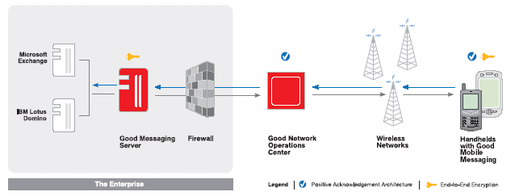
- 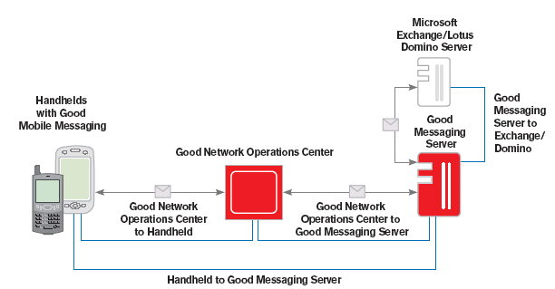

Security
Please detail how messages are secured during transport. Please detail how messages are secured on the client handheld.

Answer Guidance
Reason For Question
Security is a crucial concern not just for NWC Inc. but in many surveys is a leading concern for enterprises considering mobile deployments. We would thus like to determine the security features available for each product.

Mandatory Response Format:
Word count: Not to exceed three pages including a high level summary and a technical description. A maximum of two pages of graphical diagrams are ok to enhance your technical description and will not impact the overall word count. (I.e. five pages maximum).
Security Response (Page One)
Overview
The Good System has been specifically designed to meet the security needs of even the largest, most security-sensitive corporations. It provides an end-to-end system designed to protect corporate information at all times—while it is being transmitted over the wireless network and while it resides on the handheld. The Good System combines industry security standards, such as AES , Federal Information Processing Standards (FIPS) 140-2, and S/MIME with Good’s own patent-pending security technologies.

NETWORK PERIMETER AND TRANSMISSION SECURITY
Connections from the Good Mobile Messaging and Good Mobile Intranet Servers to the Good NOC use HyperText Transport Protocol (HTTP) and are protected by the Secure Sockets Layer (SSL). Since the connection is established in the outbound direction, there is no need to create an inbound opening in the corporate firewall. Most corporate security policies allow this type of traffic through port 443 without reconfiguring the firewall, but IT managers may use port 3101 or port 4662 instead. Connections to the Good NOC are used only for sending data to and receiving data from handhelds.

End-to-End Encryption
When the IT administrator sets up a handheld device for a user, the GMC generates an AES encryption key for that user and places the keys on the handheld device and in the user’s messaging server account. Once these keys are established, Good Mobile Messaging uses end-to-end encryption to protect every message and transmission from the server to the handheld device and vice versa. Since the client and server share encryption keys, any attempt to use a different encryption key would cause decryption to fail and the message to be discarded. The Good NOC does not have access to the keys and cannot decrypt messages flowing through it.

The Good Mobile Messaging Server can be configured to rotate the encryption key wirelessly for handhelds, providing protection against unauthorized use of a compromised key and/or simply changing the encrypted form of messages every 30 days.

AES
When a Good Messaging Server is communicating with a Good Mobile Messaging Client, all messages are encrypted using AES. AES is a standard selected by the US National Institute of Standards and Technology (NIST) for its combination of resistance to attack, ease of implementation, efficiency and scalable design. Good’s implementation of AES uses key lengths of at least 192 bits.

FIPS 140-2 Validation
The Good System has successfully completed testing with NIST and obtained FIPS 140-2
certification. FIPS certification is a critical security standard for many government organizations. FIPS 140-2 certification covers the operation of Good’s cryptographic module, which implements AES encryption. FIPS 140-2 also ensures the integrity of the cryptographic module in the field.

S/MIME
Driven primarily by the needs of the Federal Government market requirements of HSPD 12 and DoD Spec 8100.2, which require that all Sensitive But Unclassified (SBU) email be protected using the S/MIME standard for public key encryption and signing, Good Mobile Messaging 5.0 supports the S/MIME standard and will feature:

- Intuitive 3-click CAC pairing provides an easy and simple process for end-users to pair their CAC readers to their smartphones
- Server-based certificate verification validates certificates on the Good Messaging server before sending the message from the handheld

Security Response (Page Two)

- Automatic OTA synchronization of all certificates provides real-time, cable-free access to all certificates, including those stored in your Personal Contacts
- The ability to send attachments with either signed, encrypted, or signed and encrypted emails complies with secure messaging requirements of the DoD 8100.2

HANDHELD SECURITY
Locking the Handheld with a Password
The handheld may be configured with a password. When the handheld is locked, Good applications will not display any of the user’s data and the handheld operating system turns off access to the USB port, which could otherwise be used to download data from the handheld to a PC. Access can be restored only by entering the correct password. If an unauthorized user tries to guess the password too many times, the Good client software will delete any Good application data stored on the handheld.

IT Administration of Password Policies
The IT administrator can specify policies for the password provided by the user. Policies are applied wirelessly and provide a range of password control options for Good and third-party applications. Additional local wipe policies can be set so that certain applications and associated data are removed from the handheld after a specified number of failed password attempts.

When the user attempts to set a new password on the handheld, the new password will be
accepted only when it conforms to any policies set by the IT administrator.

Remote Erase of Lost or Stolen Devices
If a user’s handheld is lost or stolen, the IT administrator can use the GMC to remotely disable the handheld and remove all Good application data. If a handheld device is recovered, Good Mobile Messaging and all handheld applications selected by it will be restored OTA. Additionally, IT managers can set policies for “bitwiping” all or selected data stores on the handheld according to various parameters like number of failed password attempts. IT managers can also manually bitwipe a handheld or specific data stores on the handheld if it is lost or stolen.

Device Usage Control
Good allows IT to remotely set and enforce policies for controlling data transfer ports (e.g.,HotSync,® Wi-Fi, Bluetooth, infrared) as well as locking down handheld features such as cameras, microphones, speakers, etc.

Encryption on the Handheld
Good Mobile Messaging encrypts the local databases, which store the user’s e-mail, calendar, contacts, notes and tasks. Sensitive corporate data is protected using strong AES encryption. Additionally, IT managers can remotely set policies for encrypting selected on-handheld databases and external media Secure Digital (SD) cards.

If a user is using desktop synchronization software (e.g., HotSync or ActiveSync®) to synchronize other handheld applications, Good Mobile Messaging’s databases will not be copied onto the PC.

Restricting Handhelds by Operating System
The Good System allows administrators to control the types of handhelds, based on operating system, that are allowed to install and run Good Mobile Messaging. For example, for management simplicity, IT managers may want to standardize on handhelds running a certain operating system (like Windows Mobile Pocket PC) and prohibit all other handhelds. For various reasons, some customers may consider certain mobile operating systems to have more security
vulnerabilities than others. If this is the case, IT managers can prohibit use of Good Mobile Messaging on all devices with a certain operating system.
Security Response (Page Three)

Security Considerations for Handhelds with SD Cards
On handhelds that support external SD cards, Good applications can be backed up, allowing Good Mobile Messaging to later reconnect to the enterprise. This backup can be useful in the event that the battery drains completely, which causes memory on some handhelds to be lost. Without the SD backup, the user would need to return the handheld to the IT department for re-provisioning or go through re-provisioning via Secure OTA Setup. Information on the SD card is strongly encrypted with a passcode and is matched to the serial number of the handheld, thus providing two-factor authentication for the SD backup.

Mandatory Application Checking
The Good Compliance Manager can check for mandatory applications, like virus protection, that must be on the handheld before Good Mobile Messaging can be started. If a handheld fails a periodic check—for example, if a user has removed a mandatory application—then the user is automatically taken to an application download screen on his handheld where he must download required applications before he can launch Good Mobile Messaging. The IT department does not need to be involved.

AUTHENTICATION
The Good System provides a number of safeguards against unauthorized access. The Good Messaging Server resides behind a corporate firewall and any handheld attempting to contact it requires a three-step authentication process between:
- The Good NOC and the Good Messaging Server
- The handheld and the Good NOC
- The handheld and the Good Messaging Server

Authenticating the Server
Before the Good NOC can send data to or receive data from the handheld, it must authenticate itself to the Good Messaging Server. This authentication is handled using SSL server authentication. Once the Good NOC has established a secure connection with the Good Messaging server, the server authenticates itself to the Good NOC using the server serial number and license key, which act as a user name and password.

Authenticating the Handheld
The handheld connects with the Good NOC and two checks are performed to ensure that the handheld is authorized to access Good Mobile Messaging. First, the Good NOC ensures that the handheld has a valid service plan. Second, the handheld provides the unique serial number burned into its ROM or SIM card and requests permission to communicate with a specific Good Messaging Server. The Good NOC checks its database of handheld serial numbers and Good Messaging Servers with which each handheld is authorized to communicate. If the handheld passes both of these tests, it is authenticated to the Good NOC, but is not yet permitted to access enterprise data managed by a customer’s Good Messaging Server.
Connecting Server and Client
The handheld must be explicitly authorized to talk to a Good Messaging Server. This authorization is handled for customers by the Good NOC. Once the handheld is authorized to communicate with a customer’s Good Messaging Server, the user can access enterprise data and can send and receive information. Any unauthorized traffic cannot be routed to a customer’s Good Messaging Server and is discarded.

USER-GROUP MANAGEMENT
Good provides user-group management so that administrators can create groups to organize and manage Good Mobile Messaging users. All policies and software distribution can be managed at the global, group or individual user level. This allows IT managers to more efficiently deploy different security policies to different user groups. Additionally, the IT administrator can import user groups via .csv files or through Good’s command line interface (CLI).

E-MAIL SECURITY
Protection Against Viruses
Preventing the spread of viruses is of increasing concern for IT departments and end users. Viruses commonly infect a user’s system by delivering executable code, such as .EXE files or Visual Basic® scripts, via an e-mail or an e-mail attachment and getting the user to run the code inadvertently. The Good Mobile Messaging application will not run executable code within an e-mail or attachment and thus is less vulnerable to viruses from e-mail. Good Mobile Messaging users can use their handhelds to read e-mails or attachments without concern about viruses. If the user suspects an e-mail to be malicious, he or she can safely delete that e-mail from the Good Mobile Messaging handheld rather than risk opening it from the laptop or desktop.

Additionally, using Good Mobile Messaging’s ability to distribute handheld software OTA (refer to section on Good Secure OTA Architecture), enterprises can enhance corporate compliance by ensuring that employees are running the latest mobile security applications such as Symantec® AntiVirus for Handhelds.

Security – Part 2
NWC Inc’s Exchange server is located behind the corporate firewall. We are reluctant to open any holes into our firewall to allow for mobile clients to gain access. Please detail how your product can integrate into our DMZ (i.e. use of a proxy, via middleware server’s integration to Exchange via OWA, etc). Please also detail what firewall ports NWC Inc would need to open, if any, in order to facilitate communication between mobile clients, your mobile e-mail server and Exchange.

Answer Guidance
Reason For Question
Security is a crucial concern not just for NWC Inc. but in many surveys is a leading concern for enterprises considering mobile deployments. We would thus like to determine the security features available for each product.

Mandatory Response Format:
Word count: Not to exceed three pages including a high level summary and a technical description. A maximum of two pages of graphical diagrams are ok to enhance your technical description and will not impact the overall word count. (I.e. five pages maximum).
Security – Part 2 Response

Installation of Good applications does not require any modifications to your firewall and allows you to leverage your existing network security infrastructure.

NETWORK PERIMETER AND TRANSMISSION SECURITY
Connections from the Good Mobile Messaging and Good Mobile Intranet Servers to the Good NOC use HyperText Transport Protocol (HTTP) and are protected by the Secure Sockets Layer (SSL). Since the connection is established in the outbound direction, there is no need to create an inbound opening in the corporate firewall. Most corporate security policies allow this type of traffic through port 443 without reconfiguring the firewall, but IT managers may use port 3101 or port 4662 instead. Connections to the Good NOC are used only for sending data to and receiving data from handhelds.
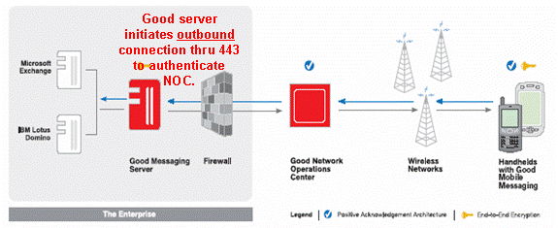

Management
Please detail the handheld management features available from your product or from products available from your company. If no product is available, please detail if any products are available from partner vendors. If management features are available as a separate product, please detail the change in the price defined above, if any.

Answer Guidance
Reason For Question
When companies start to load corporate data (like e-mail) onto their handhelds, it’s imperative that these handhelds be able to be managed from the IT department. We are curious to know if we will need to implement a separate management solution or if we can leverage management features from our mobile e-mail investment.

Mandatory Response Format:
Word count: Not to exceed three pages
Management Response (Page One)

Focusing on the costs of deployment and system management to drive down total cost of
ownership, IT managers look for applications that are easy to deploy and manage in order to minimize the number of IT hours required for support. Good Mobile Messaging minimizes support requirements via zero-desktop installation, easy administration and monitoring controls, a simple user interface, extensive support resources to reduce troubleshooting time and Secure OTA management.

Easy Administration and Monitoring
The Good Messaging Server integrates tightly into an enterprise messaging environment
to simplify administration, including setup, removal, management and viewing of users. IT administrators can easily deploy and manage a fleet of Good Mobile Messaging users by setting global policies for all users while making exceptions for individuals. The Good Messaging Server includes the Good Management Console, a powerful administration console with tools to manage both servers and handhelds.

The console supports monitoring server performance through the Microsoft Windows® NT performance monitor, monitoring troubleshooting information from error logs via such products as NetIQ and adding large groups of users to the Good Messaging Server via the Global Address List or Domino Directory. In addition, the Good Monitoring Portal helps the IT manager monitor server and handheld performance and uptime. Problems can be identified early, before end users encounter them.

Good Management Console
Good Mobile Messaging’s management console simplifies user and server management by providing an integrated, centralized management console from which an administrator can manage and monitor handhelds and servers.

- User and server management — IT managers can add, delete and monitor users and servers. In addition, they can also access detailed information about the handheld and servers, and assess performance such as coverage history.
- Secure OTA management — IT managers can enable Good Mobile Messaging users without ever touching their handhelds. Secure OTA also allows IT managers to push out third-party applications, and enforce password and other handheld policies. In addition to being able to upgrade an entire company with one command, IT managers can also schedule regular OTA upgrades of Good Mobile Messaging or third-party applications as needed.
- Role-based administration — IT managers can distribute management tasks across a hierarchy of administrators by using role-based administration that offers a set of roles, with varying permissions, for administering the Good Messaging Server and users. By assigning appropriate roles to administrators, IT can better manage assets and increase security. Routine tasks, such as loading software, can be delegated to a wider group of administrators across multiple locations. More sensitive tasks, such as setting global policies or remotely erasing a handheld when lost or stolen, can be restricted to a smaller group.
- User-group management — Administrators can create groups to organize and manage Good Mobile Messaging users. All policies and software distribution can be managed at the global, group or individual user level. This provides IT with more granular control and reduces the time it takes to manage users, especially in larger deployments.

Good Monitoring Portal
The Good Monitoring Portal (GMP) is a Web-based monitoring system that allows administrators to monitor Good Messaging Servers and handhelds remotely. Administrators can easily use any Web browser to access server and handheld status. Potential problems can be tracked and
Management Response (Page Two)

resolved before they become serious. IT managers can provide higher levels of service, and users can get increased uptime. Administrators have access to server information, including current server status, connection history and a list of connected handhelds, and they receive alerts about available server software upgrades. They can also track current handheld status by device ID or by user e-mail address, and they can view handheld radio status and coverage history, device ROM version, software version, pending messages, and more.

Zero-Desktop Installation Option
Administrators can take advantage of the zero-desktop installation option to set up handhelds completely over-the-air (OTA). This means no desktop visits to install software, no version management and no end-user desktop help-desk tickets. Companies can deploy to more users while assigning fewer employees to manage the wireless messaging system. IT managers can further decide which types of deployments to do in different parts of the company: server, kiosk or desktop.

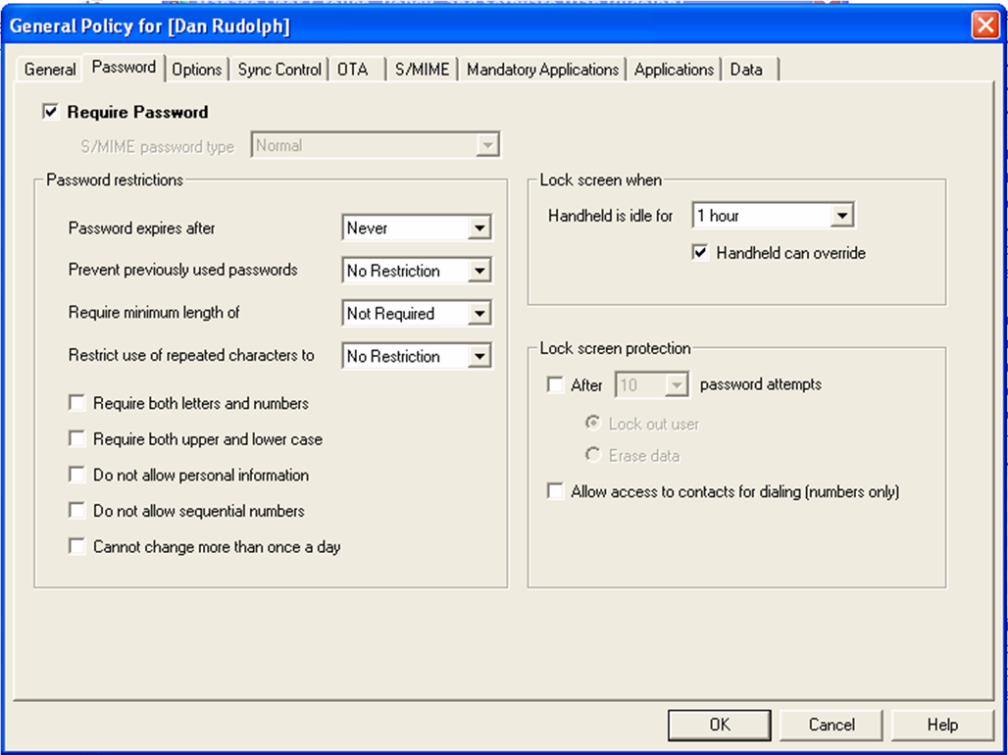
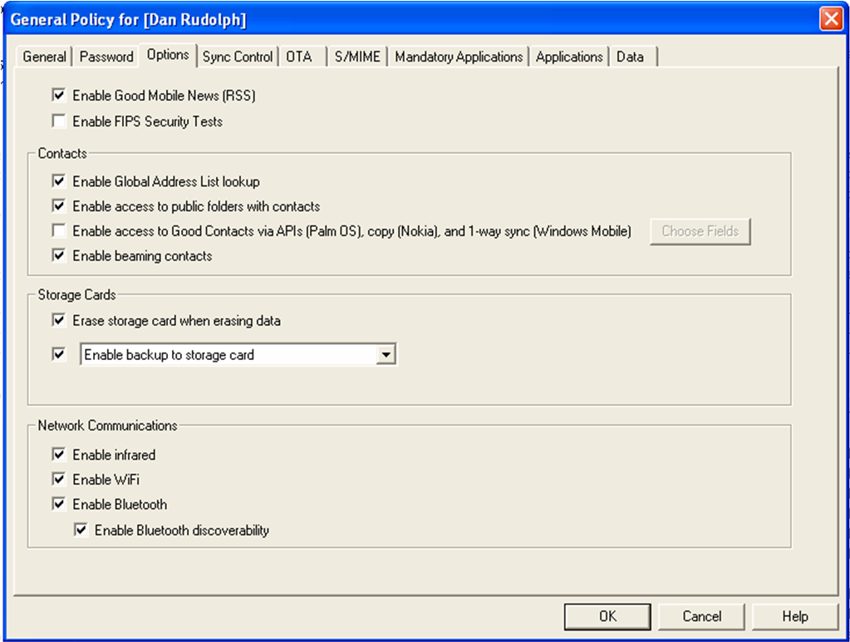
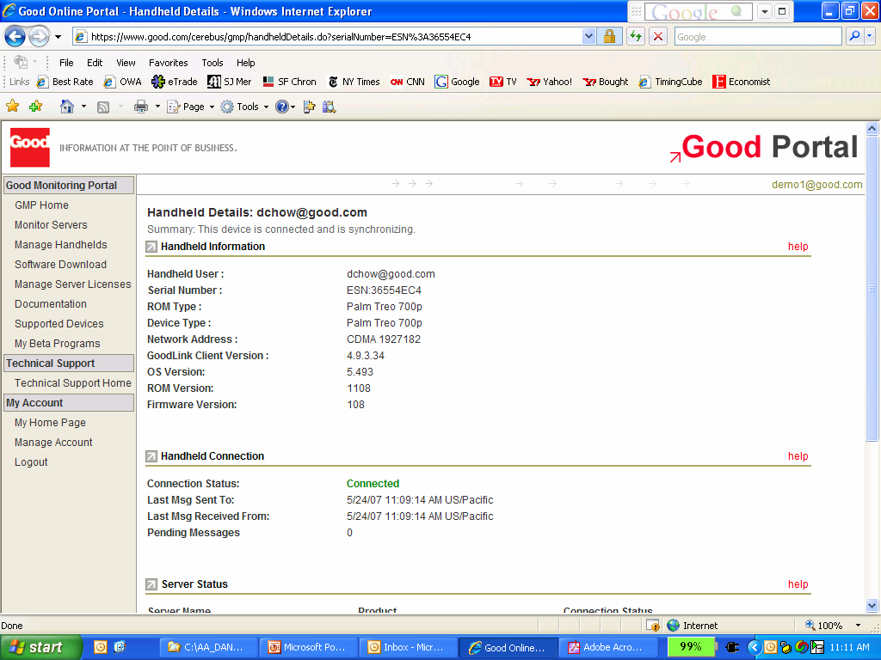
Application Support
Please detail how NWC Inc. can leverage your company to help us mobilize applications

Answer Guidance
Reason For Question
Mobile e-mail is a good way to get our foot in the door to create a larger mobile applications strategy. We are interested in ways we can create CRM, field force automation and other mobile applications for our company. We are thus interested in understanding how we can

Mandatory Response Format:
Word count: Not to exceed four pages. Please detail products available from your company and how they help create mobile applications. Please also detail any mobile application companies you are partnered with.
Application Support Response (Page One)

Good Mobile Intranet brings the power of your corporate intranet and enterprise information to your mobile personnel when and where they need it.

By empowering mobile users with interactive access to mission-critical systems—intranets and enterprise applications that have been web-formatted for Good Mobile Intranet—Good Mobile Intranet increases the ROI of your existing IT investments.

Good understands that mobile solutions must have more than just features. Mobile solutions must provide a user experience that is easy and productive before they will be adopted and, ideally, embraced.

Key features of Good Mobile Intranet include:
- Intuitive user interface. Users can get started quickly and become as productive while mobile as they are in the office.
- Online and offline productivity. Users can be kept in the loop whether in or out of coverage, since information can be pushed or broadcasted to mobile handhelds for review at the user’s convenience.
- Enterprise class security. Good Mobile Intranet leverages the same security infrastructure as Good Mobile Messaging to connect to systems residing behind the firewall and to transport information securely through the Good Network Operations Center. Good Mobile Intranet also has NTLM authentication.
- Ease of management. Good Mobile Intranet can be installed and updated using Good Secure OTA (Over-the-Air), completely wirelessly, while day to day management is easy with the Good Mobile Intranet management console.

Good Mobile Intranet provides wireless access to myriad sources of enterprise information, including intranets and applications like CRM (customer relationship management) that have been specifically web-formatted for use with Good Mobile Intranet. Good Mobile Intranet enables companies to extend valuable data to mobile users through a complete platform, including the Good Mobile Intranet Client and Server, administration tools and support for a broad range of open standards and technologies.

Working with your Good Mobile Messaging Server and applications, the Good Mobile Intranet system includes:
- Good Mobile Intranet Server for handling requests from Good Mobile Intranet Clients and managing interactions with Web sites and Web-enabled backend systems.
- Good Mobile Intranet Client running on wireless handhelds for requesting and submitting data.
- Good Mobile Intranet Server Console allowing remote administration of users, policies and pushes.

Unlike micro-browsers, Good Mobile Intranet is optimized for accessing data over today’s wireless networks and doesn’t require a continuous connection. Mobile users can request or submit information quickly and easily by using Good Mobile Intranet applications on a handheld, and receive responses while working on other tasks. Users can also save and later view information offline to maximize productivity. Additionally, unlike browsers, Good Mobile Intranet provides secure connectivity behind the corporate firewall, automatically incorporating your enterprise’s security policies.

Corporate developers can use standard Web tools to adapt and extend existing applications for use with Good Mobile Intranet, since Good Mobile Intranet is capable of rendering HTML, ASP, JSP, CHTML, XHTML, and WML content. Also, custom or non API-enabled backend systems can be accessed via a number of techniques such as light Visual Studio® .NET programming and
Application Support Response (Page Two)

.ASP page creation; and then accessed directly with Good Mobile Intranet. Using Good Mobile Intranet to access enterprise applications is simple and fast—users click one URL link to access a Good Mobile Intranet form-based application and they can then begin using it immediately. In addition to user-initiated data access, the Good Mobile Intranet system enables administrators to configure and proactively push messages, Web pages and other documents to users’ handhelds.

Geographic Coverage
Please detail the countries your product works in.

Answer Guidance
Reason For Question
As NWC Inc looks to expand globally, we want to understand where your mobile e-mail product will work.

Mandatory Response Format:
Word count: Not to exceed one page, a chart is acceptable to answer this coverage
Geographic Coverage Response

Good’s Global Connect technology facilitates wireless connectivity for global customers in all regions, without requiring dedicated connections to or agreements with individual operators. Using Good Mobile Messaging, Network Computing will be able to offer worldwide wireless reach to its employees, providing native connectivity through any CDMA or GPRS carrier in any country around the world. Thanks to Global Connect, Good Mobile Messaging users are currently running the software and service in more than 90 countries and on over 200 carrier networks around the world.
Competitive Analysis
Please detail how your product compares, and what advantages it has, against your competition. Consider competing companies to be those on the right hand side of Gartner’s mobile e-mail magic quadrant.

Answer Guidance
Reason For Question
We want to understand how vendors see themselves and how their product stacks up against competing products.

Mandatory Response Format:
Word count: Not to exceed five pages.
Competitive Analysis Response

Good Mobile Messaging strikes the ideal balance between end-user personalization and productivity and IT control. It’s the only mobile messaging system that offers a consistent, easy-to-use, highly customizable UI across multiple devices and operating systems, while still arming IT with maximum security and manageability controls.

High-Level Differentiation

Unique to Good Mobile Messaging | Description
Getting more things done, easily | - Intuitive user experience reduces support/training costs  - Advanced email management and PIM tools allow users to find what they need when they need it and complete tasks end-to-end  - Personalization options enable users to work according to their unique preferences
End-to-End, Behind-the-Firewall Security | - No inbound firewall holes  - AES-192 FIPs encryption  - S/MIME encryption support  - Granular, remotely controlled handheld security policies  - Remote erase / kill if device is lost or stolen
Low TCO / “Zero IT Touch” | - Complete over-the-air (OTA) deployment & upgrades  - OTA management of 3rd party applications  - No desktop software  - Web-based portal for real-time visibility to device fleet eases support
Broad Device and OS Choice | - Windows Mobile 5.0 Smartphone and PPC  - Windows Mobile 6.0 Standard and Professional  - Palm O/S
Diverse Backend System Support | - Exchange 2000, 2003, 2003-SP2, 2007  - Lotus Domino 6.x, 7.x, 8.x
Service, Not Just Software | - Direct support covers network, device, software  - Network Operations Center optimized for each carrier  - 24X7 SLA backed support, proactive notifications, etc
Mobilization of Enterprise Apps Beyond Email | - Secure access to web-enabled enterprise applications

