

Managed Security Services
Proposal

For



In Response to the

Request for Information (RFI)
on
Information Security Outsourcing

Letter of Transmittal

June 9, 2006

Network Computing, Inc.
Attn: Joanne VanAuken
315 439.2438
jvanauken@nwc.com

Dear Ms. VanAuken,

ISS is pleased to respond to Network Computing Inc.’s Request for Information for Information Security Outsourcing. Network Computing (NWC) will benefit significantly from ISS’ mature security expertise, global footprint of Security Operations Centers, proactive security intelligence R & D, and an average SLA adherence rate of 99.99994%. The result for NWC is maximum threat protection with a low total cost of ownership.

Enclosed is our proposed security solution which is based upon the business overview information provided by NWC within the RFI. Our proposed solution includes recommendations for Managed Security Services, Professional Services and security products that align with NWC’s business and technical goals. ISS understands the risks and rewards associated with conducting online commerce very well. Given that 90% of the NWC’s $23 million of annual revenue is delivered through e-commerce, it is absolutely critical for the security solution selected by NWC to deliver a high assurance of protection and preserve the integrity, confidentiality and availability of systems and data. ISS estimates that a loss of availability of NWC’s online e-commerce systems would critically impact business; resulting in loss of revenue ranging from $10,000 to $30,000 in a period of just four hours. In addition to the loss of revenue, NWC risks costs associated with lowered customer confidence, customer loss, lost productivity, breach of sensitive and confidential data, such as credit card and personal information, and associated litigation. These costs can quickly add up and can be devastating to a company, especially the size of NWC.

ISS’ proposed security solutions will provide NWC the assurance that your systems, data and business are secure and protected allowing NWC to continue focusing on your core business of producing widgets and further garnering success with your Mac Vittie robot.

Our solution includes the following key elements:
- Managed Protection Services based on ISS market leading Proventia M Integrated Security Appliances
- Managed Protection Services based on ISS market leading Proventia G Intrusion Prevention Appliances
- Managed Firewall Services
- Managed Protection Services based on ISS market leading Proventia Server
- Emergency Response Services for Incident Management and Forensics Analysis
- Professional Services for Risk Assessments, Penetration Tests and Staff Augmentation

ISS’ Managed Security Services provide 24/7/365 protection using multi-layered security expertise and technology to dynamically manage, monitor, and protect against escalating Internet threats while mitigating overall risk. ISS Managed Protection Services will provide NWC further assurance with our performance-based service level agreements, protection guarantees and up to $50,000 cash warranty if we fail to deliver on our protection promise.

Our security operations centers are staffed by over 120 extensively trained security technicians with an average of three years experience supporting Managed Services customers, and boast less than 3% annual Managed Services customer churn rate. We have been delivering Managed Services to hundreds of customers in the government, financial, insurance, health care, automotive, and other markets since 1995, with an average growth of 15% per quarter since 2001.

All ISS products and services are built upon X-Force® security intelligence. X-Force is the most respected vulnerability and threat sciences research organization in the industry. This elite security team discovers monitors, investigates, and gathers security intelligence from over 5,000 sources around the globe, rapidly translating it into our products and services.

ISS seeks to earn the trust of NWC and become your trusted security advisor and service provider to provide ongoing protection for the critical assets within your enterprise infrastructure. Please do not hesitate to contact us should you have any questions about our proposed solution. We are available at your convenience.

Sincerely,

Player Pate
Senior Manager, Managed Security Services
Internet Security Systems, Inc.
Phone: 404-236-4018
Fax: 404-236-2605
ppate@iss.net

Table of Contents
Letter of Transmittal 2
1.0 Executive Summary 6
1.1 Introduction 6
1.2 Overview 6
1.3 Solution Summary 6
1.4 Managed Protection Services Solution Benefits 7
1.5 Managed Protection Services Solution Features 7
1.5.1 Four Global, Redundant Security Operations Centers (SOCs) 7
1.5.2 Guaranteed, Performance-based SLAs 7
1.5.3 Managed Protection Services Warranty 7
1.5.4 X-Force® Global Security Intelligence 7
1.5.5 Virtual Patch™ Protection 8
Figure 1-1: Virtual Patch™ Principle 8
1.5.6 Managed Protection Agent (MPA) 8
1.5.7 Ongoing Security Posture Assessment 8
1.5.8 Virtual-SOC Customer Portal 8
1.5.9 X-Force Emergency Response Services (ERS) 8
1.5.10 Performance-Based Reporting 9
1.5.11 Security Command System 9
1.5.12 X-Force Threat Analysis Service 9
1.5.13 Highly-Skilled and Certified Professionals 9
2.0 Proposed Security Offerings 10
2.1 Overview 10
2.2 MPS Network Select Service 10
2.2.1 Service Overview 10
Guaranteed Protection for Critical Attack List 14
2.3 MPS Select/Standard Host Service 14
2.4 Managed Firewall Service 19
Managed Firewall Service 20
2.5 Vulnerability Management Service 32
2.6 Managed Network Intrusion Detection Service 41
2.6.1 Service Overview 41
Service Detail 42
On-going Management 42
3.0 Security Operations Centers (SOCs) Overview 43
3.1 SOC Locations 43
Figure 3-1: Four Global SOCs 43
3.2 Staff and Support Roles 43
3.3 SOC Infrastructure 44
3.3.1 Physical Security 44
3.3.2 Facilities & Infrastructure Protection 44
3.3.3 Policies, Procedures, and Programs 44
3.3.4 Network and Computer Security 44
3.4 SOC Analyst Qualifications 45
3.5 Security Incident Escalation Procedures 45
Figure 3-2: SOC Analyst Security Event Investigation 46
4.0 Managed Security Services Mechanics 46
4.1 VIRTUAL-SOC Portal 46
Figure 4-1: Virtual-SOC Portal 47
Figure 4-2: Virtual-SOC Portal Main View 48
Figure 4-3: Policy View 48
Figure 4-4: Attack Trends 49
4.2 Reporting 49
Figure 4-5: Reporting Interface 49
Figure 4-6: SLA Metric Report 50
5.0 MSS Deployment and Integration 51
5.1 Customer Responsibilities 51
5.2 Deployment Process 51
6.0 ISS Response to NWC Inc. Requirements 53
Policies, Procedures, and Programs 78
Network and Computer Security 78
General Information 106
Proventia Appliances 107
Proventia G IDS/IPS Modes of Operation 108
7.0 Corporate Overview 110
7.1 Company Background 110
7.2 Customers 110
7.3 Market Leadership 110
7.4 Expertise 111
7.4.1 Proactive Threat Research 111
Figure 7-4: X-Force High Risk Vulnerability Discovery* 1998-2005** 111
(Source: Frost & Sullivan, April 2005) 111
7.4.2 Advanced Intrusion Detection and Prevention Technology 111
7.4.3 Managed Security Services 112
7.4.4 Professional Security Services 112
7.4.5 Exemplary Emergency Response Service 112
7.4.6 Corporate Track Record 113
8.0 ISS Approach to Security Best Practices 114
8.1 Overview 114
8.2 ADDME™ Phases 116
9.0 Price Quote Summary 117

1.0 Executive Summary

1.1 Introduction

ISS understands that NWC Inc. seeks 24/7/365 network and host IDS/IPS service, firewall management vulnerability management service and remote access services with specialized security consulting expertise in these areas. ISS is well-positioned to accommodate these requirements. This proposal focuses on our Managed Protection Services which provide money-back, guaranteed protection. Conventional Managed Security Services for device management and monitoring is also available.

This proposal concentrates on the following optimal services for NWC Inc.:

- MPS Network Select Service – This Managed Protection Service guarantees protection of the NWC Inc. network using ISS Proventia G IPS appliances. Proventia G can operate as either a passive IDS or an inline IPS.

- MPS Host Select/Standard Service – This service provides server protection for two levels of assets: mission critical and business critical via ISS RealSecure Server Sensor or Proventia Server.

- Managed Firewall Service – This service provides full administration and management of firewalls from Check Point, Cisco, Sun, and Juniper (formerly NetScreen). Additionally, Content Filtering and Network Antivirus are add-on features to firewall management.

- Vulnerability Management Service – This service provides vulnerability discovery, prioritization, assignment, remediation and validation services. All stages are tracked via custom-built workflow and represented in the Customer Portal.

ISS recommends these comprehensive services for maximum threat protection and a high return on security investment.

1.2 Overview

Businesses are susceptible to an ever-increasing array of escalating threats. In today's digital economy, centralized security device management is no longer enough to protect organizations from the growing threat spectrum. Organizations need protection that can be guaranteed without sacrificing service quality, business continuity and return on investment. During an attack, even the most sophisticated technology cannot
Operate unattended. Your current software and network may be secure, but the intense pace of upgrades and patches creates new vulnerabilities daily. Without expertise and resources to appropriately manage, monitor, and protect your security posture on a 24/7/365 basis, the effects could be devastating to your infrastructure.

1.3 Solution Summary

ISS Managed Protection Services (MPS) offer the industry's only guaranteed protection solutions, enabling organizations to easily and confidently transition the protection of their network environment to a trusted security partner. The solution goes beyond simple event monitoring and device management by offering money-back guaranteed performance-based Service Level Agreements (SLAs) backed by the ISS Managed Protection Services Warranty and X-Force security intelligence. ISS MPS set a new standard of accountability in the MSSP marketplace. This guaranteed protection from the Internet's most critical known and unknown threats allows organizations to minimize risk, control escalating security costs, demonstrate due diligence, and comply with increasing legislative mandates.

1.4 Managed Protection Services Solution Benefits

ISS Managed Protection Services offer the following benefits to our worldwide customers:

- 24/7/365 guaranteed protection of mission-critical assets
- Service provider accountability
- The industry's only protection warranty
- Access to early warning security intelligence
- Improved system patching
- Maximization of IT infrastructure and resources
- Access to certified security professionals
- Meet or surpass regulatory compliance guidelines
- Lower total cost-of-ownership (TCO)
- Improved Security Posture

1.5 Managed Protection Services Solution Features

1.5.1 Four Global, Redundant Security Operations Centers (SOCs)
State-of-the-art, fully-certified facilities allow Managed Protection Services professionals to provide the highest level of 24/7/365 guaranteed protection from four globally-networked Security Operations Centers. These highly secure, redundant environments have been strategically designed to ensure that mission-critical systems, electrical, data processing and communication links are all protected from any single point of failure.

1.5.2 Guaranteed, Performance-based SLAs
ISS guaranteed, performance-based SLAs provide guaranteed response times and countermeasures for security incidents that meet organizational goals or the service is FREE. These enhanced SLAs
guarantee protection against the X-Force Certified Attack List. Always up-to-date, the X-Force Certified Attack List is a list of the most serious, high-risk vulnerabilities and attacks currently affecting computer networks that enable cost effective and proactive protection for critical business systems and applications. Additionally, these SLAs guarantee immediate action and notification the instant a security event is detected allowing for the proper identification and response to be made to maintain an effective security posture.

1.5.3 Managed Protection Services Warranty
ISS Managed Protection Services Warranty offers customers the industry's most reliable level of enterprise protection by providing a cash payment for every security breach resulting from an attack listed on the X-Force Certified Attack List. This unique offering applies specific warranties to ISS guaranteed performance-based Service Level Agreements (SLAs), ensuring your business remains protected and operational while minimizing the risks posed from the growing number of network security threats. No other managed security services provider offers this level of guaranteed protection and service provider accountability.

1.5.4 X-Force® Global Security Intelligence
ISS X-Force security team is dedicated to proactive R & D within the vulnerability and threat science disciplines. This world renowned research group monitors and gathers security intelligence from over 5000 sources around the globe, rapidly turning security research into product and service improvements.

Using a first-to-market approach, X-Force security professionals have delivered more than 51% of the industry's high-risk, high-impact advisories for critical Internet threats in products from Cisco, Microsoft, IBM, Sun, Hewlett-Packard, Oracle, Peoplesoft, BMC, Polycom, Apache and many more. X-Force' excellence in global security intelligence is also evident by its contribution to ensuring the security of national critical infrastructure as it holds the distinction of hosting the IT Information Sharing Analysis Center (IT-ISAC) on behalf of the information technology industry.

By researching critical security issues, tracking the evolution of threats through its Global Threat Operations Center and quickly converting knowledge into protection, X-Force has proven its status as the unequivocal authority on threats and vulnerabilities.

1.5.5 Virtual Patch™ Protection
A Virtual Patch is a method for blocking exploit attempts without applying a physical vendor patch. Virtual Patch protection provides a more efficient and cost-effective process for deploying security patches across an extended enterprise by proactively identifying the most serious vulnerabilities and delivering security intelligence and the ability to automatically update and apply protection policies to vulnerable systems before an attack ever takes place - all without applying a physical security patch. Virtual Patch combines vulnerability detection with best-in-class protection technologies to solve this problem and makes patching a cost-effective, proactive process that occurs on the company's time, not on the hacker's time.

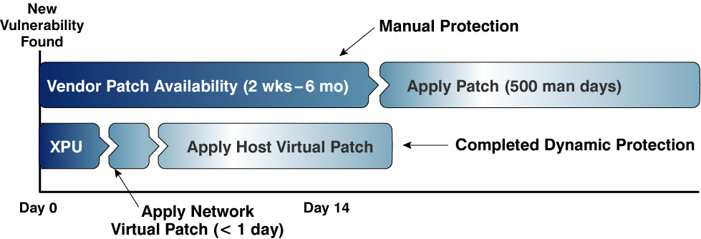

Figure 1-1: Virtual Patch™ Principle

1.5.6 Managed Protection Agent (MPA)
ISS Managed Protection Services leverage best-in-class protection agents to deliver a wide range of enterprise prevention and protection solutions for organizations of all sizes and markets. The MPA Platform unites market-leading security technologies including vulnerability assessment, intrusion prevention and
response, policy enforcement, and event management and correlation into a single protection system providing comprehensive protection across the network.

ISS recommends that NWC Inc. utilize Proventia G IDS/IPS appliances as the Managed Protection Agent of choice.

1.5.7 Ongoing Security Posture Assessment
Security assessments ensure the continued protection of critical business operations through ongoing vulnerability assessment, remediation and penetration testing to deliver on the promise of guaranteed protection.

1.5.8 Virtual-SOC Customer Portal
ISS Virtual-SOC Customer Portal provides secure, real-time access for all client/SOC communications, trouble ticket entry, event handling, incident response, data presentation, report generation and trend analyses. This highly user-friendly interface integrates X-Force security intelligence and early warning threat services into one, high-impact GUI, thus organizing and enhancing the visibility of critical security information.

1.5.9 X-Force Emergency Response Services (ERS)
X-Force ERS provides instant access to industry experts who can assist in the development of incident response procedures to control security breaches and mitigate the risk of further damage. This expert team excels in all facets of incident response including, planning, forensic analysis, preservation of evidence and data recovery. The X-Force ERS also assists in the preparation for future attacks and efficiently handles the immediate and post attack investigation.

1.5.10 Performance-Based Reporting
Performance-based reporting provides real-time reporting of key performance metrics around ISS Managed Service customers including attack trends, incident tracking and ISS SLA adherence. Delivered through the Virtual-SOC Customer Portal, this up-to-the-minute reporting feature provides actionable information and detailed summaries by specific market segments allowing customers to compare current security posture against industry trends.

1.5.11 Security Command System
ISS Security Command System enables the advanced detailed data correlation and analysis for all events on a network. This expert system provides ISS security professionals with the advanced analysis, integrated security intelligence and event prioritization tool sets needed to proactively protect your enterprise. Advanced correlation and prioritization enables real-time, automated analysis and correlation of events, preventing the misidentification of attacks, eliminating false positives and providing for the accurate identification of malicious behavior prior to those behaviors causing damage. This unique approach allows ISS security professionals to provide a higher quality of protection than that associated with manual execution of tasks.

1.5.12 X-Force Threat Analysis Service
The X-Force Threat Analysis Service is a subscription-based offering that is tailored to your specific environment (operating systems, applications, network infrastructure, etc.). It enables security professionals to provide proactive security management through the evaluation of global online threat conditions and detailed analyses that is laser-focused on your unique security challenges. This sophisticated blend of threat information collected from ISS international SOCs and the X-Force research and development organization clearly denotes the nature and severity of external Internet threats and provides the recommended course of action.

1.5.13 Highly-Skilled and Certified Professionals
Certified security professionals undergo extensive and ongoing training for combating the evolving threat spectrum to ensure the highest levels of protection for our customers.

2.0 Proposed Security Offerings

2.1 Overview

ISS proposes the following optimal threat protection services for NWC Inc.:

- MPS Network Select Service – This Managed Protection Service guarantees protection of the NWC Inc. network using ISS Proventia G IPS appliances. Proventia G can operate as either a passive IDS or an inline IPS.

- MPS Host Select/Standard Service – This service provides server protection for two levels of assets: mission critical and business critical via ISS RealSecure Server Sensor or Proventia Server.

- Managed Firewall Service - This service provides full administration and management of firewalls from Check Point, Cisco, Sun, and Juniper (formerly NetScreen). Additionally, Content Filtering and Network Antivirus are add-on features to firewall management.

- Vulnerability Management Service – This service provides vulnerability discovery, prioritization, assignment, remediation and validation services. All stages are tracked via custom-built workflow and represented in the Virtual-SOC Portal.

Should these advanced service levels not be required, NWC Inc. may choose our basic managed security services. These are:

Managed IDS Service - This service provides 24/7/365 network monitoring, intrusion detection, and incident response using IDS products from ISS, Cisco, McAfee, and 3Com (formerly Tipping Point).

For both of these options, ISS can ascertain the precise Proventia G models required that range in throughput allocation and port densities required during a subsequent solution design session with NWC Inc.

While ISS will provide and deploy these Proventia G IDS/IPS appliances at strategic locations within NWC Inc.’s infrastructure, the procurement of the firewall appliances/hardware is outside the scope of ISS SLAs. We recommend that NWC Inc. choose a best of breed firewall offered by one of the above certified vendors and allow us to provide configuration, management, and monitoring services for those devices.

2.2 MPS Network Select Service

2.2.1 Service Overview
Internet Security Systems (ISS) Select level Managed Protection Service for Networks enables security professionals to defend their network from external threats and internal risks by providing a comprehensive solution for network monitoring and protection. The Select service level extends the capabilities of the customer’s security professionals by delivering the highest levels of security awareness for maximum security protection.

ISS Managed Protection Services is the only suite of managed services that offers a 24/7 cost effective guaranteed level of protection giving organizations the confidence to focus on their core business initiatives. This total solution embodies multi-layered security expertise to dynamically manage, monitor and protect against escalating Internet threats while mitigating risk beyond device management.
This service provides managed, in-line, protection of network segments. This is accomplished by the deployment of ISS Managed Protection Agents, Proventia™ G for IPS, This service also includes essential bundled services for enhanced security threat awareness.

Key Features
Guaranteed Performance-based Service Level Agreements (SLAs)
ISS Managed Protection Services Guaranteed Performance-based SLAs provide guaranteed response times and countermeasures for security incidents or the service is FREE, as stated in the SLAs. These enhanced SLAs are based on the X-Force® Certified Attack List. The X-Force Certified Attack List is a list of high-risk vulnerabilities and attacks currently affecting computer networks that enables cost effective and proactive protection for critical business systems and applications. The enhanced SLAs guarantee protection against the X-Force Certified Attack List. Additionally, MPS SLAs contribute to effective security posture through the notification of Security Incidents 15 minutes after identification. Such measures reduce incident response times and help to maximize the effectiveness of security personnel.

Managed Protection Agent (MPA)
ISS Managed Protection Services leverage best-in-class MPA’s to deliver a wide range of enterprise prevention and protection solutions for organizations of all types and sizes. The MPA Platform unites market-leading security technologies - including intrusion prevention and response, policy enforcement, event management and correlation – into an integrated protection system providing comprehensive protection across the network. The MPA’s are based on the new Proventia G and Proventia M series protection appliances. ISS Proventia G Series appliances are in-line intrusion prevention systems (IPS) that automatically block malicious attacks while preserving network bandwidth and availability. Proventia G Series appliances employ proven protection technologies that far surpass the accuracy and capabilities associated with today’s firewalls and IDS/IPS to provide superior protection.

On-going Security Posture Assessment
Security Posture Assessment supports the continued protection of critical business operations through on-going vulnerability assessment. For each MPA purchased the customer will receive quarterly Remote Vulnerability Assessment Scanning for up to five IP addresses.

X-Force Threat Analysis Service (XFTAS)
X FTAS enables proactive security management through comprehensive evaluation of global online threat conditions and detailed analyses. The service provides a unique blend of threat information collected from Internet Security Systems global Security Operations Centers (SOC) and trusted security intelligence from the X-Force research and development team. This powerful combination clearly denotes the nature and severity of external Internet threats. For each MPA purchased the customer will receive one annual subscription to the XFTAS service.

Virtual-SOC Portal
The Virtual-SOC Portal provides secure real-time access for all client/SOC communications including: Ticket creation, event handling, incident response, data presentation, report generation, and trends analysis. This user-friendly interface integrates X-Force security intelligence and early warning threat services to organize and enhance the visibility of critical security information.

Key Benefits
- 24/7 protection of mission critical assets.
- Access to certified security professionals utilizing best-practice protection techniques.
- Early warning security intelligence of evolving Internet threats to proactively protect business operations from unnecessary down time.
- Maximization of IT infrastructure and resources on core business competencies.
- Meet or surpass industry specific certification and regulatory compliance guidelines.
- Accelerate speed to protection through reduced deployment times and a reduction in required in-house security expertise.
- Lower Total Cost-of-Ownership (TCO) while improving security posture.

Service Level Detail
A detailed description of all service features has been outlined in the following section. Unless otherwise noted, features not explicitly listed are not inclusive to the service offering. Additional feature requests will be evaluated on a per request basis and may result in additional charges. Certain features of the service may identify customer specific actions or requirements. Customer participation is a requirement for successful delivery of the service. ISS will configure a Managed Protection Service (MPS) network agent (MPA) to monitor and protect based on a comprehensive, predefined list of threats and vulnerabilities tailored to the customer’s network environment. Additionally, each MPA will be implemented with the MPS XForce
Certified Attack List Attack List activated. This Attack List is based on the X-Force Catastrophic Risk Index and provides protection against the most high-risk security incidents that are currently threatening organizations.

The MPS X-Force Certified Attack List Attack of predetermined, verified attack signatures is maintained and updated quarterly on the Virtual-SOC Portal Web site. This list regularly contains over six hundred types of attacks including Backdoors, Trojans, Worms, and others. The up-to-date, comprehensive list may be found in the download section of the Virtual-SOC Portal website. ISS will properly configure and update the agent as threats change. ISS will monitor this agent 24 hours per day, seven days a week. All non-X-Force Certified Attack List level attacks will be monitored for and reported on as stated in the MPS SLAs.

Device Management
ISS will be the sole provider of software-level device management for the customer premise MPS agent. With root/super-user/administrator level access to the device, along with an out-of-band system and an agent installed on the device, ISS will maintain system status awareness, apply OS patches and upgrades, troubleshoot problems on the device, and work with the customer to ensure that the device remains up and available. ISS will monitor for availability of the agent, notify the customer when certain utilization thresholds have been met, as well as monitor the device 24 hours per day, seven days a week. ISS provides services to remotely manage the device as part of this service. Any activity requiring an on-site presence must be facilitated by the customer or fulfilled by engaging X-Force Professional Security Services at additional cost.

Deployment Planning
- Customer will complete technical enrollment form detailing network configuration.
- Customer will complete environment questionnaire detailing applications and services for the hosts on the protected network.
- ISS will contact customer to review environment and configure initial policy for the agent.
- ISS will contact customer to introduce the MPS process, verify all contact information, and introduce contacts at ISS.

Deployment and Configuration
- ISS will deploy a new agent or manage an existing agent. If an existing agent is to be managed, it must be either a Proventia G or M. Additionally, the agent may have to be modified to meet platform specifications dictated by ISS MPS Operations, including the addition or removal of applications and user accounts.
- The MPS agent will be deployed in front of, or behind a firewall, at the customer’s discretion. Placement outside the firewall may require policy tuning to eliminate high volume false alarms and limit ISS ability to implement certain protection strategies. Placement at the network perimeter behind a properly configured firewall is recommended.
- If the customer acquires the agent from ISS, ISS will provide the customer with a self-installation kit to assist in the agent deployment. On-site professional services are also available for customer deployments.
- ISS will work with the customer to determine an optimal MPS agent configuration based on the customer’s network and firewall configuration, as well as the most active worldwide threats as determined by the ISS Global Threat Operations Center (GTOC). As needed, ISS may tune policy to reduce number of erroneous alarms.
- For all customer requested policy changes that ISS will make to the MPS agent security policy, ISS will perform the following actions:
  - Investigate and approve change request by customer within two hours.
  - Update the security policy configuration of the MPS agent within four hours of request by customer.
  - Any policy change request is subject to approval by the Security Operator. A request will only be denied if the change would result in a flood of false alarms.
  - ISS will provide security policy updates as X-Press Update™ enhancements (XPU) are made available.
  - All changes to the MPS agent security policy will result in a Service Ticket.

Service and Support
- Security Operators will actively monitor the agent 24 hours per day, seven days a week.
- Based on customer’s business requirements, network configuration and firewall configuration, the Security Operator will determine if an event (or series of events) is a Security Incident.
- ISS will notify the customer’s primary point of contact within 15 minutes of identifying a Security Incident. If the first primary contact is not available, the Operator will continue to attempt all primary and secondary contacts until someone is reached. If no contact is made on the first attempt, a second attempt will be made after 15 minutes.
- When the Security Operator contacts the customer; he/she will describe the incident, the possible impact, and a recommended course of action. An email including the details of the Security Incident will also be sent.
- For any possible or confirmed compromise, the customer will be put in contact with ISS Emergency Response Services to assist in determining the extent of the damage and for possible remediation.
- ISS will notify the customer’s primary point of contact with 30 minutes of detecting a failure in the MPS agent or an inability to communicate with the MPS agent.
- ISS will work with the customer to determine protection strategies, including which network connections may be terminated reset, or killed in the event of an attack. Action taken will be available in monthly reporting.
- ISS will audit customer’s policy settings quarterly to ensure they have appropriate settings.
- ISS Internet Scanner results are accepted to help define raw event priority and impact.
- Upon customer request, ISS will conduct a review once per quarter with the customer for all MPS agents under management to determine if changes to the network protection strategy are required.
- Customer will receive a subscription to the X-Force Threat Analysis Service.

MPS Bundled Services
One of the goals of MPS is to provide an enhanced level of protection through the delivery of bundled services. These services are specifically designed to add valuable and ongoing security threat awareness. They include:

Vulnerability Assessment Scanning
The Vulnerability Scanning Service is an electronic service that regularly and automatically scans your Internet perimeter devices for hundreds of known security vulnerabilities. Each scan results in several comprehensive reports that will identify potential weaknesses assess relative network risk, and outline steps needed to manage uncovered vulnerabilities. Scans can be scheduled to occur on quarterly basis, with the option of also performing periodic on-demand scans. Customers must declare that they are the owners of the IP address range to be scanned prior to the scan taking place.

X-Force Threat Analysis Service (XFTAS)
Internet Security Systems X-Force Threat Analysis Service (XFTAS) enables proactive security management through comprehensive evaluation of global online threat conditions and detailed analysis tailored to specific customer needs. The X-Force Threat Analysis Service is a unique blend of threat information collected from Internet Security Systems international network of Security Operations Centers and trusted security intelligence from the X-Force research and development organization. This powerful combination clearly denotes the nature and severity of external Internet threats. Daily summaries provide current and forecast assessments for active vulnerabilities, viruses/worms and threats, including links to recommended fixes and general security advice. Each customer will receive one annual subscription account for every MPA purchased and under management.

Reporting
Customer will have access to comprehensive service information via ISS security web portal to review Service Tickets and Security Incidents at any time.

Guaranteed Protection for Critical Attack List
With the MPS for Networks Select Service, ISS will configure Proventia G IDS/IPS appliances to monitor and protect based on a comprehensive, pre-defined list of threats and vulnerabilities tailored to NWC Inc.’s network environment. Additionally, each Proventia G will be implemented with the MPS X-Force Certified Attack List Attack List activated. This Attack List is based on the X-Force Catastrophic Risk Index and provides protection against the most high-risk security incidents that are currently threatening organizations.

The MPS X-Force Certified Attack List of pre-determined, verified attack signatures is maintained and updated quarterly on the Virtual-SOC Portal Web site. This list regularly contains over six hundred types of attacks including Backdoors, Trojans, Worms, and others. The up-to-date, comprehensive list may be found in the download section of the Virtual-SOC Portal website.

ISS will properly configure and update Proventia G appliances as threats change. ISS will monitor these devices 24/7/365. All non-X-Force Certified Attack List level attacks will be monitored for and reported on as stated in the MPS SLAs.

2.3 MPS Select/Standard Host Service

2.3.1 Service Overview
Internet Security Systems (ISS) Managed Protection Service for Servers provides organizations with 24/7 active protection for server devices across a variety of platforms and operating systems. With MPS for Servers, protection is applied exactly where you need it—on the resources you value most. By leveraging the expertise of ISS industry certified security professionals, organizations of any size can receive expert management, monitoring, and reporting for each protected server asset.

Whether implemented in a stand-alone configuration or as an additional layer beneath network based intrusion prevention, ISS Managed Protection Service for Servers provides true preemptive protection from both local and network based attacks. This comprehensive level of server-based protection is made possible through the deployment of ISS industry leading RealSecure® Server Sensor application. Further, choosing the Managed Protection Service for Servers does not mean sacrificing control or visibility into your critical network assets. Instead, MPS for Server customers receive unparalleled protection with an increased visibility into security events, all while still retaining administrative access to monitored assets. In the event questions arise or configuration changes to the Protection Agent are required, ISS analysts are available 24/7.

Key Benefits
Internet Security Systems Managed Protection Service enables organizations to establish a robust, multi-layered security architecture that significantly improves security posture while reducing the solution’s overall total cost of ownership. Additional benefits of choosing ISS Managed Protection Service for Servers include:
- 24/7 protection for mission critical assets.
- Reduction of security infrastructure.
- Expert management and monitoring of deployed Protection Agents.
- 24/7 access to ISS certified security professionals.
- Obtain early warning security intelligence from the Virtual-SOC Portal website to proactively protect business operations from unnecessary down time.
- Maximize existing IT infrastructure and resources by focusing on core business competencies while entrusting security to the proven experts.
- Meet or surpass industry specific certification and regulatory compliance guidelines.
- Accelerate speed to protection through reduced deployment times and a reduction in required in-house security expertise.
- Significantly lower total cost of ownership while dramatically improving security posture.

Key Features
Guaranteed Performance-based Service Level Agreements (SLAs)
ISS Performance-based SLAs are industry leading and set the standards for change management, proactive system monitoring, and application/content updates. In addition, ISS is the only managed security service provider to offer a Security Incident Prevention Guarantee, the hallmark of ISS Managed Protection Services. If, under this guarantee, ISS fails to protect against specific security incidents passing through the Protection Agent, the service for that month is free.

RealSecure Server Sensor
Server Sensor provides automated, real-time intrusion prevention and detection by analyzing events, host logs, and inbound/outbound network activity on critical enterprise servers. By applying sophisticated protocol analysis with behavioral pattern detection and automated event correlation, the Protection Agent can prevent both known and unknown attacks which results in increased availability and a reduction in costly server down-time. Some of RealSecure® Server Sensor’s industry leading features include:
- Server Based Protection – The ISS Protection Agent works to secure the underlying operating system by preventing attackers from exploiting both OS and application level vulnerabilities.
- Advanced Intrusion Prevention and Blocking – Monitors all traffic to and from the server or network to detect and prevent inbound/outbound attacks as well as block new and unknown attacks such trojans, brute force attacks, unauthorized access and network worms.
- Web Application Protection – Secure Sockets Layer (SSL) encrypted application layer intrusion monitoring, analysis, and response capability for both Apache and IIS web servers.
- Broad Platform Coverage – Provides organizations with the flexibility to grow their server protection strategy in a variety of environments – System Requirements and supported platforms are located at: http://www.iss.net
- Backed by the Intelligence of the ISS X-Force – X-Force is the most respected Internet security research group in the industry. This cutting-edge research team actively turns security research into product improvements, allowing Internet Security Systems customers to respond far more rapidly to the latest evolving threats.
- Virtual PatchTM – Reduce the urgency of security patch applications by leveraging the active blocking capabilities of the Protection Agent. Virtual Patch allows organizations to apply critical security patches while still leveraging best-practice change management procedures.

Specific supported features of the Protection Agent under the Managed Protection Service for Servers have been outlined in the section entitled “Service Details” (answer 2.2).

Reporting
Outsourcing security management and monitoring to ISS does not mean organizations lose visibility of critical security events occurring across the enterprise. On the contrary, Managed Protection Service customers receive increased visibility into network attacks and misuse in addition to security intelligence provided by the world-renowned ISS X-Force. By leveraging the detailed and customizable reporting packages provided through the Virtual-SOC Portal, Security Administrators can generate activity reports useful for frontline operators or high-level graphical summaries that help to articulate the ROI of security initiatives.

Service Details
ISS Managed Protection Service for Servers is offered at two distinct levels (Standard and Select) designed to meet the needs of organizations with varying size and protection requirements.

Managed Protection Service for Servers Standard
The Standard level of service has been designed to provide cost-effective guaranteed protection for an organization’s less critical server based assets. MPS for Server Standard provides expert management of the Protection Agent, rapid proactive updates of security content, availability monitoring, and in-depth reporting and intelligence through the secure Customer Portal website. In addition, Standard level customers have access to ISS 24/7 team of trained security analysts to assist in resolving problems or answering any service related questions.

Managed Protection Service for Servers Select
The Select level of service includes all features of the Standard service and also adds real-time 24/7 live event monitoring and escalation. The addition of real-time monitoring and escalation makes the Select level of service perfect for your organization’s most business critical assets and servers. By leveraging ISS proven methodology for incident classification, escalation, and response, Select level customers can recognize the true benefits of ISS certified Analysts and thoroughly practiced operating procedures.

Intrusion Prevention/Detection Overview
The Intrusion Prevention capabilities of the Server Sensor Protection Agent provide the foundation for active blocking and Virtual PatchTM technologies. Any traffic identified by the Server Sensor as malicious is then compared against the Agent’s policy and appropriate actions are taken whenever possible to ensure the integrity of the protected server is maintained. By employing Managed Protection Services, organizations can receive the highest levels of preemptive protection available, while offloading the complications of policy management to ISS X-Force Security Analysts.

X-Force Certified Attack List
Same as information listed in this section under MSP Network Select Service above.

Intrusion Prevention Policy and Blocking
As part of the Managed Protection Service for Servers, ISS will by default enable all X-Force Protection Responses and Attack Detection capabilities of the Protection Agent. Such a configuration shall ensure that active attacks, including those listed within the XFCAL, are blocked by the Agent whenever possible. Additional attacks not blocked by the Server Sensor will always be visible through the Virtual-SOC Portal website.

While the XFCAL is updated on a quarterly basis, ISS will continue to update the Agent’s policy and protection capabilities as new threats emerge (Pending availability of applicable product updates.)

Configurations without the X-Force Protection Responses enabled (E.g. Active Blocking) and configurations using Firecell or Fusion Scripting are not supported under this service.

Intrusion Prevention Policy Changes and Filters
All Protection Agents under the Managed Protection Service for Servers will be deployed with maximum blocking capabilities enabled as applicable to the server type and as outlined above. In the unlikely event that legitimate traffic is inadvertently blocked by the Protection Agent, a customer security contact with appropriate authority may submit a policy change request to Internet Security Systems through the Virtual-SOC Portal requesting that such traffic be allowed to pass through the Server Sensor. Following change submission, ISS analysts will process the customer’s request in accordance with the Policy Change Request Implementation Guarantee as outlined in the MPS for Server Comprehensive SLA document (attached).

Intrusion Prevention/Detection Security Content and Application Updates
To provide protection ahead of the threat, ISS updates all Agents with the latest security content as it becomes available. Security content, delivered in the form of X-Press Managed Protection Service for Servers Updates, provide the Protection Agent with additional detection and blocking capabilities. As such, ISS analysts will proactively install security content updates to ISS managed devices and an email following successful application will serve as a notice that the content update has been applied. Details on an organization’s collective device update status will always be available through the Virtual-SOC Portal website.

Application updates, or any other updates that may affect service or device availability will only be installed following the ISS Security Operation Center’s official declaration of a scheduled maintenance window.

Intrusion Prevention Notifications and Escalations
For all levels of MPS for Servers, malicious traffic will be identified and blocked as specified by the Protection Agent’s installed security policy. All blocked attacks will be reported on in real-time through the secure Virtual-SOC Portal website. As malicious activity occurs 24/7 and blocked traffic is a regular occurrence, no escalations will follow the successful inbound block of unwanted traffic. Various responses occur for other types of activity and are commensurate with the service level purchased. Service level details have been
outlined below:

Standard
Under this level of service no real-time human escalations are provided; instead all attack data from both blocked and unblocked events is recorded and viewable through the Virtual-SOC Portal in the form of raw logs and detailed reports. In the event questions arise regarding any presented data, ISS analysts are available to authorized security contacts for assistance 24/7.

Select
The Select level of service increases protection even further by adding 24/7/365 live monitoring and escalation to the Managed Protection Service for Servers. By employing ISS elite team of X-Force Security Analysts, the Select level of service provides the most comprehensive and effective security available for an organization’s most business critical assets. In the event malicious activity is detected, ISS analysts will generate a Security Incident ticket and contact the customer’s authorized security contact via telephone and/or email based on declared event severity***. In the event any critical attacks originate from the protected asset, including blocked attacks, ISS analysts will also thoroughly document and escalate such activity. Following the escalation of all security incidents, authorized security contacts may view a detailed security incident report via the Virtual-SOC Portal website. Such reports will provide relevant incident details including actions taken, and steps to remediation.
***ISS analysts will escalate to a customer’s authorized security contacts based on a pre-defined role and priority based system. ISS analysts will attempt to contact the customer’s security contacts until an individual is reached or the list has been exhausted, whichever comes first. Escalations are intended to provide awareness around the potential security incident and notice of required actions. In the event assistance is required with the end remediation of a security incident, the SOC analysts will assist customers with escalation to the ISS Emergency Response Service. (Note: Additional fees apply for ERS services.)

In addition to the service level specific notifications and escalations provided above, all MPS for Server customers will receive up to the minute Internet intelligence, virus details, and security news through ISS secure Customer Portal web interface. This extra insight provided by the experts at ISS helps to position your organization ahead of the threat, and facilitates the transition from a reactive security approach to a complete preemptive strategy.

Intrusion Detection Overview
The Intrusion Detection capabilities of the RealSecure® Server Sensor augment the Protection Agent’s IPS by providing the ability to identify and alert on potentially suspicious or unusual activity. By alerting on but not blocking this activity, the ISS Protection Agent provides a complete view of all traffic that may impact a server’s integrity, while simultaneously minimizing disruptions in legitimate traffic or requests. In addition, by merging both IDS and IPS data in the Virtual-SOC Portal, MPS for Server customers receive the most comprehensive and holistic view of their server based protection strategy available today.

Intrusion Detection Policy
As part of the Managed Protection Service for Servers, ISS will by default enable all relevant attack/suspicious activity detection capabilities of the Protection Agent. Such a configuration shall ensure that active attacks and suspicious activity will be detected (Based on policy configuration) and visible through the Virtual-SOC Portal. ISS will configure and maintain the IDS policy such that where applicable, new security checks are deployed and enabled following the release of additional security content updates (XPUs).

Intrusion Detection Policy Changes and Filters
All Protection Agents deployed under the Managed Protection Service for Servers will be deployed with attack/suspicious activity detection capabilities enabled as outlined above. In the event that such a configuration results in a high number of false positives or irrelevant data, ISS will take proactive measures to adjust the Agent’s configuration. Such changes are necessary as excessive amounts of IDS data can cloud actual attack activity or impact a device’s performance.

Intrusion Detection Notifications and Escalations
For all levels of MPS for Servers, malicious and suspicious traffic will be identified as specified by the Protection Agent’s installed security policy. All such activity will be reported on in real-time through the secure Virtual-SOC Portal website. Various responses occur for this activity and are commensurate with the service level purchased.
Service level details have been outlined below:

Standard
Under this level of service no real-time human escalations are provided; instead all attack data from both IDS and IPS events is recorded and viewable through the Virtual-SOC Portal in the form of raw logs and detailed reports. In the event questions arise regarding any presented data, ISS analysts are available to authorized security contacts for assistance 24/7.

Select
The Select level of service also provides for real-time telephone and/or email escalations of intrusion detection events that appear to be indicative of a security incident. Such circumstances may require the customer’s authorized security contact to take some form of immediate action to mitigate or remediate a specific situation.

Following the escalation of all security incidents, authorized security contacts may view a detailed security incident report via the Virtual-SOC Portal website. Such reports will provide relevant incident details, actions taken, and steps to remediation.

Application/Agent Management
ISS Managed Protection Service is not just about providing guaranteed protection; it is also about providing expert application management and best practice procedures to help ensure maximum effectiveness and performance from all monitored platforms. To this end, ISS provides a variety of standard device and application management functions as part of the Managed Protection Service for Servers.

Management Connectivity
Under the Managed Protection Service for Servers all security logs/events and management data traverse between the ISS Security Operations Center and the Protection Agent via the Internet. All data traveling across the Internet is encrypted using industry standard strong encryption algorithms inherent to the supported applications and platforms. Such best practices assure that data is transferred both securely and in a cost effective manner.

SiteProtector Infrastructure Configurations
Selecting ISS as a Managed Protection Service provider awards customers with best of breed security products and services while minimizing additional personnel and infrastructure overhead. MPS for Server customers are thus able to leverage a proven, redundant, and scalable RealSecure® SiteProtector management infrastructure located directly inside ISS Systrust certified Security Operations Centers.

To accommodate the varying needs of our customers, ISS provides several infrastructure options based on the service level purchased:

Standard
Standard level customers may choose from one of two infrastructure configurations:
- ISS Hosted SiteProtector Infrastructure - As outlined above, Standard level customers may take advantage of all the benefits provided by leveraging ISS hosted management infrastructure. This is the most commonly deployed configuration.
- Customer Hosted SiteProtector Infrastructure - Standard level customers may also choose to host and manage their own deployment of RealSecure® SiteProtector. Customers hosting their own infrastructure will be required to configure a data feed from all Event Collectors such that event data is delivered directly to ISS. Customers will also be required to provide ISS with administrative access via the SiteProtector console to the SiteProtector Application Server such that ISS may apply updates and retain sole ownership over policy change management. All other support, management, and maintenance functions of a customer hosted SiteProtector instance are the sole responsibility of the customer.

Select
Select level customers are required to use ISS hosted infrastructure in order for ISS to provide the protection guarantee.

Agent Availability Monitoring
MPS for Server customers receive device availability monitoring as a standard component of the service offering. Such monitoring allows ISS analysts to alert customers in the event that connectivity with the Protection Agent has been lost. Situations such as these are typically indicative of a device or connectivity failure. ISS monitors for agent availability by connecting to certain ports which are exposed only to ISS by the Protection Agent. Such monitoring can only be conducted if the Protection Agent resides on a server with a unique Internet accessible IP address. In the event the server is not Internet accessible, availability monitoring cannot be provided.

Agent Outage Notification
If the ISS X-Force Security Analyst confirms a monitor-able Protection Agent is not reachable through standard in-band means, he or she will escalate to the customer’s designated outage contacts via telephone using a predetermined escalation procedure jointly created by ISS and the customer during the deployment process. Following the telephone escalation, the X-Force Security Analyst will commence troubleshooting of any problems related to the configuration or functionality of the managed application. The managed application includes RealSecure® Server Sensor only. Due to the nature of the Protection Agent residing on customer owned and managed infrastructure, it may be necessary for the customer’s authorized security contacts to assist with the troubleshooting process when requested by the X-Force Security Analyst.

2.4 Managed Firewall Service

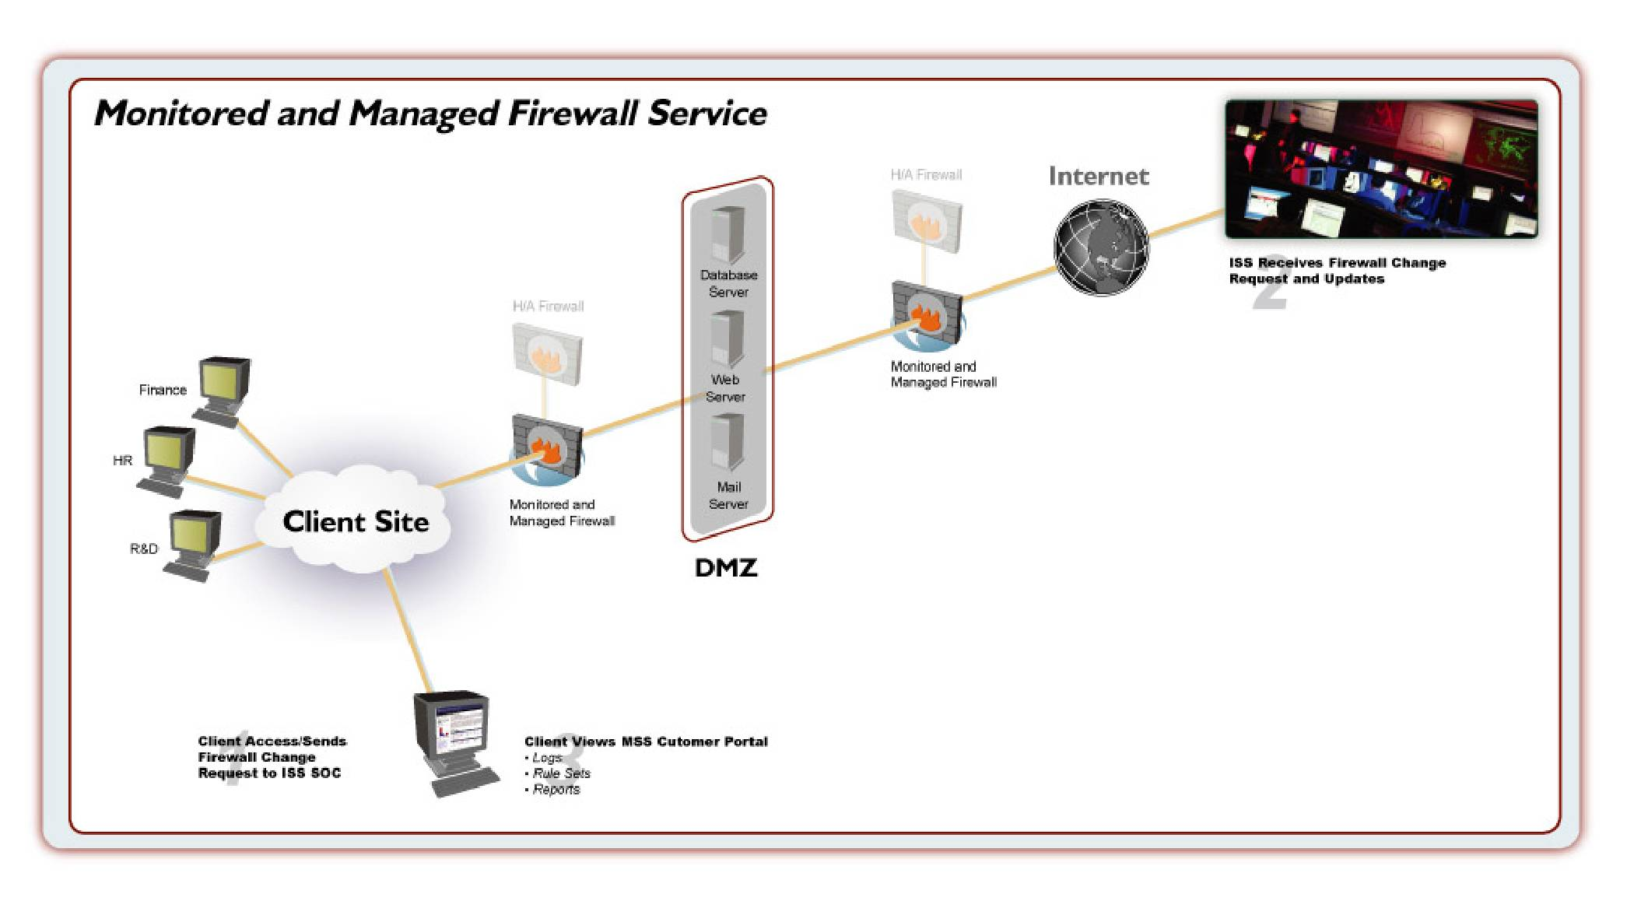
Managed Firewall Service

2.4.1 Service Overview
Internet Security Systems (ISS) Managed Security Service for Network Firewalls provides a comprehensive access control and connectivity solution deployed across a multi-vendor, best-of-breed suite of firewall applications and appliances. By leveraging the proven experience of ISS certified security professionals, organizations of any size can reduce the complexity of systems that protect their critical assets, while combining best practice change management with optimal security policy design and implementation.

ISS Managed Security Service for Network Firewalls provides more than just technical expertise.
Managed Network Firewall customers benefit from the improved uptime and availability achieved through around the clock management and monitoring of the Firewall Platform from ISS global network of redundant Security Operations Centers. In the event questions arise or configuration changes are required, ISS analysts are available to assist 24/7.

Customers requiring more than stand alone firewall management will be pleased to learn that ISS Managed Security Service for Network Firewalls also provides a number of available add-on services designed to give you the flexibility needed to implement the most efficient and cost effective access control solutions available. High Availability, Clustering, and Firewall Security Event Monitoring represent only some of the available customization that can be added to most supported firewall platforms. In addition, Managed Security Service customers are always kept up to date on the current status of open issues, managed devices, and emerging threats through the secure, real-time Virtual-SOC Portal website. The Virtual-SOC Portal provides a variety of reporting options designed to satisfy the needs of both technical and business minded individuals.

ISS Managed Firewall solutions have been carefully designed to fit the diverse requirements of today’s connected enterprises. From large scale global deployments, to small or remote offices, ISS has a Managed Network Firewall solution designed to align with your organization’s security initiatives and budgetary requirements. ISS provides three levels of Managed Firewall Service: Standard, Select and Premium. The matrix below summarizes the service features.

Features | Standard | Select | Premium
Policy Changes | 2/mo | 4/mo | Unlimited
Emergency Changes | No | No | 1/mo
Maintenance Windows | No | Yes | Yes
Site-to-Site VPNs | 2 | Unlimited | Unlimited
Client VPNs | No | Yes | Yes
Integrated Content Support | 1 Module | 2 Modules | 3 Modules
Security Event Monitoring | Optional | Optional | Included
Monthly VMS | 1 IP | 2 IPs | 3 IPs
Log Retention | 1 Year | Up to 7 Years | Up to 7 Years
OOB Required | Optional | Yes | Yes

Key Benefits
Internet Security Systems Managed Security Services enable organizations to establish a robust, multi-layered security architecture that significantly improves security posture while reducing the solution’s overall total cost of ownership. Additional benefits of choosing ISS Managed Security Service for Network Firewalls include:
- Multiple service levels addressing the unique requirements of most any sized organization.
-  24/7 access control for local networks and mission critical assets.
-  Expert management and monitoring of deployed security appliances and applications.
-  24/7 telephone / email / web access to ISS certified security professionals.
-  Reduce connectivity expenses by leveraging the firewall platform’s supported VPN capabilities.
-  Automate the process of log storage and archival to meet varying regulatory requirements.
-  Assess and track firewall vulnerabilities using ISS vulnerability management capabilities.
-  Prevent the spread of network viruses through powerful integrated antivirus capabilities on supported firewall platforms.
-  Leverage integrated intrusion prevention capabilities to reduce the ability for attacks to traverse the network.
-  Obtain early warning security intelligence from the Virtual-SOC Portal website to proactively protect business operations from unnecessary down time.
-  Maximize existing IT infrastructure and resources by focusing on core business competencies while entrusting security to proven experts.
-  Improve security posture and due diligence for regulatory compliance initiatives.
-  Accelerate speed to protection through reduced deployment times and a reduction in required in-house security expertise.

Key Features
Performance-based Service Level Agreements (SLAs)
ISS Performance-based SLAs are industry leading and set the standards for change management, proactive system monitoring, and application/content updates. Year after year, Internet Security Systems has continued to refine and develop Service Level Agreements that set the industry’s direction and raise the bar for responsiveness, availability, and protection. The Managed Security Service for Network Firewalls provides customers with a variety of Service Level Agreements including availability monitoring, policy change implementation, and more.

Best-of-Breed Firewall Platform Support
With the multitude of available firewall platform choices, it is not uncommon for a single organization to have multiple firewall platforms protecting critical entry points into the network. As part of ISS multi-vendor approach towards outsourced solutions, the Managed Network Firewall Service provides support for the following vendor’s best-of-breed firewall products and appliances:
- Internet Security Systems
- Checkpoint Software Technologies, Ltd
- Cisco Systems
- Juniper Networks (Formerly Netscreen)

Expert Management
ISS Managed Security Services eliminate the steep learning curve often associated with the deployment of new technologies. By entrusting security management and monitoring to the experts at ISS, organizations can get more out of their security investment while significantly reducing unscheduled network downtime that often results from improperly configured systems. In the event problems do arise, ISS trained security analysts leverage in-depth product knowledge and best practice procedures to quickly and efficiently remediate issues.

Reporting
Outsourcing security management and monitoring to ISS does not mean organizations lose visibility of critical security events occurring across the enterprise. On the contrary, Managed Security Service customers have increased visibility of network attacks and misuse in addition to security intelligence provided by the world renowned ISS X-Force. By leveraging the detailed and customizable reporting packages provided through the Virtual-SOC Portal website, security administrators can generate activity reports useful for frontline operators or high-level graphical summaries that help to articulate the ROI of security initiatives.

Vulnerability Management
When outsourcing firewall management it is imperative to know that the firewall policy has been properly configured and that the firewall itself is free from vulnerability exposures. ISS provides customers with this peace of mind by leveraging its industry leading vulnerability management capabilities to scan managed firewall devices for vulnerabilities on a monthly basis. Such reoccurring scans provide an organization with first hand knowledge of risk exposures, and provide an avenue for corrective measure and response. In addition, the results of these scans can always be reviewed directly through the Virtual-SOC Portal website.

Heterogeneous Event Correlation
Correlation of security events between heterogeneous technologies such as N-IDS/IPS, H-IDS/IPS and events from intelligent security appliances (advanced firewalls, intrusion prevention agents) is achieved through two primary means:

Temporal Correlation - SOC Analysts are presented with a real-time view of events collected from security sensors. This provides a holistic view of network activity allowing an analyst to correlate a threat that was viewed on the Firewall with a threat that was monitored by the network intrusion detection sensor.

Historical Correlation - SOC Analysts have the ability to analyze security events from a historical database and correlate those events against real-time activity occurring on the network. This correlation assists ISS in determining if suspicious traffic is indeed a threat to the customer's security.

A Variety of Service Levels, Supported Features, and Optional Service Add-ons
ISS has designed the Managed Network Firewalls Service so that it can adapt over time with an organization’s constantly evolving needs. The following supported features and optional add-ons are available for select platforms under the Managed Security Service for Network Firewalls:
- Three Distinct Service Levels – Standard, Select, and Premium service levels provide flexibility for the smallest of implementations to the most robust enterprise-wide deployments.
- Site-to-Site and Traditional Client Based VPNs – Secure remote connectivity is provided by integrated support for IPSEC based client and site to site Virtual Private Networks.
- SSL VPNs – Provides a clientless strong-encryption based tunnel via a standard web browser for the ultimate in secure portability.
- High Availability (HA) and Clustering – Ensure uptime and optimal performance through available active/passive HA solutions or active/active clustering.
- Content Security – Remove access to objectionable content and minimize the risk of malicious code entering the network through active screening of web and email traffic.
- Antivirus – Eliminate viruses and improve availability with continuously updated, in-line gateway based antivirus protection.
- Antispam - Transparently monitor mail traffic to eliminate unsolicited advertising and/or objectionable content without interfering with valid email.
- Firewall Security Event Monitoring – Improve security posture through live 24/7 monitoring and escalation of firewall security event data.
- Intrusion Prevention – Stop attackers in their tracks with active blocking of malicious traffic with optional Intrusion Prevention capabilities.
- Extended Log Archival – Provides extended log archival capabilities for mission critical data or regulatory compliance.

Service Details
ISS Managed Security Service for Network Firewalls is offered at three distinct service levels: Standard, Select and Premium, designed to meet the requirements of organizations both large and small.

Firewall Overview
A network based firewall provides an organization’s first line of defense in a multi-layered defense in an in-depth protection strategy. By utilizing stateful packet inspection and customized security policies, the firewall prevents unwanted traffic from entering or leaving the enforcement point. Granular control over ingress/egress traffic can protect potentially vulnerable services from exploit, and also contributes to end-user acceptable use compliance.

With a decade of experience in outsourced firewall management, ISS X-Force Security Analysts are uniquely qualified to implement, support, and meet the demanding needs of Managed Security Service customers.

Firewall Configuration
Many of the market leading firewall products provide enhanced functionality above and beyond traditional firewall capabilities. ISS provides support for a majority of features and configurations, though some may only be supported at an additional charge only. Please reference Appendix D for a supported feature list based on firewall platforms.

Due to the number of features available with each firewall platform, and the number of platforms supported by the service, it is not possible for every option to be included within this service description. However, specific platform features not addressed within this service description shall be considered unsupported until approval has been received from the Security Operations Center or Deployment and Integration team.
Examples of supported features include:
- Address and port translation
- Authentication
- Application level security configurations
- DHCP serving
- Load balancing
- High availability and clustering
- Virtual systems
- Temporary blocks/shuns
- Integrated content security capabilities

Firewall Security Policy
During the deployment process for Standard, Select, and Premium service levels, ISS will work directly with the customer’s authorized security and deployment contacts to collect data required for ISS to construct a customized security policy tailored to the needs of the individual customer. Firewall module policies will support the creation of standard rules (Source, destination, service, and action), object and protocol groupings, and network / port address translation configurations.

Firewall Policy / Configuration Changes
All policy / configuration changes will be completed in full by an ISS Security Analyst and validated for accuracy by a Senior Analyst. Customers may request a limited number of changes to the firewall platform’s security policy or configuration per calendar month commensurate with the service level purchased. Additional changes beyond those allocated monthly can be purchased on an ad-hoc basis. Following the closure of a calendar month, unused changes are considered void and may not be rolled over to the following month.

Firewall Policy / Configuration Change Maintenance Windows
By default, all firewall policy / configuration changes will be completed within a specific number of hours from change submission as outlined within the Comprehensive SLA documentation. Select and Premium level customers may optionally specify a specific time for change implementation, or a reoccurring maintenance window within which submitted changes will always be implemented. Details regarding each option have been outlined below:

- Specific Implementation Time – Upon customer request, Select and Premium level customers may specify a specific time for ISS to implement a single policy / configuration change. The specified change time must fall outside of the contracted SLA timeframe for change implementation. ISS will begin implementation of the customer’s requested policy change no later than 30 minutes after the specified time frame. Failure to begin the implementation process within this time frame would constitute a miss of the Policy Change SLA and shall be subject to the remedies outlined within the Comprehensive SLA documentation.

- Reoccurring Maintenance Window – Upon customer request, Select and Premium level customers may specify a reoccurring time within which submitted policy and configuration changes will always be implemented. Changes for a given maintenance window must be submitted prior to the windows start time and outside the contracted SLA timeframe for change implementation. Such a process ensures adequate time to process and review changes prior to the maintenance window. ISS will begin implementation of the customer’s requested policy change no later than 30 minutes after the specified maintenance window. Failure to begin the implementation process within this time frame would constitute a miss of the Policy Change SLA and shall be subject to the remedies outlined within the Comprehensive SLA documentation.

Customers wishing to specify an end-time to their maintenance window are encouraged to do so. Unless agreed upon before the maintenance window begins, ISS is unable to guarantee completion of changes within a time period less than the allotted SLA window for unscheduled policy / configuration change requests.

Emergency Change Requests
In the event a policy / configuration change is deemed an emergency, ISS will accommodate up to one (1) emergency change per Premium level managed firewall under management during each calendar month of the MSS contract. Unused emergency changes do not roll over to the following calendar month, and emergency change allotments are not provided to Standard and Select customers.

To submit an emergency change request, Premium level Managed Network Firewall customers should submit their change via the Virtual-SOC Portal website following normal change submission procedures. During the electronic submission of the change request, the change must be clearly identified as an emergency submission; an authorized security contact must place a follow-up phone call to the Security Operations Center and escalate the change submission to emergency status.

Following telephone escalation, the SOC will route the change request to the appropriate analyst, and the change will be implemented per the Emergency Change Request Implementation SLA as outlined within the Comprehensive SLA documentation.

Firewall Authentication Accounts
Specific firewall functionality often allows for the authentication of user accounts to enable access through application proxies or for usage of specific protocols. ISS will support the enablement of such functionality; however, user account management is the responsibility of the customer’s authorized security contacts. To simplify such a process, customers may wish to integrate a third-party authentication server with the firewall. Such a server is managed by the customer but simplifies the process of account management by expanding available options for user administration.

Firewall Notifications and Alerts
Inherent to specific firewall platforms is the capability for e-mails and/or SNMP traps to be generated and sent from the device when certain firewall related events occur. Upon customer request, ISS will configure the firewall platform to generate SNMP traps or deliver e-mails to an address of the customer’s choosing.
Such a configuration will only be enabled provided it does not have an adverse impact on the platform’s ability to protect the network environment. As with other device configurations, changes to the platform’s alerting and notification settings constitute a policy change request.

Virtual Private Network (VPN) Overview
Virtual Private Networking enables secure transmission of sensitive data across untrusted networks via site-to-site, client-to-site, and/or SSL communication. Establishing a Virtual Private Network was once a complicated and time consuming effort. Now, with ISS Managed Security Services for Network Firewalls, implementing cost saving VPN connectivity is as simple as submitting a policy change via the Virtual-SOC Portal website. All VPN tunnels are established using an industry standard, RFC compliant implementation of IPSEC. When export restrictions and technical platform capabilities allow, strong encryption such as 3DES or AES will be used to provide maximum data privacy and integrity.

Virtual Private Network (VPN) Capabilities and Compatibility
Virtual Private Networks may be established in three possible configurations:
- Site-to-Site – A VPN created between the firewall platform and another supported encryption device.
- Client-to-Site – A VPN created between the firewall platform and a supported client application.
- SSL – A VPN created between the firewall platform and a client endpoint that does not require the installation of a dedicated client application.
Due to the varying differences in IPSEC implementations and the possibility that manufacturers and technology vendors may occasionally stray from published IPSEC standards, ISS cannot guarantee that the creation of a VPN tunnel between the managed network firewall and another vendor’s technology will always be successful. ISS will, however, make a best effort attempt in all cases to identify the source of the problem and work with the managed product’s vendor to achieve resolution.

Virtual Private Network (VPN) Service Options
Supported VPN options vary based on the service level purchased and firewall platform deployed. Supported configurations have been outlined below:
- Standard Level – Standard level customers have the ability to create a maximum of two (2) site-to-site VPN connections. Client and / or SSL VPNs are not supported at this level of service.
- Select Level – Select level customers may create an unlimited number of site-to-site, client-to-site, and SSL VPN connections. The total number of supported tunnels, and the ability to implement SSL tunnels are subject to the technological limitations of the deployed firewall platforms.
- Premium Level – Premium level customers receive the same VPN support capabilities as Select level customers.

Site-to-Site VPNs
Site-to-site VPNs provide secure connectivity for entire networks by building a tunnel between the managed firewall platform and another compatible VPN endpoint. Such capabilities allow organizations to securely communicate with remote entities without the need for costly dedicated circuits and or frame connections.

Site-to-site VPNs can be established between two firewall endpoints managed by ISS, or a non-ISS managed endpoint. Setup of each site-to-site VPN is considered a policy change. Due to the coordination involved and the need to work with third parties, a one-time labor fee will be charged for the initial configuration of a managed-to-unmanaged VPN tunnel implementation. One-time VPN labor fees do not apply to managed-to-managed tunnels.

During site-to-site VPN creation, customers will be required to work with ISS to assist in defining key VPN parameters such as:
- Endpoint details
- Encryption types
- Shared secret information
- Encryption domains / groups
- Applicable policy requirements
In the event problems with the VPN tunnel arise after setup, ISS will work with customer and vendor contacts to identify, diagnose, and resolve performance and functionality related issues.

Client VPNs
Client VPNs provide secure connectivity into a protected network from a single workstation with the appropriate client VPN software and access credentials. Client VPNs enable remote workers to safely access internal network resources without the risk of eavesdropping or data compromise.

ISS supports client VPN implementations through an enablement model. As such, ISS Security Analysts will work with authorized security contacts to configure and test the first five (5) client VPN users. Following successful connectivity for these five (5) users, it shall be the responsibility of the customer’s authorized security contacts to perform the user administration for individuals requiring a client VPN connection. To facilitate this activity, ISS will provide authorized security contacts with a demonstration of the user management capabilities of the deployed firewall platform (if applicable), and provide the appropriate access levels and software required to complete the setup.

Client VPN solutions typically require the installation of a client VPN application onto specific workstations which will be participating in the secured tunnel. The firewall platform deployed shall dictate which specific client VPN applications will be supported under the service. Some client VPN applications may be available through their respective vendors at no additional cost, while others are licensed per seat. The customer is solely responsible for the acquisition, installation, and associated costs therein of any required client VPN software.

SSL VPNs
SSL VPNs offer secure connectivity into company resources from any web enabled PC without the need for a dedicated client VPN application. Such a capability allows remote workers to access company resources from most any Internet connected PC. Such capabilities can improve the efficiency of teleworking while also reducing IT support costs.

ISS supports SSL VPN implementations through an enablement model. As such, ISS Security Analysts will work with authorized security contacts to configure and test the first five (5) SSL VPN users. Following successful connectivity for these five (5) users, it shall be the responsibility of the customer’s authorized security contacts to perform the user administration for individuals requiring an SSL VPN connection. To facilitate this activity, ISS will provide authorized security contacts with a demonstration of the user management capabilities of the deployed firewall platform (if applicable), and provide the appropriate access levels and software required to complete the setup.

Virtual Private Network (VPN) Authentication
ISS will support static authentication methods (shared secrets) for creation of site-to-site, client, and SSL VPN configurations. At the present time, certificate based authentication for tunnel establishment is not supported.
User authentication for client and SSL VPNs is supported through the firewall’s integrated user authentication databases as well as integration of a customer’s existing authentication server implementation (if supported by the firewall platform). While ISS will configure the managed firewall platform to support pass-through authentication to the customer’s external device, it will remain the customer’s responsibility to perform all management, maintenance, and troubleshooting functions on the external authentication server device.

High Availability (HA) Overview
High Availability increases the reliability and uptime of your Managed Network Firewall Service platforms by supporting the implementation of redundant firewall devices into your managed environment. All service levels of the Managed Security Service for Network Firewalls support the addition of high availability; however, supported HA modes are dictated by the firewall platform deployed. Details on each available mode and platform compatibilities have been outlined below and within Appendix D of this document.

Active/Passive Implementations
Active/passive deployments improve the reliability of the firewall solution through redundancy. In this configuration a second firewall is configured as a hot-standby, ready to begin serving the network if the primary firewall experiences a critical hardware or software failure. In such a scenario, failover is automatic and nearly instantaneous. Active / Passive configurations are ideal for mission critical environments with low to medium traffic loads.

Active/Active Implementations
Active/active clusters improve reliability and performance of the Managed Network Firewalls by using both firewalls to handle the network traffic simultaneously. In this configuration each firewall handles a share of the network packets, determined by a round robin or other load-balancing algorithm. If one firewall should fail, the other firewall will automatically begin to handle all of the traffic until the failed firewall has been restored.

Active / Active clusters are ideal for mission critical environments with high traffic volumes and / or large fluctuations in network utilization.

HA Requirements
Adding high availability to the Managed Security Service for Network Firewalls may require changes to the firewall platform, software licensing, IP addressing requirements, and managed service fees. At the present time, ISS does not provide support of non-integrated 3rd party HA solutions. Please contact your account representative for additional details.

Firewall Security Event Monitoring
Firewall Security Event Monitoring provides an effective solution for monitoring threat data derived from the managed firewall platform. While such monitoring is not a replacement for dedicated intrusion detection and protection technology, firewall monitoring can improve the identification of basic network attacks and suspicious activity, while allowing ISS to more effectively cross-correlate attacks with the customer’s other managed devices. With Firewall Security Event Monitoring, the managed platform forwards events triggered by built-in security signatures to ISS, where the events are monitored around-the-clock by ISS Security Analysts. In the event an actionable incident is identified, the ISS Security Operations Center will escalate to the customer’s authorized security contacts via email or telephone.

Security Event Monitoring Availability
Support for Firewall Security Event Monitoring is included at the Premium level of service and is optionally available for an additional charge at both Standard and Select service levels. Security Event Monitoring at any service level may require additional licensing for the firewall platform which shall be the sole responsibility of the customer. At the present time event monitoring is available for all supported firewall platforms.

Security Event Monitoring Policy Configuration
With Firewall Security Event Monitoring enabled, ISS will configure a customized firewall security event monitoring policy designed to detect all high-priority attack activity. Such a policy may vary from one device to another based on customer requirement and the technical limitations of the deployed firewall platform.

Security Event Monitoring Policy Changes
All firewall platforms deployed with the Firewall Security Event Monitoring capabilities enabled will be configured to detect high-priority attack activity. In the event that legitimate traffic is inadvertently identified or flagged as malicious, a customer security contact with appropriate authority may submit a policy change request to Internet Security Systems through the Virtual-SOC Portal requesting that such traffic be excluded from further analysis by the security platform.

Security Event Monitoring Incident Identification and Escalation
For firewall security monitoring at all service levels, malicious traffic will be identified and responded to on a 24/7 basis by ISS trained team of security analysts. All identified attacks will be reported on in real-time through the secure Virtual-SOC Portal website. Those attacks requiring customer action will be identified as incidents and escalated via email and/or telephone based on incident severity.

ISS analysts will escalate to a customer’s authorized security contacts based on a predefined role and priority based system. ISS analysts will attempt to contact the customer’s security contacts until an individual is reached or the list has been exhausted, whichever comes first. Escalations are intended to provide awareness around the potential security incident and notice of required actions. In the event assistance is required with the end remediation of a security incident, the SOC analysts will assist customers with escalation to the ISS Emergency Response Service. (Note: Additional fees apply for ERS services).

Following the escalation of all security incidents, authorized security contacts may view a detailed security incident report via the Virtual-SOC Portal website. Such reports will provide relevant incident details including actions taken, and steps to remediation.

Intrusion Prevention Overview
The integrated intrusion prevention (IPS) features of specific managed network firewall platforms provide the foundation for the device’s active blocking capabilities. All traffic that successfully matches an allow rule on the firewall module is passed to the intrusion prevention module for further analysis. Any traffic identified by the IPS as malicious is then compared against the intrusion prevention policy and appropriate actions are taken whenever possible to ensure the integrity of protected networks is maintained. Combining intrusion prevention with the Managed Network Firewall Service, provides organizations with the highest levels of protection available while offloading the complications of policy management to ISS Security Analysts.

Intrusion Prevention Availability
Support for intrusion prevention management is optionally available for an additional charge at all managed firewall service levels on ISS Proventia M firewall platforms only. Enabling the IPS functionality at any service level may require additional licensing for the firewall platform which shall be the sole responsibility of the customer.

Intrusion Prevention Policy and Blocking
With intrusion prevention enabled, ISS will implement a standard attack based policy designed to effectively block the most high-priority attacks with the least possibility of false positives and / or alarms. This configuration shall not be customized on a per device basis unless legitimate traffic is errantly not passing through the device.

Intrusion Prevention Policy Changes and Filters
All managed firewall platforms deployed under the Managed Security Service for Network Firewalls will be deployed with maximum blocking capabilities enabled as outlined above. In the unlikely event that legitimate traffic is inadvertently blocked by the IPS, a customer security contact with appropriate authority may submit a policy change request to Internet Security Systems through the Virtual-SOC Portal requesting that such traffic be allowed to pass through the security platform.

Following change submission, ISS analysts will process the customer’s request in accordance with the Policy Change Request Implementation Guarantee as outlined in the Comprehensive Service Level Agreements document. Requests related to the inadvertent blocking of legitimate traffic will not count against the customer’s total number of allotted policy changes for the calendar month.

Intrusion Prevention Security Content Updates
To provide protection ahead of the threat, ISS automatically updates all security platforms with the latest security content. Security content, delivered in the form of Security Content Updates, provide the security platform with additional detection and blocking capabilities. As a result, each security platform may regularly check in with the vendor’s update servers and download/install new security content once publicly available.

HTTP Content Security Overview
Content security support for ISS Managed Security Service for Network Firewalls has been designed specifically to address the concerns of organizations who wish to leverage the befits of Internet web access, yet are concerned about the possible loss of productivity and potential of encountering objectionable Internet content. Using integrated or external content analysis technology, the managed firewall platform can offer organizations the flexibility of policy based content control and helps facilitates peak employee productivity.

HTTP Content Availability
Support for HTTP content security management is available in three distinct forms depending on the capabilities of the deployed firewall platform and customer preference. Details on each supported option have been outlined below:
- Integrated – Some firewall platforms provide integrated HTTP content security capabilities right out of the box. As one of the customer’s content security module allotments, ISS will support the ongoing management and maintenance of such functionality.
- External (Unmanaged) – Most firewall platforms do not include integrated HTTP content security functionality. For these platforms ISS will support the integration of a compatible customer managed HTTP content security server into the firewall implementation. In such a scenario the customer is solely responsible for all maintenance, configuration, troubleshooting, and support of the content security implementation.
- External (Managed) – For those customers looking for a fully managed solution, ISS will support the integration and full management of Websense content filtering with compatible firewall platforms. Such services are provided for an additional monthly fee only. Please contact your sales associate for details.

HTTP Content Security Configuration
In order for HTTP content security to be effective, the firewall platform (and if applicable, it’s external content security server) must be placed in a location where end user HTTP/HTTPS (Web) traffic passes through the device(s) prior to reaching its intended destination. This ensures that the firewall can compare the requested URL against the content database to validate that the requested destination is authorized.

Configuration of the content security module / server will vary depending on the firewall platform and / or the content security solution deployed. Outlined below is a general overview of features that extend across all supported content security solutions:
- Category Lists - Selection of content categories to block.
- Destination White Lists – Specific sites that should be allowed even if they exist within a denied content category.
- Destination Black Lists – Specific sites that should be blocked even if they exist within an allowed content category.
- Source White List – Specific IP Addresses that should be excluded from content filtering.

During the initial setup and deployment process, ISS will work with the customer’s authorized security contacts to create a policy that is custom tailored to the organization’s specific needs.

HTTP Content Security Policy and Configuration Changes
Following successful deployment of the content security solution, customers may submit requests to modify the content security policy and / or configuration features (including content category selections) at any time by submitting a policy change request from within the Virtual-SOC Portal Website.

HTTP Content Security Content Updates
To ensure that the most current websites are properly filtered, ISS will ensure that all security platforms are updated with the latest security content. Security content, delivered in the form of content database updates, provides the security platform with additional URL categorization capabilities.

At the discretion of ISS, content security updates may be downloaded and installed onto the security platform at any time. Such an operation is transparent to end users and always ensures that the most recent content is properly filtered from end user consumption.

Antivirus Overview
Antivirus support for ISS Managed Security Service for Network Firewalls has been designed to minimize the risk posed by malicious code within the network data stream. Using integrated or external antivirus technology, the managed firewall platform can offer organizations reduced risk and dramatically improved productivity.

Antivirus Availability
Support for antivirus management is available in three distinct forms depending on the capabilities of the deployed firewall platform and customer preference. Details on each supported option have been outlined below:
- Integrated – Some firewall platforms provide integrated antivirus capabilities right out of the box. As one of the customer’s content security module allotments, ISS will support the on-going management and maintenance of such functionality.
- External (Unmanaged) – Most firewall platforms do not include integrated antivirus functionality. For these platforms ISS will support the integration of a compatible customer managed antivirus security server into the firewall implementation. In such a scenario the customer is solely responsible for all maintenance, configuration, troubleshooting, and support of the content security implementation.
- External (Managed) – For those customers looking for a fully managed solution, ISS will support the integration and full management of Trendmicro VirusWall with compatible firewall platforms. Such services are provided for an additional monthly fee only. Please contact your sales associate for details.

Antivirus Configuration
In order for antivirus implementations to be effective, the firewall platform (and, if applicable, its external content security server) must be placed in a location where end user and inbound traffic passes through the device(s) prior to reaching its intended destination. This ensures that the firewall can compare monitored traffic against known virus signatures and/or behavior.

Configuration of the content security module / server will vary depending on the firewall platform and / or the content security solution deployed. During the initial setup and deployment process, ISS will work with the customer’s authorized security contacts to create a policy that is custom tailored to the organization’s specific needs.

Antivirus Configuration Changes
Following successful deployment of the content security solution, customers may submit requests to modify the content security policy and / or configuration features at any time by submitting a policy change request from within the Virtual-SOC Portal Website.

Antivirus Security Content Updates
To ensure that the most current viruses are properly identified, ISS will ensure that all security platforms are updated with the latest security content. Security content, delivered in the form of virus definition updates, provides the security platform with additional virus identification capabilities.

At the discretion of ISS, content security updates may be downloaded and installed onto the security platform at any time. Such an operation is transparent to end users, and always ensures that the most recent malicious code is properly filtered from end user consumption.

Device Management
ISS Managed Security Service for Network Firewalls is not just about improving an organization’s security posture; it is also about providing expert system administration and best practice procedures to ensure maximum uptime and performance from all managed platforms. To this end, ISS provides a variety of standard device management functions as part of all Managed Security Services.

Management Connectivity
Under the Managed Security Services for Network Firewalls, all security logs/events and management data traverse between the ISS Security Operations Center and the managed firewall platform via the Internet. Data traveling across the Internet is encrypted using industry standard strong encryption algorithms whenever possible. Such best practices ensure data is transferred both securely and in a cost effective manner. As such, the customer is required to maintain at all times an active and fully functional Internet connection.

Requests for connectivity through an alternate means (e.g. private data circuit and / or virtual private network [VPN]) will be addressed on a case by case basis. Additional monthly fees may apply to accommodate connection requirements outside of the standard in-band connectivity.

Health and Availability Monitoring
The health and performance of the firewall platform is monitored by ISS using a host based monitoring agent (when possible) or via SNMP. The firewall platform devices are regularly polled by the Security Operations Center, keeping analysts informed of potential problems as they develop. Key metrics analyzed by the monitoring agent include:
- Hard Disk Capacity (If applicable)
- CPU Utilization
- Memory Utilization
- Process Availability

In addition to system health metrics, ISS also monitors for device uptime and availability. In the event contact with a managed device is lost, additional time based checks will be initiated to confirm a valid outage has been identified. In the event an outage or any of the above system health problems have been confirmed, a trouble ticket is automatically created within ISS ticketing system and brought to the attention of an available analyst for additional research and investigation. The status of all system health tickets is always available through the Virtual-SOC Portal website.

Outage Notification
If the ISS Security Analyst confirms a managed firewall platform is not reachable through standard in-band means, he or she will escalate to the customer’s designated outage contacts via telephone using a predetermined escalation procedure jointly created by ISS and the customer during the deployment process_. Following the telephone escalation, the ISS Analyst will commence troubleshooting of any problems related to the configuration or functionality of the managed firewall platform.

Patches and Firmware Updates
At certain points during the lifecycle of the firewall platform, it will be necessary for ISS to install patches and firmware updates to improve device performance, enable additional functionality, and resolve potential application problems. The application of such patches and updates may require platform downtime or customer assistance to complete. As such, ISS will declare a maintenance window in advance of any such updates, and this notification will clearly articulate the impacts of the scheduled maintenance in addition to any specific requirements of customer security contacts.

Device Troubleshooting
In the event the firewall platform does not perform as expected or is identified as the potential source of a network related problem, ISS Security Analysts will respond by examining the device configuration and functionality for potential issues. Troubleshooting may consist of an offline analysis by the ISS Analyst, or an active troubleshooting session driven by ISS in conjunction with customer security contacts. All attempts will be made to resolve any technical issues as expediently as possible. However, in the event the firewall platform is eliminated as the source of a given problem, no further troubleshooting can be performed by ISS analysts.

2.5 Vulnerability Management Service

Service Overview
As the pressures of regulatory compliance continue to push organizations toward more established and accountable security measures, the importance of implementing a best practices methodology for addressing vulnerabilities is becoming increasingly apparent. With the Vulnerability Management Service (VMS) organizations can leverage Internet Security Systems (ISS) 10 years of Managed Services expertise to benefit from the practiced and proven methodologies used by security experts themselves.

VMS provides organizations with a comprehensive web-driven vulnerability management program designed to help expedite implementation of the tools, methodologies and best practices required to address today’s dynamic vulnerability landscape. By combining internal and external managed scanning services with practiced workflow and case management capabilities, organizations can receive comprehensive visibility into each area of potential exposure within a distributed network environment.

The ISS Vulnerability Management Service has been designed to provide MSS customers with a turn-key solution that focuses not just on vulnerability discovery, but also prioritization, remediation, dynamic protection, verification, and customizable reporting. Each of these components forms an integral part of the vulnerability management framework, resulting in risk reduction and effective quantification of overall security posture. These six key components have been outlined in further detail below:
- Vulnerability Discovery: Through ISS completely web driven interface, VMS customers may schedule and launch both internal and external scans of assets within their individual environment.
- Prioritization: VMS catalogs each scanned device (asset) and allows customers to assign business criticality ratings as well as system owners to specific assets. Such data facilitates the notification of asset owners when vulnerabilities are discovered, and also the establishment of a personalized view into overall program impacts on security posture.
- Remediation: Discovered vulnerabilities can be assigned to designated asset owners for review and remediation. Such capability is facilitated by allowing individual asset owners to use the secure web interface as a tool for learning about a specific vulnerability and tracking its remediation within the enterprise. Detailed workflow with visual queues and notifications is provided to guide asset owners through the simple, yet powerful workflow.
- Dynamic Protection: To reduce risk and simplify patch deployment, the Vulnerability Management Service can integrate with a customer’s existing ISS managed services to dynamically request the update of server and network IPS policies with the appropriate blocking responses. Such capabilities are responsible for evolving simple vulnerability management into true vulnerability protection.
- Verification: Responsibility for vulnerability remediation does not end when an asset owner indicates that he or she has effectively patched a vulnerable application or system. Instead, the assignment remains active until the VMS system verifies that all attack vectors for a given vulnerability have been successfully eliminated.
- Customized Reporting: Vulnerability Management Service reporting provides a results oriented view into service performance and security posture either in a stand-alone presentation, or combined with data from multiple ISS Managed Security offerings. Such capabilities allow organizations to effectively articulate the value of a point specific service, or the complete MSS solution. When combined with customized data sets, user-defined introductions / conclusions, and multiple report views (Line Level, Auditor, Manager), organizations can generate reports that speak to technical, as well as business minded individuals.

Vulnerability Management Service customers also receive secure, real-time mobile and web access to ISS highly acclaimed Customer Portal website for unparalleled access to service controls, issue status, and emerging security events. With its user-friendly interface, the Virtual-SOC Portal provides a variety of reporting options designed to satisfy the needs of both technical and business minded individuals.

Whether considering implementation due to regulatory requirements, existing problems managing vulnerability exposures, or simply as a precautionary measure, Internet Security Systems Vulnerability Management Service provides organizations with the most effective means available to discover, prioritize, protect, remediate, verify, and report against system and application vulnerabilities. In addition, in the event issues arise or questions need to be answered, ISS security experts are always available via email and telephone, 24/7/365.

Key Benefits
As one of the industry’s first true turn-key vulnerability management programs, VMS enables organizations to reduce IT / Management costs and meet regulatory compliance objectives by proactively responding to vulnerabilities before exploitation. Additional benefits of choosing ISS Vulnerability Management Service include:
- Significantly lower total cost of ownership while dramatically improving security posture.
- Meet or surpass industry specific certification and regulatory compliance guidelines.
- Minimize risk of vulnerability exploitation through dynamic virtual patching.
- Reduces exposure to worms and other high-risk vulnerabilities.
- Backed by the intelligence of ISS world-renowned X-Force security research.
- Helps track the productivity of those responsible for vulnerability remediation.
- 24/7 access to scan results and scheduling via the Virtual-SOC Portal website.
- 24/7 access to ISS certified security professionals.
- Reduce system downtime through expert management and monitoring of Scanning Agents.
- Integrates with other ISS managed services to enhance service functionality.

Key Features
ISS Vulnerability Management Service has been designed from the ground up to provide organizations with the tools and capabilities required to implement an effective vulnerability management program regardless of the size and scope of one’s implementation. To this end, VMS provides the following exciting features and capabilities:
- Completely web-driven interface for scan scheduling, review, and reporting.
- Provides internal and external scanning.
- Delivers accurate and detailed vulnerability results.
- Offers a comprehensive lifecycle-based approach toward vulnerability management.
- Provides customizable views and dynamic access to vulnerability data.
- Allows for the tracking of individual assets, device criticality, and assignment of owners.
- Allows asset owners, security administrators, and management direct access to the web portal.
- Includes a comprehensive tool-set for workflow management and remediation tracking.
- Delivers a dynamic visual lifecycle for each discovered vulnerability.
- Includes customizable multi-view reporting for analysts, auditors, and management.
- Helps track the productivity of those responsible for vulnerability remediation.
- Delivers all research needed to quickly identify the most effective remediation steps.

Service Details
ISS Vulnerability Management Service has been designed to be flexible based on the varying needs of different sized organizations – both large and small. In addition, the service is offered with two distinct types of scanning available which can be employed together or separately:

- External Scanning - External scanning provides an organization with a hacker’s eye view of the network perimeter and has been designed to highlight those risk exposures which are open to the general Internet community. Scans are scheduled through the Virtual-SOC Portal and launched from ISS secure data center environment. External scans require no customer premises equipment, setup, or hardware/software investment. External scanning is delivered based on the number of IPs and the frequency over which these IPs should be scanned. (E.g. X IPs per week, month, or quarter)

- Internal Scanning - Internal Scanning allows an organization to accurately assess the state of vulnerabilities within the private enterprise. This type of assessment is important as a large percentage of network based attacks such as mass-propagating worms often originate unknowingly from inside the protected or private network. Internal scans are launched from a Scanning Agent located at the customer premises and require that the customer provide the appropriate hardware and operating system for the Scanning Agent. An unlimited number of scans may be launched from the internal Scanning Agent based on the size of the customer’s environment and IPs purchased. Internal Scanning Agents can process up to a maximum of 10,000 unique IPs per device.

Users of the System
VMS was designed to help organizations solve the problem of managing vulnerability exposures across the enterprise. As such, multiple individuals from different levels within the organization may require varying levels of access to the system. To this end, there are currently three levels of system access available to designated contacts:
- Authorized Security Contact – An individual is classified as an authorized security contact if they have overall responsibility for the vulnerability management program. Users classified as security contacts are the primary users of VMS and have full access to the system. This includes the ability to execute scans, generate reports, assign vulnerabilities for remediation, apply virtual patches, etc. Analysts within the ISS Security Operations Center (SOC) will only receive phone calls from authorized security contacts. Customers may identify up to three authorized security contacts per VMS implementation.
- Subordinate / System Administrator – Individuals classified at this level receive limited access to the VMS system. Subordinates / system administrators are identified and input into the system by authorized security contacts, and are then assigned specific assets for which they have authority over. Vulnerabilities can then be assigned to these individuals for remediation once identified during the discovery process. Subsequently, subordinates / system administrators may login to the system, review and research assigned vulnerabilities, as well as document any remediation efforts. Users at this level do not have the authority to review data or make changes outside of vulnerabilities assigned directly to them. There are no limits to the number of subordinates / system administrators within a given VMS implementation.
- Manager / Read Only – The third access level provides managers and those with executive oversight full access to the VMS system and its reporting components, but does not allow for the ability to make changes to any configurations, scheduled scans, or vulnerability assignments. This profile is ideal for non-technical program stakeholders.

Vulnerability Management Dashboard
In addition to improving security posture, one of the most important aspects of the Vulnerability Management Service is its ability to provide an overall snapshot of an organizations state of security as it relates to vulnerabilities. The Vulnerability Management Dashboard provides security administrators with just this: a comprehensive overview of your personal threat level, current scan results, pending scan jobs, top vulnerable hosts (assets) and other information relevant to the organization’s vulnerability management program. The Dashboard can be thought of as your one stop shop for current program status, and also serves as a launch pad to the service’s other powerful features such as:
- Scan Scheduling
- Asset Inventories
- Virtual Patch Application
- Customized Reporting
- Security Activity Logs
- Service Configuration

As indicated in section 4.1, authorized security contacts will have access to the entire dashboard and all service features/functionality, while management level contacts retain a read-only view.

Subordinates / system administrators will receive access to a more focused dashboard that highlights the specifics of assigned vulnerabilities and in-progress remediation.

Scanning and Asset Discovery
Vulnerability management begins with identifying network assets (servers, network devices, etc.), recording and cataloging each item, and then building an association between these assets and their respective vulnerabilities. VMS facilitates this process through a simple web-driven interface that provides control over when to initiate a scan, what assets should be scanned, and what type of scan should be conducted. Upon completion of a scan, electronic notifications will be delivered to the appropriate authorized security contacts informing them that results are pending review.

Number of Available Scans
The number of scans available under the Vulnerability Management Service depends on the type of scanning purchased. Internal scanning provides for unlimited scan execution against a defined number of IP addresses not to exceed 10,000 unique IPs per internal Scanning Agent. Performance of internal Scanning Agents may vary depending on the specifications of the deployed hardware platform and the selected scanning policy.

External scanning is purchased based on the number of IPs one would like to scan over a given frequency. Customers may purchase any number of IPs to be scanned over a weekly, monthly, or quarterly basis. Customers may launch as many scans during the given period as desired until the allotted number of available IPs has been exhausted.

Each scan will subtract from the available pool of IPs regardless of whether or not the same or unique systems are being assessed during each scan. Available IPs will automatically refresh based on the purchased frequency. IPs that remain unused / unscanned at the close of the allotted time period will not roll over to the following week, month, or quarter.

Customers wishing to scan above and beyond their allotted limit during any given time period should contact their account executive to purchase additional IPs for their account.

Scan Policies
In order to provide maximum flexibility for each scheduled scan, a total of 16 different policies are available for both internal and external scanning. These 16 policies allow an organization to quickly assess the various vulnerabilities and exposures that exist across a wide variety of device types with varying degrees of intrusiveness. Examples include policies tailored specifically for conducting discovery scans, identifying vulnerabilities on servers, desktops, routers, switches, etc.

Scheduling of Scans
Scheduling a scan takes only a minute’s time and can be accomplished 24 hours a day through the secure web interface of the Virtual-SOC Portal. By logging into the website and visiting the VMS Dashboard, customers may schedule a scan by inputting the following parameters:
- Scan Name – A brief alias for the scan.
- Scan Date and Time – Scans can be executed each and every hour.
- Scan Retry Interval – Number of hours before a failed scan starts again.
- Policy – Any one of the policies outlined below can be selected.
- Scan Target – A predefined target rang of IPs or a user specific range.

Pending scans will always be displayed directly on the VMS Dashboard, and scans may be canceled using the ‘Cancel a Scan’ option from the Dashboard interface. Scans may be canceled at any time prior to their scheduled start date, and no penalties shall apply.

Scan Results
Scan results are available immediately following the successful completion of a scheduled scan. Results of each separate scan can be viewed independently through the ‘Scan History’ section of the VMS Dashboard, while cumulative changes in asset inventories and discovered vulnerabilities can be reviewed through their respective sections within the VMS system.

This distributed fashion of archiving and storing scan data allows authorized security contacts to quickly review the results of a single scan, while also reviewing the overall state of assets and their respective vulnerabilities across the enterprise. Scan results typically include some or all of the following information:
- Discovered Assets (IPs)
- Available Services
- Available Ports
- Banner Information
- Operating Systems Identified
- Vulnerabilities and Vulnerability Severity

Asset Identification and Grouping
As indicated above, discovered assets will be identified and cataloged into the VMS system automatically. To help make browsing and sorting assets manageable, authorized security contacts will have the option to create logical groupings in which assets may be placed (E.g. Web Server Farm, ERP Systems, Routers, etc.). Assets may exist within an unlimited number of groups to ensure that systems serving multiple functions can be organized accordingly. These groups can later be used as scan targets, report datasets, etc.

Depending on the specifics of a given environment, some systems may have more than one IP address, or may be referenced using a dedicated private IP or a translated routable IP. For organizations with such systems / configurations, the VMS system provides for the option of establishing relational linkages between assets and multiple IP addresses. Such capabilities ensure that multiple assets are not created for devices that simply might have or be referenced by more than one IP. Linkages can be established by authorized security contacts within the VMS configuration.

Prioritization and Vulnerability Assignment
All organizations employing off the shelf commercial software and appliances are susceptible to vulnerabilities. Addressing these exposures in a timely manner is critical for an organization to prove they are taking the appropriate measures to protect sensitive data. However, one of the fundamental challenges of vulnerability management is properly prioritizing which vulnerabilities should be remediated first, and tracking / recording an organization’s progress toward this endeavor. VMS helps organizations work through this often complex problem by automatically sorting and displaying vulnerable systems based on the severity of identified vulnerabilities and the business criticality of the impacted assets. Such available information makes determining which vulnerabilities to address first all that much more manageable. Further, once an organization is ready to begin addressing detected problems, each vulnerability can be assigned electronically to the appropriate subordinate / system administrator to ensure optimal usage of resources and a decreased time to resolution.

Asset Criticality
VMS provides authorized security contacts with the ability to assign a numeric business criticality ranking to each discovered asset. Such rankings can be assigned to single or multiple assets at one time. By assigning a criticality ranking to each discovered asset, organizations will find it much easier to properly prioritize which vulnerabilities should be remediated first. Business criticality ratings will be stored in the VMS system and can be modified by any authorized security contacts at any time.

Subordinates / System Administrators
One of the key benefits of VMS is the ability to track and distribute workload by assigning vulnerabilities directly to those responsible for fixing them. To make this possible, authorized security contacts can define subordinates / system administrators in the VMS system. Defining these individuals will automatically create the appropriate logins and notify the user electronically that he or she has been added into the system. This will allow subordinates / system administrators the ability to log directly into the VMS system to receive assigned workload (vulnerabilities). In the event user maintenance is required, an authorized security contact holds the authority to modify login credentials as well as add / delete accounts as required.

Once the appropriate users have been created within the system, these individuals can then be assigned directly to discovered assets for which they hold remediation responsibility. As vulnerabilities are discovered, having system administrators already associated with specific assets will speed the vulnerability assignment process.

Assigning Vulnerabilities for Remediation
As stated above, discovered vulnerabilities may be electronically assigned to subordinates / system administrators for remediation. This process is simple and allows authorized security contacts the ability to assign multiple vulnerabilities to system administrators simultaneously. Once assigned, electronic notifications are delivered to the respective subordinates / administrators requesting them to login to the service and review their respective assignments. By assigning vulnerabilities work can be distributed to multiple users across the organization and tracked centrally through the VMS interface.

Tracking Assigned Vulnerabilities
Tracking assigned vulnerabilities within the Vulnerability Management Service is quick and easy. Using the VMS Dashboard, authorized security contacts can review a summary of system administrators and their assigned vulnerabilities. For additional details regarding current assignments and historical trending, authorized contacts may also visit the ‘View and Assign Vulnerabilities’ section of the system. Finally, a host of reporting options are available that allow authorized contacts to generate reports on subordinate / system administrator activity.

Protection Through Dynamic Virtual Patching
By combining the power of ISS Vulnerability Management Service and Proventia intrusion prevention technology, VMS provides the enterprise with dynamic virtual patching capabilities. In essence, authorized security contacts can configure their VMS implementation to automatically or selectively request the deployment of virtual patches to network and server based ISS intrusion prevention devices. This capability ensures that attacks against vulnerable systems will be stopped, while system administrators are working towards resolving discovered vulnerabilities.

Dynamic virtual patching capabilities are supported on ISS Proventia G series intrusion prevention appliances, as well as RealSecure Server Sensor. For dynamic virtual patching to occur, the intrusion prevention devices must be under full management by ISS Managed Security Services. Such management services are available for an additional fee. Dynamic virtual patching of unmanaged or third party intrusion prevention technology is not currently supported at this time. Please refer to section 5 of this document for additional details outlining how the Vulnerability Management Service can integrate with other ISS Managed Security and Protection offerings.

Vulnerability Remediation
Once subordinates / system administrators have been electronically notified of vulnerability assignments, these individuals will be prompted to log directly into the Virtual-SOC Portal to review their assigned workload. Following review, users may begin researching and documenting efforts as they work towards a resolution. As progress is made, authorized security contacts can follow along using the real-time review capabilities provided through the Virtual-SOC Portal.

Significant changes in vulnerability status will also result in an electronic push of information to the authorized security contacts. This allows program milestones and achievements to be effectively communicated and acknowledged accordingly.

Reviewing / Researching Vulnerabilities
As subordinates / system administrators login to the Virtual-SOC Portal they will be provided with a detailed list of all vulnerabilities pending review. Each vulnerability can be reviewed in detail, including asset properties, vulnerability severity, description, impacts, and requisite remediation steps.

With VMS, all of the information required to understand a given vulnerability and the appropriate remediation steps is provided directly to the user in an easy to understand format. Extensive reading and outside research is not required to formulate a plan for resolving a given issue.

Remediation Workflow
ISS Vulnerability Management Service provides organizations with best practices workflow designed to guide even the most inexperienced users through the remediation process. Each discovered vulnerability is designated a security lifecycle graphic that updates in real-time as work towards remediation is completed. Using this simple tool, subordinates and system administrators will always know just what the next step is to resolve a given vulnerability.

This workflow is primarily driven by the vulnerability’s status which helps to indicate where in the lifecycle a given remediation is at a point in time. For example, the following statuses are used during the remediation process:
- Not Assigned – This is the initial status following discovery of a vulnerability and is set automatically.
- Ignored – Indicates a given vulnerability should be ignored for the time being. This status is set manually and not recommended.
- Notified – Indicates a vulnerability has been assigned for remediation. This status is set automatically.
- Reviewed – Indicates the system administrator has reviewed the vulnerability. This status is set automatically.
- Pending – Used following review while the remediation is in progress. This item is set manually.
- Resolved Pending Confirmation – The vulnerability is believed resolved and a follow-up scan is necessary to confirm. This status is set manually.
- Resolved – The vulnerability has been confirmed to no longer exist. This status is set automatically following a verification scan.

The above status indicators are provided for example purposes only. Actual status indicators in the service may be modified based on customer feedback or technical necessity.

Verification
Remediating vulnerabilities typically involves disabling vulnerable services or applying software patches. However, it is sometimes difficult to tell if a patch was applied successfully, or if a given vulnerability was actually closed. As such, the VMS system does not allow users to set a vulnerability’s status to ‘resolved’, but rather ‘resolved pending confirmation’. Vulnerabilities will remain in this status until a follow-up scan is launched and the vulnerability is confirmed to no longer be present. At this point the system will automatically set the vulnerability to ‘resolved’. Workflow such as this ensures that mistakes are avoided and remediation efforts are always effective.

Reporting
ISS Vulnerability Management Service has been designed to provide robust, and feature rich reporting capabilities that serve individuals at varying levels within the organization. To this end the service provides reports that focus on the status of vulnerabilities within the enterprise, protection measures employed, security activities, security scorecard, subordinate activities, and service summaries. Many of the available report types can be generated using customizable data sets and user defined reporting periods with varying views depending on the report audience. Currently there are three audiences available within the VMS system:
- Line Level – This report type is designed to provide actionable information to assist with the resolution and completion of activities related to asset vulnerabilities.
- Audit – Audit reports provide higher level overviews intended to articulate the current state of vulnerabilities within the enterprise.
- Management – Management level reports provide detailed trending of current and historical data designed to highlight changes in security posture and work accomplished.

Most reports within the VMS system also provide users with the capability of displaying their company logo, as well as creating and storing user defined introductions and conclusions. With such capabilities, VMS reports can be generated and handed directly to the appropriate audience with little to no offline modifications.
Specific report types, features, and available audiences are subject to change within the VMS system based on customer feedback and technical limitations.

VMS Integration Capabilities
Managed Security and Protection Services Integration
ISS Vulnerability Management Service is a powerful tool when used in a stand-alone capacity, however, it shows even more capability when used in conjunction with ISS other Managed Security Services. It is in this configuration when all of the data begins to blend together to provide a seamless view of vulnerabilities as they relate to security incidents and escalations under the Managed Intrusion Detection (MIDS) and Managed Protection Services (MPS). This type of integration is made possible through careful design of our expert systems and years of experience delivering intrusion monitoring and alerting. The following sections outline just some of the benefits customers with multiple services can receive.

Dynamic Virtual Patch Protection
Dynamic virtual patch application adds an extra layer of protection that affords system administrators the time needed to properly test and roll-out application patches in a controlled manner. Imagine identifying a host of vulnerabilities within an environment but not having to rush to close them immediately. This type of scenario is now a reality thanks to ISS Vulnerability Management Service.

Improved Escalation Accuracy
By employing VMS in conjunction with Managed Intrusion Detection or Managed Protection Services, ISS Security Operations Analysts have much more visibility into the customer environment, and have a better understand of which systems may be vulnerable to specific attacks. As a result of this enhanced level of awareness, ISS analysts are able to make more accurate determinations of serious security risks in less time. The end result is more effective escalations and more time to react to serious problems.

Customer Ticketing System Integration
As a turn-key solution, VMS provides organizations with everything they need to launch an effective vulnerability management program immediately following service turn-up. However, it is also recognized that some organizations may already have investments in trouble ticketing and case management systems that they would like to leverage as a part of their VMS implementation.

Service / Scanning Agent Management
VMS is not just about providing complete vulnerability discovery; it’s also about providing expert application management and best practice procedures to help ensure maximum effectiveness and performance from scanning infrastructure and deployed Scanning Agents. To this end, ISS provides a variety of standard device and application management functions as part of the Vulnerability Management Service.

Management Connectivity
Under the Vulnerability Management Service all data sent and received between the customer and ISS traverses the public Internet. All data traveling across the Internet is encrypted using industry standard strong encryption algorithms inherent to the supported applications and platforms. Such best practices assure that data is transferred both securely and in a cost effective manner.

Requests for connectivity through an alternate means (e.g. private data circuit and / or virtual private network [VPN]) will be addressed on a case by case basis. Additional monthly fees may apply to accommodate connection requirements outside of the standard in-band connectivity.

Management of Scanning Agents
If ISS is providing the Internet Scanner licenses as a part of the VMS implementation, by default ISS will provide full management of Scanning Agents used for internal scanning. Such management is accomplished through the use of Windows Terminal Services with encryption enabled. Under this configuration, ISS shall be the sole party who retains administrator level access to the device. Any and all changes to the scanning application or underlying operating system shall be the sole responsibility of Internet Security Systems SOC analysts.

In the event the customer wishes to perform management of the internal Scanning Agent device, this is acceptable provided the customer already owns or purchases an applicable license for the Internet Scanner application. However, the customer must receive approval from ISS prior to making any changes to the scanning application on the machine. If approval is not received, ISS cannot be held responsible for service failures related to improper Scanning Agent functionality.

Scanning Agent Availability Monitoring
When ISS is performing device management for internal Scanning Agents, VMS customers will receive availability monitoring as a standard component of the service offering. Such monitoring allows ISS analysts to alert customers in the event that connectivity with the Scanning Agent has been lost. Situations such as these are typically indicative of a device or connectivity failure.

ISS monitors for agent availability by placing a software application onto the Scanning Agent which periodically reports back in to ISS Security Operations Center. In the event that contact with a Scanning Agent is lost, additional time based checks will be initiated to improve the accuracy of detection. Once an outage has been confirmed by ISS monitoring platform, a trouble ticket is automatically created within ISS ticketing system and brought to the attention of an available analyst for additional research and investigation.

Scanning Agent Outage Notification
If an ISS X-Force Security Operations Analyst confirms an internal managed Scanning Agent is not reachable through standard in-band means, he or she will escalate to the customer’s designated outage contacts via telephone using a predetermined escalation procedure jointly created by ISS and the customer during the deployment process. Following the telephone escalation, the ISS analyst will commence troubleshooting of any problems related to the configuration or functionality of the managed device. Because the device may not be remotely accessible, it may be necessary for the customer’s authorized security contacts to assist with the troubleshooting process when requested by the ISS analyst.

Application Patches and Security Content Updates
At certain points during the lifecycle of an internal managed Scanning Agent, it will be necessary for ISS to install patches to improve performance, enable additional functionality, and resolve potential application problems. The application of such patches and updates may require platform downtime or customer assistance to complete. As such, ISS will declare a maintenance window in advance of any such updates, and this notification will clearly articulate the impacts of the scheduled maintenance in addition to any specific requirements of customer security contacts.

Scanning Agent Troubleshooting
In the event the Scanning Agent does not perform as expected or is identified as the potential source of a network or server related problem, ISS Security Operations Analysts will respond by examining the agent configuration and functionality for potential issues. Troubleshooting may consist of an offline analysis by the ISS analyst, or an active troubleshooting session driven by ISS in conjunction with customer security contacts. All attempts will be made to resolve any technical issues as quickly as possible. However, in the event the Scanning Agent is eliminated as the source of a given problem, no further troubleshooting may be performed by ISS analysts.

Data Retention and Restoration
During the course of service delivery the Scanning Agent will generate a large amount of data related to discovered vulnerabilities within the customer environment. This data will be stored within the Virtual-SOC Portal and will remain accessible online for a period of one year from the time the data enters the system.

Following display on the Virtual-SOC Portal website, logs are migrated to a physical backup media such as tape or DVD. Backup media is then delivered to a third-party offsite storage facility for archival purposes. Archived data shall be available for restoration for a period of time not to exceed one calendar year from the date of log archival. Should an organization require restoration of archived data, ISS will submit a request on the customer’s behalf for media location and retrieval. Following submittal of the request, ISS will attempt to provide the customer with an estimated time to deliver the requested log data. (Hourly consulting fees will apply for all time spent restoring and preparing data in the customer’s requested format).

Summary of VMS Policies
The table below provides a sampling of the policies available to VMS customers. As policies within the system are subject to change based on technical limitations of the products involved, the table should be used for reference purposes only.
Policy Name Description
- D0 Light Discovery Determines operating systems and services.
- D1 Standard Discovery Same as D0 but includes Netbios checks.
- D2 Full Discovery Same as D1 but includes additional checks for
- Windows service pack levels.
- D3 Maximum Discovery Same as D2 but includes additional port scanning.
- L3 Desktop Scans desktops vulnerable to the most high risk vulnerabilities.
- L3 Router and Switch Scans routers and switches for the most high risk vulnerabilities.
- L3 Server Scans any type of server for the most high risk vulnerabilities.
- L3 Webserver Scans webservers for the most high risk vulnerabilities.
- L4 Desktop Scans Desktops for high and medium risk vulnerabilities.
- L4 Router and Switch Scans routers and switches for high and medium risk vulnerabilities.
- L4 Server Scans any type of servers for high and medium risk vulnerabilities.
- L4 Webserver Scans webservers for high and medium risk vulnerabilities.
- L5 Server Scans any type of server for high, medium, and low risk vulnerabilities.
- L5 Webserver Scans webservers for high, medium, and low risk vulnerabilities.
- SANS Top 20 Scans for high risk vulnerabilities currently on the SANS Top 20 list.
- X-Force Catastrophic Risk Index (CRI) Scans for high risk vulnerabilities located on the X-Force Catastrophic Risk Index (CRI)

2.6 Managed Network Intrusion Detection Service

2.6.1 Service Overview
Should NWC Inc. be interested in just basic security services rather than guaranteed protection services, ISS offers the Managed Intrusion Detection Service for Networks which provides 24/7/365 network monitoring, intrusion detection, and incident response services, allowing customers to focus their internal resources on
core business functions. This is the service provided under our existing contract with NWC Inc.

Service Detail
The Managed IDS Service requires one certified intrusion detection platform (including hardware, software, hardened OS) and development of a complete attack policy appropriate to the specific network environment and service level.

Intrusion Detection platforms purchased through ISS are staged and pre-configured at an ISS Security Operations Center (SOC) by a certified security engineer. Alternatively, a customer may choose to procure the platforms themselves. For customers choosing this option, please note that ISS will only support the specific platforms that have been approved for management by our operations centers. For a list of certified platforms, please refer to the Certified Platform listing available from ISS.

Each customer may perform the installation of the pre-configured platform(s) themselves by following ISS detailed self-installation procedures. When self-installation is chosen, the customer will receive a detailed instruction kit that contains a step-by-step guide, easy to follow diagrams, and all applicable peripherals. Alternatively, customers may prefer to purchase on-site installation services from ISS. In such instances, ISS Professional Services team will deliver the installation services.

Upon completion of the platform installation (whether a self-install or an ISS install), the assigned ISS Deployment Engineer will work with the customer during the scheduled service installation window to test the platform, its management connectivity, and service functionality.

As a part of the setup, remote management of the intrusion detection platform is established by setting up an encrypted connection between the platform and an ISS Security Operations Center (SOC). This encrypted Internet connection provides ISS security engineers with access to the intrusion detection platform for remote maintenance, troubleshooting and problem resolution.

On-going Management
Once the Intrusion detection engines have been installed in the customer’s network, 24/7 around-the-clock management of the platform commences. On-going management includes monitoring of the Intrusion detection application for outages or loss of connection.

ISS security engineers manage the Intrusion detection engines from a centralized console, proactively watching for security violations or network misuse. Through a series of built-in alarms, our security engineers are automatically alerted to any suspicious activity, prompting quick response and escalation of active attacks to the customer’s pre-defined security point of contact.

ISS Managed Intrusion Detection Service for Networks includes the following:
- Network traffic monitoring 24 hours a day, seven days a week, providing around-the-clock attack recognition and response service
- Detection of attempted intrusions and network misuse by deploying the market leading ISS RealSecure network sensors on the remotely managed platforms
- When suspicious network activity is identified, ISS security engineers are automatically alerted and respond directly to customer’s pre-defined security point of contact
- Well-defined, automatic escalation processes for known threats and vulnerabilities
- Event inspection by a qualified security engineer of each High-level event to determine whether the event is a genuine Security Incident, indicative of network misuse, or a false-positive event.

Security Incidents are reacted upon in the following manner:
- An ISS security engineer contacts the customer to discuss the impact of the event and what actions were taken to isolate and neutralize the network traffic
- An ISS security engineer notifies the administrator or security contact of the source network and Internet Service Provider of the source network to determine the intent of the traffic
- The ISS security engineer will consult with the customer to design the appropriate firewall security policy or router access list change needed to prevent further traffic from entering the monitored network
- If necessary, the ISS Real Secure policy is updated to prevent further access by the offending source address or network block
- An ISS security engineer contacts the customer to give a final update of the event and all activity that has taken place to ensure the security and integrity of the network. All activity is documented in a permanent logging system and summarized in a monthly executive summary.

3.0 Security Operations Centers (SOCs) Overview

3.1 SOC Locations

ISS maintains four global, redundant SOCs. They are located in Atlanta, Detroit, Brussels, and Tokyo.

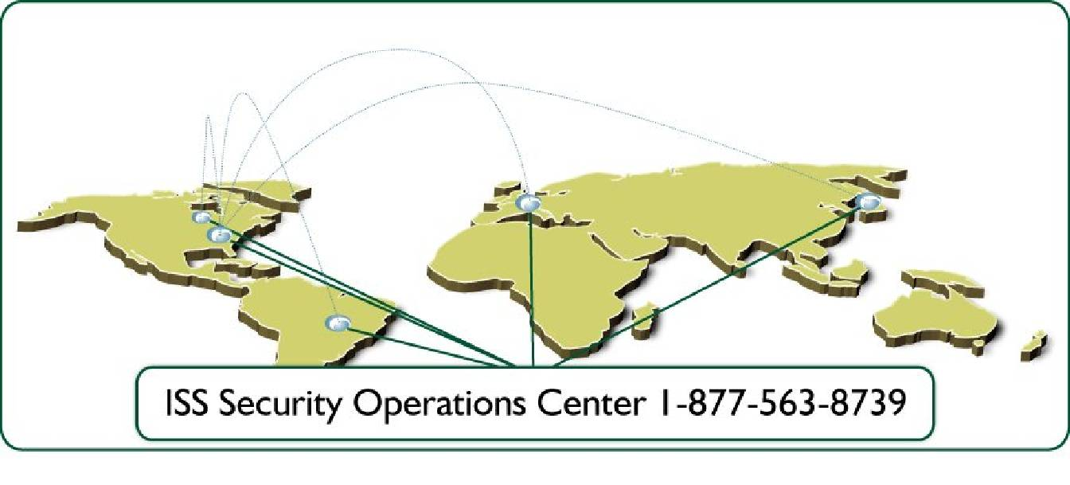

Figure 3-1: Four Global SOCs

3.2 Staff and Support Roles

The ISS SOC is staffed by certified and trained staff 24/7/365 and has experienced less than 2% Managed Services customers churn rate annually for eight consecutive years.

Technician roles include:

- Threat Analyst – 24/7/365
  - Focused on actionable events to console system
  - Integration of ISS systems, remedy, and SiteProtector
- Device Management Team – 24/7/365
  - Manages device health and availability issues
  - Performs maintenance and upgrades
  - Ensures proper application function – quiet sensors
  - Enables Threat Analysts to focus on threats and escalation
  - Service Assurance and Standards
  - Monitors process for quality control
  - Conducts training
  - Planning and operational project management

Support staff for the SOC follows:
- Project Managers
- Deployment Team
- Customer Advocacy Team
- Security Coordinators
- Infrastructure Team
- New Offer Team
- Certifications Team
- Managed Services Development Team
- X-Force Research Team

3.3 SOC Infrastructure

3.3.1 Physical Security
- Security Guards
- SOC Visitor Identity Screening
    - Drivers license, passport, etc.
    - Visitor badges
- CCTV Monitoring
- Biometric (handprint) Access Device
- Intruder Response Procedure
- Employee background checks

3.3.2 Facilities & Infrastructure Protection
- Below ground Facility
- Redundant Network Circuits
- Redundant HVAC
- Power Protection
    - Uninterrupted Power Supply
    - Diesel backup power generation
      - Contingency mobile power supply & fuel
- Fire Protection
    - Pre-action sprinkler system
    - FM-200 gas
    - Dual-zone smoke/heat detection
    - 24/7/365 on-site fire response team

3.3.3 Policies, Procedures, and Programs
- Security and Privacy Policies
- Disaster Recovery Plan
- Data Backup Program
- Security Incident Response Team (“SIRT”)
- Change Control Program
- Penetration Testing Program
- Independent Compliance Audits

3.3.4 Network and Computer Security
- Network

    - Internet perimeter firewalls
    - Intrusion detection systems
    - 24/7/365 intrusion monitoring
    - URL blocking
    - SecureID authentication
    - Virus protection

- Computer
    - Password protection
    - Virus protection
    - OS & database scanning
    - Secure access placement
    - Audit trail

3.4 SOC Analyst Qualifications

The MSS organization comprises approximately 120 personnel who are focused on service delivery in some capacity. This represents approximately 10% of the overall ISS employee base. All SOC staff are certified on all of the technologies that they are managing and monitoring. Many of the staff have achieved certifications such as CCSA, CCSE, CCNA, CCNE, CCIE, and CISSP. This expertise is very valuable and we continue to invest in the education of our SOC staff in order to retain high quality security professionals and provide high quality service to the customer. We have a 98% retention rate of SOC personnel over the last eight years.

3.5 Security Incident Escalation Procedures

ISS is dedicated to providing customers with the highest level of protection services to guard against Internet-based threats and vulnerabilities. As part of those services, highly trained security experts are constantly monitoring and evaluating real-time intrusion event data, and systematically categorizing and classifying each threat.

As depicted in the diagram below, SOC analysts inspect all incoming events in real-time. Leveraging X-Force security knowledge capital, in-depth documentation of customer environments, and state of the art technologies, these events are quickly evaluated and prioritized. Incident classification is not solely based on the vendor’s predetermined event priority, but rather on the SOC analysts’ correlation of X-Force security intelligence, global threat awareness, and customer security posture.

Suspicious Activity

Non-Targeted Script
Scanning Activity
Network Diagrams
X-Force® Intelligence
SiteProtector & SecurityFusion
Global Attack Trends
Security Incident – Priority 2

Targeted Exploit
Reconnaissance Probes
Security Incident – Priority 1

Internet Emergency
Compromised System
Security Events
Phone Escalation
Immediate Action Required
Phone or Email Escalation
Action Required: 12-24 Hours
Email Escalation
No Action Required

Figure 3-2: SOC Analyst Security Event Investigation

4.0 Managed Security Services Mechanics

4.1 Customer Portal

The ISS Virtual-SOC Portal is available for NWC Inc. to access 24/7/365 and offers many useful resources including:
- X-Force Threat Analysis Internet Threat Assessment
- Viewing of Recent Security Incidents and Open Tickets
- Help Desk Submission(s)
- 30 Day Archive of Known Worms, Viruses and Security Vulnerabilities with Informational Links
- Viewing Security Policy
- Device Health statistics
- Service Level Agreement Reporting
- ISS Service Descriptions
- Survey and Feedback
- Security News
- Downloads
- Help Desk and Customer Advocacy Chat

Figure 4-1: Virtual-SOC Portal

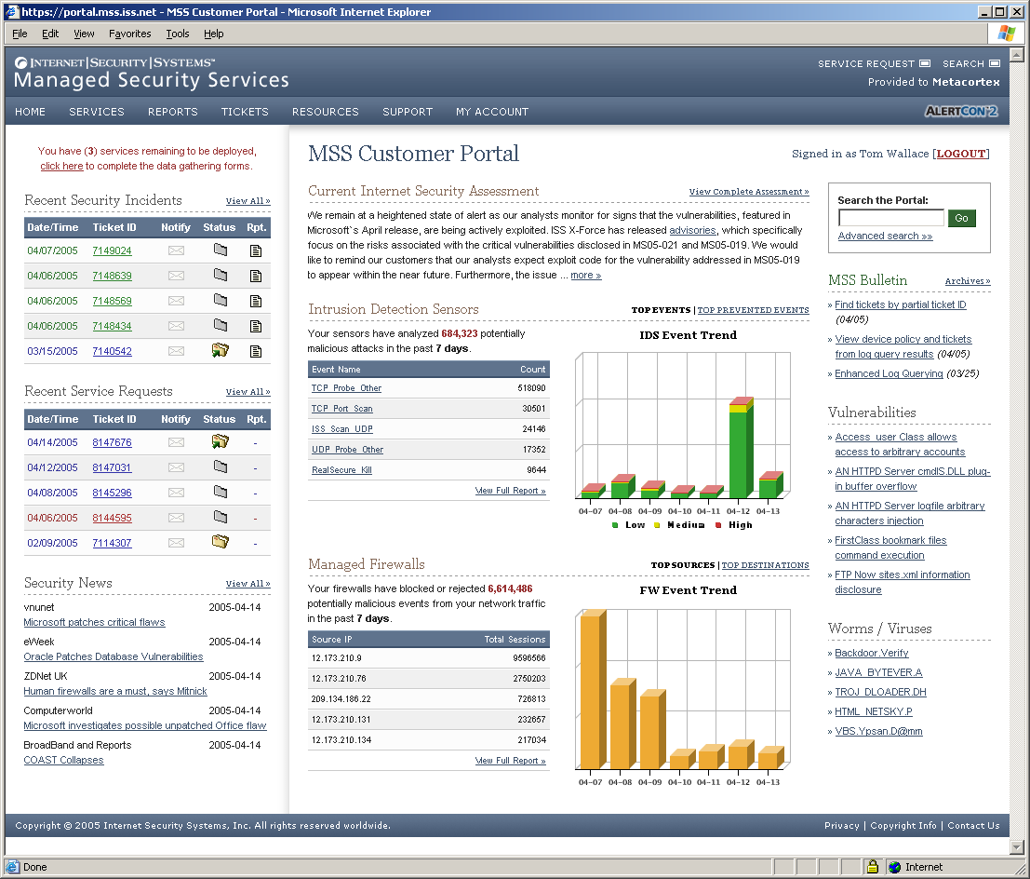

Figure 4-2: Virtual-SOC Portal Main View

Figure 4-3: Policy View
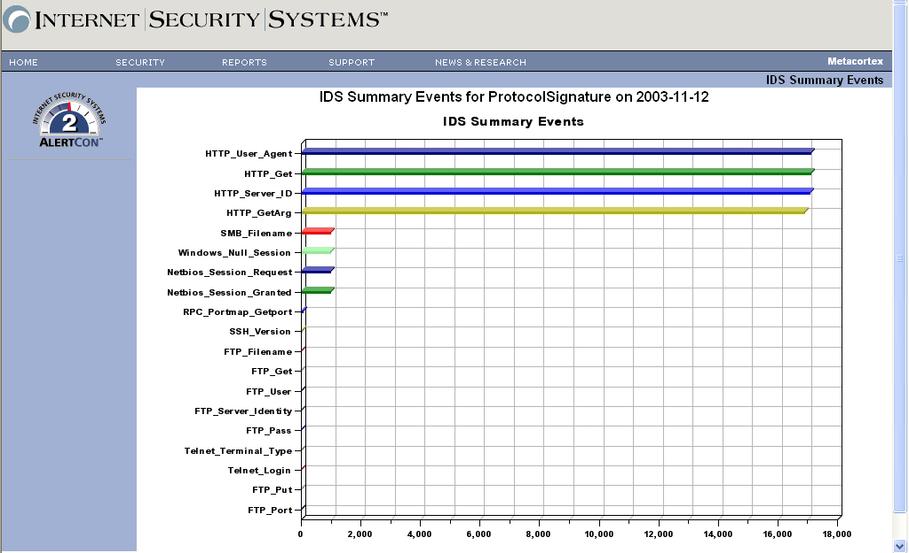
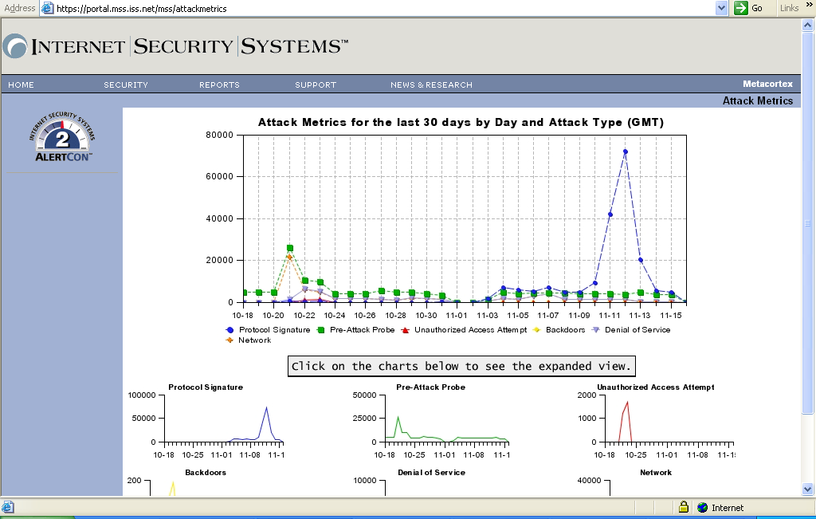
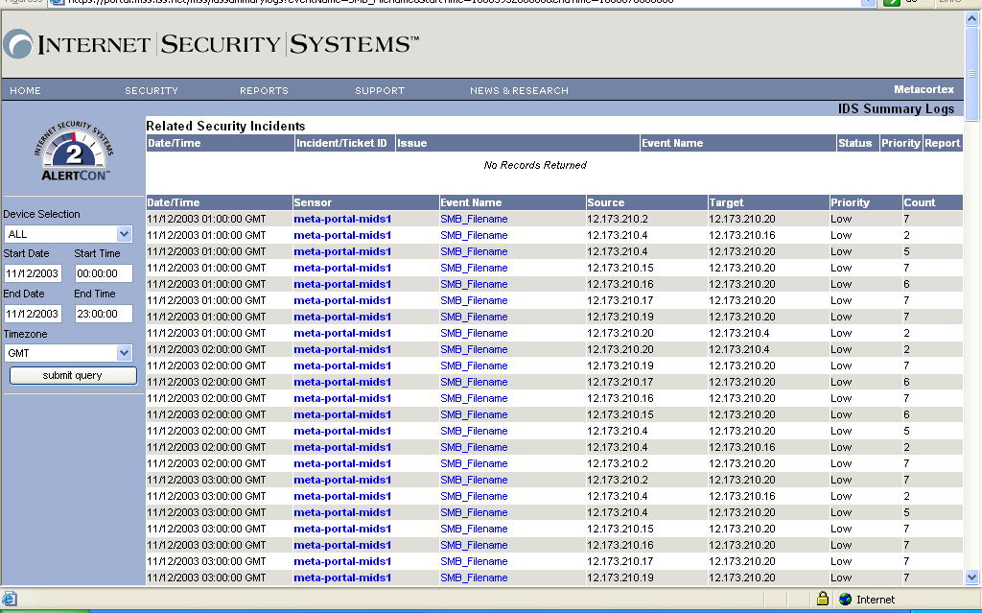
30 Day Attack Metrics with drill down ability including any ISS security reports generated on the activity from the SOC

Figure 4-4: Attack Trends

4.2 Reporting

Once per month, ISS will produce reports that include:
- The number of SLA’s invoked and met
- Number and type of Service Requests
- List and summary of Service Tickets
- Number of Security Incidents detected, priority and status
- List and summary of Security Incidents

These reports can be emailed to NWC Inc.’s primary point of contact.

Figure 4-5: Reporting Interface
NWC Inc. can also generate on-demand standardized and customized reports through the Virtual-SOC Portal 24/7/365.

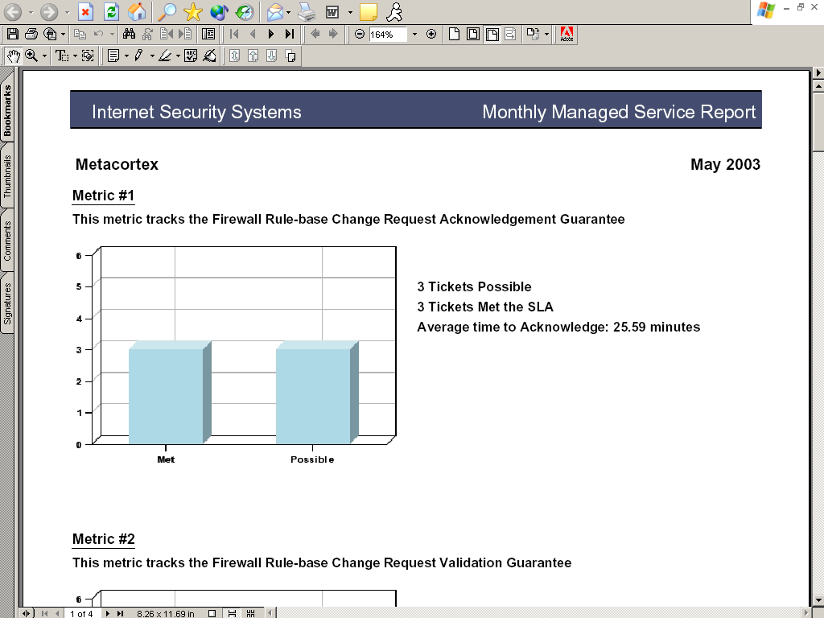

Figure 4-6: SLA Metric Report

5.0 MSS Deployment and Integration

5.1 Customer Responsibilities

ISS MSS customers are responsible for the following:
- Maintaining (paying for) current hardware and software maintenance contracts.
- Making changes to network environment based upon ISS Security Operator’s recommendations.
- Once a year, customer agrees to review with ISS the current hardware configuration of the managed devices and whether it needs to be updated given changes to operating system and application requirements.
- The SLA remedies are available provided the customer meets its obligations as defined in the SLA’s

5.2 Deployment Process

Once you are an ISS customer, you can expect the highest level of customer service and attention to detail.

First, you will be taken through the Deployment and Integration process, and then transitioned to the ISS Security Operations Center (SOC). Throughout the deployment and integration process and during your engagement with ISS, you can access the ISS Customer Portal to track ticket status, access the X-Force Threat Analysis Service, request service changes, generate reports, and more.

ISS Deployment is a five-phased process:

Phase 1: Initiation
During this phase your Deployment Engineer (DE) will review your order with you and establish the contacts involved in completing the deployment project. Your DE will begin coordinating the rest of the phases with your designated contacts.

Activities:
- Welcome call & introductions
- Deployment process overview
- Objectives and current status review
- Expectation discussion
- Initial data exchange
- Timeline and constraints identification

Phase 2: Planning
Deliverables:
- Contact list
- Site status
- Constraints
- Timeline

During this phase, the contacts specified as requiring access to the MPA Customer Portal and the SOC, and your ISS DE will plan how your security devices will be placed into your network, how ISS will manage and monitor your security devices and data via various encrypted communication channels and schedule more definitive installation and service activation dates.
Deliverables:
- Deployment questionnaire
- Installation date set

Activities:
- Architecture & placement planning
- Data gathering and critical server identification
- Data verification
- Data capture into SOC database
- Schedule service installation date
- Callout of lead time for Customer Premise Equipment (CPE) and staging materials

Phase 3: Staging

If applicable, during this phase your DE will arrange for any security devices that you have purchased through or provided to ISS to be configured, either remotely or at one of our MSS Deployment Centers. Also during this phase, your DE will set up the management architecture at ISS to be able to manage/monitor your security devices.

Activities:
Deliverables:
- Configured CPE
- Shipment notifications
- Portal tokens delivered

- Hardware inspection and assembly
- CPE configuration and hardening
- OOB configuration
- Customer portal account configuration
- Installation kit assembly
- Packaging, shipping, tracking
- ISS SOC infrastructure preparation

Phase 4: Integration
In this phase, new security devices are installed and tested for correct functionality. After thorough testing ensures that the SOC is able to fully monitor and manage your security devices, your DE will demonstrate the Customer Portal to you.
Deliverables:
- SOC contact information
- Site deliverable
- Installation log

Activities:
- Remote CPE Installation Phone Support for Onsite Installer
- Establish Connectivity to SOC
- Service Testing and Verification
- Customer Readiness Call
- Transition Service to SOC
- Quality Assurance Review
- SOC Transition Call

Phase 5: Closeout
In this final phase, your DE will wrap up any final deployment items and host or arrange an introduction call with the SOC as they begin to provide your 24/7/365 security services. From this point your primary contact will be the MSS SOC, with your DE available to you for final outstanding issues and transition questions.

Activities:
Deliverables:
- Deployment deliverable
- Project executive summary

- Review all remaining open action items
- Create Deployment Deliverable
- Create Project Executive Summary
- Conduct project review

5.3 Timeline

The total length of time for the deployment of ISS MSS is 3-4 weeks from the signing of the contract.

6.0 ISS Response to NWC Inc. Requirements

Below are ISS responses to NWC Inc.’s requirements (original RFI numbering scheme retained).

Question B.1: Corporate Capabilities
Corporate capabilities are broken into the following categories:
- Financial
- Services Offered
- Organizational Breadth
- Investment Strategies
- References
Financial
- Provide your most recent annual report and financial statement and those of your key investors if they are not publicly available.

ISS RESPONSE:

ISS is publicly traded on the NASDAQ under the symbol ISSX. Revenues for the year ended December 31, 2005 were $329,772,000 compared with $289,893,000 for the year ended December 31, 2004. Reported GAAP net income for the year ended December 31, 2005 was $38,545,000, or $0.82 per diluted share, compared to $26,293,000, or $0.54 per diluted share, for the year ended December 31, 2004. Non-GAAP net income for the year ended December 31, 2005 was $43,069,000, or $0.91 per diluted share, compared to $30,866,000, or $0.64 per diluted share, for the year ended December 31, 2004. Cash and marketable securities totaled $239 million. Total assets of $618.6 million. No debt. Cash generated by operating activities totaled $72.6 million for the year.

For the year ending December 31, 2006, ISS currently expects to achieve revenues in the range of $358,000,000 to $368,000,000. GAAP net income is expected to be in the range of $0.66 to $0.72 per diluted share. Non-GAAP net income is expected to be in the range of $0.94 to $1.00 per diluted share.

b. Indicate the total number of active security service contracts, indicating the percentage of multi-year and single year contracts. Describe your annual rate or percentage of new, renewing, and terminating contracts.

ISS RESPONSE:

1,600 customers, of which 80% are in multi-year contracts. ISS has a 98% renewal rate.

c. Provide information regarding any recent mergers and acquisitions, initiated by your organization or initiated by others.
ISS RESPONSE:

None.

Services Offered

- Name the markets or industries you target for each of the services you offer

ISS RESPONSE:

ISS services the SMB and enterprise markets and has customers in every major vertical.

- What percentage of your staff is involved in direct service delivery and managing current client accounts?

ISS RESPONSE:

The complete MSS organization is comprised of approximately 120 personnel who are focused on service delivery in some capacity. This represents approximately 10% of the overall ISS employee base.

Organizational Breadth

- Is your current business regional, national, or international? Describe your approach and your capabilities to provide global support, including, but not limited to, worldwide locations, expertise in national languages, knowledge of national and local laws that affect requested services, and relationships with national and local law enforcement agencies.

ISS RESPONSE:

ISS business is international with offices in more than 20 countries, servicing customers in more than 70 countries. ISS global presence and experience with customers in all parts of the world gives the company a wealth of expertise in global languages and knowledge of national and local laws that can affect service delivery. ISS has strong relationships with law enforcement agencies on international, national and local levels.

ISS Global Security Operations Center (SOC) activity is orchestrated from a centralized command and control Global Threat Operations Center (GTOC) in Atlanta, Georgia, separate from the Atlanta SOC. Here, workload balancing, managed device fail over, and event correlation and analysis occur. Additionally, each SOC has visibility into one another. Through the use of web cams, voice over IP, and a digital SOC engineer dashboard, SOC engineers actually feel as if each SOC is in the room next door regardless of how many thousands of miles away they may be.

ISS has strategically placed SOCs globally, commensurate with existing theatres of operation as well as the existing customer base. ISS has SOCs in the following locations:

- Atlanta, Georgia, USA
- Southfield, Michigan, USA
- Tokyo, Japan
- Brussels, Belgium

All ISS SOCs have the same capabilities and their staffs all receive the same training. They use the same hardware and software tools. All SOC data flows in real time to the GTOC in Atlanta where we monitor the global threat landscape, assist the SOCs in understanding the patterns that emerge, check for spikes in activity in one region that will provide threat Early Warning to the others, and ultimately, provide a universal, virtual Security Operations Center.

Investment Strategies
- Describe your approach for investing in technology and research and development to increase operational efficiency while keeping up with the rapidly changing threat environment.

ISS RESPONSE:

Last year, ISS invested 14% of company revenue into research and development. ISS invests in proactive vulnerability and threat research through its X-Force research and development group. Through the use of this proactive security research and technology, ISS has created a process by which customers can shield security vulnerabilities without applying vendor-supplied patches. This process, ISS has trademarked, Virtual Patch™ application, allows customers to avoid rushed patching exercises every time security vulnerabilities are discovered, instead buying them time to patch on a regularly scheduled basis, after they have had time to properly test the patches and when it is convenient to them.

Furthermore, ISS invested $450 million in its Security Operations Centers (SOC) infrastructure to create fully redundant systems among its global theatres with proprietary Artificial Intelligence (AI) systems that are employed to detect statistical deviations in network traffic patterns that may not be caught by human monitoring but could be indicative of malicious activity. These systems analyze approximately 250 million events daily and provide ISS with early-warning information that Is fed directly to SOC analysts. These systems create greater efficiencies for both ISS personnel and customers alike.

- What are the highest priority initiatives in your company that affect the requested services?

ISS RESPONSE:

The company’s highest priority initiative is in delivering Protection On-Demand Services. See description below under Phase Four.

- What is your company’s vision and direction for currently offered services as well as plans for additional services and support of new technologies?

ISS RESPONSE:

Internet Security Systems is well known for product innovation: it created the first commercially available vulnerability assessment product, Internet Scanner®, in 1994; the first intrusion detection (IDS) product, RealSecure® Network, in 1996; and the first intrusion prevention (IPS) product, RealSecure Guard, in 2001. The creation of these products has had a tremendous impact on the industry. These technologies have spawned numerous security companies, and thousands of companies rely on the technologies to protect their network infrastructures.

The ISS advancement of information security is not limited to products alone. ISS is dedicated to helping its customers succeed in the battle of securing the network infrastructure, which is why it provides a platform of both products and services. As a pioneer in the Managed Security Services (MSS) space, ISS has been serving as the trusted security provider and advisor to commercial and government customers worldwide for over a decade. As the security industry has matured, so have customers’ needs. ISS has responded with new service offerings that help you keep your networks, assets, users, customers and partners safe and secure.

ISS has evolved into one of the largest pure-play managed security services providers, and not by coincidence. It is the result of strategic planning based on listening to customers’ needs and its ability to anticipate trends and future security challenges. This strategic planning has enabled the company to build upon a phased approach to introduce services that solve your challenges now and in the future.

Below, ISS outlines its four-phased approach for advancing Managed Security Services. In this approach, ISS lays out a roadmap for continuing to bring about advancements in security to keep customers Ahead of the threat.

Phase One – Managed Security Services: Device Management
The first phase of the Managed Security Services evolution was 24/7 monitoring and management of disparate security devices. This is what is traditionally thought of as Managed Security Services and the extent of what most MSSPs offer today. The offerings are technology-specific, such as Managed Firewall/VPN, Managed IDS and IPS. These solved internal security organizations’ challenges of staffing hard-to-find, skilled security experts for monitoring and managing security events and logs on a 24/7 basis.

ISS Managed Security Services offerings include monitoring and management for numerous security technologies from vendors including 3Com, Check Point, Cisco, Internet Security Systems, Juniper, McAfee and more.

Phase Two – Managed Protection Services: Guaranteed Protection
ISS recognized the lack of accountability most managed security services providers have to their customers. Traditional managed security services typically specify penalties for reacting to events and security attacks, but only if the security devices are able to detect them. ISS did not believe this was adequate. In 2004, ISS raised the bar when it introduced the industry’s first protection guarantee through its Managed Protection Services.

ISS Managed Protection Services go beyond simple event monitoring and device management by offering money-back, guaranteed performance-based Service Level Agreements (SLAs). These SLAs are based on ISS ability to protect your organization before attacks reach your system, not afterwards. ISS Managed Protection Services are offered on the ISS marketing-leading Proventia® and RealSecure network, server and desktop products.

Phase Three – Virtual-SOC: Services Integration and Personalization
The third and current stage of the ISS approach brings you new offerings that better enable you to manage your in-house security programs through its new Virtual Security Operations Center (Virtual-SOC) architecture and portal. ISS Virtual-SOC is a framework for integrating security tools, multiple managed services and intelligence into a consolidated view, enabling the management and monitoring of security operations from a single point.

Your organizations can use the ISS Virtual-SOC to control your entire security operation – managed and unmanaged devices (both ISS and third-party), security intelligence, reporting, archiving, remediation, escalation and cooperation with ISS Managed Security Services analysts. Through the Virtual-SOC, ISS offers new tightly integrated services that you can use to take a more proactive stance in network security.

Service offerings include ISS Vulnerability Management Service, Security Event and Log Management Services and X-Force Threat Analysis Service.

Phase Four – Protection On-Demand Services
The fourth phase of the ISS approach will bring about sweeping new changes to the way you procure, deploy and manage your security. Protection On-Demand Services will provide you with the ability to secure your enterprise, customers and partners in a fast, simple, reliable and highly scalable manner. You may choose to have ISS Managed Security Services take over managing your security infrastructure during non-business hours every evening, or simply provide monitoring and management for your new offices until they are fully staffed. ISS Protection On-Demand Services will allow you to leverage the full ISS Managed Security Services capabilities when, where and how you need them.

References
Include, for each reference: the company name, contact name, contact title, phone number, e-mail address, types of service, and dates of service.

a. Provide three references from clients:
- With similar types of organizations (size, market segment)
- With similar levels of infrastructure complexity and capacity requirements
- That are currently using the services requested in this RFP
ISS RESPONSE:

Hollister
John Zak
Network Design Architect
john.zak@hollister.com
847-680-2811

Hollister has been a customer for six years. ISS provides Managed Intrusion Detection and Managed Firewall Services to Hollister. Hollister’s service package is very similar to that we are proposing to NWC.

Exchange Bank
Bob Gilgorea
Information Security Officer
bgligorea@exchangebank.com
707-524-3225

Exchange Bank has been a customer for just over one year. ISS provides Managed Intrusion Detection and Managed Firewall Services to Exchange Bank. Exchange Bank’s service package is also very similar to that we are proposing to NWC.

Question B.2: Country Handling Outsourcing and Associated Environmentals
NWC Inc. strongly prefers to utilize a United States-based outsourcing location; however, if you strongly feel that you have a location outside the United States that could better service NWC Inc. as it looks to outsource information security, please indicate the country and answer the question based on the specific location you think will be a best fit. If outsourcing will be handled outside of the United States, be sure to include why this will benefit NWC Inc.’s business operations.
- Does the outsourcer monitor and review all physical access including the following:
- Identify and authenticate customer and outsourcer staff members who have physical access to IT assets providing customer services?
- Have a process for requesting and approving physical access?
- Are physical assets dedicated to each customer or can they be shared by multiple customers?
- How do you physically and securely segregate your assets and customer assets?
- Is there a presence of a physical security system like a UPS, backup generator, redundant climate control systems, and a fire-control system?

Please describe environmental controls and features of your proposed hosting service for NWC Inc. broken into the following areas:
Air Conditioning
Power
Physical Access control
Fire
Other

ISS RESPONSE:

ISS delivers service from our network of Security Operations Centers located strategically around the globe. With two centers in the United States (Atlanta, GA; Detroit, MI), and centers in Japan (Tokyo), Europe (Brussels, Belgium) and Australia (Brisbane), ISS can leverage in-country resources to provide local touch to our global services. All of our centers adhere to strict infrastructure, operational and security best practices to ensure the excellence of our services. These best practices include third-party audits and certifications such as SysTrust, BS7799 and SAS-70.

Every aspect of our service delivery is tightly controlled and managed as detailed within our internal policies and procedures. These internal controls govern the confidentiality, integrity and availability of all our managed services and include the following major categories; physical and logical security, environmental controls, and disaster recovery/business continuity.

Physical and Logical Security
The following list outlines the types of measures in place to govern the physical and logical security aspects of our service delivery personnel at our Security Operations Centers.
- SOC personnel are physically separated from ISS corporate personnel within a secured facility.
- SOC personnel are granted access and permissions only as required by job description.
- Changes to SOC personnel access and permissions are documented and archived for reference.
- SOC personnel are subjected to rigorous background checks.
- SOC personnel are required to obtain government security clearances as required by their position and job description.

The list below outlines the types of controls in place governing the physical and logical security aspects as it pertains to the systems and customer data within our Security Operations Centers.
- SOC systems are housed within a secured facility, physically separated from ISS corporate resources.
- Changes to access and permissions for each system must follow standard change control procedures and are documented and archived for reference.
- Customer data within the systems is segregated for analysis and archival.
- Shared systems are utilized where appropriate and segregate logically customer data.

Environmental Controls
The following list outlines the types of measures governing the environmental controls of the Security Operations Centers.
- All SOC facilities are outfitted with complete fire control systems for the safety of both personnel and infrastructure.
- Power to SOC facilities are fed by redundant power circuits and are fed through a series of both battery and UPS systems to ensure a clean and steady power feed. Auxiliary power is provided by on-site generators where appropriate.
- HVAC, air purification and like units within SOC facilities are made as redundant as possible within each facility.

Question B.3: Customer Satisfaction
Describe your processes for handling client inquiries and reported problems.

ISS RESPONSE:

ISS Managed Security Service Global Security Operations Center staff are available for client inquiries and to address service problems 24/7/365. Additionally, ISS Managed Security Services provides a global Customer Advocacy team to handle non-technical inquiries and escalations.

• Describe customer service responsiveness, hours of staff availability, and available mechanisms for communication such as written, verbal, e-mail, face-to-face.

ISS RESPONSE:
Security Operations Center staff are available 24/7/365 and use verbal, written and email communication as needed. Upon request face to face communication with Security Operations Center management and staff is available. The Customer Advocacy team is available during standard business hours per theatre of operation, and will employ the most appropriate communication method including verbal, written, email and face to face upon request.

• Describe how issues involving unsatisfied customers are addressed. For example, is it described in service level agreements?

ISS RESPONSE:
To ensure high levels of service satisfaction, service level agreement compliance and awareness, the Customer Advocacy team retains oversight for all service level agreement reporting and dispute resolution. Global SLA metric reports are regularly reviewed with the ISS Managed Security Services Management team, and distributed to the ISS Executive Management Team.

• Describe the secure communications available when privacy is of the utmost concern. For example, secure voice, fax, encrypted e-mail.

ISS RESPONSE:
ISS Managed Security Services provides secure communications via the Virtual Security Operations Center Portal, and encrypted email or secure fax as needed.

• Describe both, national and international service support.

ISS RESPONSE:
ISS Managed Security Services provides security services to over 70 countries. Services are provided and managed through our network of Global Security Operations Centers located in, Atlanta, GA; Southfield, MI; Brussels, Belgium; and Tokyo, Japan. ISS Managed Security Services also offers language localization, for most languages, for its Virtual Security Operations Center portal.

ISS was the first company to achieve global certification for J.D. Power and Associates Certified Technology Service & Support (CTSS). It was also the first security company to receive global certification from Support Center Practices and did so with a 94% customer satisfaction rate.

Question B.4: Business Partnerships/Relationships
- Provide a complete list and brief description of your channel partners, resellers, vendors, subcontractors, and other providers (tiered providers including ISPs) who may be involved in delivering NWC Inc.’s requested services. What is your due diligence process for engaging in these types of business relationships.

ISS RESPONSE:

ISS would provide all services directly.

- Where do you plan to use tiered providers to satisfy our requirements? In what capacity do you plan to use them? What mechanisms are in place to allow us to verify that these requirements are met?

ISS RESPONSE:

We do not plan to use tiered providers.

- Indicate how our requirements flow to all involved tiered providers and how requirements satisfaction is determined.

ISS RESPONSE:

Not applicable.

- Can NWC Inc. identify any requirements or restrictions we may have when outside parties (providers, tiered providers) connect to our network. These may include: disallowing certain protocols, requirements for or restrictions on communications or encryption methods and confidentiality requirements. The provider indicates how they plan to meet these requirements and restrictions.

ISS RESPONSE:

No.

- How can NWC Inc. establish a direct relationship (either informal or contractual) with your tiered providers when they are involved in delivering the requested services? Indicate if we are free to contact these organizations and, if so, provide contact information.

ISS RESPONSE:

Not applicable.

- When client information is shared with and used by tiered providers, what procedures do you have in place for protecting this information?

ISS RESPONSE:

ISS believes it is absolutely critical that the MSS systems be secure, available when needed, and consistently able to produce accurate information. An unreliable system can trigger a chain of business events that affect our customers and business partners. In response to this business need, the American Institute of Certified Public Accountants (AICPA) and the Canadian Institute of Chartered Accountants (CICA) created a professional service called SysTrust which enables a CPA to provide assurance that a system is, in fact, reliable. A reliable system is one that is capable of operating without material error, fault, or failure during a specified period in a specified environment. SysTrust is designed to increase the comfort of ISS management, our customers, and our customers’ business partners with the systems that support our MSS business.

The E&Y SysTrust examination was conducted in accordance with the Trust Services attestation standards established by the AICPA:

http://www.aicpa.org/assurance/trustservices/index.asp

The Trust Services standards were promulgated by the AICPA and CICA to address concerns in the marketplace for assurance around systems reliability and e-commerce activities. The E&Y examination addresses the following Trust Services principles:

- Security - The MSS system is protected against unauthorized access (both physical and logical) in conformity with ISS security policies.
- Availability - The MSS system is available for operation and use in conformity with the ISS availability policies.
- Confidentiality - Information designated as confidential is protected in conformity with the ISS confidentiality policies.

Confidentiality
Internet Security Systems regards all customer security data as highly confidential and considers the protection of said data a business critical activity. ISS has company policies in place that include, but are not limited to, an Employee Handbook, Employment Policies and Practices, confidentiality of internal information and external customer information, security in the work place best practices, and an employee code of conduct and business practices. All employees must sign and adhere to these policies as part of employment with ISS.

ISS conducts regular training to employees regarding the lawful and intended purposes of processing customer data, the need to protect and keep information accurate and up-to-date, and the need to maintain the confidentiality of this data. Authorized users will comply with this policy, and ISS entities will take appropriate disciplinary actions, in accordance with applicable law, if customer data are accessed, processed, or used in any way that is inconsistent with the requirements of this policy.

ISS will continually police data privacy safeguards to ensure compliance with industry and legal requirements. A continuous improvement process ensures privacy protection measures are commensurate with access threats of the day.

Integrity
Regardless of managed service the data originates from, all customer data stored within the SOC infrastructure is isolated from other customers’ data. ISS maintains security device information in the same format provided by the security device/application vendor. These two actions are taken to maintain the integrity of the security information contained within.

Data integrity is also ensured through proper configuration of managed applications. In each case where multiple customer's data is stored on a single server, ISS uses the built in data segregation functionality of managed applications to ensure that each event and log entry is properly tagged and associated with the proper parties. ISS does not modify or self code data segregation solutions. This ensures that customer data is truly segregated using tried and tested methods.

Primary customer data is maintained and short-term date stored in Atlanta, GA, Security Operations Center. ISS maintains longer-term backup at a secured off-site facility, and will store data to the customer requirements.

In addition, ISS enforces and audits electronic and physical access control to all areas where customer data will be stored, processed, and monitored leveraging 3-factor biometric and keycard authentication. Customer data is only available from within and available to individuals with the appropriate keycard and biometric authenticated clearance.

The ISS Managed Solution addresses privacy issues related to our own offering by using a detailed data integrity methodology.

Data integrity is ensured through proper configuration of managed applications. In each case where multiple customer's data is stored on a single server, ISS uses the built in data segregation functionality of managed applications to ensure that each event and log entry is properly tagged and associated with the proper parties. ISS does not modify or self code data segregation solutions. This ensures that customer data is truly segregated using tried and tested methods.

The MSS solutions address section 404 of Sarbanes-Oxley by providing a protection solution to ensure that the company’s assets are safeguarded against unauthorized or improper use. By obtaining the ISS managed security solution, companies are able to demonstrate that they are taking reasonable efforts to not only safeguard company assets, but to also provide an environment where the key stakeholders can more confidently feel that the company’s transactions are properly authorized, recorded, and reported.

The Managed Solution also applies directly to California Senate Bill 1386, as it ensures that the company has taken prudent measures to protect their customers information from various forms of security breaches.

More information on client data privacy is available in the Ernst & Young SysTrust Audit, which is available upon request.

Availability
ISS believes it is absolutely critical that the MSS systems be secure, available when needed, and consistently able to produce accurate information. An unreliable system can trigger a chain of business events that affect our customers and business partners.

The core foundation of our services is to ensure the availability of the devices that we are managing. In order to ensure minimal disruption of service, we have separated the functions of security monitoring and device management. The Implementation Desk is dedicated to monitoring the health and status of the devices under management to concentrate on the uptime and availability. We have separated the Security Monitoring and Threat Analysis group in order to allow them to concentrate on providing high value security content expertise and recommendations without the distraction of device management.

ISS monitors managed devices using an open source tool called “Nagios,” an enterprise level device monitoring and management system. It allows for the remote monitoring of device uptime, system health metrics, and facilitates large-scale device management capabilities. By utilizing a proprietary encrypted channel to each device, Nagios enables the ISS SOC to remotely upgrade devices and run commands on remote machines with the click of a button.

Our monitoring systems run 24/7 to alert Engineers to potential problems in real time. Each monitoring system reports events back to our standard incident handling system, which is also monitored by our engineers. Monitoring includes all network traffic entering and leaving the network.

- How are security risks associated with tiered providers defined and monitored?

ISS RESPONSE:

Not applicable. Internet Security Systems provides all services direct to the customer on the partner’s behalf.

- What security research organizations do you partner with to stay informed about new threats and vulnerabilities?

ISS RESPONSE:

ISS world-renowned X-Force® research and development team provides the security intelligence foundation for all ISS products and services. This group of approximately 65 security engineers is solely dedicated to research and development associated with the vulnerability and threat science arena. The result of their efforts is the most extensive commercial database of threats, vulnerabilities, and security best practices available - yet another ISS expertise advantage. From internal testing to open source research to monitoring the hacker underworld, the X-Force leverages the power of multiple sources of information to proactively defend ISS customers from new and dangerous threats.

More than 17,000 public websites host links to our publicly available X-Force Database. The list of sites linking back includes: CERT, CIAC, NIPC, Mitre, NSA, SecurityFocus, SANS, CSI and several competitors. Below is a TouchGraph illustrating this.

ISS holds daily calls with national security and intelligence agencies to discuss new vulnerabilities and threats and recommended courses of action. ISS also holds the distinction of hosting the IT-Information Sharing Analysis Center on behalf of the information technology industry. ISS also shares threat and vulnerability information with CERT and other credible security research organizations.

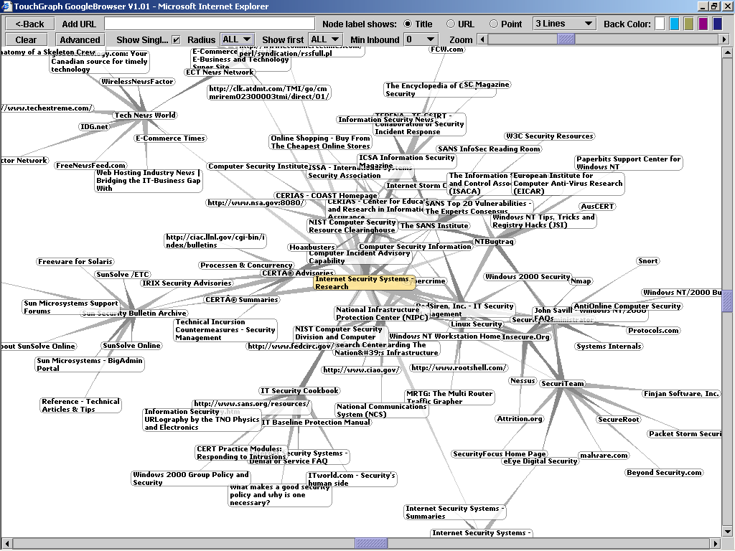

Question B.5: Independent Audits
Describe the independent evaluations/audits that you and any other tiered provider participate in.

- Do you periodically information security risk evaluations or contract with an independent, outside organization to perform them? If yes, how often are they done?
- How do you communicate risk evaluation results with your customers?
- Describe how you respond to significant changes in technology.
- Describe how you respond to both internal and external threats.
- Do you require independent risk evaluations from your tiered providers? If yes, do you actually obtain copies of the evaluations?
- Do you demonstrate service compliance with regulations like GLBA, HIPAA, SAS 70.

ISS RESPONSE:

Every aspect of ISS managed service delivery is tightly controlled and managed as detailed within our internal policies and procedures. These internal controls govern the confidentiality, integrity and availability of all our managed services. In addition to our rigorous best-practice controls, ISS supplements our internal checks and balance measures by utilizing a third party to perform annual audits and certifications. Our global Security Operations Centers currently hold SysTrust, BS7799 and SAS-70 certifications and we welcome our customers to review this information at any time.

As part of these annual audits, our third party auditors also complete a security penetration test to ensure every component of our services is secure. Additionally, internal administrators run quarterly vulnerability scans to maintain the highest level of security and bi-annually we have our X-Force penetration test experts complete a checkup penetration test.

These periodic tests are just part of the controls that enable ISS to stay ahead of emerging threats and respond rapidly to the growing threats facing both ourselves and our customers. For example, in the event of a security emergency, ISS leverages over a decade of experience within the SOC to respond to both internal and external threats. These emergency response procedures have been battle-tested within our daily operations with customers and enable ISS to handle any threat, known or unknown, facing our operations. Further, as technology changes and regulatory controls continue to solidify, ISS remains flexible to refine our delivery mechanisms to adopt new methods to improve our service capabilities.

Question B.6: Personnel Security
NWC Inc. recommends personnel screening of outsourcing company’s employees as a safeguard.

- Do you conduct background check on all potential employees or only if their role and responsibility within your organization mandates it?

ISS RESPONSE:

ISS values its position as one of the most well respected computer security companies in the industry. As such, strict hiring practices are employed to ensure the most qualified and trust worthy individuals are selected to become part of the ISS team.

Each ISS candidate is subjected to a thorough background check performed by an independent investigative agency. The check validates a candidates employment history, work references, personal references, and includes both credit and criminal background checks.

Due to the nature of our customer base and ISS delivery of services to federal and state government entities, personnel in the ISS SOC are also required to complete documentation for federal background checks. Completion of form 85 p from the U.S Office of Personnel Management provides the foundation for such checks.

- What is your policy on hiring former computer hackers?

ISS RESPONSE:

ISS has a strict policy of not hiring anyone convicted of or known to be/have been a computer hacker or engaged in black hat activities.

- For personnel assigned to provide services to NWC Inc. as specified in this RFI, what is their job year’s experience? In addition, how many yearly classroom instruction hours are given these personnel? If allowed, include resumes for key personnel and managers having responsibility for NWC Inc.’s outsourcing contract.

ISS RESPONSE:

The complete MSS organization is comprised of approximately 120 personnel who are focused on service delivery in some capacity. This represents approximately 10% of the overall ISS employee base. All SOC staff are certified on all of the technologies that they are managing and monitoring. Many of the staff have achieved certifications such as CCSA, CCSE, CCNA, CCNE, CCIE, and CISSP and have an average of three years experience supporting Managed Security Services customers. These analysts staff ISS global Security Operation Centers – the largest Managed Security operations team in the industry.

Resumes of key SOC personnel and Management will only be provided if selected for the RFI.

- What is your annual staff retention rate for key security positions?

ISS RESPONSE:

We have a 98% retention rate of SOC personnel over the last 8 years.

- Are your personnel permanently assigned to a client for the length of the contract?

ISS RESPONSE:

Yes. SOC personnel remain with a client for the duration of the contract. Staff members are assigned to a particular set of customers based on the required skill-sets, and they deliver service to those customers every day. This insures familiarity with not only the network traffic baseline, and event frequency, but it also builds a personal relationship with the client.

- Do you provide your personnel with refresher training and periodic review of industry standard security policies and procedures?

ISS RESPONSE:

All new SOC staff members go through 12 weeks of training before taking on customer delivery. All SOC personnel spend 20% of their time in ongoing training for processes and technologies. This expertise is very valuable and we continue to invest in the education of our SOC staff in order to retain high quality security professionals and provide high quality service to the customer.

ISS offers all employees team development courses. These courses are designed to build stronger internal teams to ensure a collaborative approach to meeting the needs of the business.

ISS also provides employees with the opportunity for on-the-job training and formal training. New employees participate in a new hire orientation program where information about the company history, culture, organization, business, policies, resources and competition is presented and a tour of the Headquarters facilities is conducted. Sales employees are provided with a second day of in-depth training that includes understanding ISS sales strategies, product/services offerings, features and benefits and ISS competitive advantage. As part of the current strategic human resource plan, comprehensive training programs are available which include professional skills and leadership training.

- Do you require your personnel to sign non-disclosure agreements?

ISS RESPONSE:
Yes. For the purposes of both the RFI/RFP process and ongoing contractual activities, our key personnel are required to sign non-disclosure agreements with clients.

- Do you inform your customers of key personnel who have privileged access to client data, software, and hardware and why?

ISS RESPONSE:

Yes, Our customers are informed of our key personnel who will be managing the service for the client and who have access to client data, software, and processes.

- What security procedures do you follow when one of your personnel terminates employment?

ISS RESPONSE:

All physical and network access is revoked when SOC personnel is terminated. ISS does not have remote access to the SOC infrastructure for personnel, so they must have physical access to the SOC in order to access customer data. All passwords are changed for systems that were used by the terminated employee.

Access to all resources, including physical and technology systems, is removed when staff terminate their employment. This includes, but is not limited to, network accounts, physical building and restricted areas access, and any access to client systems or information. This is performed quickly and has many areas of automation (including an ISS termination electronic mail alias for quick communication) in order to streamline the process.

- Do you require the same level of personnel information from your business partners?

ISS RESPONSE:

Yes. Our business partners are required to provide the same stringent level of personnel information that ISS requires.

Question B.7: Asset Ownership
NWC Inc. wants to be able to identify the owner of assets used in providing the service (hardware, software, processes, etc.). Providers either manage their own systems or manage equipment that the client owns. NWC Inc. realizes that client ownership may cost more in the short term, but may reduce transition issues when the relationship terminates.

- Is any and all intellectual property created by the outsourcer on behalf of the client and in the course of the relationship owned by the client? This statement references reports, logs, and audit and evaluation results.

ISS RESPONSE:

As a standard feature of ISS Managed Security Services, ISS provides management and monitoring of customer owned hardware and software. Such an implementation ensures that the customer’s security infrastructure does not require significant changes at the end or beginning of a new managed services contract.

ISS also realizes that customers who are looking for security appliances in addition to managed services may incur large capital expenses that often force organizations to contend with less than adequate security deployments due to budgetary constraints. As such, ISS provides managed services in a stand-alone fashion, or bundled with applicable ISS Proventia intrusion prevention or multi-function security appliances. In a bundled scenario, hardware ownership is transferred to the customer on day-1 of the contract, while the costs of the hardware and any applicable maintenance fees are amortized over the length of the service contract as an operating expense. No financing charges are applied to leverage ISS bundled MSS pricing.

Over the course of the service contract, a variety of data elements which directly relate to the customer environment will be created by managed devices and the ISS MSS infrastructure. Such data elements include logs, events, alerts, reports, tickets, incident investigations, assessment results, and so on. All of these data elements will be maintained by ISS on the customer’s behalf for the specific time periods outlined within the respective ISS service description documentation. ISS customers retain ownership to this customer specific information, and In the event customers require export of any data, a request may be submitted to the ISS Security Operations Center for processing.

- If you propose using proprietary assets (policies, processes, software, hardware), describe how the client is not placed at risk when the relationship terminates.

ISS RESPONSE:

With the exception of our Log Management Service which includes a proprietary on-site aggregator for the secure collection and transmission of log / event data, all ISS managed security services are delivered on industry standard, best-of-breed security products offered by vendors such as ISS, Checkpoint, Cisco, Juniper, McAfee, 3Com, etc. As indicated above, customers who wish to transition management in-house or to another provider can easily do so as devices are customer owned and can be managed using each respective vendor’s management console / infrastructure.

Within the ISS Security Operation Centers are a variety of proprietary systems, applications, and processes that are used by ISS Security Analysts to facilitate remote management of devices, monitoring of events, and the escalation of alerts / incidents. This patent pending proprietary system is known as the X-Force Protection System (XPS), and it provides long term storage of log data, automated analysis of security events, and intelligent correlation and escalation of security incidents.

Because the XPS architecture has been developed in an open and extensible fashion, devices can be added or removed from system with minimal effort. Such a capability ensures a simple and efficient deployment and decommissioning process at the time of service commencement or termination. In no way does the XPS architecture prevent a managed device from being monitored or managed by its native management console / infrastructure.

- Describe all software and hardware license and patent issues that may arise to delivering requested services and how such assets are transitioned upon contract termination.

ISS RESPONSE:

As all customer premises managed and monitored assets are customer owned (including hardware, software licenses, and maintenance), the contract termination process does not involve any patent or ownership transition issues. At the time of contract termination, ISS analysts complete a device turn-down process which includes general clean-up of the managed device, removal of any proprietary applications used for remote management, and hand-over of logins to a designated customer security contact. At this point the customer may begin managing the device themselves or transition it to another provider of their choosing.

Question B.8: Contractual Terminology
NWC Inc. is interested in reviewing contractual exceptions, penalties, and exit terminology.

ISS utilizes a Master Agreement to define all contractual terminology and agreements between parties.

- Provide your standard language for contractual exceptions and penalties.
Changes to the Master Agreement, contractual exceptions and penalties will be addressed jointly between the parties. Either party may make changes to Service descriptions, schedules, fees or other aspects of the Services by means of a change Order.

- Provide your standard contract termination language and provisions.
Customer may cancel the Managed Services at any time during the initial, or any renewal, duration by providing sixty (60) days prior written notice. Upon cancellation Customer agrees to pay ISS all Managed Service fees through the effective date of cancellation and an early cancellation fee equal to fifty percent (50%) of such fees for the remaining cancelled period.

- Provide conditions under which contract termination may occur.
Either party may terminate the Master Agreement or any Order in the event of a material breach by the other party which is not cured within thirty (30) days of receipt of written notice thereof. Termination of this Agreement or any Order shall not relieve Customer of its obligation to pay all fees incurred prior to the effective date of such termination and shall not limit either party from pursuing any remedies available to it. Terms of this Agreement relating to confidentiality, proprietary rights, disclaimers, limitation of liability and infringement, along with other provisions intended to survive, will survive termination of this Agreement.

Question B.9: Service Level Agreements (SLAs)
Provide your standard SLA.

ISS RESPONSE:

ISS Service Level Agreements vary depending on the specific service / service level purchased. A summarized matrix of ISS SLAs and their respective remedies have been outlined below. Specific SLA documentation for each managed security and protection service is available upon request.

Service Level Agreement Summary Table

SLA | Description | Applicable Times | Applicable Services
Policy Change Acknowledgement | Guarantees receipt of a policy change request will be acknowledged within a designated number of hours, | 2 Hours | Managed IDS / IPS, Managed Firewall, Managed Protection Services (Networks, Servers, and Desktops)
Policy Change Implementation | Guarantees a policy change will be implemented within a designated number of hours. | 4 – 24 Hours depending on service level. | Managed IDS / IPS, Managed Firewall, Managed Protection Services (Networks, Servers, and Desktops)
Emergency Policy Change Implementation | Guarantees an emergency policy change will be implemented within a designated number of hours. | 2 Hours | Managed Firewall, MPS for Desktops
Device Outage Notification Guarantee | Guarantees that a customer will be notified of a device outage within a designated number of minutes. | 15 – 30 Minutes depending on service level. | Managed IDS / IPS, Managed Firewall, Vulnerability Management, Managed Protection Services (Networks, Servers, and Desktops)
Security Incident Identification Guarantee | Guarantees that all priority 1, 2, and 3 security incidents will be identified by the ISS Security Analysts. | N/A | Managed IDS / IPS, Managed Firewall, Managed Protection Services (Networks, Servers)
Security Incident Notification Guarantee | Guarantees that the customer will be notified of all Priority 1, 2, and 3 security incidents within a designated number of minutes. | 15 – 30 Minutes depending on service level. | Managed IDS / IPS, Managed Firewall, Managed Protection Services (Networks, Servers)
Security Incident Countermeasures Guarantee | Guarantees that security countermeasures will be implemented on the managed device within a designated number of minutes from customer approval. | 30 Minutes | Managed Protection Services (Networks, Servers)
Security Incident Prevention Guarantee | Guarantees that the customer’s network segments, critical servers, or end-user desktops will remain protected from all attacks on the X-Force Certified Attack List. | N/A | Managed Protection Services (Networks, Servers, Desktops)
Security Content Update Guarantee | Guarantees that all vendor security content updates will be pushed to managed devices within a designated number of hours. | 48 – 72 Hours | Managed IDS / IPS, Managed Firewall, Vulnerability Management, Managed Protection Services (Networks, Servers, and Desktops)
Vulnerability Scan Execution Guarantee | Guarantees that a customer’s requested vulnerability scan will execute within a designated number of hours from the requested scan time. | Within 1 hour | Vulnerability Management
Virtual Patch Application Guarantee | Guarantees that a customer’s virtual patch request will be implemented across all applicable devices within a designated number of hours. | 2 Hours | Vulnerability Management
Internet Emergency Guarantee | Guarantees that customers will be notified of an Internet Emergency within a designated number of minutes from emergency declaration. | 15 Minutes | All Services
Virtual SOC Portal Availability Guarantee | Guarantees that the Virtual-SOC Portal will be available 99.9% of the time for client usage outside of regularly scheduled maintenance windows. | N/A | All Services

- Does your SLA provide for client-specific requirements for performance, remediation, restoration of service, response time, and customer service satisfaction levels?

ISS RESPONSE:

To ensure scalable, efficient, and predictable service levels, ISS SLAs are standardized across each individual service offering and 1 of 3 possible service levels (Standard, Select, and Premium). ISS has been recognized by industry analysts for having the most aggressive SLAs in the industry, and provides the industry’s only offering of true, guaranteed protection. Through ISS Managed Protection Services and their performance oriented SLAs, ISS ensures that customer networks, critical servers, and desktops remain protected or the service is delivered free of charge. In the case of our Premium level MPS services, remediation for violation of the protection warranty includes a $50,000 cash payment.

- Describe customer and provider responsibilities for monitoring and verifying SLA measuring tools.

ISS RESPONSE:

Through the Virtual-SOC Portal website, ISS customers are provided full visibility into the service delivery process. This includes detailed access to trouble tickets, security incident reports, logs and events, reports, automated alerts, device policies / configurations, and so on. This unprecedented level of visibility into the service allows customers to track every action taken by the Security Operations Center ensuring accountability and full disclosure of management / monitoring functions.

In addition to the above visibility into day-to-day service delivery, ISS also proactively reports SLA compliance for all services and all SLAs on a monthly basis. Detailed SLA reports can be accessed within the Virtual-SOC Portal 24/7, and in the event of non-compliance, ISS will proactively credit customer accounts for the agreed upon remedies upon issuance of the following month’s invoice.

- If provider falls into SLA non-compliance, are credits issued to customer?

ISS RESPONSE:

SLA remedies vary based on SLA and service level purchased, and the amount of the credit is commensurate with the severity of the violation. SLA remedies for traditional managed security services range from a 1 day credit for the affected managed device, to 1 month credit for all managed devices under the same level of service. SLA remedies for Managed Protection Services range from a 1 day credit for the affected managed device to a $50,000 cash payment. SLA credits are provided proactively upon issuance of the following month’s invoice.

- Describe the business process a customer would follow to amend an existing SLA.

ISS RESPONSE:

As stated above, SLAs are standardized based on the service offering, and the service level purchased. In the event customers require modification to an SLA, such a request may be submitted to and evaluated by our client advocacy team. The ISS client advocacy team is a dedicated group of individuals whose purpose is to provide customers with an escalation point for non-technical service related issues. The client advocacy team works on behalf of the customer to ensure total satisfaction with all purchased services.

- Describe the business process a customer would follow to escalate an SLA.

ISS RESPONSE:

SLAs are proactively reported on monthly through the secure Virtual SOC Portal website. In the event the customer wishes to escalate an SLA, such a process can be achieved by completing a service escalation form within the Virtual-SOC Portal, or by telephoning / emailing the client advocacy team.

- Describe how you calculate service outage times.

ISS RESPONSE:

Service outages are calculated based on the time an outage ticket is created within the ISS ticketing system. All managed devices are monitored for system health and availability in real-time by the X-Force Protection System. In the event a device is unreachable during 3 polling periods or 10 consecutive minutes (whichever comes first), the X-Force Protection System will automatically create an outage ticket which is immediately brought to the attention of a Security Analyst within the Security Operations Center. Following receipt of the ticket, the analyst will validate the outage ticket for accuracy, and escalate to the customer per the Device Outage Notification SLA.

Question B.10: Site Visits
NWC Inc. believes they have the right to conduct a site visit to all physical facilities involved in providing information security services.

- Do you permit site visits for verification of outsourcer capabilities as described in your informational answers?
ISS RESPONSE:

Yes. ISS will permit NWC Inc. to visit any Security Operations Center involved in the delivery of any of their Managed Security Services.

- Do you take responsibility for expenses incurred by you during the site visit?
ISS RESPONSE:

ISS will assume expenses incurred by ISS during an NWC Inc site visit as long as such expenses are considered fair and reasonable. Expenses related to ISS personnel assisting NWC Inc or an authorized NWC Inc party to perform audits or other activities requiring dedicated ISS personnel must be approved by ISS in advance of the site visit and may be handled as a chargeable engagement. The scope and fee for such an engagement will be agreed upon between ISS and NWC Inc in advance of any such site visit.

- Describe any constraints on site visits.
ISS RESPONSE:

Site visits should be requested by an authorized Security Contact or member of NWC Inc management at least one week in advance of visit to confirm date of visit, names and titles of attendees.

Question B.11: Implementation Schedule
Describe your implementation plan with a timeline and duration (in hours, days, weeks, etc.) for installing and maintaining requested services. A high-level implementation plan is acceptable

ISS RESPONSE:

ISS uses the following implementation process to take a customer from solution purchase to being in production with the Security Operations Center. For a solution this size, we typically see a two to three month duration period from the project introduction call until the final service is under SOC management.

Once you are an ISS customer, you can expect the highest level of customer service and attention to detail.

First, you will be taken through the deployment and integration process, and then transitioned to the ISS Security Operations Center (SOC). Throughout the deployment and integration process and during your engagement with ISS, you can access the ISS Virtual-SOC Portal to track ticket status, access the X-Force Threat Analysis Service, request service changes, generate reports, and more.

ISS Deployment is a five-phased process:

Phase 1: Initiation

During this phase, your Deployment Engineer (DE) will review your order with you and establish the contacts involved in completing the deployment project. Your DE will begin coordinating the rest of the phases with your designated contacts.

Activities:
- Welcome call & introductions
- Deployment process overview
- Objectives and current status review
- Expectation discussion
- Initial data exchange
- Timeline and constraints identification

Phase 2: Planning
Deliverables:
- Contact list
- Site status
- Constraints
- Timeline

During this phase, the contacts specified as requiring access to the Vitual-SOC Portal and the SOC, and your ISS DE will plan how your security devices will be placed into your network, how ISS will manage and monitor your security devices and data via various encrypted communication channels and schedule more definitive installation and service activation dates.
Deliverables:
- Deployment questionnaire
- Installation date set

Activities:
- Architecture & placement planning
- Data gathering and critical server identification
- Data verification
- Data capture into SOC database
- Schedule service installation date
- Callout of lead time for Customer Premise Equipment (CPE) and staging materials

Phase 3: Staging

If applicable, during this phase your DE will arrange for any security devices that you have purchased through or provided to ISS to be configured, either remotely or at one of our MSS Deployment Centers. Also during this phase, your DE will set up the management architecture at ISS to be able to manage/monitor your security devices.

Activities:
Deliverables:
- Configured CPE
- Shipment notifications
- Portal tokens delivered

- Hardware inspection and assembly
- CPE configuration and hardening
- OOB configuration
- Customer portal account configuration
- Installation kit assembly
- Packaging, shipping, tracking
- ISS SOC infrastructure preparation

Phase 4: Integration

In this phase, new security devices are installed and tested for correct functionality. After thorough testing ensures that the SOC is able to fully monitor and manage your security devices, your DE will demonstrate the Virtual-SOC Portal to you.
Deliverables:
- SOC contact information
- Site deliverable
- Installation log

Activities:
- Remote CPE Installation Phone Support for Onsite Installer
- Establish Connectivity to SOC
- Service Testing and Verification
- Customer Readiness Call
- Transition Service to SOC
- Quality Assurance Review
- SOC Transition Call

Phase 5: Closeout

In this final phase, your DE will wrap up any final deployment items and host or arrange an introduction call with the SOC as they begin to provide your 24/7/365 security services. From this point your primary contact will be the MSS SOC, with your DE available to you for final outstanding issues and transition questions.

Activities:
Deliverables:
- Deployment deliverable
- Project executive summary

- Review all remaining open action items
- Create Deployment Deliverable
- Create Project Executive Summary
- Conduct project review

Question B.12: Account Management
Provide the outsourcing organization’s point-of-contact. Describe the procedures, policies and organization of account management. Respond where applicable in the following areas.
Account representative(s)
ISS RESPONSE:

An ISS Account Executive will serve as NWC’s primary point-of-contact for facilitating all aspects of the ISS-NWC relationship. While other more direct relationships will likely form between ISS and NWC personnel working together on a frequent basis, the ISS Account Executive will always be available to serve and assist. As previously stated, SOC analysts and customer advocates also play integral roles on the account.

Project Management
ISS RESPONSE:

ISS Project Management is recommended for medium to large managed security services deployments where resources must be coordinated across multiple sites, time zones / countries and/or a broad team. The ISS Project Manager will serve as NWC’s primary point of contact for the implementation of the new managed services; coordinating ISS resources for planning, staging and installation activities. The Project Manager will keep an active project plan for the implementation and communicate status to key stakeholders and executive sponsors on a routine basis.

Problem Management
ISS RESPONSE:

Problems affecting NWC as result of products or services being provided by ISS are taken very seriously and addressed with rapid attention at ISS. Problems associated with any ISS product or service should be addressed with your ISS Account Executive. Your ISS Account Executive will coordinate ISS resources to facilitate and address problem in a timely and diligent manner. As a managed services customer, NWC may also call the MSS Customer Advocacy team should you prefer an alternate method to address a problem. The sole mission of the MSS Customer Advocacy team is to promote customer satisfaction and ensure NWC has a great experience with ISS.

Service Level management and remediation
ISS RESPONSE:

Service level management and remediation can be addressed by contacting your ISS Account Executive, a member of the SOC management team or the MSS Customer Advocacy team.

Training
ISS RESPONSE:

Training needs can be coordinated through your ISS Account Executive of the MSS Customer Advocacy Team.

Question B.13: Market Position
Describe why you would buy your service instead of contracting with one of your
competitors.

ISS RESPONSE:

When selecting an MSSP, the most important consideration is whether that MSSP is committed to delivering exceptional protection. The most reliable method of determining an MSSP's level of dedication is to review the provider's accountability if it violates the terms of its service level agreement (SLA). For this reason, enterprises should consider Managed Protection Services (MPS) from Internet Security Systems (ISS).

Traditional vendor SLAs usually offer customers only a day of free service if a violation occurs which, given the amount of financial damage hacker attacks can cause, is not much compensation. Internet Security Systems managed services offer a higher standard of protection through performance-based SLAs that guarantee response times and countermeasures for security events. For example, when Internet Security Systems publishes software updates for the latest threats circulating the Internet, it promises to apply that intelligence to customer systems within 48 hours. If Internet Security Systems does not meet this goal or any other goal listed in its SLA, customers receive a free month of managed protection services, not just one day.

Further, Internet Security Systems offers the MSSP industry's only money-back protection warranty, providing companies with a cash payment of $50,000 for any security breach resulting from a successful attack listed on the company's X-Force™ Certified Attack List. The X-Force is world-renowned for its proactive research on security flaws in software and the techniques hackers use to attack networks. The X-Force Certified Attack List includes the most critical security threats and is updated regularly. Internet Security Systems is the only MSSP to offer customers this high level of accountability. As a result, ISS customers rest comfortably knowing that even if an intrusion occurs, their business is protected.

MSSPs differ greatly not only in the levels of accountability that they offer, but in many other respects as well. Many providers monitor the security of a few network devices, but do not supply
the kind of guaranteed, comprehensive protection that businesses require to defend their online assets. ISS Managed Protection Services deliver the infrastructure, knowledge resources and on-demand expertise that organizations need to secure their systems from Internet attacks all at a fraction of the cost of in-house security resources.

Internet Security Systems global network, which includes five security operations centers, monitors customer servers, firewalls, intrusion prevention systems and other network elements on a 24/7 basis, identifying and addressing any unauthorized behavior before it disrupts business operations. Additionally, Internet Security Systems provides knowledge assets such as the X-Force Certified Attack List, a continuously updated inventory of Internet threats compiled by the company's elite research and development organization. Armed with this early warning intelligence, enterprises can stay one step ahead of hackers and ensure business continuity by addressing problems before they spread.

The time frame between the discovery of a vulnerability and hacker exploitation of that weakness is continuing to shrink. For this reason, it is extremely important for companies to team up with a security partner that warns them of threats in advance of an attack-so they can use that knowledge to proactively protect information resources.

Unlike other MSSPs Internet Security Systems protects vulnerabilities the weak spots commonly targeted by Internet attacks. When a new vulnerability is discovered, Internet Security Systems world-class security services team immediately prevents against any attack targeting that weak spot.

The benefit to your business? You no longer need to patch vulnerable software in an emergency or when it is inconvenient, which saves you time and money. Internet Security Systems preemptive approach to protection keeps you ahead of the next threat and the next patching cycle.

Bundled services are another important feature of ISS Managed Protection Services offering. Internet Security Systems X-Force Emergency Response Services help customers develop incident response procedures, including planning, forensic analysis, preservation of evidence and data recovery. These expert services enable customers to respond quickly and effectively to security breaches keeping critical systems up and running, and minimizing damage to their business.

Internet Security Systems Deployment Services are another valuable component of Managed Protection Services. Implementing new technologies can be a long, people-intensive process and can disrupt IT operations. By providing skilled security personnel who help customers install, configure and integrate new security technologies within existing IT environments, ISS Deployment Services ensure that deployments go smoothly. As a result, Internet Security
Systems customers avoid deployment hassles while receiving a customized solution that meets performance and security needs.

ISS is committed to customer satisfaction. ISS has a dedicated team of customer advocates who are solely responsible for customer satisfaction and retention. This group provides on-going support to customers to ensure they are getting the most from ISS services whether it is to help generate reports on their behalf or notify and educate them of a new worm outbreak. This commitment to providing customers with a great experience using ISS is reflected in the company being the first enterprise security company to receive the J.D. Power and Associates Certified Technology Service and Support Certification. ISS was also recently awarded Frost & Sullivan’s Award for Customer Service Innovation.

C. Security Requirements

The following questions explicitly address outsourced information security requirements. Please answer each.

Question C.1: Security Requirements
You are able to demonstrate that customer assets (software, hardware, data) are delivered services assured of confidentiality, availability, and integrity? For example, customer data is protected to include security posture and vulnerability and attack status.

ISS RESPONSE:

Customer data stored within the ISS Security Operations Center is maintained by strict best practice polices and procedures to govern the confidentiality, integrity and availability of all our managed services. See response to question B2 above for more detailed descriptions of the specific controls that maintain security. Additionally, ISS best practices include third-party audits and certifications such as SysTrust, BS7799 and SAS-70 to validate processes.

Customer data is stored with ISS secured facilities in a segregated manner so that each individual customer’s data is either logically or physically separate from each other. Logically, this is done by the assignment of a global customer identification number that is given to each customer and every data element collected as part of the service. All customer data including security events and logs, incident and investigation information, reports, security posture, and vulnerability data is maintained within this framework.

Question C.2: Network Service Architecture
Describe, using text and graphics, how your services will be implemented to include:
- Remote administration. Service hardware and software are located on our network. Your security center connects to this equipment via secure means like VPN.

ISS RESPONSE:

ISS primary medium for managing the IDS devices is the Internet, over encrypted channels. ISS performs all device management and security monitoring functions over encrypted channels or encrypted applications such as Secure Shell. No Clear Text is passed from the SOC to the customer premise.

- Co-location. Your security devices, such as managed firewalls and web servers, are placed within your data center. Does access to and from our networks pass through your infrastructure? Do you run our service on a dedicated server? If not, how is exposure to other customer’s data, systems, networks, and performance protected?

ISS RESPONSE:

No. The access to and from your network passes through the security devices at your locations--not through an ISS data center. ISS data handling procedures cover any customer event data, network maps, configurations, policies and any other customer owned information being managed by ISS. The data handling procedures are covered within the scope of the SysTrust Audit. ISS enforces data handling integrity through a combination of:

Policies, Procedures, and Programs
- Security and Privacy Policies
- Disaster Recovery Plan
- Data Backup Program
- Security Incident Response Team (“SIRT”)
- Change Control Program
- Penetration Testing Program
- Independent Compliance Audits

Network and Computer Security
- Network
      - Internet perimeter firewalls
      - Intrusion detection systems
      - 24/7/365 intrusion monitoring
      - URL blocking
      - SecureID authentication
      - Virus protection
- Computer
      - Password protection
      - Virus protection
      - OS & database scanning
      - Secure access placement
      - Audit trail

MSS customer data is held in the strictest confidence at all times. All customer information, which MSS security operations personnel come into contact with during the course of performing their duties, is considered privileged and sensitive. Information submitted by customers is stored in a secure manner unavailable to anyone outside of cleared MSS security operations personnel.

MSS will only use event and alert information for statistical and global threat analysis purposes to better understand historical and emerging threats to the MSS customer base. At no time will any client data be released to third-party organizations in other than aggregate statistical form. A valid court order will be the only means by which customer data is surrendered.

MSS will continually police data privacy safeguards to ensure compliance with industry and legal requirements. A continuous improvement process ensures privacy protection measures are commensurate with access threats of the day.

- On-site. You offer permanent, on-site staff to supplement our existing security staff and hardware/software.

ISS RESPONSE:

Yes. ISS can offer permanent staff augmentation through our Professional Security Services Consulting organization.

- Do you anticipate changing your architecture over the next six to twelve months?

ISS RESPONSE:

ISS is constantly making improvements to our managed services. However, we do not anticipate fundamental changes to our architecture in the next six to twelve months.

- Do you anticipate changing your architecture over the next one to five years?

ISS RESPONSE:

ISS does not expect large changes in the delivery of our existing managed services over the next one to five years. However, we are constantly adding new managed security services to our portfolio to better serve our customers.

- How do you account for network configuration changes to accommodate new business partners NWC Inc. may bring on?

ISS RESPONSE:

ISS Managed Security Services offerings are built to be partner-friendly. Through flexible backend and front end systems, we allow partners to develop network configurations to fit their business environments. ISS accounts for this configuration changes by following the change management process described in section D5.

- Can your service architecture be easily changed with minimal impact to our ongoing operations and performance?

ISS RESPONSE:

Yes. Our services architecture is fully redundant and highly available. Any change that will affect our customers is scheduled into a maintenance window with the customer to ensure minimal impact to their network.

- Will you be able to monitor our network configuration with no performance impact?

ISS RESPONSE:

Yes. ISS security specialists work with client staff to determine and plan the most effective and strategic locations in which to install ISS solutions, how to best implement them with minimal impact on current network operations, and how to plan for the ongoing management and maintenance of the security solution.

- Describe how you manage multi-vendor equipment on the same network?

ISS RESPONSE:

ISS manages all of our managed devices through a combination of vendor provided management tools as well as ISS built tools. All of the devices are managed remotely from the ISS Security Operations Center and all management infrastructures are housed within this ISS Data Center. Through this management architecture we are able to manage products from ISS, Checkpoint, Cisco, Juniper, McAfee, Symantec, and 3Com and display their policies and events in a single unified view for the customer in our Virtual-SOC portal.

- Are your management tools hardened and secured?

ISS RESPONSE:

Yes. Every application utilized by MSS engineers to provide ISS managed security services is tightly controlled to ensure access control and the highest level of security. Applications are closely monitored to verify authorized access and usage. Strict controls are placed on the addition, modification and deletion of user accounts and privileges. All actions regarding the security of an application are submitted, reviewed, and recorded. Intrusion detection sensors deployed on infrastructure devices also monitor the security of each application.

- Is the traffic between your security center and our systems encrypted?

ISS RESPONSE:

Yes. ISS performs all device management and security monitoring functions over encrypted channels or encrypted applications such as Secure Shell. No Clear Text is passed from the SOC to the customer premise.

- Are your service systems built and tested in a non-production, like a lab, environment?

ISS RESPONSE:

Yes. All of our management systems are first built in our ISS SOC Lab Network where they are tested and certified before being installed in the production environment.

- Do you provide a trial period during which you provide on-site or immediate on-call support?

ISS RESPONSE:

Customers have immediate on-call support from our 24/7/365 SOC staff for the entire duration of their managed services – not just for a trial period. On-Site support can be provided through our professional services organization via a limited engagement or from a permanent onsite staff augmentation.

- Do you use modems for remote access administrative purposes? If yes, are modems disconnected or disabled when not in use?

ISS RESPONSE:

Yes. ISS uses out-of-band modems to provide console access to the managed devices for the purpose of performing maintenance or troubleshooting device outages. The modems can be disconnected or disabled when not in use if the customer requires it.

Question C.3: Hardware and Software Services
Describe the products, technologies, and operating systems that you use to deliver requested services. Some providers like to lock a customer into a single technology, product, or operating system. NWC Inc. wants to ensure that the provider it chooses can function using a range of solutions.

ISS RESPONSE:

ISS is vendor-neutral and supports a variety of products, technologies and operating systems. ISS supports products from 3Com, Checkpoint, Cisco, Internet Security Systems, Juniper, McAfee and Websense. ISS supports security technologies for networks, servers and desktops/laptops such as Firewalls and VPNs, Intrusion Detection Systems, Intrusion Prevention Systems, Vulnerability Assessment, Antivirus, Web Filtering and Email Security.

ISS supports products and technologies running on different operating systems including Windows, Linux, Unix and Solaris.

Systems administration and network management is provided internally by our MSS Engineering team who is responsible for the availability of the devices and components that deliver MSS to our customers. ISS uses the same tools to manage the infrastructure that delivers the MSS service as we do to provide the service to our customers We use a combination of in-house tools, open source tools, and ISS products to deliver these services. Our tools are summarized here:

Remedy
All products under management (firewall, IDS, IPS and multi-function devices) are integrated with ISS Managed Services’ Remedy Trouble Ticketing system. ISS utilizes a Remedy trouble ticketing system to track all customer interactions and SLA compliance. Specific problem/action tracking is done via Remedy, which is integrated into the MSS Customer Web Portal so that the customer is able to see the actual security incident and service tickets the analyst is using to track action and response. ISS provides the customer with a transparent view into our efforts to protect the customer. This functionality includes the ability for the customer personnel to annotate trouble tickets as needed as part of a collaborative response to security incidents. All system alerts are fully documented with timestamps in GMT. The Remedy Trouble Ticket includes all relevant information and is available via the ISS Customer Portal (in GMT and user-selectable local time zone).

Nagios
ISS monitors managed devices using an open source tool called “Nagios”, an enterprise level device monitoring and management system. It allows for the remote monitoring of device uptime, system health metrics, and facilitates large scale device management capabilities. By utilizing a proprietary encrypted channel to each device, Nagios enables the ISS SOC to remotely upgrade devices and run commands on remote machines with the click of a button.

ISS SiteProtector
MSS utilizes ISS SiteProtector a centralized, command and control security management system, whose three-tiered architecture includes Agents, Event Collectors, and Managers allowing for scalable management of geographically dispersed and complex deployments or simpler, centralized deployments as your growth and business needs require.
The SiteProtector centralized management system provides unified configuration and data analysis capabilities for ISS network, server, desktop, and assessment agents. SiteProtector simplifies large scale security deployments through cost-efficient, central command, control, and monitoring, thereby reducing security management demands on staff and other operational resources. Event prioritization and correlation enable real-time attack and misuse tracking. SiteProtector’s interface helps administrators work more efficiently through flexible views built around asset grouping and event aggregation. Powerful filters screen for event exceptions and false alerts. Additionally, SiteProtector automates ISS protection agent deployment, and enables multi-site management via secure remote administration.

Sentry
To ensure that ISS always has a view into the status of a managed device, all managed devices are deployed in conjunction with Sentry Out Of Band (OOB) Remote Access Server (RAS) solutions. The RAS provide for direct console access to managed devices, as well as remote power management capabilities. Security is achieved through a dual layer authentication system, with passwords altered on layer 2 monthly. Internally, ISS uses an IP based modem pool that allows for 4 simultaneous dial-outs to outside numbers. Users of this system may dial-out to customer devices from any machine with a terminal application that has access to the ISS SOC management network. This system ensures that technicians and engineers will have immediate access to OOB services in the event of a customer emergency.

Firewall
We use tools specific to each firewall (Check Point Provider-1, Cisco PDM, and Web-based interfaces for Netscreen and ISS products). We can additionally leverage SSL-based command line tools where requested or necessary.

XPS (X-Force Protection System)
We utilize proprietary scripts, Artificial Intelligence, log aggregators, and open source Nagios on our MSS Infrastructure for the purposes of monitoring, analyzing and reporting security events. Collectively these tools make up the X-Force Protection system which scales with our MSS customers to provide efficient event consolidation, correlation, and trend analysis over time as well as data storage. The XPS is flexible enough to accommodate new emerging technologies and products and can seamlessly be integrated in the existing environment easily.

The ISS X-Force Protection System (XPS) has the ability to receive, process, and store logs in various formats and protocols. Primarily, syslog is used as the transport mechanism for delivering logs to the XPS from disparate security devices. The system compresses and stores logs in a hierarchical directory structure from each distinct source. This architecture allows the XPS to store logs for an extremely long period of time which is only limited by the amount of physical storage available to the system (as opposed to a traditional RDBMS's storage method where an upper limit of data that can be stored and retrieved efficiently does exist). Additionally, XPS can quickly narrow search parameters down to the time frames requested and deliver logs in a normalized or un-normalized output for auditing.

The XPS system stores raw data while building statistical profiles of each device that sends data in. The log data itself is not normalized in a traditional sense where it is altered, but instead merely broken apart into distinct types of data elements for analysis. As XPS reviews the inbound data, it uses the normalized data elements of each log in addition to the statistical profiles to derive alerts. These alerts are then pushed into the Virtual-SOC portal for display as a Commented Security Incident (CSI) following an analyst's review of the event.

Question C.4: Scalability
Describe how you are able to handle new geographic locations—consider international locations in your answer, growth in business transactions and network traffic.

ISS RESPONSE:

ISS Managed Security Services has maintained a global operations footprint with Security Operation Centers in Southfield, Mi; Atlanta, GA; Brussels, Belgium; Tokyo, Japan; a new facility opening in Q3-06 in Brisbane, Australia, and a partner facility in Rio de Janeiro. ISS has service delivery reach and capacity in every major theatre around the globe. Current SOC build-out activities are being driven not by the need for additional capacity, but rather the need for representation within specific countries to meet legal/regulatory requirements, local language capabilities, and local presence for sales initiatives.

Because the ISS managed security business is profitable and does not require support from other lines of the company’s business to continue operations, scaling the backend infrastructure, Internet connectivity, and even the SOC facilities themselves to accommodate customer growth is an expected reality of the business in which we operate. Regular forecasting and capacity planning sessions enable MSS to build capacity in advance of upcoming business to ensure service levels remain consistent and within established guidelines.

All of ISS SOCs are interconnected via common procedures and technology which facilitates load balancing of monitoring / management activities, distribution of inbound calls to the most available analyst, and redundancy in the event a SOC were taken offline for any reason, planned or unplanned. While ISS does not operate the Security Operation Centers under a follow the sun model, the presence of centers within multiple time zones also means that retaining senior escalation engineers on shift 24/7 is a much simpler task. This ensures that customers with complex and demanding deployments always have access to the resources required to address nearly any situation.

To ensure that ISS is able to consistently provide the same level of service to all customers as the number of devices under management continues to grow, ISS continually works to improve the capabilities and efficiency of our backed infrastructure, while also scaling the growth of the security analyst team in a linear fashion. Further, ISS takes the approach of staffing our operation centers using a seat based model where 6 analysts cover a given group of customer devices on a 24/7 basis. Such a model ensures adequate time for training and personal growth of the security analyst team, allowing them to become more proficient in their monitoring and management capabilities over time, while simultaneously improving retention rates. As a large portion of effective security monitoring must still lie with the analysts themselves, ensuring that employees are retained also ensures that networks are monitored with the highest level of consistency possible.

To ensure proper investment in SOC capacity, infrastructure, and personnel, ISS delivers managed services with minimum contract terms beginning at a length of 1 year. ISS provides multi-year discounts for extended contract commitments that currently equate to a 10% discount for 2 year contracts and a 20% discount for 3 year contracts. During the course of a given contract, customers may elect to deploy additional devices (which can result in a contract extension) or disconnect specific devices (which can result in a contract penalty). Contract penalties vary per contract but typically average 20% of the remaining contract value for the specific devices on which service has been terminated.

Question C.5: Reporting
Describe the standard and customized reports included in your cost proposal.

ISS RESPONSE:

The following table provides a sampling of the reports that would be available based on the proposed solution:

Report Type | Yesterday | Today | Last 7 Days | Monthly | Custom
General Service Related
Service Level Agreement |  |  |  | ü | ü
Service Overview |  |  |  | ü | ü
Security Manager Overview |  |  |  | ü | ü
IDS / IPS Reports
Prevented Attacks | ü | ü | ü |  | ü
Vulnerability Impact | ü | ü | ü |  | ü
Source IPs | ü | ü | ü |  | ü
Destination IPs | ü | ü | ü |  | ü
Detected Events | ü | ü | ü |  | ü
Sensor Counts | ü | ü | ü |  | ü
Sensor, Event Name, IPs | ü | ü | ü |  | ü
Global Attack Metrics | ü | ü | ü |  | ü
Your Attack Metrics | ü | ü | ü |  | ü
Events | ü | ü | ü |  | ü
Vulnerability Management
All Scan Jobs
Vulnerability Status
Vulnerability Remediation |  |  | ü
Firewalls
Firewall Service Overview | ü |  | ü
All Sources | ü |  | ü
Web Sources | ü |  | ü
Email Sources | ü |  | ü
FTP Sources | ü |  | ü
All Destinations | ü |  | ü
Web Destinations | ü |  | ü
Email Destinations | ü |  | ü
FTP Destinations | ü |  | ü
General Network Trends | ü |  | ü
Blocked Traffic Trends | ü |  | ü
VPN Traffic Trends | ü |  | ü
Web Traffic Trends | ü |  | ü
Email Traffic Trends | ü |  | ü
FTP Traffic Trends | ü |  | ü

- How frequently are reports provided? Can they be provided upon client request?

ISS RESPONSE:

Reports are available 24/7/365 through the Virtual-SOC Portal based on the frequencies outlined in the table above. Reports can be saved in HTML or exported in CSV and PDF formats. In the event a customer would like reports pulled and delivered to them, such a request can be accommodated by the ISS customer advocacy team.

- What do reports cover? For example, are all policy modifications included, all configuration changes, and security alerts listed by severity.
ISS RESPONSE:

Reporting in the Virtual-SOC Portal has been designed to meet the needs of a variety of audiences, ranging from business minded individuals to security analysts. As such, customers will find a mixture of activity-based reporting (tickets opened, events escalated, logs collected) and statistical analysis / trending (Attack metrics, traffic trend reports, etc.). One of the most powerful reporting capabilities of the Virtual-SOC Portal is its ability to provide blended reporting across disparate technologies (E.g. a single report for ISS Proventia and Cisco IPS). Such capabilities assist organizations in understanding their overall security posture and the effectiveness of their current security deployment.

For reference, a sampling of specific report types has been outlined in the table above.

- Can you provide sample reports and describe how they are used by the provider and the customer?

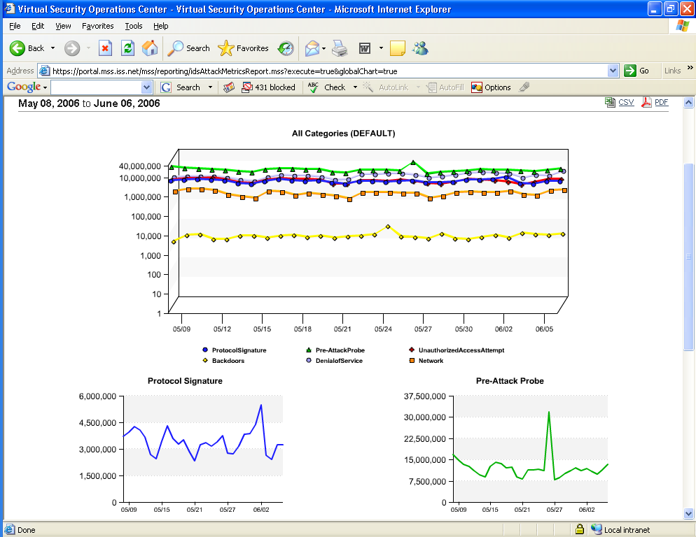

ISS RESPONSE:

The above Global Attack Metrics report helps organizations benchmark their unique attack activity against the aggregate attack metrics collected across the entire ISS MSS customer base. Such reporting can be beneficial for identifying new mass-propagating attacks and exploit attempts against a specific vulnerability.

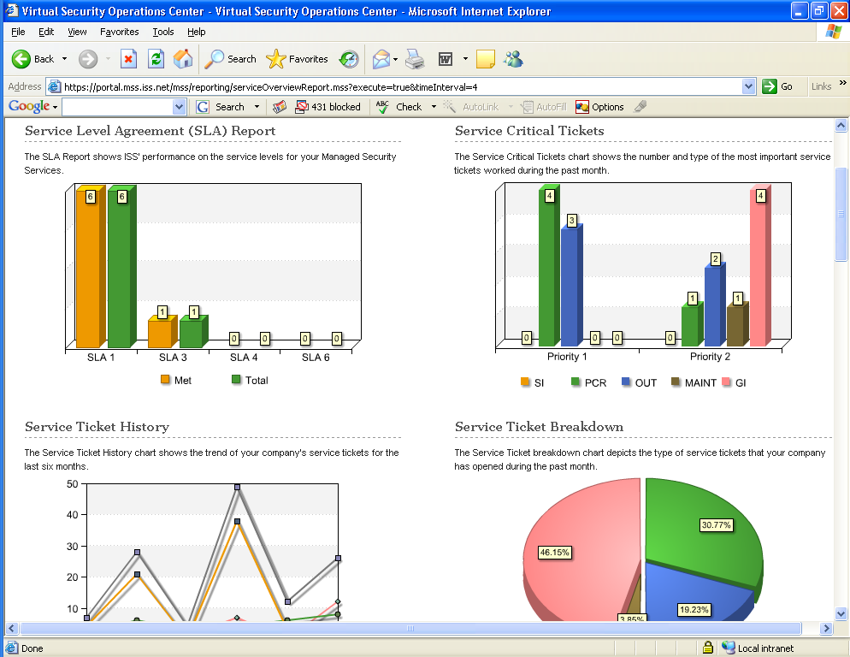

The Service Overview report provides organizations with a graphical representation of key performance metrics for the service such as SLA adherence, critical tickets opened over the month and their current status, historical ticket / incident trends, and so on. Such a report can be used to judge performance and effectiveness of the ISS Security Operations Center in providing service to your account.

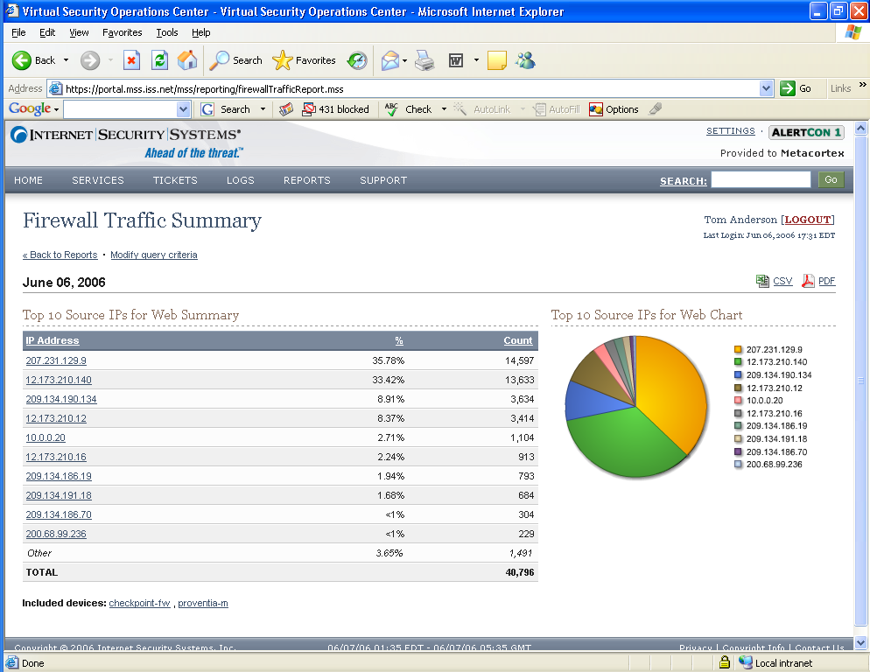

The web traffic summary report for firewalls provides security analysts with an interactive summary of the top web users within an organization. This can be used to identify network misuse, top bandwidth consumers, etc.

- Can reports be generated for specific network segments/devices?

ISS RESPONSE:

By utilizing the custom report features of the Virtual-SOC Portal, organizations can generate reports that apply to specific devices, groups of devices, IP addresses / networks, dates / times, protocols, priorities, actions, etc.

- Can trend analysis reports be generated?

ISS RESPONSE:

Yes. A variety of available trend analysis reports have been outlined in the table above on a per-service basis.

- How are reports delivered?

ISS RESPONSE:

Reports can be saved in HTML or exported in CSV and PDF formats. In the event a customer would like reports pulled and delivered to them, such a request can be accommodated by the ISS customer advocacy team.

- Is real-time access to network and system security status provided via a Web interface?

ISS RESPONSE:

Yes. ISS Provides a comprehensive web based interface known as the Virtual-SOC Portal for access to all service related information. By leveraging the Virtual-SOC Portal, organizations can receive real-time status information on all managed devices including system health, availability, configuration, policy, logs / events, and detailed reporting. In addition, ISS provides all MSS users with integrated security intelligence, vulnerability management, and interactive online trouble-ticketing as a standard feature of all managed offerings.

The general design concept of the Virtual-SOC Portal was to create a web based interface capable of helping organizations bring together information from disparate security technologies in an effort to better assist organizations in assessing their security posture. Secondly, the Virtual-SOC Portal serves as a launch point for ISS on-demand services strategy which allows organizations to better address emerging threats without the costly deployment of new security technologies / appliances. Examples of on-demand solutions include being able to provide after-hours security event monitoring and management, as well as allowing organizations to enable vulnerability scanning and management functions without the requirement of working with an account representative.

- Describe the training provided to assist us in understanding how to access online report versions and interpret and audit them?

ISS RESPONSE:

Following deployment of the managed security solution, new customers are introduced to the Virtual-SOC portal for the first time by their assigned deployment engineer. It is the deployment engineer’s responsibility to ensure the customer’s respective security contacts are aware of portal functionality and how to most effectively use the system. In the event additional portal assistance is needed following service turn-up, the client advocacy team would be pleased to assist customers with a live demonstration. For specific services involving substantial workflow within the portal (e.g. Vulnerability Management), ISS has also prepared detailed user guides for end-user use.

Question C.6: List Pricing
Define all costs billed by you to NWC Inc. for services delivered. Please indicate any front-loaded one-time expenses in addition to monthly recurring charges. NWC Inc is considering a three year agreement, but wants to weigh that against a month-to-month option and so will need to understand both monthly and 3-yr. contracted pricing. Please provide both. Indicate early termination costs where applicable. Please respond with pricing in the following categories:
Monthly Reccuring Charges
Annual or other periodic fees
Conversion Charges
Project Management
fIREWALL MANAGED SERIVCES
iNTRUSION DETECTION MANAGED SERVICES
ROUTER/SWITCH MAINTENANCE AND SECURITY
SECURITY MONITORING
LOG MONITORING SERVICES
Problem Management INCLUDNG FORENSIC ANALYSIS CAPABILITIES
VULNERABILITY AND PENETRATION TESTING
RISK ASSESSMENTS
CONTENT FILTERING SERVICES
Service Level management and remediation
High Availability
Coordination with NWC Inc. Trading partners
ON-SITE CONSULTING
other

ISS RESPONSE:

Following an analysis of NWC's available IT budget and the possible solutions NWC might seek from an outsourcer, ISS has determined that it may be difficult to fulfill all of NWC's requested services given the current IT budget constraints. According to the 2005 CSI / FBI Computer Crime and Security Survey (http://www.usdoj.gov/criminal/cybercrime/FBI2005.pdf), the average organization typically allocates between 0 and 5% of IT budgets for security. This would allow for a monthly spend of approximately $14,500.00. As such, the ISS proposal has provided NWC with details on all managed solutions that may be an ideal fit based on the NWC environment or specific service types requested. The final solution, however, will likely require NWC to prioritize on those services that deliver the highest value in relation to NWC security staff competencies. ISS will be pleased to assist NWC in making this determination.

D. Security Practices
The following questions explicitly address outsourced information security best practices. Please answer each.

Question D.1: Policies, Procedures, and Regulations
You have a comprehensive set of documented, current policies that are periodically reviewed, updated, and enforced. NWC Inc. can review these at any time.

ISS RESPONSE:

Security Policies & Procedures
ISS contracts with Ernst & Young LLP (E&Y) to perform annual SysTrust Audits of our MSS operation. Independent research has pointed to organizations like ISS with deep compliance expertise.

This SysTrust audit is an adaptation of the SAS70 certification specifically for service providers. E&Y performed its most recent examination of controls in November, 2005. The accompanying report from ISS management includes the “Description of Managed Security Service (MSS) Systems” and an assertion by ISS management regarding the controls surrounding the MSS systems. This report describes the MSS system, which consists of the procedures, infrastructure, data, software, and personnel organized to provide information protection solutions for our MSS customers.

ISS believes it is absolutely critical that the MSS systems be secure, available when needed, and consistently able to produce accurate information. An unreliable system can trigger a chain of business events that affect our customers and business partners. In response to this business need, the American Institute of Certified Public Accountants (AICPA) and the Canadian Institute of Chartered Accountants (CICA) created a professional service called SysTrust which enables a CPA to provide assurance that a system is, in fact, reliable. A reliable system is one that is capable of operating without material error, fault, or failure during a specified period in a specified environment. SysTrust is designed to increase the comfort of ISS management, our customers, and our customers’ business partners with the systems that support our MSS business.

The E&Y SysTrust examination was conducted in accordance with the Trust Services attestation standards established by the AICPA.

The Trust Services standards were promulgated by the AICPA and CICA to address concerns in the marketplace for assurance around systems reliability and e-commerce activities. The E&Y examination addresses the following Trust Services principles:

- Security - The MSS system is protected against unauthorized access (both physical and logical) in conformity with ISS security policies.
- Availability - The MSS system is available for operation and use in conformity with the ISS availability policies.
- Confidentiality - Information designated as confidential is protected in conformity with the ISS confidentiality policies.

ISS decided to obtain a SysTrust versus an AICPA Statement on Auditing Standards No. 70 (SAS 70) examination. SAS 70 and SysTrust have several features in common:

1. Focused on information systems and are provided by CPAs
2. Focused on internal control and include a report on the effectiveness of controls
3. Addresses needs for assurance and best practices pertaining to various types of information systems
4. Designed to be used to meet requirements set by corporations, other CPAs, and government

The SAS 70 report is an auditing standard that is to be used in very specific situations. SAS 70 reports are technical reports primarily designed to be sent from one auditor to another and are typically used to evaluate an internal control environment as part of a financial statement audit. SAS 70’s are highly customizable and must detail a company’s controls and the audit tests performed, as well as the results. The controls addressed by SAS 70 reports may vary from company to company, and are limited in distribution to customers and their auditors. A SAS 70 examination is generally applicable when an auditor is auditing the financial statements of an organization that obtains financial transaction processing services from a service organization. The user auditor may be required to gain an understanding of the controls at the service organization through the evaluation of a SAS 70 report if controls may affect assertions in the user organizations’ financial statements.

The ISS Managed Intrusion Protection Service unobtrusively monitors client servers and network traffic for potential threats, and prevents attacks or misuse from damaging critical online information resources. Since the MSS systems do not process financial transactions for customers, ISS selected the SysTrust examination rather than the SAS 70 since SysTrust provides answers about critical system issues important to our customers, which include the security, availability, and confidentiality of information. SysTrust is based on predefined principles and criteria, which have been developed specifically to address key business needs regarding reliability of a system.

The intended audience for the SysTrust report is customers and potential customers, and ISS management. The E&Y SysTrust report for the Managed Information Protection Service system will be posted on the ISS web site and will be accessed by clicking the SysTrust and Ernst & Young CyberProcess Certification seal.

Compliance & Regulatory Issues
Internet Security Systems is very sensitive to compliance and regulatory issues, as we routinely perform assessment work for our clients around issues that may affect NWC such as Sarbanes-Oxley, California Senate Bill 1386, and various privacy regulations. ISS Managed Security Solutions (MSS) absolutely addresses these issues by providing for a more secure company infrastructure.

The MSS solutions address section 404 of Sarbanes-Oxley by providing a protection solution to ensure that the company’s assets are safeguarded against unauthorized or improper use. By obtaining the ISS managed security solution, companies are able to demonstrate that they are taking reasonable efforts to not only safeguard company assets, but to also provide an environment where the key stakeholders can more confidently feel that the company’s transactions are properly authorized, recorded, and reported.
The Managed Solution also applies directly to California Senate Bill 1386, as it ensures that the company has taken prudent measures to protect their customers’ information from various forms of security breaches.

It also addresses privacy issues related to our own offering by using the following detailed data integrity methodology. Data integrity is ensured through proper configuration of managed applications. In each case where multiple customer's data is stored on a single server, ISS uses the built in data segregation functionality of managed applications to ensure that each event and log entry is properly tagged and associated with the proper parties. ISS does not modify or self code data segregation solutions. This ensures that customer data is truly segregated using tried and tested methods.

More information on client data privacy is available in the Ernst & Young SysTrust Audit.

Question D.2: Contingency Planning (Disaster Recovery)
The provider has business continuity and disaster recovery plans for critical assets and confirms that they are routinely tested and found to be effective.

ISS RESPONSE:

The Disaster Recovery Program and all procedures contained within it, are subject to a quarterly review, where appropriate. Each policy and procedure shall define a recommended period by which it should be assessed. This period does not exceed one year past the previous assessment. Additionally, any changes to an entity caused by certification of new offers or service pack/upgrades may also trigger a review for that entity’s policies and procedures. Each assessment shall include a test of the policy and procedures. The assessment shall evaluate and update accordingly the damage assessment and impact analysis for the entity policy under review. The disaster recovery plan can be provided to clients upon request.

Disaster Recovery Plan highlights
ISS has located SOCs in low-risk threat zones as well as house their operations within a disaster resistant or hardened facility. The design of the facilities and structural hardening is commensurate with the proximal risk profile where the facilities are located. Accepting the fact that no geographical location is risk free, facilities are located in areas where the Annualized Loss Expectancy (“ALE”) is acceptably low. Known risks can subsequently be managed or mitigated through the application of generally accepted risk management and disaster recovery strategies.

ISS has also adopted the basic precept of risk management; geographically distributing assets to reduce the loss potential. In other words, “never leave all your eggs in one basket.” To that end, ISS has operations physically and geographically separated among multiple locations. These facilities can back one another up which reduces the hardening requirements and cost of any single facility.

For power redundancy, ISS ensures that the facilities infrastructure design is commensurate with the level of protection of the facility itself. ISS SOC infrastructure includes the concept of N+1 (needed plus one) from the Uptime Institute. The N+1 strategy ensures that the failure of any single infrastructure system would not adversely affect the whole of the operation. Each SOC has multiple power feeds, duplicate switchgear, UPS, and backup power generation. Additionally, the SOC facilities can accept remote power connectivity in the event of catastrophic power equipment failures and/or extended periods of backup power generation when primary power is lost.

Network Transport in ISS SOCs have multiple Internet connections. A circuit, typically a DS3 running at 10 megs, is fully redundant and load balanced with the primary circuit. In each case, the circuits are provisioned from alternate carriers. Multiple Internet connections support the SOCs in a number of ways: First, a second Internet connection ensures that the SOCs stay connected to the Internet. In a bandwidth critical role such as MSS, it is vital that connectivity to the Internet is never lost. This strategy overcomes any number of problems at either the ISP or the Telco. ISS MSS clients are ensured maximum uptime of their service in the event of an outage to a single ISP since ISS has a redundant connection to complete and separate ISP’s.

Second, having multiple connections allows ISS to perform an expanded range of preventative maintenance without affecting production. It also allows clients to have more confidence in our ability to deliver on our commitment of 24/7 uptime and helps to demonstrate our commitment to redundancy in all crucial areas.

This also allows ISS to have two paths to choose from when travelling the Internet to clients, as well as offering the client two paths to reach a SOC. This ensures the quickest path is chosen, reducing latency and improving response time. Our two service providers have largely diverse backbones, maximizing the likelihood that our clients are close to either carrier and minimizing their latency over the Internet. In the event that a SOC does lose one of the two Internet connections, the fail-over is instantaneous, transparent, and automatic.

Question D.3: Data Handling
The provider treats data in accordance with its classification (confidential, sensitive, public) and complies with customer’s policies, procedures, and regulations.

ISS RESPONSE:

ISS classifies all customer data as confidential and treats that data accordingly. Please see answer for C2 for further explanation of customer Data Handling. As referenced, ISS Data Handling procedures are covered within the scope of the Systrust Audit (below).

ISS Managed Security Services (MSS) team has policies and procedures in place to protect and secure customer data. By customer data we mean any collected information from the customer to include but not limited to:
- Event data and log files
- Customer contact information
- Network maps
- Trouble Ticket details
- Managed device details
We view the process of protecting this data as Customer Data Lifecycle Management. Customer Data Lifecycle Management is the ISS MSS process of managing customer data throughout its lifecycle from receipt to ISS, to presentation, to archival, until disposal across different storage media, within the constraints of the business process. The lifecycle is the time from the moment data is created until it is stored, deleted, or transferred back to the customer.
The nature of the MSS business is that depending upon the service, event data typically from malicious attacks aimed at their network, servers, desktops or log data from managed firewalls, is sent from managed customer devices to ISS to deliver managed services. This event data does not contain actual customer payload information, but does contain sensitive information about the customer’s network environment or host environment.

This information, if not properly managed, could leave the customer at risk and in a vulnerable position. ISS believes it is absolutely critical that the MSS systems be secure, available when needed, and consistently able to produce accurate information. An unreliable system can trigger a chain of business events that affect our customers and business partners. In response to this business need, ISS contracts with Ernst & Young to provide an audit of our systems that provide Managed Security Services for our customers. This audit is aimed at ensuring that we have taken the necessary steps to safeguard our customer’s data.

Customer Data Flow
ISS primary medium for managing the IDS devices is the Internet, over encrypted channels. ISS performs all device management and security monitoring functions over encrypted channels or encrypted applications such as Secure Shell. No Clear Text is passed from the SOC to the customer premise.

Event data is sent to ISS where it is then stored in our Log Management Server (LMS), a component of the X-Force Protection System. It resides solely on an access controlled, SysTrust certified, fully redundant array that makes up the LMS storage system. The system is designed to store data in a safe, secure manner for up to 7 years. These media are stored in a secured off-site facility. On-line access to raw event data is available for 2.5 years. Aggregated summary logs are available on-line for up to one year. All event data is stored in vendor native format and archived via a well-documented and standardized procedure.
While stored in the LMS, customers can view information about the collected data through the Virtual-SOC Portal where it is presented to customer appointed and authorized users. Authentication to the Customer Portal is handled by two factor authentication using RSA SecurID tokens. Customer’s logging into the Portal are required to provide their unique username, and a 4 to 8 digit static pin number along with the alternating number on the SecurID token. In conjunction with SSL based encryption, the Virtual-SOC Portal provides a secure, trackable means of transmitting information and requests directly to the ISS SOC.

Finally, upon contract termination, the customer is handed over all polices, configurations, network maps, and any other ISS managed customer data.

SysTrust Certification
The American Institute of Certified Public Accountants (AICPA) and the Canadian Institute of Chartered Accountants (CICA) created a professional service called SysTrust which enables a CPA to provide assurance that a system is, in fact, reliable. A reliable system is one that is capable of operating without material error, fault, or failure during a specified period in a specified environment. SysTrust is designed to increase the comfort of ISS management, our customers, and our customers’ business partners with the systems that support our MSS business.

The E&Y SysTrust examination was conducted in accordance with the Trust Services attestation standards established by the AICPA: http://www.aicpa.org/assurance/trustservices/index.asp

The Trust Services standards were promulgated by the AICPA and CICA to address concerns in the marketplace for assurance around systems reliability and e-commerce activities. The E&Y examination addresses the following Trust Services principles:

- Security - The MSS system is protected against unauthorized access (both physical and logical) in conformity with ISS security policies.
- Availability - The MSS system is available for operation and use in conformity with the ISS availability policies.
- Confidentiality - Information designated as confidential is protected in conformity with the ISS confidentiality policies.

A copy of the most recent SysTrust Audit for ISS during the period July 1, 2005 to September 30, 2005, can be found at the following link: https://cert.webtrust.org/pdfs/iss_systrust.pdf

Question D.4: Software Integrity
Describe how you maintain the integrity of installed software. Consider how often virus, worms, and other malicious software are checked; are virus signatures updated regularly; and are checksums compared against a valid, known baseline.

ISS RESPONSE:

ISS maintains only the highest level of availability for every aspect of the services delivered including from the back-end infrastructure to the security enforcement point deployed at the customer premise. As such, we make a sizable investment in dedicated platform certification and device maintenance teams to ensure that each supported security platform can perform at peak levels.

The platform certification process involves the evaluation of all updates, patches and service packs to ensure that the platforms are configured properly to take advantage of the latest advancement and also kept current to protect against security threats. These certifications are done for both SOC infrastructure platforms as well as platforms deployed on customer premise.

Internal infrastructure is maintained by a dedicated administration team. Customer premise is maintained by a separate device maintenance team. Both administration teams utilize several automated tools and procedures to effectively monitor and update device configurations. These tools compare any given deployment to the certified platform configurations. Any deviations are documented and corrected. These teams are also responsible for scheduling and performing all maintenance on managed devices.

Question D.5: Secure Configurations
Provider ensures secure configurations of all customer information assets throughout its lifecycle—installation, operation, maintenance, retirement including:

• Authentication on both ends is required when a configuration change is requested.

ISS RESPONSE:

ISS accounts for configuration changes by following the change management process described below.

ISS will receive change requests from an authorized contact. ISS works with an authorized requestor to evaluate and implement the appropriate change. These requests will be implemented in accordance with all applicable Service Level Agreements.

Roles and Responsibilities
ISS will not make a change unless it is requested in writing from an authorized requestor.

Customer Notification Policy
ISS will notify an authorized requestor when a change has been validated by a Security Engineer and when the change has been implemented.

Multiple Levels of Customer Approval
A customer may have multiple levels of approval for policy changes as long as one point of contact from the customer notifies ISS of the final approval of the change.

Roll-Back Strategy
ISS can roll back any previous change but will only do so if an authorized requestor has asked ISS to perform that roll back.

Monitoring & Reporting Systems
ISS monitoring and reporting are tied together by our backend customer relationship management database (Remedy). Remedy drives the displays in the Customer Portal so that customers can see trouble tickets and policies for services in real time

• Patches are applied to correct security and functionality bugs. Is there are specific day of the week where routine, non-critical patches are applied?

ISS RESPONSE:

A standing maintenance window (Saturdays from GMT 13:00-15:00) is defined in all service descriptions or for individual customer devices; however, it is possible for these administrators to define custom windows for specific installations. ISS also reserves the right to invoke an emergency changes with thirty minutes notice to address security or imminent failure situations. Notice of all changes is sent to all customers impacted by the proposed change at least ten days prior to the change window. Upon request a customer may suggest a different change window and ISS administrators will accommodate when appropriate.

During a defined or scheduled maintenance window, ISS administrators have complete access to versioned backups of configuration data for both internal infrastructure and customer premise equipment. Per standard procedures, in the event of an unsuccessful upgrade/change, the administrator can utilize these backups to completely restore the system to pre-upgrade status.

• Unnecessary application and services are removed or disabled?

ISS RESPONSE:

Yes. ISS removes or disables all unnecessary applications and services that are running on the managed devices during the deployment process. As the managed devices are transitioned to the Security Operations Center for management a QA process is followed to double check that each devices is configured securely.

• Default accounts are also removed?

ISS RESPONSE:

Yes. All default accounts are removed and only the accounts necessary for ISS to manage the devices are enabled.

• Are configurations tested in a non-production environment prior to deployment?

ISS RESPONSE:

Yes. All devices are configured and tested prior to being put into production. Once in production ISS tests the devices to ensure they are performing correctly and also asks the customer to perform tests on their network to ensure it is still performing as it should. Once the customer authorizes the ISS deployment engineer to turn the manage device over to the ISS SOC the SOC also performs one last check of the managed device to ensure that it meets ISS standards.
.

Question D.6: Backup’s
You provide a regular schedule of backups for data including how often partial, full backup’s are performed; is data validated both before and after a backup; is encryption used; how do you separate one customer’s backup media from others; and have a process implemented to accommodate a customer’s request for an unscheduled backup restore.

ISS RESPONSE:

As part of the MSS service, event data is sent to an ISS Event Collector where it is then stored in a SiteProtector database and simultaneously also routed to a Log Management Server (LMS), a component of the X-Force Protection System. It resides on SiteProtector for 2 weeks before being purged, after which time it exists solely on an access controlled, SysTrust certified, fully redundant array that makes up the LMS storage system. The system is designed to store data in a safe, secure manner for up to 7 years. These media are stored in a secured off-site facility. On-line access to raw event data is available for 2.5 years. Aggregated summary logs are available on-line for up to one year. Restoration may involve retrieving the archived media from the off-site storage facility and could take up to one week. After researching customer’s request, the SOC will attempt to provide a more definitive timeframe for log availability. All event data is stored in vendor native format and archived via a well-documented and standardized procedure.

Question D.7: Monitoring and Auditing
Describes the actions the provider takes to monitor and audit its own systems and networks. Also applies to customer systems and networks if included in the requested services. The provider describes their ongoing processes for global vulnerability and threat analysis.

How is correlation from all data sources performed when monitoring includes firewalls, intrusion detection systems, routers, and servers?

ISS RESPONSE:

The MSS Infrastructure is monitored and audited in the following ways:

Realtime Device Health and Process Monitoring: Our monitoring system continuously monitors the uptime, health, and capacity of our Infrastructure. Hundreds of customized checks ensure that all components of our systems are functioning properly.

System Trending: Our trending system allows us to view historical performance data for dozens of OS, hardware and application - level components on each of our systems.

Log Aggregation: All systems report their logs to a centralized server. System errors (OS, hardware and application failures) and user - related errors (failed logins, etc.) generate alerts within our device monitoring system.

Intrusion Detection / Prevention: Our networks our monitored by ISS Proventia appliances. These devices are managed in the same manner as our customers' devices are.

Vulnerability Management: Our infrastructure takes full advantage of our Vulnerability Management Service. Our servers are scanned, reported on, and remediated through the Virtual-SOC Portal.

Network Monitoring: All traffic to and from the MSS networks is analyzed by a Proventia Anomaly Detection system.

Change Auditing: We use a file integrity checker to detect changes to designated files on our systems and report accordingly.

User Access: Automated processes run to compare permissions on our servers to the permissions specified in our access policy.

Certification Compliance: Our Infrastructure has been certified under E&Y's Systrust standard for security, availability, and confidentiality for the past 3 years. This year, we will add SAS 70 certification to our audit process.

The provider describes their ongoing processes for global vulnerability and threat analysis.

ISS RESPONSE:

ISS world-renowned X-Force® research and development team provides the security intelligence foundation for all ISS products and services. This group of security engineers is solely dedicated to research and development associated with the vulnerability and threat science arena. The result of their efforts is the most extensive commercial database of threats, vulnerabilities, and security best practices available - yet another ISS expertise advantage. From internal testing to open source research to monitoring the hacker underworld, the X-Force leverages the power of multiple sources of information to proactively defend ISS customers from new and dangerous threats.

The MSS Services Management team works closely with the ISS X-Force to stay abreast of the latest vulnerabilities. The X-Force is a primary security intelligence research organization, not just a distributor or aggregator of this information like SANS, CERT, and Security Focus (now Symantec) are. The X-Force releases security advisories on an ongoing basis. These security flaws are discovered based on the original, independent research of ISS. Some examples of X-Force security advisories include detailed information on new and dangerous vulnerabilities pertaining to Apache, OpenSSH, MS Exchange, Polycom, BIND DNS, SQL, SSL, PeopleSoft, Sendmail, and RPC DCOM. The SQL Slammer worm, discovered by the X-Force, was one of the most disruptive events yet observed on the Internet, interrupting operations to scores of Internet-based services.

Not only does the X-Force discover new threats and vulnerabilities, it also thoroughly examines pre-existing, or known, vulnerabilities discovered by other entities. This level of scrutiny includes determining the likely consequence of certain security risks and the prioritization of coverage to enable customers to stay Ahead of the threat. Contrarily, other security technology vendors tend to give credence to a new vulnerability only after it is exploited.

How is correlation from all data sources performed when monitoring includes firewalls, intrusion detection systems, routers, and servers?

ISS RESPONSE:

We utilize a number of tools to correlate alerts between sensors, the first of which is our SiteProtector console. MSS utilizes a centralized SiteProtector, command and control security management system, providing unified configuration and data analysis capabilities for ISS network, server, desktop, and assessment agents. Event prioritization and correlation enable real-time attack and misuse tracking. SiteProtector’s interface helps administrators work more efficiently through flexible views built around asset grouping and event aggregation. Powerful filters screen for event exceptions and false alerts. Additionally, SiteProtector automates ISS protection agent deployment, and enables multi-site management via secure remote administration.

In addition we utilize proprietary scripts, Artificial Intelligence, log aggregators, and open source Nagios on our MSS Infrastructure for the purposes of monitoring, analyzing and reporting security events. Collectively these tools make up the X-Force Protection system which scales with our MSS customers to provide efficient event consolidation, correlation, and data storage.

Question D.8: Intrusion Response
Describe how your service responds to a detected intrusion to include the following:

- Describe escalation timing for the service provider. For example, notification could occur within one hour of detection to the first level supervisor, four hours to the next level, eight hours to the next level, and so on. These times may be outlined as part of a service level agreement.

ISS RESPONSE:

Escalations within the ISS Security Operations Center are handled as follows.

After 1 hour the issue is escalated to the on-shift SOC supervisor.
After 4 hours the issue is escalated to the SOC manager
After 8 hours the issue is escalated to the SOC director
After 24 hours the issue is escalated to the MSS Operations VP

- Describe the escalation process for the client.

ISS RESPONSE:

ISS works with the client to define the escalation process that best fits their company. Typically, ISS escalates security incidents in the following manner:

- ISS contacts the Level 1 contact at the company by calling each of the phone numbers you have provided for that contact.
- ISS will leave a voicemail at each phone number. If live contact is not made with the Level 1 contact ISS will immediately begin calling the Level 2 contact.
- ISS will continue this process through all of the defined contacts (Typically 3 Levels of escalation). Once all contact phone numbers have been exhausted an email notification will be sent out to all security contacts.

Internet Security Systems (ISS) is dedicated to providing customers with the highest level of protection services to guard against Internet-based threats and vulnerabilities. As part of those services, highly trained security experts are constantly monitoring and evaluating real-time intrusion event data, and systematically categorizing and prioritizing each threat.

As depicted in the diagram below, SOC analysts inspect incoming events in real-time. Leveraging X-Force™ security knowledge capital, in-depth documentation of customer environments, and state of the art technologies, these events are quickly evaluated and prioritized. Incident classification and priority is not solely based on the vendor’s predetermined event severity, but rather on the SOC analysts’ correlation of X-Force™ security intelligence, global threat awareness, and customer security posture.

Security Incident – Priority 3

Email Escalation
No Action Required
Network Diagrams
X-Force™ Intelligence
SiteProtector & Fusion
Global Attack Trends
Security Incident – Priority 2

Phone or Email Escalation
Action Required: 12-24 Hours
Security Incident – Priority 1

Phone Escalation
Immediate Action Required
Security Events
Vulnerability Scans
Event Baselines
}
X-Force™
Protection
System &
Security
Operations
Center

During the event triage process, SOC analysts draw from their in-depth knowledge of vulnerabilities and attack vectors to quickly eliminate false alarms from the customer dataset. Events that cannot be immediately dismissed trigger a comprehensive review of vulnerability data, past security incidents, customer network diagrams, and real-time cross-correlation of global attack trends. SOC analysts employ a five-phase methodology to thoroughly interrogate anomalous or suspicious activity.

Phase 1: Intelligence & Attack Analysis

ISS X-Force™ intelligence provides the basis for the initial triage of the activity. Using in-depth knowledge of how the exploits work, SOC analysts correlate activity patterns with signature severity to associate their behavior with known attacks. This allows the SOC analyst to determine the potential risks associated with a series of network, server or desktop events.
SOC analysts are kept up to date on the latest threats via daily briefings with the ISS X-Force™ Research & Development team and by evaluating attack behaviors and patterns within SOC Labs. SOC Labs is an isolated environment that allows analysts to launch exploits against targets so that their behaviors, impacts and steps to remediation can be studied first hand. SOC analysts are also kept on a rigorous training program that maintains and continually improves their skill sets, which includes industry training and certifications as well as proprietary internal programs.

Customers are also encouraged to study X-Force™ intelligence located on the Virtual-SOC Portal. As shown below, the customer portal provides the latest Internet security intelligence generated or gathered by the ISS X-Force™.

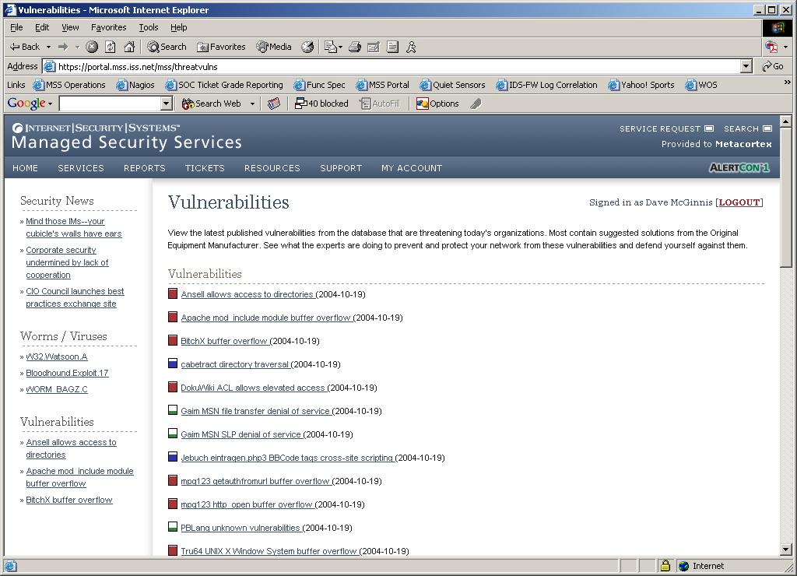
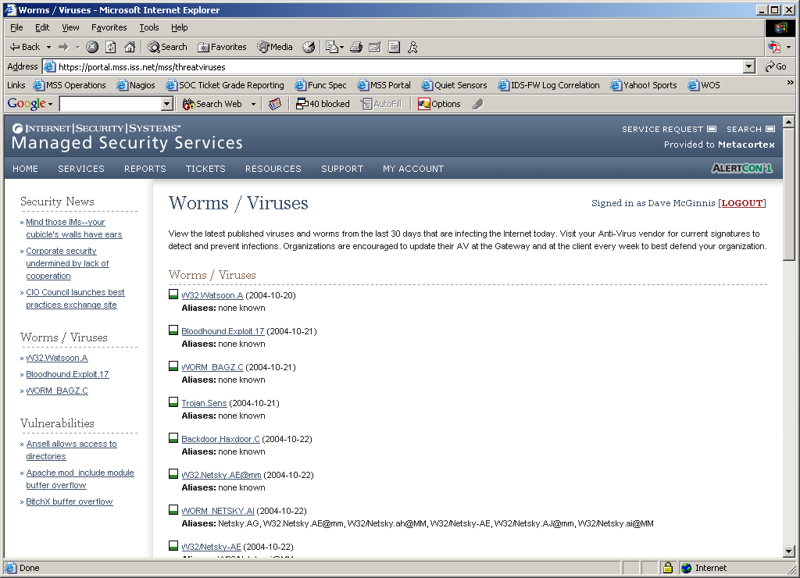

Phase 2: Source & Target Investigations

The second phase of incident investigation requires the interrogation of the source(s) and target(s) of the activity. The investigation of the activity varies based upon the location of the source and target machines, internal or external to a customer’s network. Internal machines are cross-referenced against monitored network diagrams, critical server information, and vulnerability scan data. External machines are examined against the X-Force™ black list IP blocks, known attackers and past investigations and escalations.

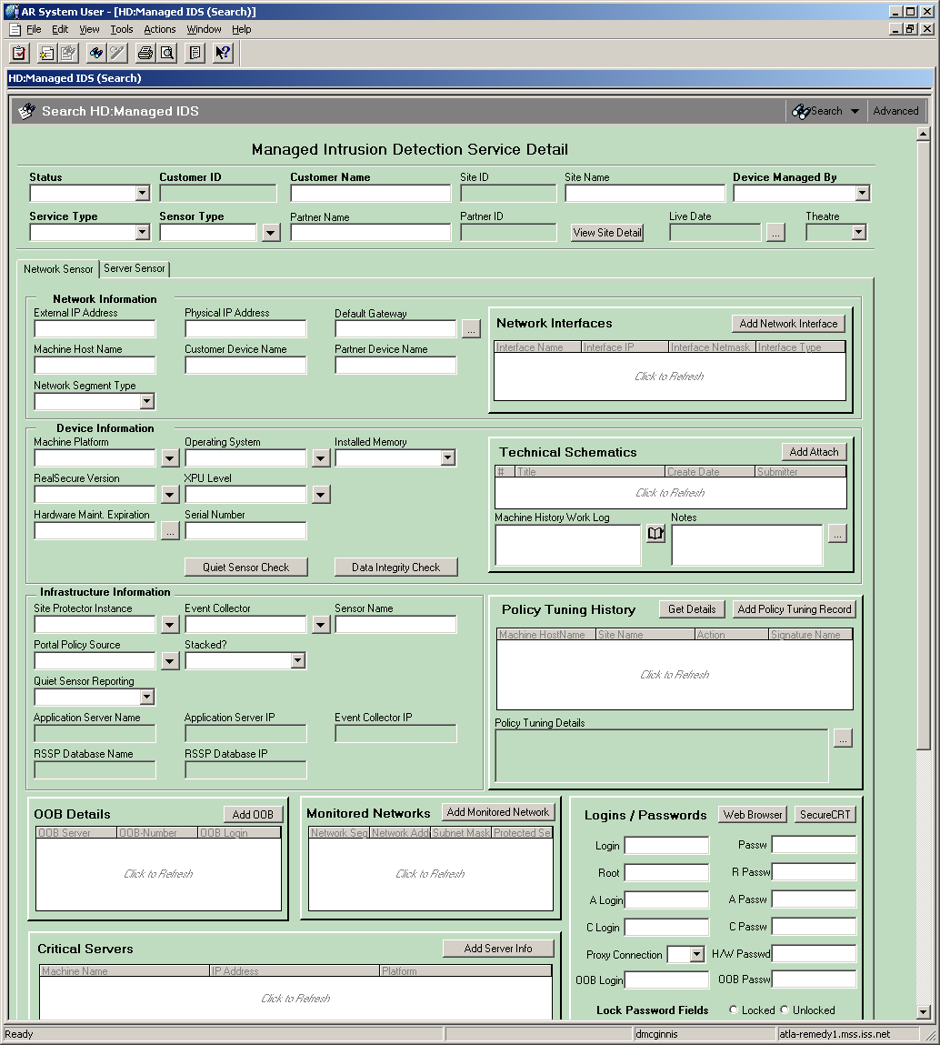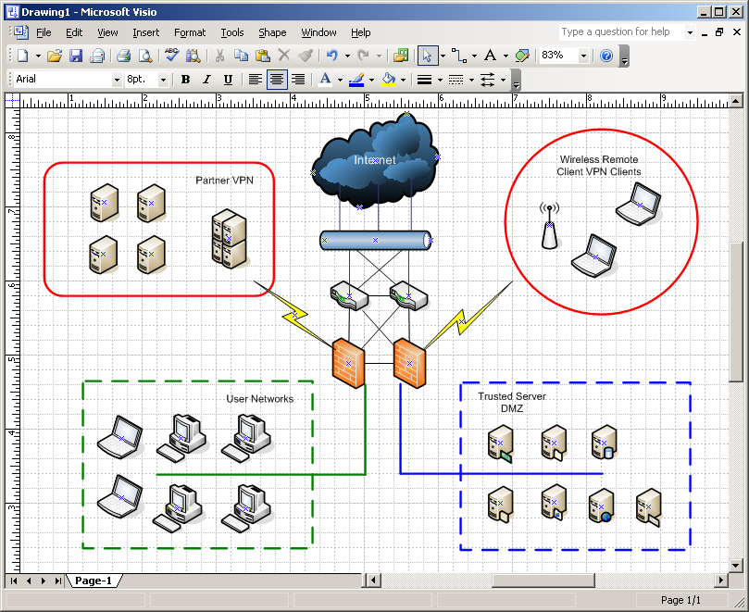

The two figures above depict typical customer information that is cross-referenced during an incident investigation. Network diagrams, critical server information and any other customer provided information are categorized and stored within the SOC support system.

Phase 3: Incident Classification & Prioritization

Once the activity has been analyzed it is then classified and prioritized. It is important to note that not all investigations of suspicious activity result in the declaration of a Security Incident (SI).

Incident Classification Categories
After careful examination of the event data, SOC analysts will classify the attack into one of the following incident categories. The categories are used to quickly identify the type of incident that has occurred.

- SI–Malicious Code
The SI-Malicious Code incident category is used to classify a virus, worm, Trojan or other code-based entity that has successfully infected or compromised an internal system and has begun propagating within internal networks or systems.

- SI – Probes & Scans
The SI-Probes & Scans incident category is used to classify activity on a network that is indicative network or system probes and reconnaissance scans.

- SI – Denial of Service
The SI–Denial of Service incident category is used to classify an attack that impairs the use of networks, systems or applications by exhausting resources of the given network, system or application. Both Denial of Service (DoS) and Distributed Denial of Service (DDoS) attacks are tracked by this classification.

- SI – Unauthorized Access
The SI-Unauthorized Access incident category is used to classify a situation where a person gains logical unauthorized access to a network, system, application, data or other resource. This incident category includes root compromises, unauthorized data altercations, and web-site defacements.

- SI – Inappropriate Use
The SI-Inappropriate Use incident category is used to classify a situation where a person violates acceptable use policies. Peer-to-peer file sharing applications and other like abuses of resources are tracked by this classification.

- SI – Trend Analysis
The SI-Trend Analysis incident category is used to classify anomalies within a standard event stream for a given device. Since trend analysis requires a historical review of an event stream, it is not typically performed in real-time.

- Non-actionable Activity
A vast majority of the events inspected by SOC analysts result in false alarms. These events are triggered by malicious traffic inspected in the customer environment; however, the networks and servers under attack are not vulnerable to the exploit. A common false alarm is the presence of mass worm traffic on a network. Worms such as Code Red, Nimda, Slammer and Blaster will propagate perpetually on the Internet and connected customer networks. Unless a customer server is infected and actively propagating that worm, there is no need for action and therefore the event is not escalated.

Security Incident Priorities
After classification, the SOC analyst will declare the activity a Security Incident (SI) and prioritize it by correlating three factors; the attack signature severity as set by X-Force™, the incident category from above, and findings from the interrogation of known customer information such as vulnerability data and critical server data. As shown in the diagram below, the priority is drawn from the intersection of three datasets, which encompass all aspects of the Security Incident.


SI Category
X-Force™
Attack
Severity
Incident
Priority
Analyst
Investigation
& Correlation

- Priority 1 Security Incident
Security incidents at this level are actionable, high-risk events that have the potential to cause severe damage to customer environments. Investigations that result in priority require customers to take immediate defensive actions. System or data compromises, worm infections/propagation, massive denial of service (DOS) attacks, and like incidents are grouped into this classification.

- Priority 2 Security Incident
This is the lowest level of actionable incidents generated by SOC analysts. A Priority 2 incident requires customers to take action within 12-24 hours of notification from the SOC. Incidents such as unauthorized local scanning activity and attacks targeted at specific servers or workstations are grouped into this category.

- Priority 3 Security Incident
This category of investigation encompasses activity on a network or server that is not directly actionable. Discovery and vulnerability scanning, information gathering scripts, and other reconnaissance probes are grouped into this category.

- Phase 4: Response – Incident Escalations & Countermeasures

In accordance with ISS standard service level agreements (SLA), SOC analysts will escalate a security incident to authorized customer contacts within fifteen minutes of the incident identification. The method of the escalation differs by the priority of the Security Incident.

ISS security escalation best practices are based on the principle of actionable information. Those items that require immediate action are escalated to customers first via the most rapid method. Lower priority items are escalated to customers in accordance with the recommended time to resolve the issue. The table below illustrates the recommended escalation methods for each security incident classification.

Standard Escalation Methods
Incident Classification | Primary Method | Secondary Method
Security Incident – Priority 1 | Telephone | Pager / SMS
Security Incident – Priority 2 | Telephone or Email | Pager / SMS
Security Incident – Priority 3 | Email | Portal
False Alarm | None | None

Customers have the flexibility to configure the methods by which SOC analysts will escalate security incidents to them. Changes to the primary and secondary escalation methods per contact can be submitted via the Virtual-SOC Portal or authenticated telephone call into the SOC.

Escalation Paths
SOC analysts use a custom escalation path to contact customers during a security incident escalation. This escalation path includes the order in which to call authorized security contacts as well as the telephone numbers the SOC may use. As shown in the figure below, a security incident escalation that requires immediate action triggers the following telephone escalation process. Starting with the primary security contact, the SOC will dial through all provided telephone numbers prior to moving to the secondary contact. The process repeats for each authorized contact in the escalation path until a customer representative is reached, or all contacts have been exhausted.

Primary Contact
Tertiary Contact
Secondary Contact
Telephone Escalation
Office
Cell
Home
Cell
Office
Home
Office
Cell
Home
Primary
Method
Secondary
Method
Tertiary
Method

The order of security contacts and their contact methods are customizable. Changes to the ordering of authorized contacts and the telephone numbers can be submitted via the Virtual-SOC Portal.

Countermeasures
Once an authorized contact is reached during a Priority 1 Security Incident escalation, the SOC analyst will recommend appropriate actions to thwart or contain the attack. The countermeasures available to the SOC and customers varies based upon the services and platforms managed by ISS at the affected site. A list of countermeasures and their associated properties is detailed in the table below.

Countermeasure Deployment
Type | ISS Default Action | Requires Authorization | Platform(s) | Protocol
Reactive Block* | No | Yes | Proventia G/M,  Host Sensor | Any
RealSecure Kill* | No | Yes | All Network &  Host IDS/IPS | TCP
ISP Notification | Yes | No | All | n/a
Firewall Policy or ACL Change | No | Yes | Proventia G/M, Managed Firewall | Any
* The reactive blocking and kill countermeasures are only required for attacks that are not blocked by ISS SOC default policies.

Phase 5: Documentation & Reporting

The final stage of any incident escalation is documentation. All aspects of the activity and attack are documented within a Security Incident ticket and report. All ticketing and reporting information is available to customers in real-time via the Virtual-SOC Portal shown below.

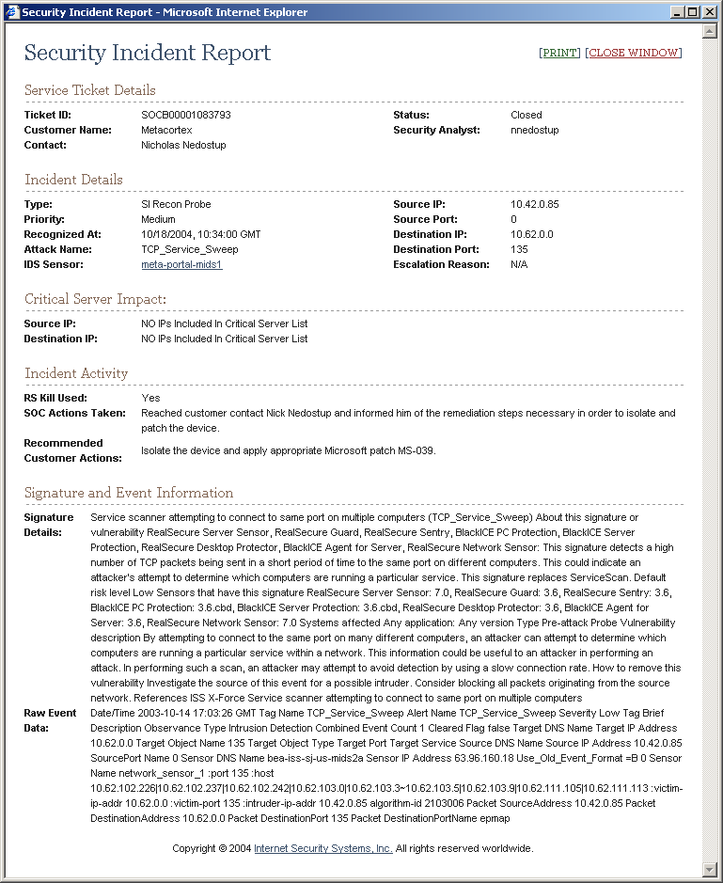
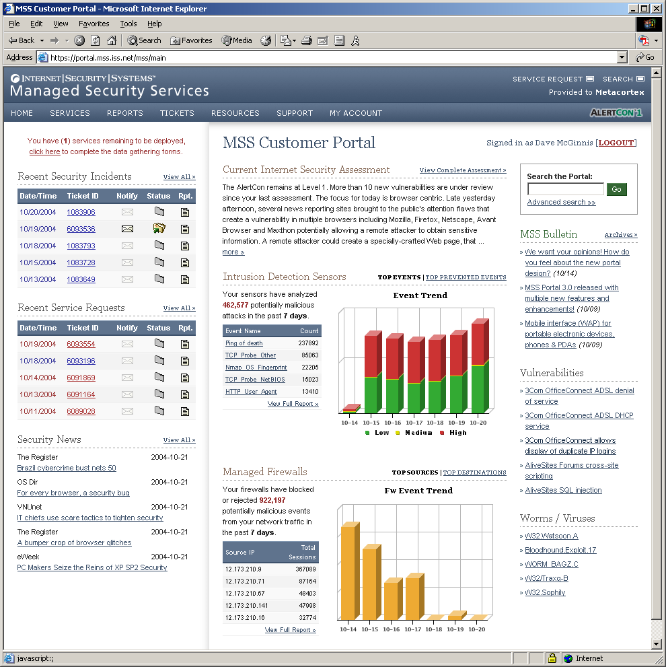

Incident Documentation & Reporting
A Security Incident Report (shown above) is created for all incidents escalated by the Security Operations Center. The report will include the following information.

- Service Ticket Information: Ticket ID, Status, Security Analyst
- Incident Details: Reason for Escalation, Priority, SI Category, IDS Sensor, Source & Destination IP/Port
- Incident Impact/Activity: Critical Server Impact, SOC Actions Taken, Countermeasures Deployed, Recommended Customer Actions
- Detailed Attack Information: MAC Addresses, Specific Signature Information

Exceptions & Special Conditions

Occasionally, there are situations beyond ISS or the customer’s control that will impact the SOC’s ability to respond to threats facing customer resources. The two most common situations are defined in this section.

Internet Emergency
In the event of a widespread incident where the Internet Alert Condition exceeds AlertCon-3, or when an incident is affecting a significant portion of ISS protected networks, an Internet Emergency will be declared. A notification of the emergency declaration will be provided to authorized security contacts via email within fifteen minutes of declaration of the emergency. This notification is designed for display on any device, including SMS capable devices such as Cellular Phones and Pagers and will include an incident tracking number, telephone bridge number and the time that a situation briefing will occur.

During declared Internet Emergencies, ISS will provide regular, live telephone-conference situation briefings and summarized email briefings designed to provide the customer with actionable information that can be used to protect their organizations. Regular situation briefings following the onset of an Internet Emergency supersede any requirement for Internet Security Systems to provide customer specific escalations for events directly related to the declared Internet Emergency. All other priority level incidents during this time will only be communicated via automated systems such as email, pager and voice mail.

Standard escalation practices will resume upon conclusion of the stated Internet Emergency. Termination of an emergency state is marked by a decrease in the Alert Condition to AlertCon-2, or an email notification delivered to authorized customer security contacts.

Widespread Internet Worm Infections
During a widespread Internet worm infection, SOC analysts will escalate the initial infection(s) to authorized security contacts. Following the initial escalation, worm infections can propagate through the customer network at an exponential rate. As such, after the initial infection has been escalated, additional propagation within the customer site will not be reported. Subsequent escalations would be warranted if additional sites become infected with worm activity. An updated list of infected hosts as the worm propagates is available via the Virtual-SOC Portal.

- Describe how you return affected systems back to normal operation.

ISS RESPONSE:

ISS provides customers with a detailed description of the issue detected, makes recommendations to stop the issue, and recommendations on how to recover from the issues. If you require hands-on support in recovering the affected system(s), ISS can provide ISS Emergency Response Service at an additional charge.

- Do you support automated responses?

ISS RESPONSE:

Yes. ISS can support automated responses where appropriate.

- Do you perform forensic analysis? Is this an additional charge?

ISS RESPONSE:

Yes. ISS employs forensic analysis experts as part of the Professional Security Services division who provide this for customers at an additional charge.

- How do you preserve evidence?

ISS RESPONSE:

Internet Security Systems, using specially designed, forensically sound hardware, software, and techniques, will make “bit-for-bit” copies of relevant hard disks and storage media from the computer systems specified to analyze the data collected. Analysis may include examination of existing data files, “deleted” data files (when such data is available), and “slack space” and other unused disk areas. ISS will search the data collected for key words, key phrases, and other information provided in an attempt to locate specific data and/or gain access to password-protected and/or encrypted information contained in the data collected.

- Do you get involve local, national, and international law enforcement?

ISS RESPONSE:

ISS Computer Forensics, Analysis and Litigation Services determines the effects an attack has had on an organization’s assets and helps track the origin of the attack. This service leverages the forensics expertise of an elite group of ISS consultants. These consultants will insure that any evidence found will preserved in a manner that can be used in court. In addition, they are available to testify as expert witnesses on behalf of our clients.

- Do you recommend improvement steps to ensure the same intrusion is not again successful?

ISS RESPONSE:

Yes, If the incident was related to mis-configuration of systems or negligence/violation of policies and procedures, ISS will approach this type of remediation effort with special sensitivity. If the incident is related to a willful targeted attack and subversion of specific controls, ISS will recommend a full analysis of the architecture and infrastructure to ensure comprehensive remediation. Either way, the outcome should be to mitigate the risk of reoccurrence, specifically through the same vector but also through other potential methods if discovered.

Regardless of the type of attack, systems are always scanned for vulnerabilities to ensure any attack related or other previously unknown holes have been patched. This includes the use of multiple different techniques such as antivirus and spyware scanning, traditional vulnerability scanning, and baseline analyzers for version and patch level compliance. Again, while ISS is present during these scans, the actual execution of the scan is conducted by an employee of the organization. The results of the scan are reviewed by ISS and may also be reviewed by the organization. At this point the organization is requested to determine further course of action to mitigate the vulnerability.

Vulnerabilities may also have been discovered from evidence gathered during the investigations such as network packet captures, and log analysis. If a vulnerability was discovered in this manner, remedial actions will typically have already been discussed upon discovery but will be covered again to ensure they were correct and properly designed. When a vulnerability is discovered, incident related or not, the organization is informed and can choose to remediate directly or through compensating or mitigating controls. ISS can assist in the identification of potential compensating controls; however, the organization is ultimately responsible for implementing any controls to remediate a known weakness. In addition, ISS can assist in confirming the remediation of the vulnerability if requested.

General Information

Internet Security Systems serves more than 12,000 corporate customers, including all of the Fortune 50, the world’s top 10 banks, top 10 IT companies, top 10 telecommunications providers, 9 out of 10 of the world’s top automotive manufacturers, 7 out of 10 of the world’s top insurance providers, and major agencies and departments within U.S. local, state and federal governments.

ISS is a publicly traded company with $330,000,000 revenue in fiscal 2005 sales and is debt-free with over $239M in cash and short-term investments.

ISS has been recognized by Gartner as a Leader in its Managed Security Services Providers Magic Quadrant report and in its Network Intrusion Prevention Appliances Magic Quadrant reports. ISS also enjoys market leadership in several of its offerings.

ISS is focused on the protection of our customers and working to prevent attacks. We have about 10 years of experience in Managed Security Services and we are solely focused on security services. All of our resources are security professionals that have spent the majority of their careers in the business of defending corporate and government networks. Combined with all of the research and development that we do for threats and vulnerabilities, our Threat Analysts are better informed about how to respond to threats than any other service provider in the business.

We are continually re-evaluating our services to make sure that we are keeping up with the latest customer requirements. We also meet regularly with the industry analysts to make sure that we are getting regular feedback on what they are hearing from their customers in order to keep up with the market trends. We have a dedicated Product Manager and Engineering group that focuses on the development of Managed Security Services offerings. This helps to ensure the continued focus that is necessary to stay current and competitive.

Technical IDS/IPS Solution

Products Used

ISS will protect NWC Inc. ahead of the threat using the following products:

Proventia A Intrusion Detection Appliances and/or Proventia G Intrusion Prevention Appliances - Proventia IDS/IPS appliances offer both passive monitoring and inline intrusion prevention capabilities. Proventia A operates as an IDS while Proventia G may operate as either an IDS or IPS. Both appliance product lines offer a wide array of models with varying throughput allocations and port densities.

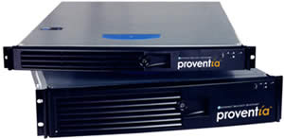

Proventia Appliances
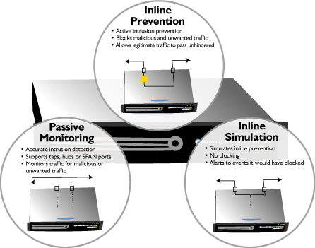

Proventia G IDS/IPS Modes of Operation

IDS/IPS Methodologies

ISS Protocol Analysis Module (PAM) logic uses these deep packet analysis techniques in a variety of orders and combinations to detect and prevent actual attack traffic while allowing normal business communications. This virtual elimination of false positives, false alarms, and false negatives results in comprehensive threat protection while benign traffic passes unhindered. The PAM performs full seven-layer, state-based decoding and analysis of over 100 internet protocols. The specific elements within this broader category are:

- Stateful packet inspection
- Protocol anomaly detection
- Outbound hybrid threat detection
- Port Variability (port-independent protocol decoding)
- Application-layer Pre-processing
- Heuristics
- Context Field Analysis
- IP Defragmentation
- TCP Reassembly
- Vulnerability Signatures
- Exploit Signatures
- Pattern-matching Signatures
- Host Response Analysis
- Pre-emptive Behavioral Analysis
- Reconnaissance (port probe detection)

How to Detect Non-Standard Behavior

Dynamic Blocking - Without impacting network performance, Proventia G uses vulnerability-based attack identification to enable an immediate and reliable blocking response to unwanted traffic while allowing legitimate traffic to pass unhindered. It employs a “traffic purification” process utilizing detection-based blocking to stop previously unknown attacks as well as known attacks such as denial of service, trojans, peer-to-peer downloads, and malicious HTTP traffic and e-mail attachments. It is able to dynamically create blocking rules to stop traffic such as worms that use viral propagation methods then automatically delete those rules once the threat has passed, thus allowing normal traffic to continue.

Granular Policy Control - SiteProtector uses policies to control what the Proventia G will detect and how it responds to malicious activity. With in the policy, each Security Event, or signature, can be configured with its response which can include a combination of preventive and recording actions. A policy can be assigned to a Group, which contains multiple sensors or to a specific sensor.

Proven attack detection and prevention - Proventia G consists of detection and prevention technologies that have been validated by an independent, third party using real-world criteria. It utilizes proven techniques that perform complete packet stream mastering to eliminate false positives, false negatives, and false alarms. It also encompasses the use of vulnerability signatures in order to detect known exploitations of the underlying vulnerability as well as new, previously unknown variants. This is necessary for preemptive, zero-day protection against attack variants. Proventia G is also resistant to evasion techniques such as exploit modification, ADMmutate, fragroute, whisker, stick, and the like.

7.0 Corporate Overview

7.1 Company Background

Founded in 1994, Internet Security Systems is a pioneer and world leader in software and services that protect corporate and personal information from an ever-changing spectrum of online threats and misuse. Our mission is to be our customers’ trusted security partner and premier provider of threat information protection solutions for Internet and other online business operations.

Headquartered in Atlanta, Internet Security Systems has additional operations throughout the Americas, Asia, Australia, Europe, and the Middle East. ISS employs over 1,200 people worldwide, and operates four Security Operations Centers (SOCs) for our Managed Security Services (MSS) customers. These SOCs enable comprehensive global threat monitoring which is utilized by the X-Force research team for identifying, tracking, and analyzing new and existing threats around the world in real-time.

7.2 Customers

Internet Security Systems serves more than 12,000 corporate customers, including all of the Fortune 50, the world’s top 10 banks, top 10 IT companies, top 10 telecommunications providers, 9 out of 10 of the world’s top automotive manufacturers, 7 out of 10 of the world’s top insurance providers, and major agencies and departments within U.S. local, state and federal governments.

ISS is a publicly traded company with $330,000,000 revenue in fiscal 2005 sales and is debt-free with over $239M in cash and short-term investments.
ISS 10K and all other SEC Filings are located at http://phx.corporate-ir.net/phoenix.zhtml?c=93082&p=irol-sec.

ISS Customer Satisfaction rating is 94% and is based on post technical support customer surveys. Through our survey and customer feedback processes, we stay in touch with our customers and respond to their feedback to improve our services.

- Our continuous staff training programs ensure that our support consultants are ready to respond to customer needs.
- Our support processes and infrastructure are designed and deployed to meet the highest industry standards.

All of our support efforts are guided by our customers’ feedback and satisfaction with our service.

7.3 Market Leadership

ISS enjoys a substantial lead in the Intrusion Detection and Prevention and Vulnerability Assessment markets and is the worldwide leader in IDS/IPS and VA for the sixth consecutive year according to IDC.

ISS MSS won the 2005 Frost & Sullivan Award for Customer Service Innovation Award. According to Frost & Sullivan,

“ISS is distinguished by being the only known MSSP to offer solutions that come with a money-back guarantee and by being one of only a few industry providers to also serve as a leading product vendor. It is further distinguished through its X-Force R&D team, the world’s largest IT security vulnerability and threat research organization, which contributes to the company’s ability to produce products and deliver services that preemptively protect customers prior to known and unknown threats. ISS sets the standard for customer satisfaction and delivery excellence founded on 4 key principles: breadth of offerings, quality of service, customer advocacy and effective communication.”

7.4 Expertise

7.4.1 Proactive Threat Research

ISS X-Force is the most respected security research team in the industry. Comprised of over 130 highly skilled security engineers, consultants, and developers, its focus is original, proactive research and development in the discipline of vulnerability and threat science. ISS is the only major security solutions provider that invests heavily (nearly 20% of annual revenues) in uncovering security weaknesses before they are exploited by malicious entities. X-Force researches an average of over 200 new vulnerabilities and exploits on a monthly basis. With 21,000 vulnerabilities now described in the publicly accessible X-Force database, the team continues adding to its 13,000 algorithms to model vulnerabilities and detect exploits and their variants. This information is continually integrated into ISS products, customer email alerts, the online database, and several internet risk summary reports distributed on a regular basis.

The X-Force also collaborates with government agencies, military branches, industry experts, OS and software vendors, and many other entities to ensure maximum protection of critical business systems and networks around the globe.

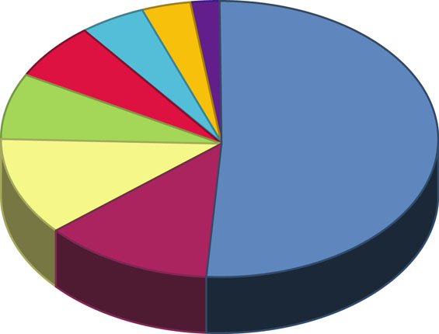

ISS
51.1%
eEye
12.4%
NGS
10.9%
iDefense
8.0%
Symantec
(@Stake)
6.6%
McAfee
5.1%
Core
SDI
3.6%
Bindview
2.2%
--Remote compromise (compromise
over a network), not local
--Do not require user interaction to exploit
--Do not require authentication to exploit

** Q1 2005
* High risk vulnerabilities are comprised of vulnerabilities that meet the following combination of conditions:

Figure 7-4: X-Force High Risk Vulnerability Discovery* 1998-2005**
(Source: Frost & Sullivan, April 2005)

7.4.2 Advanced Intrusion Detection and Prevention Technology

The patented Protocol Analysis Module (PAM) is the implementation of many types of unique combinations of attack identification methods and security algorithms. These sophisticated logic blocks were developed to efficiently analyze and master digital data streams on both saturated and low utilization networks and at all layers of the OSI model of networked servers and desktops.

PAM logic is applied to X-Force security data based on the type of attack (denial of service, reconnaissance, unauthorized access, brute force intrusion attempt, backdoor, worm, virus, hybrid, etc.) and then implemented into ISS protection agents, including the Proventia A, G, and M appliances, RealSecure Server Sensor (RS3), and Proventia Desktop in the form of an X-Press Update. The result is reliable threat detection, prevention, and response that truly protects while enabling electronic business continuity and integrity.

7.4.3 Managed Security Services

As a world leading provider of managed services, ISS possesses:

- An unprecedented 98% retention rate for the past six years for Security Operations Center (SOC) personnel. This high retention rate helps assure long-term continuity of a dedicated, knowledgeable security team.
- An average SLA adherence rate of 99.99994% (considered a perfect score by industry standards).
- Over 120 highly trained security technicians with average of 3 years experience supporting Managed Services customers staff ISS global SOC operations – the largest Managed Security operations team in the industry.
- Less than 2% annual Managed Services customer churn rate, reflecting long-term customer satisfaction with ISS.
- Intensively trained technicians to ensure continuous high level of security expertise and operation savvy.
- Experience in delivery of Managed Services since 1995 with an average growth of 15% per quarter since 2001.

7.4.4 Professional Security Services

- Worldwide organization of security professionals, specializing in ISS adaptive network security tools and methodologies, as well as distributed computing system and network security.
- Senior security professionals with varied backgrounds and expertise derived from experience in corporate security leadership functions, security consulting, system administration, and research and development.
- Supported by the ISS X-Force with the most current intellectual capital and security tools. ISS Professional Security Services relies heavily on internal and undisclosed security research. This unparalleled resource is what allows ISS to provide a realistic and valuable snapshot of the true security posture of a network.
- Experience providing services to many organizations in the Fortune 500, Fortune 100 and Fortune 50.
- In-depth knowledge of best security practices, vertical market needs and regulatory compliance enables ISS X-Force Professional Security Services Group to provide clients with robust full life cycle services of assessment, design, deployment, management and knowledge transfer.
- This combination of solid methodologies, deep technical talent, and comprehensive security offerings has placed ISS Professional Security Services in IDC’s top right-hand, “Out-Performers” quadrant.

7.4.5 Exemplary Emergency Response Service

ISS X-Force Professional Security Services Emergency Response is the most prominent, highly acclaimed ERS in the industry. It is comprised of former law enforcement, military, and university experts on information security, cybercrime, and digital forensics. This 24/7/365 service provides immediate assistance to customers, regardless of ISS product usage at the victim site. There are no restrictions on evidence gathering, i.e. brand of equipment, network configuration, etc. Services include incident response, evidence collection, investigation, and court testimony for any size security breach. ERS can be purchased ad-hoc or at a discounted subscription rate. Customers benefit from this expert forensic analysis with actionable results.

7.4.6 Corporate Track Record

ISS pioneered vulnerability assessment technology in 1992 when founder, Chris Klaus, developed the first network-based scanning engine. Later named Internet Scanner, this UNIX program was quickly commercialized and expanded to comprehensively scan all flavors of UNIX, Windows, and Cisco’s IOS across any IP network. In 1997, ISS pioneered another technology in the security space – the world’s first intrusion detection system. RealSecure Network Sensor soon became the standard by which all other IDS products were measured. ISS still leads the market in these two areas while further advancing their fundamental techniques to provide the world’s first intrusion prevention system and host-based protection products.

ISS has the longest history as the largest managed firewall service provider since 1997. A proven track record has helped ISS maintain financial stability and accomplish successful acquisitions such as Netrex, Network ICE, vCIS, and Cobion. This proud history helps ISS maintain its status to longstanding customers as their trusted security advisor.

8.0 ISS Approach to Security Best Practices

8.1 Overview

Many organizations face the challenge of implementing security best practices without actually inhibiting user productivity or spending unnecessarily on inappropriate technologies to mitigate risks. To effectively protect an organization from risk, an organization must implement policies, processes, technology, and managed services in a cost-efficient manner.

ISS developed the ADDME™ security lifecycle based on the globally accepted ISO 17799 best security practices. This cycle integrates risk assessments, planning, documentation, technology, education, and managed services to assist organizations in achieving best security practices as well as regulatory compliance.

ISS Managed Security Services capture the initiatives for Phase 4 (Manage and Support).

ADDME™ Security Lifecycle
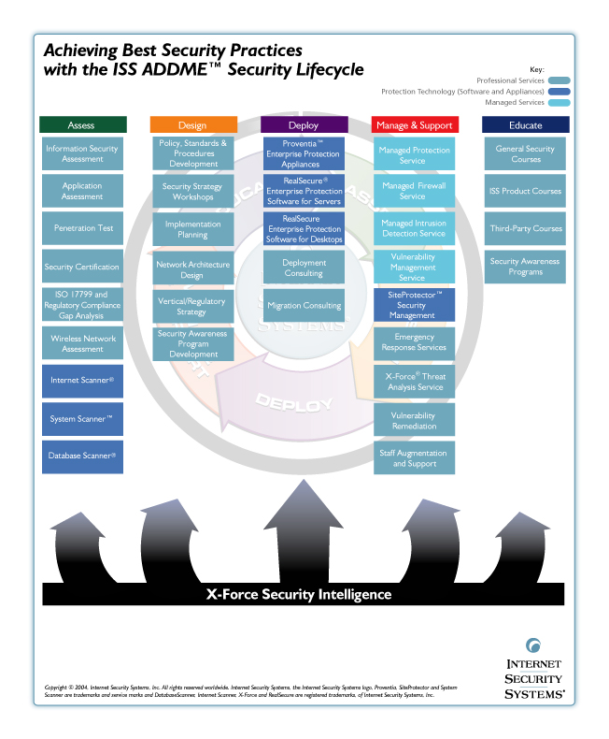

8.2 ADDME™ Phases

In order to streamline security and help meet your information security needs, ISS has developed a five-step methodology covering the complete security management lifecycle, including phases for Assessment, Design, Deployment, Management and Education (ADDME). The ADDME™ process identifies and analyzes gaps between the current security state and industry standards and best practices, designs and implements solutions to close those gaps and ensures that the gaps remain closed.
Phase 1: Assessing the current level of information security

This phase systematically identifies and baselines all network devices and resources. It assigns values to all data groups on the network. This results in a clear understanding of the gaps between the current network security state and industry standards, regulations, best practices, and SBC’s desired security level. From the assessment results, ISS can design an effective security policy and infrastructure for SBC.

Phase 2: Designing policies, processes and solutions to ensure protection

This phase converts the assessment data into lists of network security applications, deployment locations, implementation strategies and specific configuration guidelines for each network device or security application. At the completion of this stage, a final security policy document exists, accompanied by a deployment plan for all necessary technologies.

Phase 3: Deploying protection technologies and services

This is the process of implementing the plans and deploying the technologies detailed in the design phase. It includes the installation, the testing, the training and the conversion to a production environment.

Phase 4: Managing the security program to serve business goals

This involves measuring performance data from the network security infrastructure against the goals stated in the security policy. Non-compliant systems and events trigger specific actions, as stated in the policy, including re-evaluating the policy and restarting the policy generation process. This stage can manifest itself either as an in-house operation or, more commonly, as outsourced managed security services. It should include a detailed incident response plan.

Phase 5: Educating the organization on security best practices and superior technologies

This phase is an ongoing effort to raise awareness of the need for network security at the executive, management, administrator, and end user levels. Education is woven into all other steps, and includes both continuing training for administrators regarding emerging threats to their systems, and awareness among end users of the security diligence.

9.0 Price Quote Summary

ISS has provided price quotes for the follow services:

- Managed IDS – management of all “in-place” Proventia A IDS devices using our Managed Security Services.
- Managed IPS – management of all new Proventia G IPS devices using our Managed Protection Service.
- Managed Firewall – two managed firewall options are quoted: Select and Premium Firewall Service. These quotes are to manage “in-place” equipment. Content Filtering and Network Anti-Virus service add-ons are quoted in Volume Pricing Matrix.
- Managed Host Protection – Standard Host Protection for up to 500 servers. A Volume Pricing Matrix is attached to show pricing based on quantity purchased.
- Vulnerability Management Service – scanning service for one external Class C and 2,048 internal IP addresses

Proposal Terms and Conditions

ISS proposes that, if ISS is included in the competitive range or selected as the vendor of choice, its Master Agreement be used as the terms and conditions for any resulting transactions with NWC Inc. If there are additional terms or conditions that NWC Inc. requires, or modifications necessary to the Agreement, ISS agrees to negotiate mutually agreed terms with NWC Inc. ISS proposal assumes that neither the Solicitation nor ISS proposal will become a part of any resulting contract between the parties.

Copyright© 2006, Internet Security Systems, Inc. All rights reserved worldwide.
This document and the corresponding files referenced may contain information that is proprietary or confidential to the parties. The disclosure of such information is governed by the existing nondisclosure agreement between the parties.
Internet Security Systems, SiteProtector, Virtual Patch, and X-Press Update are trademarks, and the Internet Security Systems logo, Proventia, X-Force, RealSecure, and Internet Scanner are registered trademarks of Internet Security Systems, Inc. Other marks and trade names mentioned are the property of their owners, as indicated. All marks are the property of their respective owners and used in an editorial context without intent of infringement. Specifications and content are subject to change without notice.

