

OUTSOURCED SERVICES@GLOBIX PROPOSAL

Network Computing Inc.

Presented to: Presented by:
Bruce Boardman Shelagh Montgomery
Network Computing Inc. General Manager
206 Hines Hall Globix Corporation
Syracuse University 139 Centre Street
Syracuse, NY 13244 New York, NY 10013
315-730-9963 212-625-7566
bboardman@nwc.com smontgomery@globix.com

TABLE OF CONTENTS

- Executive Summary & Ability to Execute
- Environmentals
- Network
- Systems
- Application and System Expertise
- Service Levels
- Account Management
- Management
- List Pricing

1. Executive Summary

Client Objective
On behalf of Globix, we are pleased to submit our response to Network Computing Inc. request for a quotation of our services. As a premier hosting, media, and networking company, Globix has the capabilities necessary to deliver the services requested in a reliable, secure and cost-effective manner.

Since 1998, Globix has invested hundreds of millions of dollars in infrastructure assets including networking, data centers, resources, training, and transport related telecommunications assets. The managed hosting platform and Globix’s application management service are premium services which have the distinction of having placed first in the Technology Managers Forum’s Best Practice Awards Outsourcing Management category for work done for a financial firm based in New York. Globix delivers this same value on a day-to-day basis to all managed hosting clients and welcomes an opportunity to do so for your company as well.

Network Computing Inc. is searching for a managed outsourced solution for provisioning, networking, maintenance and systems support and needs 24x7 security, monitoring, management, and uptime. Globix is basing their response, technical solution, and support level based on these requirements.

Globix History
Globix was originally incorporated in New York in 1989 as NAFT International Ltd. In 1995, the company recognized the enormous potential and growing demand for Internet services and solutions, and thus began to implement a strategy to provide Internet solutions to businesses.

After an initial public offering in 1996, the company began the early development of its Internet business model and expanded to offer Internet access, Web Hosting, and Co-location solutions. Leveraging its considerable experience as a value-added solutions provider, Globix was able to provide customers with an end-to-end solution, enabling them to effectively utilize the Internet as a business tool. By 1997, Globix was recognized as one of the leading Internet solutions providers in the New York regional market serving major national and international corporations, local businesses and Internet start-ups.

In 1998, Globix embarked on a global growth strategy that included the construction of a high-speed, ATM fiber-optic backbone network connecting three advanced Internet Data Centers in New York, Santa Clara and London. These were financed through a series of bond, public and private offerings and began serving customers in the summer of 1999. This construction increased the total Internet Data Center space to 63,000 square feet and due to increased growth from 2000 to 2001 Globix built out and acquired additional Data Center space in New York City and London (listed below).

The events of September 11, coupled with turbulent market and economic conditions and the dot-com fall out, affected Globix as it did all participants in our market. As a result, Globix sought to greatly reduce its debt burden so that it would have the necessary liquidity to focus on the competitive advantage it enjoyed as a premium provider of complex hosting services.
In April 2002 after only 38 days, Globix emerged from its pre-packaged bankruptcy, having eliminated $600 million of cash-pay notes from the balance sheet. For the next year Globix continued to cut costs, restructure its business and generate revenue.

In October of 2003 it acquired managed services provider Aptegrity, Inc. The acquisition has become a key component of Globix's continued evolution into a full-service managed applications and hosting provider.

The sole focus of Globix’s managed applications division, formerly Aptegrity, is the monitoring, management, maintenance and enhancement of Internet-based applications and their supporting infrastructure. Its mission is to apply the best practices of the past 2 decades of Information Technology to the new and challenging environment of Internet applications. In so doing, Globix provides customers a competitive advantage and improves the way in which business is done.

In March of 2004 Globix announced a merger with NEON, an optical network provider in the North East and East Central region of the US. The strategic merger has benefited both companies greatly from a financial perspective and put Globix back above $100 million in revenue annually.

Globix maintains many important strategic partnerships, the most relevant of which for the Network Computing Inc. project are Hewlett-Packard, Microsoft, SUN, and Cisco. Should the client’s needs change or grow to include Oracle, DAM solutions or countless other technologies, Globix is in an excellent position to support these as partnerships exist with them all.

Globix employs approximately 380 people worldwide with offices in New York, New York, Santa Clara, California, and London, England.

Globix has over ten years experience in providing outsourcing services to its clients. This experience ranges from straight-forward collocation services and dedicated access, to managed hosting, managed security and backups to application management. Application management consists of database administration, custom code management, systems administration, content integration, monitoring, and performance scalability management.

We are happy to provide client references for similar outsourced solutions. Names and numbers will be provided as we are further along in the process. Clients include: The NY Post, J.& W. Seligman, and KPMG.
2. Environmentals

Globix services are tailored to environments which require 100% availability and scalability without significant infrastructure and overhead costs. Globix offers several solutions to minimize initial customer investment, with the ability to upgrade several optional services. All Globix Web Hosting services are provided from the Globix secure, state-of-the-art Internet Data Centers, utilizing 24x7x365 monitoring systems and the power of the Globix high-capacity network. Information is available to clients via a Customer Web Portal to allow continuous access to your system information and status.

Infrastructure
While infrastructure has become a commodity in many peoples’ minds since the dot-com bubble busted, Globix does not agree. Technology infrastructure is as important as the business application that runs on your equipment. Globix passionately subscribes to the philosophy of giving you to tools to succeed. Like our people, our infrastructure has been designed and built to give you the service on which you can depend.
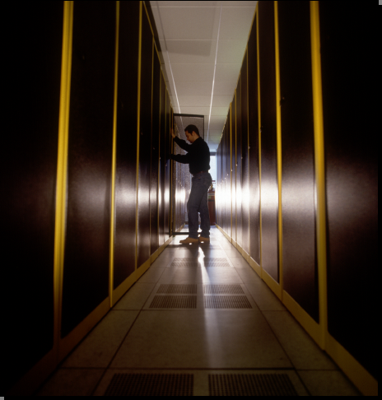

Jason Vitale, IDC Manager, works in the New York data center

Physical Security

The Globix security system incorporates distributed control with central monitoring located within the security center. The use of distributed control with central monitoring prevents tampering at any given point in the system without at least one other system being aware of the tamper. The three components of the Globix security system are a comprehensive state-of-the-art security system, trained security personnel, and closed-circuit television cameras. All primary entry and egress points have card access readers installed. All Internet Data Center and support system area entries have fingerprint biometric access devices installed. In addition, Globix security personnel staff the facilities 24x7, while roving security personnel constantly police the exterior of the premises.

Environmental Controls
Globix utilizes state-of-the art environmental control systems to maintain optimal temperature, humidity levels, and air quality for the operation of sophisticated electronic equipment in all of our SuperPOP data centers. Each of our New York, Santa Clara, and UK data centers have a minimum of n+1redundancy amongst its environmental control systems. This means that in the unlikely event of a complete failure of an environmental control unit or units, the remaining operational units are able to maintain optimal temperature and humidity levels even when the data center is at full capacity. Air filtration is accomplished via the use of both pre-filters and high efficiency air filters.

Fire Suppression
The Globix fire-suppression systems consist of both above and below raised floor detection systems, a central control panel, abort stations, and agent storage containers. The detection system is capable of detecting a fire condition prior to a visible smoke condition.

Electrical Infrastructure
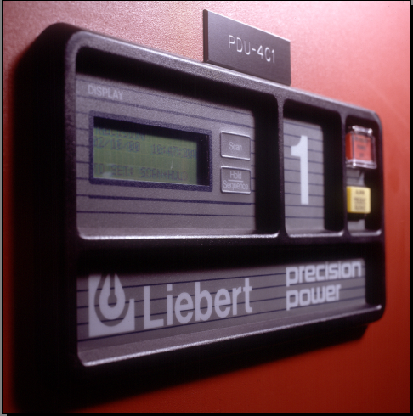
The Globix electrical infrastructure consists of two major components: a distribution system and an emergency power generation system. The distribution system is based on 20 Amp redundant diverse distributed power feeds consisting of demarcation power, power distribution units, static transfer switches, uninterruptible power supply systems, and a utility service bus. The emergency power system consists of automatic transfer devices, emergency service bus, and emergency power generation. The Globix grounding and bonding system is designed and installed to exceed the Telecommunications Industry Association standards.

In addition to these systems, Globix Managed Hosting systems employ specific power cycling equipment to quickly handle your requests for equipment resets.

3. Network

Managed Network
Managed Hosting clients receive the benefits of Globix’s Tier 1 trans-continental and Trans-Atlantic backbone. While Globix owns and operates its own network, Globix also peers with 400 global peering partners, some of which are the largest networks in the world including MCI, SBC, and British Telecom. As a part of the standard managed hosting offering, Globix provides the following service for customers:

- 100 Mbps Network Port
- 1 to 100Mbps Internet connectivity
- 8 to 32 IP addresses
- Free network peer exchange with over 400 global peering partners

Managed Firewall
Globix monitors and maintains a dedicated Cisco 506E or 515E firewall for your environment. During the presales process, your Globix Sales Engineer will review your requirements and advise you as to which firewall makes the best sense from a functional and fiscal perspective.

Site-to-Site VPN

Site-to-site Globix managed VPN is an option in the Globix’ managed hosting service. Globix is responsible for installing, configuring, and maintaining usernames and passwords and is available during business hours to mitigate any VPN issues.

Firewalls
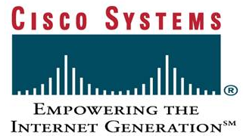
Globix has selected Cisco firewall appliances as the standard platform for managed hosting. As a founder in the industry, Cisco’s 506E and 515E allow Globix to make swift changes to your firewall as well as giving you the VPN capability you desire.

Security Services
Security is a constant concern. The challenge with security is not just keeping your environment secure but also keeping staff trained on mitigating the latest malicious threats that are cycling through the digital space. Our professionals are certified to manage your firewalls, hardening you servers, and keeping your server’s virus free.

We have not included full networking of all NWC Inc facilities as part of this proposal but these services can provide if desired.
A Globix network diagram is attached:

4. System

Included Hardware and Operating System Selections
Managed Hosting is a robust business solution in part because the equipment, licenses, and services are reliable, highly-available, and implemented by Globix so you don’t have to worry about ongoing management. Globix uses best of breed servers, operating systems and firewalls as part of your Managed Hosting environment. Firewalls include a rich feature set and come from security industry leader Cisco Systems.

Operating systems


Globix provides managed hosting clients the option of a suite of Microsoft server operating systems as well as Solaris and Linux Red Hat. Globix employs certified experts in building each type of server and Globix also provides you with a standard build that gives you the platform to start layer your applications on and begin extracting the value out of software.

Servers


Hewlett-Packard and Sun servers are the industry-leading hardware options for the Globix customer. While a great deal of the mid-market and large enterprises has gone with Intel-based Dell, Globix selected HP because through ten years of server management experience, Globix engineers understand the superiority and performance which HP offers over the rest of the Intel-based products. Globix is committed to holding the highest standards in performance and, as a result, we only provide HP servers that are configured with redundant fans and redundant CPUs insuring that you are always on.

Patch Management Reporting Service
Operating Systems are updated frequently to keep up with security and performance concerns. As patches become available, you are notified via the Globix Customer Web Portal that a patch affecting your environment is available for installation. The reporting service shows you the severity, provides information about what the patch does, and verifies the patch does what it claims to do. Full administrative rights to the operating system remain with our clients unless Globix Operating System Management is selected, in which case you still receive the benefit of notification of any new critical patches within 24 hours to keep your sites secure and functional. Take the guesswork and complexity out of keeping securely up to date with the Globix Patch Reporting Service.

Monitoring Services
Globix Managed Hosting includes a full suite of monitoring tools combining enterprise-grade software including NetCool and HPOpenview. Globix monitors operate continuously in the background, ensuring your site’s availability, performance, and predicting trouble before it occurs.

Your business is monitored thoroughly with the following list of included monitors:

- Port Monitoring
- HTTP Monitoring
- Device Monitoring
- Hardware Monitoring for Intel Systems (Hewlett-Packard Insight Manager)
- Empire SystemEDGE Threshold Monitoring
- 7x24x365 Alerts via Email, Pager, Phone
- Bandwidth Utilization Monitoring
- Backup Reporting

Server Hardening
After a standardized installation of the O/S on your managed server, Globix performs a system security scan using Qualys, an industry leading security scanning service. Our certified Qualys technicians are trained to not just perform the scan, but also on how to evaluate your report to insure that the server is delivered a solidly configured server.

Virus Protection
Anti virus protection agents are installed on every server Globix deploys. These agents are monitored by Globix 24x7 for any signs of undesired activity. Clients may also monitor these agents.

Managed Backup
Globix provides 50GBs of backup services utilizing Legato backup software included with this solution. Backup is accomplished using a high speed dedicated backup to disk network that allows for reliable data retention and restores up to 50% faster than tape. Data is retained onsite for 30 days, and the back up schedule follows daily incremental and weekly full backups.

Your servers come preconfigured with Legato installed and connected to the central backup network. Through the implementation process you will be asked for your requirements and after that Globix storage engineers execute against your requirements.

Offsite tape and/or disk backup services are available for long term retention.

5. Application and System Expertise

In addition to the systems expertise described in Section 4, Globix provides remote management of custom and off-the-shelf web-based applications on any server, anywhere, at any time. By managing such complex e-commerce, database, content management and customer relationship management software for its clients, Globix helps them to protect Internet revenue streams, reduce technology operating costs and operating risk, and improve user satisfaction. These are all services which Network Computing Inc. can leverage should they so chose.

All processes and procedures provided by Globix adhere to ISO certified standards and are defined as such. Globix maintains a Knowledge Management System as a repository for all standardized procedures. Among the procedures used in client engagements are:

- Application monitoring procedure
- Method overview
- Audits
- Business planning
- Call center procedure
- Change request procedure
- Client relationship management
- Content integration
- Corrective and preventive action
- Corrective maintenance
- Client support
- Customer satisfaction
- Document and knowledge management
- Incremental enhancement procedure
- Infrastructure change procedure
- Infrastructure management
- Management review
- Partner relationship
- Performance testing
- Project management
- Quality assurance
- Service delivery
- Service level reporting
- Software configuration management

Globix has internal application expertise in the following technologies:

3rd Party Applications & Frameworks
ATG Dynamo, Atomz, ColdFusion, Interwoven, Microsoft Commerce/Site Server, MQ Series, Vignette, WebMethods

Application Servers
BEA WebLogic, JRUN, iPlanet, IBM Websphere, COM+/MTS, BizTalk

Operating Systems: Solaris, Windows 2000/NT/2003, Linux, HP–UX

Web Servers: Apache, IIS, iPlanet, Web Proxy, SSL

Databases: Oracle, SQL Server, Informix, mySQL/mSQL, Sybase

Frameworks / Languages
.Net (C++, VB.Net, ASP.Net, Web Services), Java, JavaBeans, JSP, EBJ

Reporting: WebTrends, Crystal Reports, Actuate

Testing and Monitoring: Keynote Web Integrity/Test Perspective, Segue, LinkBot, WebKing, HP OpenView, SiteScope, SysEdge, Keynote Web Site Perspective, WebTrans

Configuration Management: Visual Source Safe, Rational Clear Case, PVCS, RCS, CVS

Over 40 Globix employees are exclusively dedicated to supporting applications and systems. This group of systems professionals are certified in various technologies and include: CNEs, CISSPs, MCSEs, MCPs, GIAC Certified Incident Handlers, SCJPs, CCSE+s, and CCMSE+VSXs. An additional 60 employees support the network infrastructure and first tier customer care issues.

Globix facilities and solutions carry the following certifications:
HP Certified Partner
MS Certified Partner
Cisco Authorized Reseller and Certified Partner,
Qualys Certified Partner
SAS 70

6. Service Levels

Globix Managed Hosting Services are built on a solid foundation including 16 years of industry experience, technical innovation, and SLA guarantees. Our people, policies and procedures allow us to offer SLAs that are clear and without hidden legal clauses. At Globix you will find a firm that is filled with people who love technology and are prepared to stand proudly and deliver against our SLA.

Availability

Your business is online and ready for customers 24x7. Globix guarantees your customers can always reach you with a Network Uptime and availability guarantee of 100% and at least 99% sustained packet throughput. Globix guarantees an average round trip latency of not more than 120 milliseconds, as measure as round trip times taken between core routers within the Globix POP facilities within the continental US. The network Service Level Agreement is spelled out in detail in your Master Services Agreement (MSA).

Hardware Replacement
Globix Managed Hosting equipment comes from quality manufacturers, is designed to operate 24x7 without interruption, and is part of systems and processes that allow your customers to continue doing business with you regardless of any technical issues related to hardware. Many times, automated monitoring systems will provide predictive information about hardware performance that allows Globix to replace hardware before problems become critical. In situations where hardware replacement is required, it can often be done without interruption to your business. Globix guarantees to notify you and to be ready to begin work quickly.

Firewall Rule Changes
Security keeps your business in business. When you require changes to the type of access allowed to your site, you are able to instruct Globix specifically how to change access at your firewall. Your Service Level Agreement spells gives details about the types and hours supported.

Power Cycling of Equipment
Some changes you make to your environment require hardware power cycling before they take effect. Managed Hosting includes a fast and easy process to have this work done 24x7.

The above attachment is the full Service Level Agreement and associated restitution.

The following Response Expectation Table specifies the level of response that will be given to a client issue at each step of the process based upon the assigned severity of the problem.

Acknowledge is defined as Globix’s acknowledgement via either email or telephone of client’s problem and the beginning of information gathering process.

Resolution Goal represents the time frame by which either a “fix” or a plan for achieving a fix is provided. A fix is defined here as a temporary or permanent patch, correction, or workaround.

Response Expectation Table
SEVERITY | CLASSIFICATION | ACKNOWLEDGE | RESOLUTION GOAL
Severity 1 | Critical | Within 15 mins | Within 3 hours
Severity 2 | Serious | Within 15 mins | Within 1 day
Severity 3 | Degraded | Within 15 mins | Within 1 week
Severity 4 | Minimal | Within 1 hour | On a time available basis

Additionally, Globix is willing to commit to the following escalation process/commitment: All problems with a severity level of 1 will be escalated if a solution or plan of resolution cannot be achieved within the designated amount of time as described above. This escalation path is as follows:

GLOBIX MANAGEMENT ROLE | NAME | ESCALATED IF PROBLEM NOT RESOLVED BY
Client Relationship Manager | TBD | Resolution goal
Service Manager | TBD | Resolution goal + 3 hours
Service Director | TBD | Resolution goal + 8 hours

Globix requires that as succeeding levels of Globix management become involved in the resolution process, the client must provide contacts at similar levels within their organizations, to ensure that the level of management involvement matches the decision-making level dictated by the resolution requirements of the problem.

7. Account Management

Standard Offering
Globix Managed Hosting Service is a package of essential services and equipment that Globix manages. Installation is fast and efficient once Globix receives your Customer Information Forms. These customer information forms are attached to this RFP and your Account Executive and/or Sales Engineer will help you complete these forms. Once completed, the process of provisioning and configuring your server begins within 24 hours.

Account Team
Your Globix Account Team will consist of the following individuals:

Account Manager - <NAME>
Account Executive - <NAME>
Sales Engineer - <NAME>
24x7 Globix GNOC Team

This dedicated team is supplemented by additional Globix Technical Staff for Systems Operations, Network Operations, and Systems Administration. Together they keep your business online, secure, and running efficiently.

Kick-Off Meeting
Managed Hosting incorporates many technical components and will fully support your business objectives. To ensure everything is built to your specification, works reliably, and is explained clearly, Globix meets with you to ensure all your questions are answered and that you are satisfied with your new business environment. Your site does not go online until you approve its operational status. Your Account Team will be in touch to set up this meeting as your site is being installed.

Customer Information Forms
Each service comes with configuration options. These configurations will determine exactly how your business environment operates. For example, your firewall rule set is applied and tested during setup, determining the base security level for your environment. Your rule set is communicated to Globix via a Customer Information Form. Subsequent changes to your firewall rule set will also be documented via these forms.

Standard Run Book
You receive Call Center support staff will reference this snapshot of your environment as needed to quickly and effectively understand, support, troubleshoot, and escalate your services. When you add service elements, change configurations, or company contact information, it is reflected in your run book.

Quarterly Account Review
Over the course of this engagement Network Computing Inc. and your Globix Account Managers will meet quarterly to review your overall satisfaction level, review performance versus the Service Level Agreements, plan for remediation if necessary, and identify the enhancement or necessary changes that need to be addressed in the following quarter.

These sessions help to ensure that you are receiving the services that fit your business. As new initiatives appear, Network Computing Inc. and Globix will define and document the requirements so they may be implemented smoothly.

Post Sales Expectations
As a client you will immediately begin working with your account manager on implementing your managed hosting solution. The turn-up process has been carefully designed with you, the customer in mind. The process has several checks and balances, through customer forms and project management, to make certain that what you are delivered is what you want. You can expect to be treated as a valued client whether you have one server or twenty managed hosting servers.

Account Management
When Network Computing Inc. becomes a Globix customer the account relationship will be led and managed by a named Account Manager who will serve as Network Computing Inc. ’s single point of contact for non-emergency issues and for the delivery of all services being provisioned. In addition, the Account Manager ensures your technology questions are addressed and that any issues are aggressively pursued.

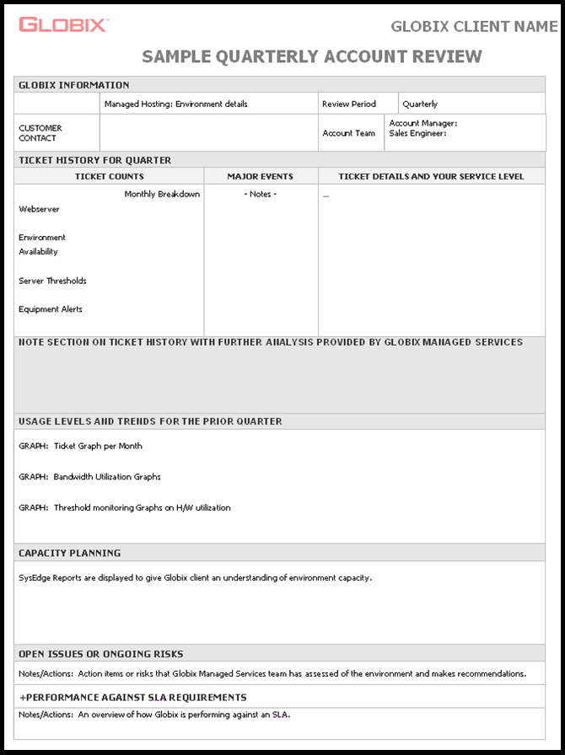

8. Management

Standard Process
We implement Managed Hosting by following a standard turn-up process. This ensures you get a timely, high-quality installation in a short amount of time. Your Account Team can give further details on the specific steps and procedures.

Quality Assurance
Following a proven installation process is one of the best ways to ensure you get the quality installation you deserve. As a last step to your installation, we check the security and availability of your environment with your configurations applied—just as it will be when you do business on the internet. That test is reviewed and, if needed, changes are applied to increase security or performance. When all components in your Managed Hosting environment are ready and configured properly, you will receive an information packet to keep for your reference. Globix stores a snapshot of your installation, services, and configuration into your individualized Run Book.

Change Management
Keeping your Managed Hosting installation up to date with your latest business requirements translates to success process here at Globix. Globix policies and procedures ensure change is implemented correctly by carefully and tactically following best-practice standards while also staying in close touch with you and your team.

Control
You are in control. Network Computing Inc. maintains the root password to the operating system. You are able to add and remove user accounts, configure system parameters, administer services, and install applications on each of your servers. Additionally, you may choose to have Globix supplement your IT team by performing these and other technical functions for you.

Customer Web Portal

You receive access to your individualized website where you are able to monitor your site services, receive critical updates, review product choices, and communicate to your Globix Account team. Your Web Portal is the hub for your site’s activity and your 24 hour information center

Provisioning
Getting your business up and running quickly and reliably is important. Globix speeds the process of setup, configuration and making your server securely available on the internet by using a standardized environment build. We remove the variations and time consuming portions of typical server deployment through automation and predefined operating system configurations. Once installed, you will receive notification and a status report. The final step in provisioning is to ensure your environment is safe. Globix security engineers run and review tests to harden and secure of your server solution. Receiving this verified document is your assurance of sound preparation and safety.

Customer Support
In addition to a dedicated account team, Globix has a staff in its 24x7 Global Network Operations Center ready to assist you by phone and/or email. This staff does not sit and wait for you to reach out to them as they are trained to actively monitor system alerts so Globix technicians can proactively reach out to you and notify you of an issue. We also staff our data centers around the clock with engineers that can be ready to meet our four hour SLA guaranteed full hardware replacement.



Inside the Globix Global Network Operation Center

Solution Diagram

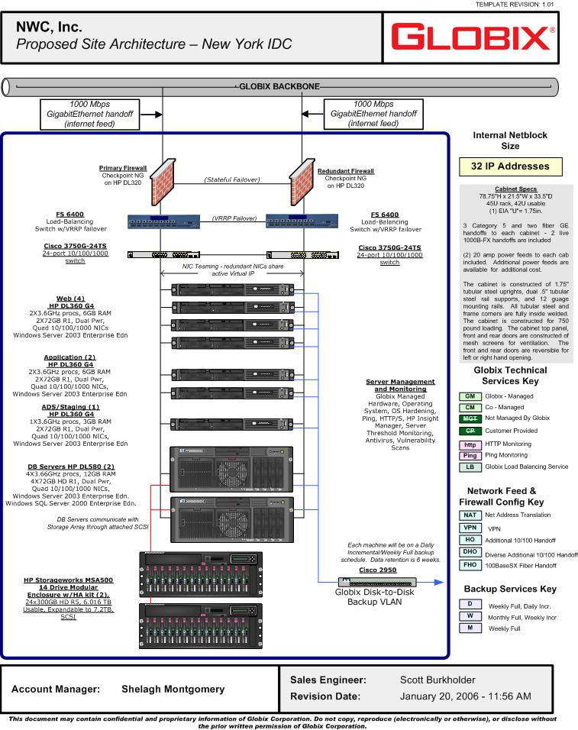

9. List Pricing

Detailed line items and associated pricing are attached in the following spreadsheet. Pricing assumes a 24 month term but can be modified to accommodate the term of NWC Inc.’s choice.

This proposal reflects a solution based on high-performance, resiliency and guaranteed uptime; all with an acute focus on expandability to meet the growing ecommerce needs of NWC’s business.

Globix offers network bandwidth in the multiple Gigabit per second ranges; the proposed design allows leverage of that capacity as needed. All components are Gigabit capable and deployed in high-availability structures. Globix maintains an abundance of new spares in inventory for immediate replacement should a component fail. In the event that spares are not available, Globix also purchases 4-hour vendor response for all of our managed appliances. The entirety of this hardware and associated services are supported by Globix technicians on a 24x7 basis, all backed by an SLA.

- Industry leading HA Check Point firewalls utilize stateful failover should any single component fail. Capable of full Gbps speeds with acceleration cards.

- Globix chooses F5 Big-IP 6400 load balancers based on raw performance, customizability of application data delivery, and management capabilities.

- NIC-teaming is utilized for all servers. A set of NICs share the same MAC and IP address allowing immediate remediation from a switch or network segment failure.

- Web servers are grouped in four to accomplish increased performance and resiliency. Users will access the site via a virtual IP address and the load-balancer will send each request to the appropriate web server based on tunable metrics. We have chosen Windows Server 2003 Enterprise Edn for the OS for improved compatibility with the recommended application and database servers. The per-processor model is selected to prevent licensing limitations based upon number of customers.

- Application servers are paired for performance benefit and resiliency. These are intended to run both IBM WebSphere and NWC’s financial Great Plains application.

- We have added an ADS server, allowing additional functionality as a staging server.

- The database servers are high-end quad processor machines in a clustered pair capable of very high performance. Windows SQL Server 2000 Enterprise Edn is chosen to provide true Active/Hot-Standby with strong mechanisms for database replication and log-shipping for DR deployments.

- The database servers will share database information in the storage array partition. Initial deployment will support a database size of 6TB allowing immediate growth beyond today’s database size of 4TB. Simply by adding 4 additional drives, the size can reach 7.2TB. Storage estimates are based upon RAID 6 using two hot spares. The database servers communicate with the storage array via directly attached SCSI connections.

All bandwidth and disk-to-disk data backup requirements are included in this solution.

