
The following information will help us profile your company in our Service Management Analysis. We reserve the right to publish all answers returned in print and on our Web site. If your company has additional material in the way of research, white papers and demonstrations that you feel would be helpful, please include it. If your have questions contact Bruce Boardman via email bboardman@nwc.com. Companies that decline to answer questionnaire may still be included in the article, at the author’s discretion.

June 22 Service Management Survey

1. Please provide at least two reference customer contacts for interview.
- Interviews will take place between NWC and the customer without the vendor.
- The interview will be used to understand Service Management issues, challenges and strategies
- We can shield the contact’s identity by saying, for example, “an IT manager for a 10,000 employee manufacturing firm.”

2. Describe your Service Management features architecture regarding:
- Automation
3. Please provide an annotated architectural diagram in jpeg or bitmap format.

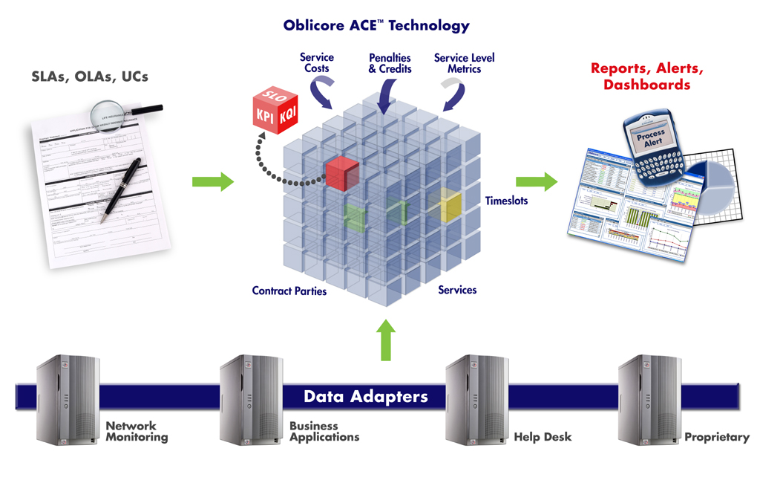
Oblicore Guarantee starts by mapping the business and operational terms of your service delivery obligations and objectives. It then aggregates data from all relevant, underlying data sources and correlates that data against the terms of your contracts. This process yields a series of reports, alerts and SLA dashboards.

4. Please provide Service Management metrics reported/measured by product, categorized by the following:
- Technical IT infrastructure, i.e. CPU, IO, MTTR
- Financial impact of service
Oblicore utilizes all service performance metrics that are incorporated into SLAs, including metrics related to both availability and performance. Oblicore Guarantee can also calculate penalties and credits, as necessary.

5. Please provide figures on units sold, delivered, customers serviced, etc.

6.Product pricing:
- High and low ranges
$100K to $1 million+

- Average initial purchase
Varies by region.

7. Please provide project implementation planning guidelines.
Most Oblicore implementations follow a successful “pilot”. Over 95% of pilots transition to full-blown implementation. Oblicore boasts 100% customer retention.
Whether implementing a pilot or a production implementation, the following major steps are followed:
- Kick-Off Meeting
- Design
- Configuration
- Testing
- Deployment
- Training
- Acceptance
Oblicore Professional Services Consultants can also help customers that are just getting started in developing SLAs by promoting “best practices” for SLA development. Oblicore provides a series of SLA templates to accelerate the creation and management of SLAs.

8. Describe your Service Management product roadmaps – including market segmentation and underlying assumptions like required customer process maturity – for the next 2 years.
- Benefits of your Service Management solutions to IT and to the business.
- Organizational profiles of businesses that will best be able to take advantage of your Service Management offering(s). Include factors such as size of business by gross revenue, market, industry, technology deployed, and processes implemented.
Oblicore’s Product Roadmap is confidential and not available for public consumption.

9. Describe your company’s market presence, including the following:
- Number of customers
Over 45 customers.
- Service management revenue for fiscal year 2005
Oblicore is a privately-held company and does not disclose financials.
- Recent acquisitions, partnerships and technology developments related to service management
No major acquisition, partner ship or technology development announcements at this time.
- Third-party indicators of market leadership (for instance, analyst rankings or awards)
In 2005, Gartner published a “Cool Vendor” report related to “IT Service Portfolio Management”, which includes SLA Management and Reporting as a subset of that category. Of all of the vendors listed in that report, Oblicore has more customers in production than any other vendor.
Oblicore maintains that it is the largest “pure play” SLM vendor in the world. Other vendors (i.e., HP, CA, IBM, etc.) may achieve higher revenue from SLM-like capabilities. But of those vendors that are 100% exclusive to the SLM space, Oblicore believes it has more customers, revenue, and worldwide office locations than any other vendor that is dedicated to the SLM market space.

