The following information will help us profile your company in our Service Management Analysis. We reserve the right to publish all answers returned in print and on our Web site. If your company has additional material in the way of research, white papers and demonstrations that you feel would be helpful, please include it. If your have questions contact Bruce Boardman via email bboardman@nwc.com. Companies that decline to answer questionnaire may still be included in the article, at the author’s discretion.
Please RSVP by March 27

June 22 Service Management Survey

1. Please provide at least two reference customer contacts for interview.
- Interviews will take place between NWC and the customer without the vendor.
- The interview will be used to understand Service Management issues, challenges and strategies
- We can shield the contact’s identity by saying, for example, “an IT manager for a 10,000 employee manufacturing firm.”
1. AARP (American Association of Retired Persons): Leverages Mercury Application Management for their Business Service Management initiative.
2. Neustar: Depends on Mercury offerings for End to End Change and Configuration Management with consolidated IT Governance and integrated Application Management
3. Quixtar: Powers their Change and Configuration processes for critical business services by using Mercury solutions
4. Liberty Mutual: Offers end to end Service Management visibility and control to executives on critical production services delivered to the business with Mercury.
5. First American: Provides visibility into critical business services by managing availability and performance of those services and reporting on service levels using Mercury solutions.

2. Describe your Service Management features architecture regarding:
- Automation
- Demand Management automation: As opposed to just automating reactive service requests coming into the help desk, Mercury can help with the automation and aggregation of strategic, tactical and operational demand into the service organization and provide a comprehensive view into their request and priorities. With this visibility, senior management and line managers in IT can proactively act on complete information and manage by business priorities instead of reacting to urgent requests.
- Process automation – “digitization of key process steps” for reporting, management, control and audit. Workflow Automation built on ITIL-based processes
- Corrective actions – In Mercury Infrastructure Management, monitoring scripts allow automation of corrective action (restart servers, change cache settings, etc.)
- Integration

- Integration with Help desk & Service desk systems such as Mercury Demand Management, BMC Remedy, HP Service Desk, and Peregrine Service Center are out of the box with native adapters.
- Integration with EMS (Management tools such as IBM Tivoli, CA Unicenter, BMC Patrol and HP Openview, Micromuse NetCool, among others).
- Integration with change control systems and process tools.
- Integration and Federation with CMDB and asset repositories such as home grown databases.
- Processing

3. Please provide an annotated architectural diagram in jpeg or bitmap format.

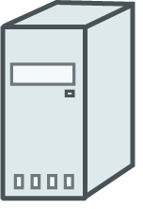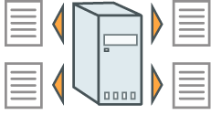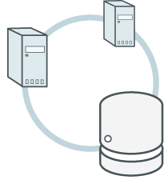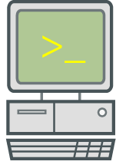
ITG Demand Management
Strategic
Projects
Application Changes
Service
Desk
Business Availability Center
(Business Service Management)
Business
Service Level
Management
Availability and Problem
Management
Change and
Configuration Management
Financial
Management
Federated CMDB
Application Mapping
Application Change Lifecycle
Time, Resource, and Project Management
Role-based Dashboards and KPIs
Leverage existing tools
Infrastructure
ITG process
automation
Assets
Source Code Mgmt
Software Distribution
NSM Platforms

4. Please provide Service Management metrics reported/measured by product, categorized by the following:
- Technical IT infrastructure, i.e. CPU, IO, MTTR
- Mercury tracks over 350 different metrics across various tiers in five broad categories:
- System metrics - CPU, Memory, Disk Space, etc.
- Network & Database metrics – Queries, Main, DNS, Ping, etc.
- Application metrics – Weblogic, SAP, Siebel, Websphere, MQSeries,
- User Performance metrics - Response time, Network latency for user, Round trip time
- Process and Operational Metrics around Incident and Problem Management processes
- Custom KPI (Key Performance Indicators) – Business metrics tracked by customer
- Financial impact of service
Most Mercury customers have implemented the solution for tracking internal metrics in three areas:
  - Resource utilization: scheduling, time management
  - Asset utilization: Consumption, leverage utilization, shelfware consumption
  - Project utilization: Resources, time and deployment metrics for on time delivery
  - Strategic Financial Management around portfolio and demand
5. Please provide figures on units sold, delivered, customers serviced, etc.
Mercury Service Management offerings have thousands of customers in all major vertical industries. Mercury is the only vendor to be awarded the SSPA best software support organization award for over 4 years in a row:

http://www.mercury.com/us/company/pr/press-releases/041904webstar-award.html

Mercury Managed Services (MMS) provides Mercury’s application management, application delivery, and IT governance products as a hosted service through the internet. As part of the service, Mercury deploys a team of experts to help customers remotely manage the performance and availability of business-critical ERP, CRM, and custom applications. On average, Mercury Managed Services can help customers achieve initial time to value on their IT initiatives in weeks or even days.. For more information on Mercury Managed Services visit:

http://www.mercury.com/us/services/managed/business-availability-center/

6.Product pricing:
- High and low ranges

- Mercury Service Management implementations range from an initial End User Management purchase for $100,000 to a complete end-to-end Service Management offering in the million dollar range.
- Average initial purchase
- Average initial purchase starts in the $100,000 range.

7. Please provide project implementation planning guidelines.
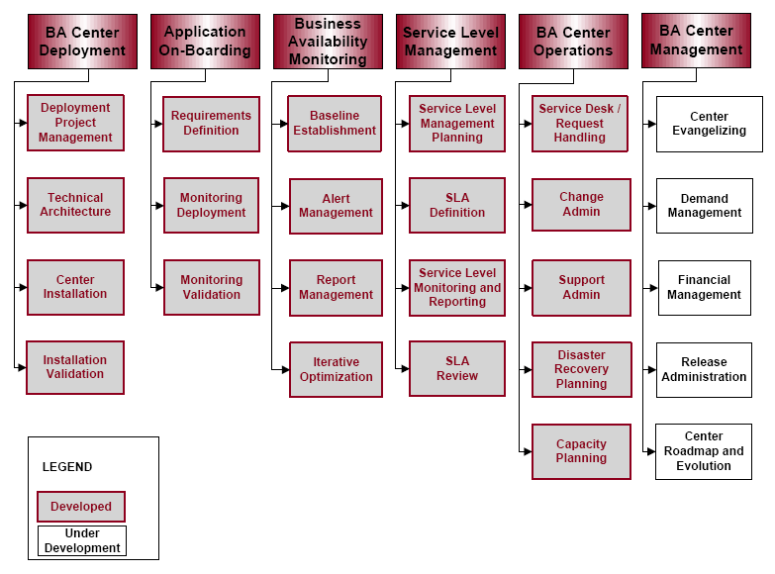

Mercury provides three types of best practices: Process, Product, and People Best Practices.
Process Best Practices describe a set of processes for the implementation, operation, and management of a center. The Process Best Practices are organized around a set of top-level processes, each one containing a set of sub-processes. Each sub-process describes a set of steps for the implementation of a goal.
Product Best Practices are technical documents containing detailed technical instructions in support of implementing a goal. The goal is dictated by a sub-process, and therefore the Product Best Practices are in support of the Process Best Practices. For example, within each center’s deployment top-level process there is a sub-process called center installation. Its goal is to define the installation of a center’s hardware and software. It describes a set of steps required to purchase the hardware, secure the software and licenses, open change requests, secure technical assistance, etc. In support of this process, there may be one or more technical documents describing the best way to configure the center or deal with security issues.
People Best Practices deal with issues surrounding roles and responsibilities, suggestions on assembling an optimal organization, training and certification, and skill assessment.
Best Practices are comprised of multiple components:
1. A process map that describes, at a high level, the process that is described by the best practice.
2. A series of steps for implementing and deploying the process or sub-process. The steps describe specific guidelines that describe the Mercury-recommended approach for any of the processes or sub-processes under different circumstances (e.g., perform a smoke test every day during the last month before an application’s scheduled release).
3. Specification of the roles required for the processes.
4. Artifacts or supporting documents that are used in the process (for example, an interview questionnaire or a requirements template).
5. References to relevant articles and user documentation.
Wherever possible, Mercury Best Practices use or implement ITIL best practices.

Process Map Top Level Descriptions
The Business Availability Center process map presents a high-level view of all of the Business Availability Center top-level processes. To balance between comprehensiveness and overview, some details may have been omitted. The actual flow of sub-processes together with additional process-level details may be more complex and is presented with additional detail in the appropriate section of Mercury Best Practices.

Business Availability Center Deployment
The goal of this process is the deployment of Business Availability Center and its components. It does not concern itself with monitoring activities. The Deployment Project Management sub-process addresses project implementation methodology. The Technical Architecture sub-process ensures that based on the initial customer requirements, appropriate servers are configured and Business Availability Center services are distributed appropriately. The Center Installation sub-process ensures that all components are installed correctly and according to Mercury Best Practices. Finally, the Installation Validation sub-process ensures that the system operating correctly.

Application On-Boarding
The goal of this process is the enablement of application monitoring. This process works hand-hand with the Business Availability Center Management process. Requests for monitoring are received and evaluated through the Demand Management sub-process of Business Availability Center Management. Once a request has been accepted, approved, and scheduled, it undergoes the formal Requirements Definition sub-process, followed by design and implementation within the Monitoring Deployment sub-process. The process is completed by the Monitoring Validation sub-process, which ensures the proper operation of the implemented monitors. The process explicitly does not concern itself with the value derived from monitoring.

Business Availability Monitoring
The goal of this process is to ensure value realization through ongoing availability improvements. It first establishes a baseline of availability. Based on this baseline, the Alert Management sub-process establishes thresholds for alert generation and incidents to be reported to a service while the Report Management sub-process evaluates and reviews availability reports. The Iterative Optimization sub-process monitors the availability reports and sets in motion sub-processes for improvement by setting up new availability and performance goals, tuning the infrastructure and defining deeper and wider monitoring targets based on lessons learned.

8. Describe your Service Management product roadmaps – including market segmentation and underlying assumptions like required customer process maturity – for the next 2 years.
- Benefits of your Service Management solutions to IT and to the business.
Benefits to the business:
- Ensuring End User quality of service (QOS)
- Proactive application monitoring and effective diagnostics mitigate the risks and costs associated with outages by reducing the number and duration -- minimizing the impact on end user productivity.
- Managing business impact of service level performance leads to greater customer satisfaction.
- Automated service level reporting will reduce costs by lowering the level of effort associated with consolidating, reconciling, reporting, and distributing Service Level Reports.
- Managing all changes with visibility into Business Impact and collisions reduces the risk to Business Critical applications due to change.

Benefits to IT:
- A set of applications, dashboards, and reports understandable to the business. IT spends less time explaining and translating infrastructure impact to the business.
- Cost effective application monitoring reduces costs by eliminating the need to maintain and support homegrown solutions.
- Reduced Mean Time to Repair by being able to identify, isolate, diagnose and fix the problems quicker.
- Effective application mapping reduces costs by reducing the number and duration of change impact review sessions required each day to assess medium to high risk change requests.
- Proactive application monitoring and effective diagnostics contain IT costs by reducing number and duration of outages -- thereby reducing the level of effort associated with problem identification and resolution.
- Proactive end user monitoring reduces costs by minimizing the number and duration of bridge calls related to business critical application problem.
- Automated application mapping reduces costs data collection and assessment for data center consolidation initiatives.
- An enforceable, automated change management process leveraging the CMDB for Service Dependency Mapping helps prioritize change management and minimize production issues due to changes.
- Organizational profiles of businesses that will best be able to take advantage of your Service Management offering(s). Include factors such as size of business by gross revenue, market, industry, technology deployed, and processes implemented.
- Mercury Service Management offerings are modular to fit the needs of mid-sized and departmental customers and large enterprises.
- Mercury solutions are most effective when the customers previously had problems deploying framework tools which took over 18 months and delivered little value to the business. Processes implemented include: ITIL for Service Delivery and Service Support including Change, Configuration, and Release Management.

9. Describe your company’s market presence, including the following:
- Number of customers
- Mercury has tens of thousands of customers worldwide. Mercury is one of the largest enterprise software companies in the world. Fortune 100 companies, and a number of government agencies globally rely on Mercury to fulfill their BTO strategies.
- Service management revenue for fiscal year 2005

- Mercury does not break out service management revenue

- Recent acquisitions, partnerships and technology developments related to service management

- SAP to Provide Customers with Business Technology Optimization Software from Mercury
http://www.mercury.com/us/company/pr/press-releases/121305-sap-reseller.html

- BEA and Mercury Offer Joint Lifecycle Solution for Application Optimization
http://www.mercury.com/us/company/pr/press-releases/120805-bea-mercury-joint.html

- Mercury to Acquire Systinet to Capitalize on High-Growth SOA Market
http://www.mercury.com/us/company/pr/press-releases/010906-systinet.html

- Mercury Announces BTO Core Technology Acquisitions http://www.mercury.com/us/company/pr/press-releases/091205-beatbox-intuwave.html

- Mercury Unveils Mercury BTO Enterprise
http://www.mercury.com/us/company/pr/press-releases/101005-a-bto-enterprise.html

- Mercury Announces Mercury Business Availability Center 6.0
http://www.mercury.com/us/company/pr/press-releases/101005-e-bac6.html

- Mercury Showcases Breakthrough in Application Problem Resolution
http://www.mercury.com/us/company/pr/press-releases/041206-rum-diagnostics.html

- Mercury BTO Software Receives Certification for ITIL Support
http://www.mercury.com/us/company/pr/press-releases/081105-pink-verify.html

- Third-party indicators of market leadership (for instance, analyst rankings or awards)
Gartner:
- 2005 Magic Quadrant for Application Quality Ecosystem – Leader
- 2005 Magic Quadrant for J2EE Application Server Management – Leader
- 2005 Magic Quadrant for IT Project and Portfolio Management – Leader

Forrester:
- Forrester Wave™: Application Mapping For The CMDB, Q1 '06 – Strong Performer
- The Forrester Wave™: Project Portfolio Management, Q1 2006 – Leader
- Forrester Wave™: Automated Functional Testing Tools, Q1 '05 – Strong Performer/Leader

IDC:
- Worldwide Distributed Automated Software Quality Tools 2005-2009 Forecast and 2004 Vendor Shares – Leader (uncontested)
- Worldwide Distributed Automated Software Quality Tools 2004-2008 Forecast and 2003 Vendor Shares. – Largest and fastest growing vendor

