The following information will help us profile your company in our Service Management Analysis. We reserve the right to publish all answers returned in print and on our Web site. If your company has additional material in the way of research, white papers and demonstrations that you feel would be helpful, please include it. If your have questions contact Bruce Boardman via email bboardman@nwc.com. Companies that decline to answer questionnaire may still be included in the article, at the author’s discretion.
Please RSVP by March 27

June 22 Service Management Survey

1. Please provide at least two reference customer contacts for interview.
- Interviews will take place between NWC and the customer without the vendor.
- The interview will be used to understand Service Management issues, challenges and strategies
- We can shield the contact’s identity by saying, for example, “an IT manager for a 10,000 employee manufacturing firm.”

2. Describe your Service Management features architecture:

Alive Integrity Manager provides a unifying view into the operational “health” of business-critical Services that cross multiple domains in your IT infrastructure. Alive visualizes the specific chain of IT components involved in a given Service, eliminating the need for manual filtering and correlation of events and data in the usual case where they are displayed in separate silo tools. Alive’s intuitive dashboards guide you from 1) an overview of the state of all managed Services to 2) a holistic view of the cross-silo states of each Service to 3) a drill-down into the state of the devices involved in each service to 4) detailed metrics for the relevant devices.
Alive learns what’s normal and “who owns what” in order to detect abnormalities and assign responsibility for correcting them with an Integrity Alert™. Integrity Alerts are sent when a device is out of normal and an associated Service is being impacted.
Alive also learns to identify events that precede problems as a “Problem Fingerprint” in order to deliver early warning and recommend your best practice for resolving the issue to the right expert. Other products pass these through as an alert storm, but Alive’s Correlation Engine performs real-time comparison of stored fingerprints to the incoming stream of events. When a match is found, the name of the problem, time to occurrence, and recommended resolution for the class of problem identified is sent to the appropriate individual for rapid resolution. By learning from a history of system metrics and correlated events, Alive simplifies identification of problems associated with IT-based business services.
Automation
Automation of troubleshooting. Unlike Business Service Management tools that diagram business services and report on potential business impacts and historic service levels, Alive automates real-time analysis of the components involved in a service to alert organizations to emerging abnormal behavior in order minimize business impact and optimize service levels. Instead of a passive repository for post-mortem reference and reporting, Alive’s service map drives real-time troubleshooting.
Automation of threshold setting and abnormal behavior detection. Detecting abnormal metrics is difficult because what’s “normal” changes based on the dynamics of the end-to-end system load. Static thresholds are thus difficult to set and can only detect abnormal behavior at a “high-water mark” condition. Alive’s dynamic thresholding engine learns “normal” down to the hour and the day in order to set meaningful thresholds that adapt to changing conditions. When a metric is out of normal and the associated Service is being impacted, Alive sends an Intgrity Alert.
Automation of Service Mapping. Alive automates discovery of the building blocks of a service, but those blocks must be mapped manually into an ordered, tiered set to enable Service navigation in the dashboards and Problem Fingerprinting. Integrien plans to integrate with leading service mapping products and/or automate service mapping. For now, Integrien maps services for you during configuration.
Automation of Correlation. Most tools that correlate events require rule writing. Alive automates correlation with an advanced, statistical approach that eliminates the need for rule writing.
Integration
Alive 5.4 has an open API for taking in data gathered by monitoring tools such as MOM, OpenView or any other source of collected metrics, allowing Alive to turn simple monitoring into an Integrity Management solution focused on real-time problem detection and resolution.
Integrien also intregrates with Wily Introscope and integrations are underway for products from HP and IBM/Tivoli.
Processing Architecture
To get an end-to-end picture of what's happening with important Services running across your infrastructure, you need a solution that's not only system-wide, but system-deep. To meet that need, Integrien Alive is driven by advanced service modules that monitor and analyze every aspect of your business-critical Services.
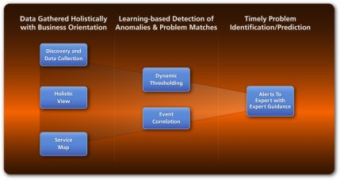
Figure 1: Alive's Modules
Alive tightly integrates the functions necessary to achieve true integrity in managing business services.
The tightly integrated modules pictured in Figure 1 provide the following capabilities:
- Discovery and mapping of the Service Path through your IT infrastructure
- Real-time data collection (with advanced analytics to detect meaningful patterns despite noise in data)
- Showing it all in one tool that learns from what it sees via:
- Dynamic Thresholding (the basis for flagging abnormal behavior early)
- Event Correlation (based on statistics so no rule writing is required)
- An Integrity Alerts™ engine that narrowcasts to the right expert with information he can act on to resolve problems quickly
In many ways the core of Alive's value is delivered in the learning capabilities embodied in Alive's Analytic Architecture.
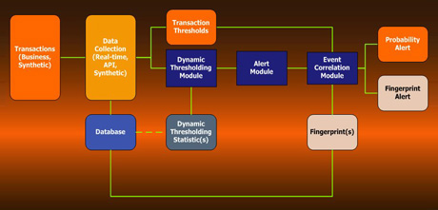
Figure 2: Alive's Analytic Architecture
The data collection, dynamic thresholding, and event correlation engines are tightly coupled
to reduce false positives and deliver problem prediction.
Although they are shown as separate modules in Figure 1, Figure 2 reflects just how closely linked the underlying capabilities of Alive must be to deliver alerts to the right expert at the first sign of abnormality or a recurring problem.
The Dynamic Threshold Module creates adaptive, statistical models for all monitored metrics to establish thresholds in real-time. Based on this sophisticated notion of statistical normal for a given point in time, Alive can send threshold alerts to the correlation engine or other end points when a threshold level or behavior of a metric indicates abnormality. Unlike manually set static thresholds that simply detect when a metric exceeds an arbitrary "high-water" mark and a problem is already occuring, Alive's Dynamic Threshold Module will pick up developing abnormalities in a meaningful manner.
The Event Correlation Module is based upon the end-to-end structure of business services, allowing for symptoms on a device to be associated to business functions for prediction that’s meaningful for your business. The Event Correlation Module captures Fingerprints of problems for post-mortem analysis and, more importantly, to detect newly arriving Fingerprints that forewarn of a problem's recurrence prior to the Service being impacted.
The Dashboard Module presents data collected from devices, synthetic transactions that measure Services from the end user point of view, and Alive's own analytical modules in an intuitive, actionable manner. With the ability to scale to thousands of devices, the Dashboard Module provides a holistic, business-centric view of IT infrastructure. You can follow Services through the infrastructure, explore by device type or arbitrary groupings of devices, or drill down to the level of device detail needed for the task at hand.
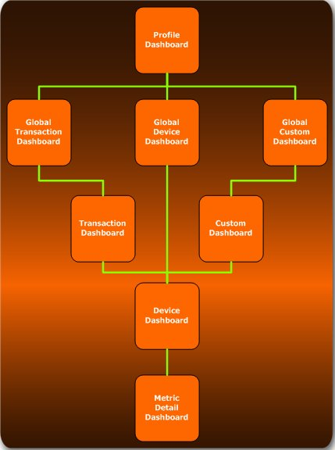
Figure 3: Alive's Dashboard Hierarchy
Tightly linked dashboards guide users from the big picture
down to the detailed metrics needed to identify problems.
Under the Hood: The Alive server is a J2EE-based application that can be installed on a Windows or Linux server. As an agentless system, Alive requires no client software to be installed on the monitored servers. Instead, it collects relevant data and performs various system availability and performance tests by sending messages to the monitored systems in the form of ICMP pings, TCP/IP messages, commands over SSH terminal sessions and via Windows Management Instrumentation (WMI) methods.
Alive may be installed on a Windows or Linux server running any J2EE compliant application server. Alive comes with JBoss Application Server. The JBoss Application Server is an open source application that provides a robust, scalable platform to allow for a full range of J2EE 1.4 features to include clustering, caching, and persistence. Alive is managed entirely through an intuitive, web-based interface.
Alive processes metrics in real time to detect emerging problems. It gathers the metrics via open APIs including WMI, JDBC, JMX and SNMP with periodic polling that causes server CPU hits of as much as 10% at 1 to 5 minute intervals. This is opposed to agent-based approaches that have a continual hit on processing of approximately 6 to 8 percent.
Customer usage and independent lab testing shows that Alive can support

3. Please provide an annotated architectural diagram in jpeg or bitmap format.
See IntegrienArchitecture.jpg, attached to the message this document was attached to.

4. Please provide Service Management metrics reported/measured by product, categorized by the following:

- Technical IT infrastructure, i.e. CPU, IO, MTTR

Alive collects an extensive set of metrics See CLI504000 Alive5 R4 Data Collection.pdf (attached to the same email as this document). One powerful aspect of Alive is its use of SLA measurement to govern whether an abnormal metric matters (i.e., is negatively impacting a service the business cares about).
- Financial impact of service
Integrien has an ROI whitepaper (attached) and associated spreadsheet model that focuses on the positive financial impact of Alive’s improvement to Service Levels and Availability via more rapid troubleshooting and early problem detection and prediction. The calculations are driven by the SLA improvements Alive reports by Service. Integrien leaves the accounting issue of deciding what revenue and productivity should be associated with a particular service to personal interaction between IT and the business side of the organization. In our experience, the urgency is with improving Availability and Service Levels rather than providing an estimate of what the financial impact of those improvements are.

5. Please provide figures on units sold, delivered, customers serviced, etc.

As a privately held company, Integrien does not disclose financial information.

6.Product pricing:
- High and low ranges

Pilot Projects Deliver Value for $50k and up.

- Average initial purchase
~$300K

7. Please provide project implementation planning guidelines.
See file ProjectImplementationPlanningGuidelines.PPT

8. Describe your Service Management product roadmaps – including market segmentation and underlying assumptions like required customer process maturity – for the next 2 years.
- Benefits of your Service Management solutions to IT and to the business.
- Organizational profiles of businesses that will best be able to take advantage of your Service Management offering(s). Include factors such as size of business by gross revenue, market, industry, technology deployed, and processes implemented.
Benefits
Alive’s Integrity Management fundamentally improves availability and service levels by augmenting the IT Infrastructure management products organizations already have in place. One big business benefit, then, is to protect an organization’s revenue, productivity, and brand value (brand because brand can be damaged easily by customer service issues related to poor availability and performance of applications).
The visibility Alive Integrity Manager provides into the end-to-end state of IT infrastructure transforms compartmentalized IT groups into problem-solving teams. Component monitoring and alert triage evolves into purposeful management of the overarching integrity of the services your business depends on. The person with the ability to solve the problem gets the responsibility and the information he needs to solve it. Typical time to problem resolution is reduced by an order of magnitude. Companies that let Alive’s learning of their environment mature and tune the Problem Fingerprint technology for maximum applicability can prevent problems from impacting the business, although doing so presupposes a base level of maturity in the processes of the IT organization.
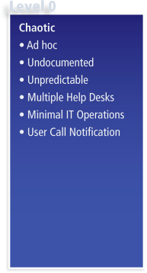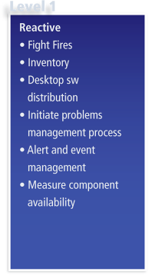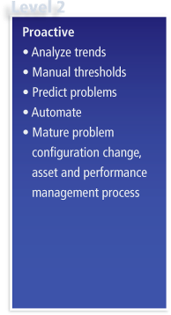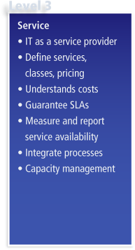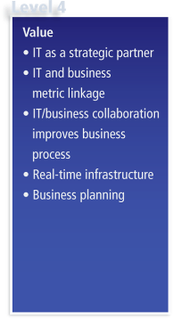
Gartner, 2005
Using the Gartner Maturity Model above as a gauge, getting Level 0 and Level 1 organizations out of firefighting mode allows IT to make much more strategic contributions to the business (disruptive, unplanned work is a less mature IT organization’s curse). Integrien’s customer’s organizations benefit from Alive’s base capabilities even if the IT group is up at Level 1 or even Level 2. Note that Level 2 still lists Manual Threshold setting and otherwise falls short in terms of getting an organization to predicting problems and automating IT operations.
For an organization to be ready to fully leverage the predictive capabilities of Alive’s Problem Fingerprints, organizations have to be at Level 2 in order to have fine-grained enough understanding of their service mappings to tune correlation and deploy teams quickly enough to prevent business impact of problems.
Roadmap. Over the next two years, Alive’s roadmap will allow Alive to go beyond sending the appropriate expert alerts with expert guidance in order to speed the resolution of problems. As organizations become more comfortable with Alive’s learning-based analytics, and as Integrien’s extensive R&D pays dividends in finer understanding of the source of problems, Integrien will gain its customer’s confidence in allowing Alive to automate problem resolution to a greater degree. Service Level guarantees and automatic handling of provisioning to get around capacity issues will come into place through both internal development and integrations with partner products. Integrien is also planning to leverage the efforts of partners in providing the base prediction and problem understanding needed to control the business processes that ride on top of IT-based Services. All of these things will help drive more process-oriented organizations towards Level 4 on the maturity scale.

9. Describe your company’s market presence, including the following:
- Number of customers (more than a dozen)
- Service management revenue for fiscal year 2005 (do not disclose)
- Recent acquisitions, partnerships and technology developments related to service management
- Third-party indicators of market leadership (for instance, analyst rankings or awards)

In its first year after funding Integrien has amassed more than a dozen customers. As a privately held company, Integrien does not disclose financial information.

The companies partnerships include IBM, HP, Wily Technology, Microsoft, Citrix, Oracle, and Tata Consulting Services.
The addition of Problem Fingerprints in the 5.4 Alive product lead to the following comment:

"Alive’s Problem Fingerprints add predictive power to its pattern recognition technology," said Dennis Drogseth, Vice President at Enterprise Management Associates. "Rather than identifying a problem after it has occurred, the time series aspect of Alive’s event correlation approach allows early prediction. This new capability is distinctive in the industry, and represents a potentially important advance. It leverages an already rich set of analytics from Integrien, including a pragmatic application of Chaos Theory in combination with correlative analysis."

Just over 20 percent of Integrien’s permanent staff hold PhDs, reflecting the advanced and innovative nature of the Integrity Management solutions Integrien provides. That heavy investment in R&D, coupled with projects completed or underway with the Illinois Institute of Technology, University of California at Riverside, and others including RADLab will be showcased at the first annual Integrity Management Conference in the Silicon Valley in September of 2006.
We don’t expect analysts to catch up to our thought-leading point of view for at least another year. We believe there is a need for this new category and thus we are helping organization this conference. Integrien believes Integrity Management differs from Business Service Management tools, which diagram the IT infrastructure components that provide business services and report on both potential business impacts and historic service levels. BSM is thus useful for planning and post mortem assessments. In contrast, Integrity Management focuses on preventing rather than reporting on trouble. Like BSM, Integrity Management depends on the Service Map, but applies analysis to it in real time to minimize the business impact when the underlying components of a service leave normal operation and begin to impact service levels.
The heavy focus on analytics and event correlation in the Alive product derives from an observation of the difficulty organizations have in finding problems in distributed systems architectures. System interdependencies, not single component failures, are the real threat to Enterprise IT vulnerability. Those interdependencies are growing as systems become increasingly complex, notwithstanding the attempts to hide that complexity with virtualization. The adoption of SOA architectures will only exacerbate these issues. This all leads to the following Law of Integrity:
The vulnerability of systems to interdependencies
increases geometrically with the increase in underlying complexity.
We’d be happy to discuss this topic in more depth and share some of the issues and findings we plan to cover in more detail at the Fall Integrity Management Conference.

