
Request for Information
Managed Security Services

Response Submitted By


Due on May 19, 2006

Proprietary Notice
Restriction on Use Disclosure of Proposal and Quotation Information Data
The information (data) contained in all sheets of this proposal or quotation constitutes information that is commercial or financial and confidential or privileged. It is furnished to the prospective customer in confidence with the understanding that it will not, without the permission of LURHQ be used or disclosed for other than evaluation purposes; provided, however that in the event a contract is awarded on the basis of this proposal or quotation, the prospective customer shall have the right to use and disclose this information (data) to the extent provided in the contract. This restriction does not limit the prospective customer right to use or disclose this information (data) if obtained from another source without restriction.
Question B.1: Corporate Capabilities
Corporate capabilities are broken into the following categories:
- Financial
- Services Offered
- Organizational Breadth
- Investment Strategies
- References
Financial
a. Provide your most recent annual report and financial statement and those of your key investors if they are not publicly available.
LURHQ is a privately-owned corporation; therefore our financial statements are not publicly available.
b. Indicate the total number of active security service contracts, indicating the percentage of multi-year and single year contracts. Describe your annual rate or percentage of new, renewing, and terminating contracts.

LURHQ currently monitors and manages thousands of devices for hundreds of clients around the globe. LURHQ is rapidly growing and leads the industry in terms of renewal rates and client satisfaction.

c. Provide information regarding any recent mergers and acquisitions, initiated by your organization or initiated by others.

LURHQ has not engaged in nor have participated in any merger or acquisitions.

Services Offered

a. Name the markets or industries you target for each of the services you offer

LURHQ targets the enterprise market and currently serves leading organizations in industries such as financial services, healthcare, manufacturing, energy and utility.

- What percentage of your staff is involved in direct service delivery and managing current client accounts?

The overwhelming majority of LURHQ employees are involved in servicing and managing client accounts. LURHQ’s Analysts deliver day-to-day service to our clients. In addition, each client is assigned a dedicated Account Management team to ensure clients get the most value possible from our services.

Organizational Breadth

- Is your current business regional, national, or international? Describe your approach and your capabilities to provide global support, including, but not limited to, worldwide locations, expertise in national languages, knowledge of national and local laws that affect requested services, and relationships with national and local law enforcement agencies.

LURHQ serves the international market and currently manages and monitors devices located all around the world.

Investment Strategies

- Describe your approach for investing in technology and research and development to increase operational efficiency while keeping up with the rapidly changing threat environment.

100% of research and development investments have been and will continue to be solely targeted at improving the effectiveness, efficiency and depth of our Security Services. We work closely with our clients to ensure we are continuously exceeding their expectations as we evolve with their dynamic security requirements.

- What are the highest priority initiatives in your company that affect the requested services?

While we cannot disclose specific information publicly, at a high-level our highest priority initiatives will always be to enhance our services to ensure we always lead the market in terms of effectiveness and consistently exceed client requirements.

- What is your company’s vision and direction for currently offered services as well as plans for additional services and support of new technologies?

With our technology platform, we can monitor virtually any security technology or critical information asset, which enables our clients to always choose the technologies that are appropriate for their organization.

References
Include, for each reference: the company name, contact name, contact title, phone number, e-mail address, types of service, and dates of service.

a. Provide three references from clients:
- With similar types of organizations (size, market segment)
- With similar levels of infrastructure complexity and capacity requirements
- That are currently using the services requested in this RFP

We cannot disclose this information publicly.

Question B.2: Country Handling Outsourcing and Associated Environmentals
NWC Inc. strongly prefers to utilize a United States-based outsourcing location; however, if you strongly feel that you have a location outside the United States that could better service NWC Inc. as it looks to outsource information security, please indicate the country and answer the question based on the specific location you think will be a best fit. If outsourcing will be handled outside of the United States, be sure to include why this will benefit NWC Inc.’s business operations.

LURHQ provides all of our services on a 24x7x365 from two geographically dispersed Secure Operations Centers in Myrtle Beach, SC and Chicago, IL.

- Does the outsourcer monitor and review all physical access including the following:
- Identify and authenticate customer and outsourcer staff members who have physical access to IT assets providing customer services?

Yes. All access to sensitive areas is granted only if necessary to perform one’s duties.

- Have a process for requesting and approving physical access?

Yes. All requests for access must be submitted to and approved by a Senior SOC Management.

- Are physical assets dedicated to each customer or can they be shared by multiple customers?

Physical assets are dedicated to each client.

- How do you physically and securely segregate your assets and customer assets?

All client assets are physically and logically separated from LURHQ’s assets and protected by extensive security mechanisms.

- Is there a presence of a physical security system like a UPS, backup generator, redundant climate control systems, and a fire-control system?

LURHQ has all these mechanisms.

Please describe environmental controls and features of your proposed hosting service for NWC Inc. broken into the following areas:
Air Conditioning

LURHQ has multiple AC systems in place at each of our SOCs which maintain optimal conditions in all operating environments.

Power

LURHQ’s SOCs are redundantly powered via UPS and generator. Generators are supported by priority maintenance and refueling contracts.

Physical Access control

Our SOCs are secured with a multitude of both physical and information security measures. Physical security measures deployed at our SOCS include:

- 2 factor and greater authentication
- Video surveillance
- 24x7x365 monitoring of all physical security mechanisms
- Etc

Fire

LURHQ has redundant fire control systems in place at each of our SOCs to quickly contain and extinguish any fires.

Question B.3: Customer Satisfaction
Describe your processes for handling client inquiries and reported problems.

- Describe customer service responsiveness, hours of staff availability, and available mechanisms for communication such as written, verbal, e-mail, face-to-face.

LURHQ’s team is available 24x7x365 and handles all incidents, requests, etc according to our SLAs. Communication mechanisms can include written, phone, email, face-to-face, pager or other method by request.

- Describe how issues involving unsatisfied customers are addressed. For example, is it described in service level agreements?

All client issues are handled immediately by Senior SOC Management and LURHQ Executives.

- Describe the secure communications available when privacy is of the utmost concern. For example, secure voice, fax, encrypted e-mail.

Clients can communicate securely with our Intrusion Analysts securely via the Sherlock Client Interface and encrypted email.

- Describe both, national and international service support.

LURHQ’s supports our clients worldwide 24x7x365 from our SOCs in Chicago, IL and Myrtle Beach, SC.

Question B.4: Business Partnerships/Relationships
- Provide a complete list and brief description of your channel partners, resellers, vendors, subcontractors, and other providers (tiered providers including ISPs) who may be involved in delivering NWC Inc.’s requested services. What is your due diligence process for engaging in these types of business relationships.

Not applicable. LURHQ does not rely on any of the above entities for delivery of the services detailed in this RFP.

- Where do you plan to use tiered providers to satisfy our requirements? In what capacity do you plan to use them? What mechanisms are in place to allow us to verify that these requirements are met?

Not applicable. LURHQ does not rely on tiered providers for the delivery of our services.

- Indicate how our requirements flow to all involved tiered providers and how requirements satisfaction is determined.

Not applicable. LURHQ does not rely on tiered providers for the delivery of our services.

- Can NWC Inc. identify any requirements or restrictions we may have when outside parties (providers, tiered providers) connect to our network. These may include: disallowing certain protocols, requirements for or restrictions on communications or encryption methods and confidentiality requirements The provider indicates how they plan to meet these requirements and restrictions.

Not applicable. LURHQ does not rely on tiered providers for the delivery of our services.

- How can NWC Inc. establish a direct relationship (either informal or contractual) with your tiered providers when they are involved in delivering the requested services? Indicate if we are free to contact these organizations and, if so, provide contact information.

Not applicable. LURHQ does not rely on tiered providers for the delivery of our services.

- When client information is shared with and used by tiered providers, what procedures do you have in place for protecting this information?

Not applicable. LURHQ does not rely on tiered providers for the delivery of our services.

- How are security risks associated with tiered providers defined and monitored?

Not applicable. LURHQ does not rely on tiered providers for the delivery of our services.

- What security research organizations do you partner with to stay informed about new threats and vulnerabilities?

LURHQ’s Threat Intelligence Group gathers threat and vulnerability intelligence from a wide variety of internal and external sources. LURHQ’s Threat Intelligence Group and SOC team take immediate action on any emerging threats discovered to protect our clients’ environments.

Question B.5: Independent Audits
Describe the independent evaluations/audits that you and any other tiered provider participate in.

- Do you periodically information security risk evaluations or contract with an independent, outside organization to perform them? If yes, how often are they done?

LURHQ undergoes a SAS 70 Type II audit annually.

- How do you communicate risk evaluation results with your customers?

LURHQ can make our SAS 70 audit results available to clients by request.

- Describe how you respond to significant changes in technology.

LURHQ’s Sherlock Enterprise Security Management Platform is completely vendor-neutral and can monitor virtually any security technology without development. This provides our clients with the flexibility to adopt and incorporate the technologies that best meet their business’ constantly evolving needs without having to consider their provider’s ability to support them. This also applies to the technologies we use internally to protect the assets of ourselves and our clients. Our entire security infrastructure is monitored and managed on a 24x7x365 basis in real-time by our Sherlock Platform and SANS GIAC Certified Intrusion Analysts. We adopt technology changes as they are needed to ensure the integrity of our assets.

- Describe how you respond to both internal and external threats.

All external and internal threats are quickly and thoroughly investigated by our expert Analysts in real-time, who take the appropriate steps to mitigate all threats in an efficient and effective manner.

- Do you require independent risk evaluations from your tiered providers? If yes, do you actually obtain copies of the evaluations?

Not applicable. LURHQ does not rely on any tiered providers for any aspect of our service delivery.

- Do you demonstrate service compliance with regulations like GLBA, HIPAA, SAS 70.

Yes. LURHQ undergoes a SAS 70 Type II audit annually.

Question B.6: Personnel Security
NWC Inc. recommends personnel screening of outsourcing company’s employees as a safeguard.

- Do you conduct background check on all potential employees or only if their role and responsibility within your organization mandates it?

LURHQ conducts background checks on all employees regardless of their responsibility.

- What is your policy on hiring former computer hackers?

LURHQ does not hire those with an established history of hacking or other computer crimes.

- For personnel assigned to provide services to NWC Inc. as specified in this RFI, what is their job year’s experience? In addition, how many yearly classroom instruction hours are given these personnel? If allowed, include resumes for key personnel and managers having responsibility for NWC Inc.’s outsourcing contract.

All of LURHQ’s Analysts are true security experts with multiple years of real-world network security and intrusion analysis experience. To become a member of the LURHQ Secure Operations Team, a candidate must possess or attain SANS’ Global Information Assurance Certification Intrusion Analyst (GIAC GCIA). As of this date, all analysts in the SOC’s are GIAC Certified Intrusion Analysts. In addition to the GIAC Intrusion Analyst certification, our SOC team members also hold a variety of security industry and product certifications such as CISSP, CCNA, CCSE, CCSA, MCSE, etc.

- What is your annual staff retention rate for key security positions?

LURHQ has retained virtually all of our key technical personnel since we began providing Managed Security Services in 1998. This includes key members of our development, management and operations teams.

- Are your personnel permanently assigned to a client for the length of the contract?

LURHQ does not assign Analysts to specific client accounts. All our Analysts are true, senior-level security experts and work in a team environment to utilize their combined knowledge and experience to deliver the most effective event analysis and response possible.

- Do you provide your personnel with refresher training and periodic review of industry standard security policies and procedures?

All new SOC employees are either hired holding the SANS GIAC Intrusion Analyst certification, or they are attain it immediately after joining. All SOC employees receive ongoing SANS and other training to enhance their skills and stay current on industry best practices.

- Do you require your personnel to sign non-disclosure agreements?

Yes. All employees of LURHQ are bound by confidentiality and NDAs.

- Do you inform your customers of key personnel who have privileged access to client data, software, and hardware and why?

Only those Analysts performing device management for your Firewalls and IDS/IPSs will have privileged access and you will be notified of who they are.

- What security procedures do you follow when one of your personnel terminates employment?

When any team member leaves, the following procedures are invoked:

  - Change internal passwords; disable certificates and accounts.

  - Forward employee's email to supervisor.

  - Disable physical access to operations centers.

  - Change certificates and/or passwords on all customer premise systems.

- Do you require the same level of personnel information from your business partners?

Not applicable. LURHQ does not utilize any business partner or tiered providers for the delivery of our services.

Question B.7: Asset Ownership
NWC Inc. wants to be able to identify the owner of assets used in providing the service (hardware, software, processes, etc.). Providers either manage their own systems or manage equipment that the client owns. NWC Inc. realizes that client ownership may cost more in the short term, but may reduce transition issues when the relationship terminates.

- Is any and all intellectual property created by the outsourcer on behalf of the client and in the course of the relationship owned by the client? This statement references reports, logs, and audit and evaluation results.

Any intellectual property utilized by LURHQ to deliver our services remains the property of LURHQ. Any information collected, logs, reports, results, etc are retained by the client.

- If you propose using proprietary assets (policies, processes, software, hardware), describe how the client is not placed at risk when the relationship terminates.

Should the relationship terminate between client and LURHQ, there would be no disruption in business since we do not have asset ownership of any key devices on the network. LURHQ’s customer premise device passively collects log-files and alerts and cannot disrupt business.

- Describe all software and hardware license and patent issues that may arise to delivering requested services and how such assets are transitioned upon contract termination.

LURHQ does not foresee any issues with software and hardware license. The Client retains ownership of all monitored or managed security infrastructure, including all software and hardware licenses.

Question B.8: Contractual Terminology
NWC Inc. is interested in reviewing contractual exceptions, penalties, and exit terminology.

- Provide your standard language for contractual exceptions and penalties.

LURHQ cannot disclose this information publicly.

- Provide your standard contract termination language and provisions.

LURHQ cannot disclose this information publicly.

- Provide conditions under which contract termination may occur.

LURHQ cannot disclose this information publicly.

Question B.9: Service Level Agreements (SLAs)
- Provide your standard SLA.

LURHQ cannot disclose this information publicly.

- Does your SLA provide for client-specific requirements for performance, remediation, restoration of service, response time, and customer service satisfaction levels?

LURHQ is more than willing to work with you to negotiate acceptable client-specific requirements should they be needed.

- Describe customer and provider responsibilities for monitoring and verifying SLA measuring tools.

Our SOC management team is responsible for the daily audit of service delivery against SLA requirements. Additionally, NWC can monitor their SLAs by viewing the security events and the actions taken against them in real-time using Sherlock, our web-based client application. Using Sherlock, NWC can see our performance every second of every day.

- If provider falls into SLA non-compliance, are credits issued to customer?

The Customer will automatically receive credit for any failure to meet the guarantees outlined in our SLAs, as well as notification of such credit. The customer may also request a credit if Customer feels that LURHQ Corporation has missed its guarantee obligations.

- Describe the business process a customer would follow to amend an existing SLA.

A call with Senior SOC Management would be requested to review any amendments that NWC may require.

- Describe the business process a customer would follow to escalate an SLA.

A customer only needs to contact our SOCs via phone, email or Sherlock’s Client Interface to escalate any service issues to SOC Management, including SLA issues such as non-compliance or requested amendments.

- Describe how you calculate service outage times.

Outages are calculated as any disruption outside of scheduled maintenance windows.

Question B.10: Site Visits
NWC Inc. believes they have the right to conduct a site visit to all physical facilities involved in providing information security services.

- Do you permit site visits for verification of outsourcer capabilities as described in your informational answers?

NWC is more than welcome to visit LURHQ’s SOCs in Chicago, IL and/or Myrtle Beach, SC at any time of their choosing.

- Do you take responsibility for expenses incurred by you during the site visit?

Yes. LURHQ will take responsibility for the expenses incurred by us during any site visit.

- Describe any constraints on site visits.

The only constraint is that you will not be physically allowed into our Analyst environment for privacy reasons and to ensure that our Analysts remain focused on protecting our clients’ assets. We have a specially designed “glass house” that is adjacent to our Analyst environment. From this room, you will have an unobstructed view into of our Analysts’.

Question B.11: Implementation Schedule
Describe your implementation plan with a timeline and duration (in hours, days, weeks, etc.) for installing and maintaining requested services. A high-level implementation plan is acceptable.

LURHQ’s services were designed to enable your business, rather than hinder it. Because of this intent, we developed our technology platform with a distributed architecture that is non-intrusive and requires no client resources to maintain or manage. Its design allows us to implement our services quickly and effectively, delivering immediate value to your security program without interrupting your usual business activities.

Should LURHQ be selected as the provider, a high-level project plan would look like this:

- A LURHQ Project Manager would be assigned to handle the implementation planning. This would include either an on-site or conference call meeting to review the details of the devices to be managed and/or monitored. This call would include specifics about network layout, IDS placement, etc. A date is typically discussed for installation during this call.

- LURHQ will pre-configure all necessary equipment prior to installation.

- Timeframe of installation is dependant on the type and number of devices being installed and/or integrated into the LURHQ services. Typically, most implementations can be performed in a matter of a few days.

- Once implementation is complete, NWC, the Project Manager and the SOC Manager will have a conference call that will cover basic training and other topics that will complete the transition process and begin NWC’s service delivery.

Question B.12: Account Management
Provide the outsourcing organization’s point-of-contact. Describe the procedures, policies and organization of account management. Respond where applicable in the following areas.
Account representative(s)

Day-to-day contact will be with our expert Intrusion Analysts at our Secure Operations Centers. LURHQ also has an experienced Account Management Team that is assigned to our clients and dedicated to ensuring LURHQ is meeting or exceeding your expectations. The team handles all concerns, questions, and requests in regards to existing contracted services and any services that may be added.

Project Management

During implementation you will be assigned a Project Manager to oversee this process.

Problem Management

All issues are escalated by contacting the SOC and will be handled by Senior SOC Management and LURHQ Executives.

Service Level management and remediation

LURHQ’s SOC Management is responsible for day-to-day service delivery and they perform daily audits of service delivery, using several key metrics to effectively manage performance and quality of service. These metrics are also closely monitored over time to ensure we continue to provide a consistently high level of service that meets and exceeds our clients’ expectations.

Training

Training is provided by the Project Management team at the conclusion of the implementation. All ongoing training is provided by the Account Management Team.

Question B.13: Market Position
Describe why you would buy your service instead of contracting with one of your
competitors.

LURHQ is the leading provider of Managed Security Services for security professionals.
These are the strengths we possess that differentiate and add value to our services:

- Our focus on a True Partnership with our clients. Our clients do not want to lose control by outsourcing their security. They want a partner. Our OPEN Service Delivery Methodology facilitated by our proven industry-leading Interface, precisely caters to this demand.

- Only experts talking to experts – all our Intrusion Analysts hold the SANS GIAC GCIA (GIAC Certified Intrusion Analyst). When clients need assistance, the first person they speak with is fully capable of helping them.

- We are the only MSSP to present our analysts with known threats (signature matching known bad) and unknown events (whatever did not match a known “good” or known “bad” signature) in real-time. This allows us to be first to market with emerging threats.

- Sherlock is also the only Platform to present analysts with detailed, real-time information and context, allowing them to perform FULL analysis in real-time to reduce false-positives.

- Our technology combined with geographically dispersed, staffed secure operations centers enables seamless delivery, without interruption, in the event of catastrophe.

- LURHQ is the only Provider to have a suite of services that are fully integrated around your critical business assets. Within Sherlock, information from all of our services is linked to your assets and their corresponding criticality in real-time. This enables rapid, accurate analysis and seamless visibility over the business risk facing your environment.

- Sherlock’s web-based client interface is the industry’s leading client “Portal”, featuring the most advanced reporting capabilities available from a MSSP. Intuitively designed by our security professionals to present real-time security information, the Interface provides robust Security Information and Event Management capabilities while maintaining ease-of-use.

- All Managed Firewall and IDS/IPS services are delivered in a co-managed fashion where the client retains full control and administrative rights to these devices.

LURHQ is the only MSSP that can offer these value-adding differentiators with our services.

C. Security Requirements

The following questions explicitly address outsourced information security requirements. Please answer each.

Question C.1: Security Requirements
You are able to demonstrate that customer assets (software, hardware, data) are delivered services assured of confidentiality, availability, and integrity? For example, customer data is protected to include security posture and vulnerability and attack status.

Yes. LURHQ can provide our SAS 70 Type II results if required.

Question C.2: Network Service Architecture
Describe, using text and graphics, how your services will be implemented to include:
- Remote administration. Service hardware and software are located on our network. Your security center connects to this equipment via secure means like VPN.

LURHQ’s Sherlock Enterprise Security Management Platform provides the aggregation, correlation, and graphical tools to enable real-time enterprise security monitoring and management. The Sherlock Platform utilizes a highly distributed architecture with three components: Inspector, Sherlock Analysis Engine, and Inspector Agents. The Platform takes millions of daily events in real-time from the average customer and filters and correlates this data to present our Analysts with events of interest and Unknown activity. Sherlock’s Analyst Interface displays these events in real-time and in context to LURHQ intrusion analysts, who then utilize their experience and expertise to assess the threat level and respond accordingly around the clock.

Residing on the customer network, Inspector is the event aggregation and filtering point for all client devices. Through encrypted communication channels, events are transmitted from the Inspector to the Sherlock Analysis Engine in LURHQ’s SOCs. Each security event is carefully analyzed by LURHQ’s expert Analysts and processed according to a predefined Incident Handling Process and escalated according to pre-defined procedures outlined by the customer that can include telephone calls, paging, email or other alerting mechanisms.

The Sherlock Enterprise Security Management platform can aggregate, correlate and analyze logs generated by virtually any security technology. This allows us to be completely vendor-neutral and integrate with your existing and future security infrastructure. This gives you the flexibility to choose the technologies that best fit your needs without having to consider our ability to monitor them. Using one of the following methods, LURHQ’s Sherlock Enterprise Security Management Platform can be used to monitor virtually ANY device WITHOUT development:

  - Syslog
  - Simple Network Management Protocol (SNMP) Trap
  - Simple Mail Transport Protocol (SMTP)
  - Check Point’s OPSEC Log Export API (LEA)
  - Cisco’s Remote Data Exchange Protocol (RDEP)
  - Sourcefire’s Event Streamer
  - Sherlock Inspector Agent

LURHQ’s preferred collection method depends on the technology that is being monitored and the network architecture.

- Co-location. Your security devices, such as managed firewalls and web servers, are placed within your data center. Does access to and from our networks pass through your infrastructure? Do you run our service on a dedicated server? If not, how is exposure to other customer’s data, systems, networks, and performance protected?

Not applicable.

- On-site. You offer permanent, on-site staff to supplement our existing security staff and hardware/software.

Not applicable.

- Do you anticipate changing your architecture over the next six to twelve months?

Our core architecture should not change over either the short or long term. LURHQ does, however, make relatively frequent updates to our Platform to improve service delivery. These updates are performed in a manner that does not impact our clients’ operations or performance.

- Do you anticipate changing your architecture over the next one to five years?

Our core architecture should not change over either the short or long term. LURHQ does, however, make relatively frequent updates to our Platform to improve service delivery. These updates are performed in a manner that does not impact our clients’ operations or performance.

- How do you account for network configuration changes to accommodate new business partners NWC Inc. may bring on?

The distributed architecture of the Sherlock Platform provides our solution with the flexibility and adaptability needed to accommodate any changes in your network environment. Should any changes be required, they will be tracked, fully documented and accounted for within Sherlock’s Client Interface.

- Can your service architecture be easily changed with minimal impact to our ongoing operations and performance?

All operational and ongoing development changes to the Sherlock Platform will not impact your ongoing operations and performance. Devices can be added or removed from the scope of the project with no impact to your operations.

- Will you be able to monitor our network configuration with no performance impact?

Since information is filtered onsite at Inspector, LURHQ has never seen any negative bandwidth or operational implications occur as a result of our service. Implementing our service is completely unobtrusive and usually does not require any changes to your environment.

- Describe how you manage multi-vendor equipment on the same network?

The Sherlock Enterprise Security Management platform can aggregate, correlate and analyze logs generated by virtually any security technology or critical information asset, such as servers, network infrastructure, etc. This allows us to be completely vendor-neutral and integrate with your existing and future infrastructure. This gives you the flexibility to choose the technologies that best fit your needs without having to consider our ability to monitor them.

- Are your management tools hardened and secured?

Yes. All management tools are hardened and secured in accordance with industry best practices.

- Is the traffic between your security center and our systems encrypted?

All traffic between client networks and systems and LURHQ is secured with strong encryption and authentication mechanisms.

- Are your service systems built and tested in a non-production, like a lab, environment?

All service systems are built and tested from a validated system build specification in a staging environment.

- Do you provide a trial period during which you provide on-site or immediate on-call support?

LURHQ provides unlimited and un-metered support via phone, email and Sherlock’s Client Interface with all of our services on a 24x7x365 basis. Once our services have been implemented, you will be able to call our SOCs at any time and speak directly with one of our expert SANS GIAC Certified Intrusion Analysts for support and consultation.

- Do you use modems for remote access administrative purposes? If yes, are modems disconnected or disabled when not in use?

No.

Question C.3: Hardware and Software Services
Describe the products, technologies, and operating systems that you use to deliver requested services. Some providers like to lock a customer into a single technology, product, or operating system. NWC Inc. wants to ensure that the provider it chooses can function using a range of solutions.

LURHQ relies on our proprietary Sherlock Enterprise Security Management Platform to deliver our Managed Security Services. The Platform is completely vendor-neutral and can aggregate, correlate and filter security events generated by any security technology and critical information asset using the methods detailed above. This gives you the flexibility to choose the technologies that best fit your constantly evolving needs without having to consider our ability to monitor them

Question C.4: Scalability
Describe how you are able to handle new geographic locations—consider international locations in your answer, growth in business transactions and network traffic,

The Sherlock Enterprise Security Management Platform is the one of the most scalable enterprise security management technologies in the industry. Developed internally by our security professionals for the explicit purpose of monitoring and managing thousands of enterprise devices across the globe, our Platform is capable of aggregating, correlating and fully analyzing billions of security events in real-time without reducing service quality.

Because of our Platform’s scalability, we are able to handle extremely rapid growth without impact to our service levels. We can accommodate any changes to NWC’s environment that would impact the scale of services we will be providing, including the addition of new geographic locations, growth in transactions, etc.

Question C.5: Reporting
Describe the standard and customized reports included in your cost proposal.
- How frequently are reports provided? Can they be provided upon client request?
- What do reports cover? For example, are all policy modifications included, all configuration changes, and security alerts listed by severity.
- Can you provide sample reports and describe how they are used by the provider and the customer?
- Can reports be generated for specific network segments/devices?
- Can trend analysis reports be generated?
- How are reports delivered?
- Is real-time access to network and system security status provided via a Web interface?
- Describe the training provided to assist us in understanding how to access online report versions and interpret and audit them?

For all of the above:

The Sherlock Enterprise Security Management Platform was strategically designed to provide our client with a comprehensive Threat and Vulnerability solution that integrates scanning, intelligence, management, monitoring and reporting processes into a single, continuously improving system. Because Threat and Vulnerability Management, by definition, is built around the business critical assets within organizations, Sherlock correlates all service information to your underlying assets’ criticality. Monitored security events, scanning data, vulnerability data, intelligence data and even help desk tickets are all seamlessly linked to assets or groups of assets within Sherlock.

Sherlock’s secure, web-based Client Interface is LURHQ’s primary communications mechanism, through which real-time information concerning the security posture of NWC will be delivered. NWC can monitor their security events and the all of the actions taken against them in real-time using the interface and see our performance every second of every day.

Reports are suited for technical audiences, management, and auditors. Sherlock’s web-based interface provides clients with extensive asset-based reporting capabilities including trending and comparative analyses, customized reports, and real-time security event monitoring. NWC will be able to access the interface at any time to generate or schedule a wide variety of reports, charts, and graphs based on real-time information to analyze enterprise-wide security event activity. Using the reports, you can view business risk trends and patterns to assess the efficiency, effectiveness, and return on investment of your information security program. Additionally, the Summary and Dashboard reports give you the ability to demonstrate provable security to management, auditors and regulators by providing them with an overview of security incidents, vulnerabilities and threat intelligence as well as your efforts to remediate them. The following are some screenshots illustrating the interface’s reporting capabilities.

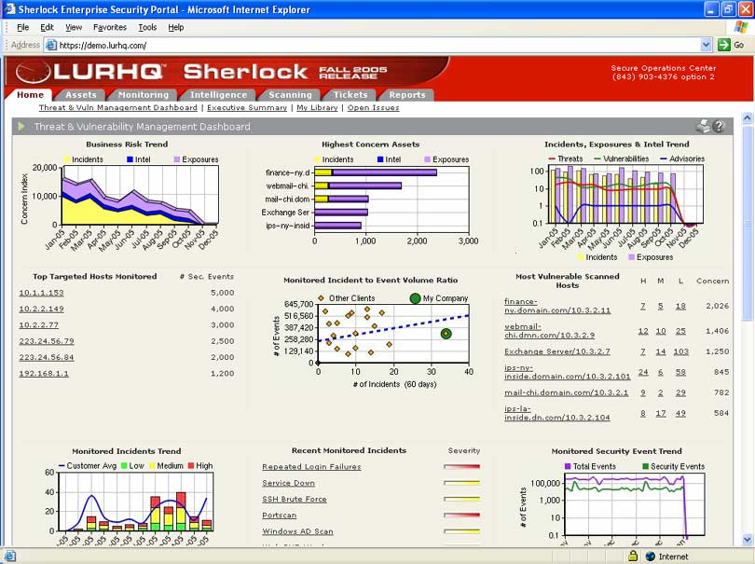

Threat Management Dashboard Report

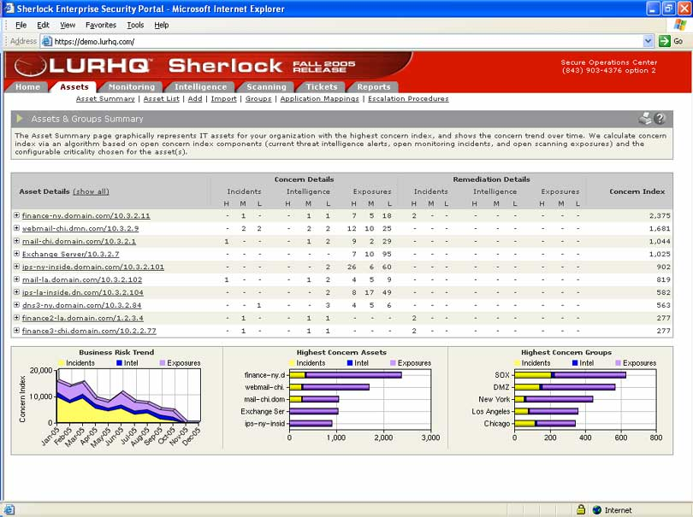
Asset Summary

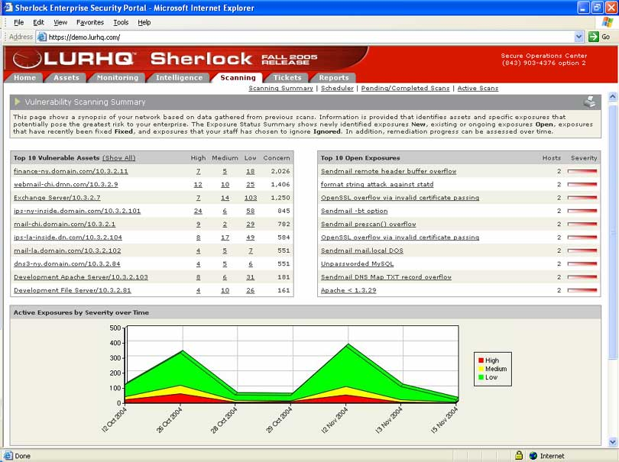
Vulnerability Scanning Summary Report

Sherlock’s web-based client interface also features many pre-built report templates, which allow enterprises to quickly and easily generate Summary, Regulatory Compliance (SOX, HIPAA, GLBA), Monitoring, Scanning, Tickets, Threat Intelligence, and Administrative Reports. Additionally, using Sherlock you can create a wide variety of custom reports based on the information we collect as part of our services.

Using Sherlock’s interface, NWC will be able to schedule any reports to be generated on-demand, or automatically at customizable intervals. Scheduled reports can also be delivered via email to selected NWC staff as a PDF secured by certificate or password authentication.

LURHQ will provide training on how to best utilize the features and functionality of Sherlock’s web-based Client Interface at the conclusion of implementation. Additional training and support can be received at any time by contacting our SOC staff via telephone, email or the interface at no additional cost.

Question C.6: List Pricing
Define all costs billed by you to NWC Inc. for services delivered. Please indicate any front-loaded one-time expenses in addition to monthly recurring charges. NWC Inc is considering a three year agreement, but wants to weigh that against a month-to-month option and so will need to understand both monthly and 3-yr. contracted pricing. Please provide both. Indicate early termination costs where applicable. Please respond with pricing in the following categories:
Monthly Reccuring Charges
Annual or other periodic fees
Conversion Charges
Project Management
fIREWALL MANAGED SERIVCES
iNTRUSION DETECTION MANAGED SERVICES
ROUTER/SWITCH MAINTENANCE AND SECURITY
SECURITY MONITORING
LOG MONITORING SERVICES
Problem Management INCLUDNG FORENSIC ANALYSIS CAPABILITIES
VULNERABILITY AND PENETRATION TESTING
RISK ASSESSMENTS
CONTENT FILTERING SERVICES
Service Level management and remediation
High Availability
Coordination with NWC Inc. Trading partners
ON-SITE CONSULTING
other
Service | Price (Per Device Per Month Unless Otherwise Stated)
Managed Firewall | LURHQ cannot publicly disclose this information.
Managed IDS | LURHQ cannot publicly disclose this information.
Security Monitoring of Routers, Servers, Applications and Other Infrastructure | LURHQ cannot publicly disclose this information.
Vulnerability Assessment/Pen Test/Other Assessments | LURHQ cannot publicly disclose this information.
Forensics Consulting | LURHQ cannot publicly disclose this information.
Setup Fee (one time implementation fee) | LURHQ cannot publicly disclose this information.

D. Security Practices

The following questions explicitly address outsourced information security best practices. Please answer each.

Question D.1: Policies, Procedures, and Regulations
You have a comprehensive set of documented, current policies that are periodically reviewed, updated, and enforced. NWC Inc. can review these at any time.

LURHQ Information Security Program charter and supporting policies and procedures are based on the ISO 17799 standard and other industry best practices. Our security policies and controls are thoroughly audited internally by management and externally as part of annual SAS 70 Type II audits.

Question D.2: Contingency Planning (Disaster Recovery)
The provider has business continuity and disaster recovery plans for critical assets and confirms that they are routinely tested and found to be effective.

LURHQ has two fully redundant SOCs located in Myrtle Beach, SC and Chicago, IL. Both SOCs are redundantly powered via UPS and generator. Generators are supported by priority maintenance and refueling contracts. Both facilities are equipped with multiple Internet connections to diverse ISPs. LURHQ conducts regular BC/DR testing, which is also covered in our SAS 70 Type II audit.

Question D.3: Data Handling
The provider treats data in accordance with its classification (confidential, sensitive, public) and complies with customer’s policies, procedures, and regulations.

All data is handled in accordance with our General Information Security Policy and is classified according to level of confidentiality.

Question D.4: Software Integrity
Describe how you maintain the integrity of installed software. Consider how often virus, worms, and other malicious software are checked; are virus signatures updated regularly; and are checksums compared against a valid, known baseline.

Our extensive security infrastructure is monitored 24x7x365 in real-time by the Sherlock Platform and our SANS GIAC Certified Intrusion Analysts. Any malicious activity discovered is immediately eradicated. All security infrastructure is regularly updated. Also, LURHQ regularly audits its cryptographic infrastructure to ensure its integrity.

Question D.5: Secure Configurations
Provider ensures secure configurations of all customer information assets throughout its lifecycle—installation, operation, maintenance, retirement including:

- Authentication on both ends is required when a configuration change is requested.

Sherlock’s web-based Client Interface is used as the primary means for change requests. This interface uses strong authentication to ensure the integrity of all requests. Additionally all requests are confirmed by the client prior to implementation.

- Patches are applied to correct security and functionality bugs. Is there are specific day of the week where routine, non-critical patches are applied?

LURHQ monitors patch releases from all the vendors we manage. When a patch is released, our SOC team tests it in our test environment. Upon client approval, the SOC team will implement the patch at the client designated time. The device is then monitored to ensure it is performing properly.

- Unnecessary application and services are removed or disabled?

All service systems are built from known good images that include service and default account removal, configuration hardening, and patches. Once a system is built from an image, it is updated to the latest patches before being put into production.

- Default accounts are also removed?

Yes. See above response.

- Are configurations tested in a non-production environment prior to deployment?

All configurations are in accordance with industry best practices and are thoroughly tested in a non-production lab environment prior to being implemented.

Question D.6: Backup’s
You provide a regular schedule of backups for data including how often partial, full backup’s are performed; is data validated both before and after a backup; is encryption used; how do you separate one customer’s backup media from others; and have a process implemented to accommodate a customer’s request for an unscheduled backup restore.

LURHQ performs full backups nightly, validating them before and after backup to ensure their integrity. All data is encrypted during transit and client specific data is isolated from that of other clients. Any client in need of an unscheduled backup restore may request it from our SOCs via Sherlock’s Client Interface, phone or email. Regardless of the method used, the backup will be documented and tracked.

Question D.7: Monitoring and Auditing
Describes the actions the provider takes to monitor and audit its owns systems and networks. Also applies to customer systems and networks if included in the requested services. The provider describes their ongoing processes for global vulnerability and threat analysis.

How is correlation from all data sources performed when monitoring includes firewalls, intrusion detection systems, routers, and servers?

LURHQ’s entire IT and security infrastructure is monitored using the Sherlock Enterprise Security Management Platform. The Platform aggregates, filters and correlates all security events from across our infrastructure in real-time. LURHQ’s Intrusion Analysts are presented with these security events in real-time for analysis and response.

Question D.8: Intrusion Response
Describe how your service responds to a detected intrusion to include the following:

- Describe escalation timing for the service provider. For example, notification could occur within one hour of detection to the first level supervisor, four hours to the next level, eight hours to the next level, and so on. These times may be outlined as part of a service level agreement.

Response times and other key metrics are guaranteed as part of our SLA.

- Describe the escalation process for the client.

LURHQ will escalate events to your designated points of contacts in accordance with your escalation procedures.

- Describe how you return affected systems back to normal operation.

As part of our services, we provide unlimited and un-metered remediation support from our expert team of SANS GIAC Certified Intrusion Analysts, who will work with your security staff as much as needed to mitigate threats to your critical assets.

- Do you support automated responses?

If requested by the Client, we can automatically respond to incidents with pre-defined actions to mitigate threats if we are managing the device in question.

- Do you perform forensic analysis? Is this an additional charge?

As a part of the services proposed above, LURHQ’s expert SOC staff can work with your organization to ensure proper forensic proceedings and will aid in the prosecution of the case by being expert witnesses or in any other capacity needed by NWC at no additional cost. Should on-site forensic assistance be needed, our Consulting team has extensive forensics experience and can go to your facilities as part of a separate consulting engagement.

- How do you preserve evidence?

LURHQ’s expert SOC staff can work with your organization to ensure proper forensic proceedings and will aid in the prosecution of the case by being expert witnesses or in any other capacity needed by NWC at no additional cost.

- Do you get involve local, national, and international law enforcement?

Yes. LURHQ regularly works with law enforcement agencies. We are more than willing to assist in any evidence gathering and prosecutorial activities needed by NWC.

- Do you recommend improvement steps to ensure the same intrusion is not again successful?

LURHQ provides highly detailed remediation recommendations for all security incidents, which include the appropriate steps that should be taken to mitigate such risks in the future. Our SANS GIAC Certified Intrusion Analysts will work with your security team as much as needed on an unlimited and un-metered basis at no additional cost to ensure that your assets are protected.

