The following information will help us profile your company in our Service Management Analysis. We reserve the right to publish all answers returned in print and on our Web site. If your company has additional material in the way of research, white papers and demonstrations that you feel would be helpful, please include it. If your have questions contact Bruce Boardman via email bboardman@nwc.com. Companies that decline to answer questionnaire may still be included in the article, at the author’s discretion.
Please RSVP by March 27

June 22 Service Management Survey

1. Please provide at least two reference customer contacts for interview.
- Interviews will take place between NWC and the customer without the vendor.
- The interview will be used to understand Service Management issues, challenges and strategies
- We can shield the contact’s identity by saying, for example, “an IT manager for a 10,000 employee manufacturing firm.”

2. Describe your Service Management features architecture regarding:
- Automation
- Integration
- Processing
BMC® Service Level Management is ready to work out-of-the-box with BMC® Remedy® IT Service Management applications, as well as with BMC® Transaction Management and BMC® Performance Manager.
- BMC Remedy IT Service Management not only streamlines the processes around IT service desk, asset management, and change management, it also enables you to link your business services and IT infrastructure to help manage the impact of technology changes on business and business changes on technology — in real time and into the future.
- BMC Transaction Management provides a multi-dimensional view of business transactions, both synthetic and real, across the enterprise, including mainframe, distributed, and n-tier environments. This multi-dimensional view is integrated with automated problem isolation and resolution capabilities that identify and resolve related problems in the IT infrastructure. BMC Transaction Management consolidates and correlates transactional data, end-user experience monitoring data, and infrastructure monitoring data, ensuring real-time business service delivery across complex, heterogeneous environments.
- BMC Performance Manager helps you manage, optimize, and automate distributed and mainframe operating systems, servers, storage, networks, middleware and hardware. BMC Infrastructure Management software products help to simplify network and systems management by monitoring and overseeing system performance and availability across your entire environment. Using these products, you can avoid IT infrastructure problems and resolve issues before they impact business availability.
By integrating BMC Service Level Management to the solutions above, you can map SLAs to the service desk to ensure that service interruptions are resolved as quickly as possible and that support personnel are able to prioritize and respond to issues based on business objectives. Moreover, you can control the priority, activity, and timeliness of change management processes to ensure that individual tasks, as well as end-to-end change projects, are completed in accordance with service commitments. You can also link BMC Service Level Management to service impact and event management products from either BMC or other vendors to deliver business-aware information about the real-time state of services. And, by referencing transactional metrics, you can set SLAs on throughput performance from the end-user’s point of view, which helps your support staff to prioritize service tasks. The result is that your IT organization can make decisions based on their impact on the business.

Additional Details:

BMC Software Service Management and System Management Capabilities

BMC® Remedy® IT Service Management for the Enterprise is a suite of highly flexible applications from BMC Software that takes a uniquely integrated approach to automating IT service and support. BMC® Remedy® Help Desk, BMC® Remedy® Change Management, BMC® Remedy® Asset Management and BMC® Service Level Management work together seamlessly straight out-of-the-box. Shared workflow, a consistent user interface and a common platform result in fast implementation, low total cost of ownership, and unprecedented synergy between related ITIL® processes, including incident, problem, change, configuration, service level and financial management. Each application in the suite is part of one or more Business Service Management Routes to Value™, complete solutions that can be implemented independently for quick ROI but that ultimately function together to deliver business-IT alignment. In addition, along with other BMC Software solutions, each shares common infrastructure services, such as the BMC® Atrium™ Configuration Management Database (CMDB). By operating on this common model of the IT environment, service and support applications and infrastructure management are finally unified.

Built on the Action Request System® (AR System®) service process management platform, the BMC Remedy IT Service Management Suite provides proven best practice processes to get you up and running quickly and the flexibility to configure and extend processes—without programming. This both improves business effectiveness and lowers total cost of ownership as you adapt the application to your unique and evolving needs.

- BMC Remedy Asset Management - provides best practice automation of IT asset lifecycle management from requisition to retirement, and enables contract entitlement, compliance management, and total cost and financial controls.

- BMC Service Level Management - IT Support staff can manage the entire range of service level agreement (SLA) processes, from defining SLAs and monitoring compliance, to collecting and analyzing performance data, addressing problem areas, and continually refining the services offered.

- BMC Remedy Change Management - Remedy Change Management enables IT to implement the critical, standardized processes needed to effectively manage enterprise change processes

- BMC Remedy Help Desk - provides the foundation for an integrated, end-to-end approach to IT Service Management. Based on best practices, Remedy Help Desk automates your ability to submit, monitor, and manage help desk cases, change tasks, and asset inventory records.

BMC Software’s Infrastructure and Application Management products serve as a foundation for Business Service Management, enabling the customer to proactively manage and control all enterprise applications and underlying IT infrastructure components from a business service perspective. This solution enables significant improvement in IT efficiency and cost reduction by controlling all aspects of infrastructure management with a common toolset across the enterprise: mainframe and distributed, online and batch. It provides intelligent automation across all platforms and applications, improving the productivity and cost-effectiveness of IT staff and allowing them to become more proactive when addressing problems. It also enables IT to address potential problems before they jeopardize service levels by proactively monitoring vital components and manually or automatically addressing imminent problems. What’s more, the Infrastructure and Application Management Route to Value assists in the prioritization of problem resolution and IT resource allocation by providing business context to underlying IT component status and propagating business priority to IT staff, thereby enabling IT to address the most urgent issues first.

- BMC Transaction Management provides a multi-dimensional view of real and synthetic business transactions across the enterprise that is integrated with automated problem isolation and resolution capabilities to help you identify, analyze, and resolve problems that affect transactions before they hurt critical business services. With BMC Transaction Management you can simultaneously understand the true end-user experience and see the components involved in end-to-end transaction service delivery.
- Infrastructure Management solutions from BMC Software allow you to manage, optimize, and automate distributed and mainframe operating systems, servers, storage, networks, middleware and hardware all to speed the attainment of Business Service Management. Our infrastructure management software products help to simplify network and systems management by monitoring and overseeing system performance and availability across your entire environment. Using these products, you can avoid IT infrastructure problems and resolve issues before they impact business availability. With our Performance Assurance® products, you can analyze and predict performance to optimize current and future IT utilization and investment.
- BMC Application Management solutions put you in total command of your application environments, regardless of platform or application. Control your operating costs, reduce application complexity, improve reliability – and manage what matters from a business service perspective. BMC Application Management products support: BEA WebLogic, Microsoft Exchange, Oracle Applications, PeopleSoft, SAP, Siebel, webMethods, WebSphere and WebSphere MQ.

3. Please provide an annotated architectural diagram in jpeg or bitmap format

BMC Service Level Management Process Flow

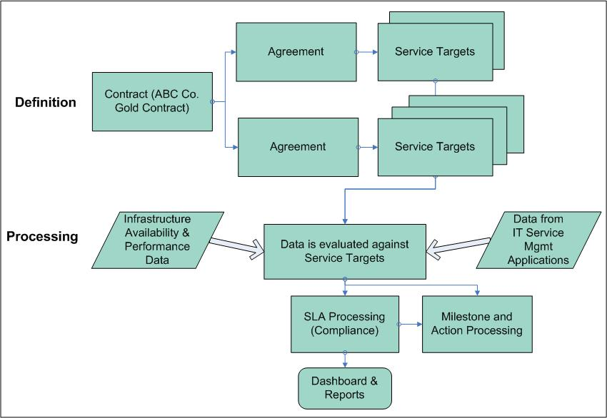

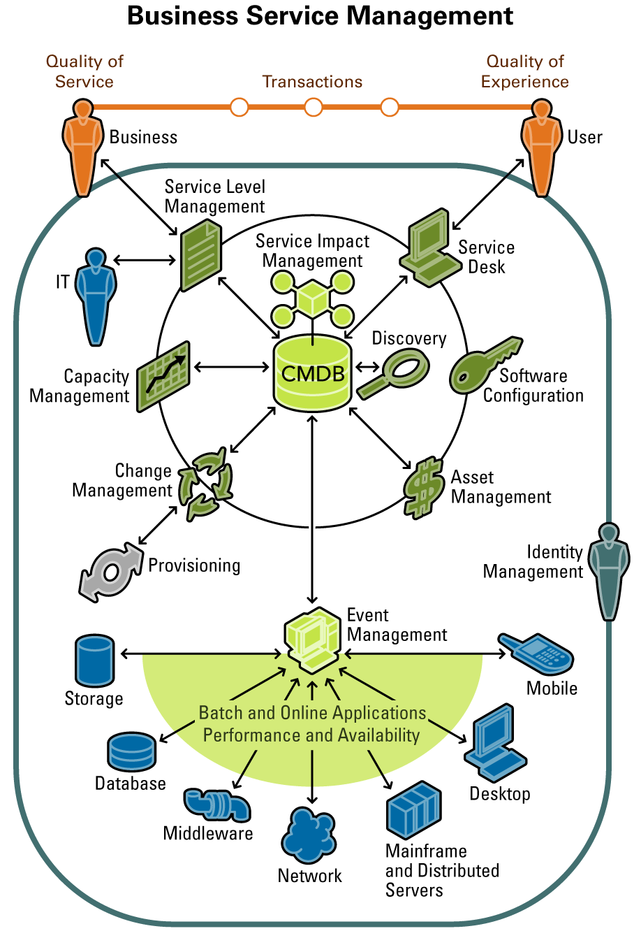

4. Please provide Service Management metrics reported/measured by product, categorized by the following:
- Technical IT infrastructure, i.e. CPU, IO, MTTR
- Financial impact of service

BMC® Service Level Management helps customers align crucial IT infrastructure and service desk processes with the priorities of the business. BMC Service Level Management automates, monitors, and manages the entire range of service level agreement processes for commitments made between IT and the businesses or customers they support.

BMC Service Level Management includes collection points that contain plug-ins to collect data from different data sources, including BMC® Performance Manager, BMC® Transaction Management, and SNMP. The application also tracks service level agreements (SLAs) against configuration items (CIs) contained in the BMC® Atrium™ Configuration Management Database (CMDB). Through this intelligent, centralized repository, BMC Service Level Management shares data with other BMC products to speed the organization’s progress toward comprehensive IT service management (ITSM) and Business Service Management (BSM).

With BMC Service Level Management, you can manage the entire lifecycle of SLA processes — from defining agreements and monitoring compliance to collecting and analyzing performance data, addressing problem areas, and continually refining the services offered to ensure that expectations are met or exceeded.

Multiple Service Target Types
You can create the type of SLA service target — time-based, availability, or performance-monitoring — that best matches the needs of your business. Time-based service targets measure how long it takes to complete a process, such as incident response or resolution time. Availability service targets measure the time that an asset or service is either available or unavailable, and sets a commitment to keep that asset or service available for a certain percentage of time. Performance-monitoring service targets are evaluated on system metrics coming from the infrastructure, such as end-user transactions, servers, or applications. Performance-monitoring service targets compare the measurements to the key performance indicators defined in a service target to determine if the service target is met or missed.

Alerts and Notifications
BMC Service Level Management alerts you when an SLA, Operational Level Agreement (OLA), Underpinning Contract, or an individual service target is in danger of being missed. You can create milestones or thresholds to trigger actions, such as alerts, e-mails, pages, escalations, and reassignments, which will be initiated when service standards and commitments are at risk. You can specify when to escalate an issue, to whom it should escalate, and by what means, as well as how frequently notifications should be delivered. These actions can be performed discretely, or in a recurring manner, until appropriate actions are taken to make sure that the commitments are met. You can even define one or more actions to be triggered with a particular milestone.

Proactive Management
Flexible tools enable you to manage SLAs proactively. You can track service performance by individual occurrence and over various periods of time. For example, IT might commit to the engineering department that the service target will guarantee a response time of four hours for urgent help desk incidents. The SLA compliance target specifies how often IT will meet the four-hour commitment, such as 98 percent of the time over a daily, weekly, monthly, or quarterly review period. Whenever performance drops below the specified threshold, you and your team can be notified to avoid missing the overall committed SLA.

Cost of Service
BMC Service Level Management lets you set cost for both agreements and service targets. For agreements, you can set penalties for noncompliance, and rewards for exceeding the goals. For service targets, you can estimate the cost to the business for failing to meet a goal. You can also associate multiple agreements with a customer contract and segment the BMC Service Level Management data by multiple tenants or groups. This enables you to offer a different price for each contract which represents the level of service offered. For example, a service provider might offer a contract of type Gold, Silver, or Bronze, where the Gold contract provides the highest level of service at the greatest price to the customer, while Bronze offers the lowest service levels at a lower price. In addition, segmentation also provides you with the ability to use one agreement for multiple groups, where each group will see only their own agreement measurements and the request to which the agreement is tied. This helps with security needs in cases where each group must not know of the existence of the others. Customers can then choose the appropriate level of service for their needs.

5. Please provide figures on units sold, delivered, customers serviced, etc.

I wasn’t sure on the need for this breakdown since those figures span across 450 products and solutions. I felt that these financial figures better represent BMC health over the last couple of years.

6.Product pricing:

- High and low ranges
- Average initial purchase
BMC Software delivers product for both small and mid-size companies to enterprise level which can range from less than 100 employees to more than 50000 employees. Products span both distributed as well as the mainframe, from utilities, to user-based pricing so these purchased cost can vary based on a number of factors.
BMC Service Level Management was built for enterprise sized customers. Average initial purchase for BMC Service Level Management ranges from $60,000 to $85,000. BMC Service Level Management is usually bought with other products required to gather metrics used for availability, performance and response time SLAs.
7. Please provide project implementation planning guidelines.
Since we offer a wide variety of product, and each customer needs are unique there isn’t one single project implementation guideline. The difference could be based on the maturity of the customer with deploying new technology to ones that want straight out-of-the-box solutions. Below are some of the service offerings that we provide. In addition, we have a large number of system integrators and service providers who can offer a broad level of services that a customer may need.

OFFERINGS
Project Scope and Analysis
Our Business Solution Consultants are available for needs analysis, application and integration scoping, and quote generation activities.
Project Management
All projects are assigned a dedicated Project Manager to define and manage the project resources, schedule and scope.
Technical Consulting
Our Consultants provide the skills required to build solutions that meet your specific IT infrastructure and corporate needs.
Business Analysis / Process Consulting
Our Consultants provide the domain expertise and skills required to define business case and functional requirements, and ensure a technical solution that is aligned to corporate and IT strategies, supporting business profitability and end-user satisfaction. They are also responsible for integrating best practices and documenting customer processes.
Administrator and End-User Training
Our Consultants and Instructors support engagements by providing many training options: Remedy training facilities, customized onsite training, or customized web-based training.
Product Migration and Upgrades
Our Consultants and Business Solution Consultants can plan, execute and manage legacy and solution migrations, and solution upgrades.

8. Describe your Service Management product roadmaps – including market segmentation and underlying assumptions like required customer process maturity – for the next 2 years.

For Service Level Management there are clearly delineated maturity levels involved in progressing from Technical Service Level Agreements to Integrated and Predictive Service Level Agreements. For those companies using SLM products most are at Stage 1 with many currently considering or deploying Stage 2 capabilities. We see a continuation of this trend over the next two years. There already are a few leading-edge companies implementing Stage 3 capabilities. We will see more companies move in this direction as they adopt Business Service Management (BSM). BSM provides IT with the tools it needs to be a key driver of business value. BSM ensures that everything IT does is prioritized according to business impact, and enables IT to proactively address business requirements to lower costs, drive revenue and mitigate risk. At Stage 3 companies can take advantage of service level management and BSM to drive efficiencies within IT and/or as a competitive advantage.
Stage 1:
Technical Service Level Agreements are very system-centric and are focused on measuring discrete IT goals, such as the performance of underlying IT infrastructure, end-user transaction response times, service performance, and applications availability. At this stage, IT typically measures the individual components in silos of support, whether they are operating system, database, or application-oriented, and doesn’t look at the impact on the overall business service these components support.
Stage 2:
End-to-End, User-Based Agreements are based on the measuring of the quality of service (QoS) factors, such as how long a customer has to wait for a transaction to complete, and the quality of experience (QoE), such as how long it takes to get a service representative on the phone when a Web site is down or when transactions fail to complete. At this stage, SLAs are based on business-related issues, such as the responsiveness of the IT staff to requests for service, change requests, problem resolution times, and change implementation times.
Stage 3:
Integrated and Predictive Service Level Agreements provide continual measurement of performance against SLAs and swift action on the part of IT when goals are in danger of being missed. At this stage, alerts and notifications are automatically generated to warn the appropriate people when out-of-compliance states exist or have the potential to occur. Workflow is key to promoting proactive handling of SLA performance problems, heading them off before they result in negative business impacts. Where possible, automatic recovery actions are taken to address problems without the need for human intervention. This speeds problem resolution and reduces the workload on the IT staff.

- Benefits of your Service Management solutions to IT and to the business.

Underlying assumptions and benefits
It is critical that service level management supports end-user and service-driven IT management that enables IT professionals to operate from the perspective of the business services they deliver. It helps drive business success by enabling enterprises to align their IT operational technical metrics and service support processes with the needs and priorities of the business. Because of the vital role service level management plays in BSM, enterprises need to choose a solution with great care. They need to evaluate a solution with respect to how well it meets major criteria, such as supporting full SLA lifecycle management, providing tight integration of all solution components, leveraging existing components of the IT environment, and operating seamlessly with other BSM applications. SLAs are essential building blocks of service level management. They define agreed-upon service level commitments against which IT service performance is measured. The service level management solution should provide end-to-end, process-based service level management that covers the full lifecycle management of SLAs—establishing SLAs, tracking performance against them, and managing them to maintain compliance with internal service standards and external commitments for IT operations and support services.
The solution should permit the IT staff to set service level commitments from a business perspective and in cooperation with the consumers of the business services. The service level commitments need to cover the entire customer experience. On the technology side, commitments must address infrastructure, applications, end-user transactions, and service impact. On the service desk side, they must encompass help desk, change management, and asset management.
In addition, the ability to monitor and measure service levels from an end-user perspective is essential. For example, the solution should measure the availability and response times for transactions that comprise business services as they are actually consumed by users. This means collecting transaction response time data from the outside in, and doing it in a statistically valid way that takes into account the end-user computing environment and end-user location. The response time measurements collected must be acceptable to users as truly representative of their actual experiences, regardless of whether the measurements are collected through synthetic or actual transaction monitors. For example, a field engineer may access an enterprise application through a Web portal to clear a trouble ticket. The solution needs to measure the end-to-end experience, from loading the application client and bringing up the desired portal, to entering the information and saving it. This transaction could involve a Web server, network switches and routers, an application server, and a database server. What is important is not just the individual response times of these resources but the total time required to deliver the business service as seen by the user. Solutions that ignore parts of the overall process, such as client load time, do not provide an accurate view of performance. Service performance measurement also includes measuring service levels for service desk processes as they reflect the actual experience of users who are consuming services. For example, the solution should measure the service desk personnel response time and resolution time for incidents. This means that IT must track the length of time it takes service desk personnel to respond to help desk tickets or change requests, as well as the time is takes to inform customers of the disposition of their issues or requests. The solution should provide the ability to report service level measurements to meet the needs of multiple audiences— business owners, executives, service managers, IT professionals, and, in some cases customers—who all need different views of performance information. This capability is of particular importance in the service provider (xSP) environment.
Service level management requires continual measurement of performance against SLAs and swift action on the part of IT when goals are in danger of being missed. To support IT in these efforts, the solution should support workflow, by generating alerts and notifications, to warn the appropriate people when out-of-compliance states exist or have the potential to occur. The solution should also execute additional workflow when service levels further degrade, such as by escalating an issue when response does not occur within a specified time period. Workflow is key to promoting proactive handling of SLA performance problems, heading them off before they result in negative business impacts. Where possible, the solution should automatically initiate recovery actions, addressing problems without the need for human intervention. This speeds problem resolution and reduces the workload on the IT staff.
Another key capability is keeping users informed of the status of business services. To this end, the solution should permit IT to monitor SLAs in real-time and give users a heads-up when potential problems are discovered. In this way, IT can eliminate surprises that can be costly to the business. Additionally, users should be able to view in real-time the status of service delivery relative to SLAs, and for any services out of compliance, see how much time will be required to bring them back to acceptable levels. These capabilities open a dialog between IT and business service users, enabling the users to plan around outages and eliminating needless calls to the help desk. Further, it is critical that the solution provide the ability to generate on-demand and scheduled enterprise reports to keep the business, executives, and IT all informed of the actual level of service being delivered compared to the service level agreements in place. SLA outage costs (penalties) incurred also need to be reported. This enables consistency in SLA performance reporting throughout the company and helps IT better prepare for reviews.

Business Problem and Benefits of our Service Management solutions

IT’s historic inability to manage according to business needs or communicate in business terms is a well-known problem. The challenge is that most IT organizations have been established to manage specific components, rather than designed to help business units apply technology as a strategic weapon to cut costs, gain competitive advantage, realize better relationships with customers, improve quality and boost productivity. Additionally, IT is so busy reacting to problems that there is rarely time to create a strategy to move from reacting to urgent crises to proactively driving business value.

What’s more, IT leaders are struggling to identify the best technology solution to further their business—while also making the most of current investments—so that they can:

- Reduce costs through efficiency/increased productivity
- Increase business efficiency through IT-enabled process improvement
- Create competitive advantage through IT
- Improve internal customer (user) satisfaction
- Ensure regulatory compliance
- Ensure privacy of customer and employee data
- Align IT and business goals
- Measure and communicate bottom-line impact from IT
- Implement mechanisms for IT governance

BMC Solution Description

Business Service Management (BSM) provides IT with the tools it needs to be a key driver of business value. BSM ensures that everything IT does is prioritized according to business impact, and enables IT to proactively address business requirements to lower costs, drive revenue and mitigate risk.

BSM is a flexible, comprehensive approach that links IT resources and business objectives. BMC helps improve business performance in the short term while moving toward long-term alignment goals. As a result, IT can clearly demonstrate its strategic value to the business, while also lowering total cost of ownership (TCO) and delivering a higher quality of service than ever before.

What’s more, to meet the unique needs of each business, BMC Software has developed BSM Routes to Value™, a coordinated, incremental approach to BSM. Providing targeted solutions to help IT drive business value, BSM Routes to Value guide and measure the progression from basic achievement to higher levels of maturity. BSM Routes to Value are field-proven solutions that can be implemented independently, but ultimately leverage one another to interconnect the related disciplines within BSM, enabling you to quickly synchronize resources and goals throughout the enterprise.

Software is Our Business

Business Service Management requires innovative and powerful software solutions that can only be developed if a company is completely dedicated to finding and developing those solutions. Our focus helps us move ahead at a much faster pace.

BMC Software is focused solely on what customers need to drive business value in their organization.

- Organizational profiles of businesses that will best be able to take advantage of your Service Management offering(s). Include factors such as size of business by gross revenue, market, industry, technology deployed, and processes implemented.

BMC Software delivers product for both small and mid-size companies to enterprise level which can range from less than 100 employees to more than 50000 employees. Typically our service level management offering is used by enterprise-level companies who manage large IT shops.

9. Describe your company’s market presence, including the following:

- BMC Software is one of the world’s largest software companies
  - Annual revenues of more than $1.46B
  - Solid Balance Sheet – No debt,
$1.4 Billion in current assets
  - Member of S&P 500 Index; listed on NYSE: BMC
- 15,000 customers in over 115 countries
- 95 of the Forbes Global 100 and more than 80% of the Fortune 500™ rely on BMC Software
- Coverage in more than 50 countries
- Driving innovation to help IT align with the goals of the business
  - 73 patents
  - 25% of revenues reinvested into R&D and Support
- Number of customers
  - Over 15,000 customers
- Service management revenue for fiscal year 2005
  - Over 1.4 Billion

- Recent acquisitions, partnerships and technology developments related to service management

March 27th

BMC Software Announces Plans To Acquire Identify Software Ltd.
Identify Software’s market-leading technology will provide a key differentiator for our Transaction Mgmt solutions

BMC Software has announced plans to acquire Identify Software Ltd., a leader in Application Problem Resolution software. BMC will acquire Identify Software for $150 million in cash, in a stock purchase defined under the terms of the purchase agreement signed on Tuesday, March 21. Pending regulatory and stockholder approval, the deal is anticipated to close during the first quarter of FY07.

“We anticipate that Identify Software will make an immediate and positive impact to our business, enabling us to quickly expand our market presence, market share, and domain expertise in a key growth market that is strategic to BMC,” said Dan Barnea, SVP, Strategy and Corporate Development.

In February, BMC announced its comprehensive Transaction Management strategy and the delivery of the first transaction-centric application performance management solutions – BMC Transaction Management Application Response Time and BMC MAINVIEW Transaction Analyzer. These products were developed as incubator products in conjunction with OEM technology. Identify Software has market leading technology that will provide a valuable complementary piece and a key differentiator for our Transaction Management strategy.

BMC Software Introduces End-to-End Transaction Management Solutions
Solutions identify, analyze, and resolve problems that affect business transactions before they impact critical services.

February 14, 2006

BMC announced a comprehensive Transaction Management strategy and the delivery of the first products in this family of transaction-centric application performance management solutions focused on:

delivering on market and customer demands for a multidimensional view of business transactions across the enterprise; providing complete insight into the end-user experience, the path a transaction takes across the IT infrastructure and specific IT domains; and uniting end-user experience with BMC Software’s deep platform expertise and strength in enterprise systems and service management.
Despite the fact that businesses must provide consistent IT service levels to compete, they often lack accurate, integrated, and comprehensive tools to measure and manage the performance of business transactions from the end-user perspective across complex, heterogeneous computing environments. In fact, according to a December 2005 Ziff Davis Survey, few companies (37%) currently measure end-to-end service availability from the user’s perspective, even though most companies (68%) feel they have the need.

BMC Transaction Management is a family of solutions that empowers IT to deliver improved business services by profiling the performance of business transactions across the enterprise. These products provide a multi-dimensional view of business transactions – both synthetic and real – across the enterprise that integrate and automate problem isolation and resolution. IT staff can simultaneously understand the true end-user experience and see the components involved in end-to-end transaction service delivery so they can identify, analyze, and resolve problems that affect transactions before they impact critical business services.

August 30, 2005

BMC Software®, Inc., [NYSE: BMC],a leading provider of enterprise management solutions, today announced the acquisition of KMXperts, a leader in knowledge management solutions for IT service and customer support centers. The acquisition builds upon the market share leadership position in service desk software held by BMC Software, and furthers the company's strategy to provide the most comprehensive service desk solution worldwide. The acquisition of KMXperts empowers BMC Software offerings with a full-featured knowledge management solution that dramatically improves efficiencies for both internal and external service desks. KMXperts product functionality will enable customers to quickly achieve their Information Technology Infrastructure Library (ITIL) and Business Service Management (BSM) goals with robust knowledge management integrated seamlessly within BMC Software service management solutions.

More press releases

http://www.bmc.com/BMC/News/CDA/hou_PressRelease_index/0,3520,8573740_8630060,00.html?yearParam=2005

Acquisition History
  • OpenNetwork | March 2005
  • Calendra | January 2005
  • Marimba | July 2004
  • Magic Solutions | February 2004
  • ASA Knowledge | January 2004
  • IT Masters | March 2003
  • Remedy® assets from Peregrine Systems | November 2002
  • Perform, SA | February 2001
  • Sylvain Faust, Inc. | October 2000
  • OptiSystems Solutions | August 2000
  • Evity Inc. | April 2000
  • New Dimension Software | April 1999
  • Boole & Babbage, Inc. | March 1999
  • BGS Systems | March 1998
  • DataTools | May 1997
  • PATROL Software | January 1994

- Third-party indicators of market leadership (for instance, analyst rankings or awards)

March 2006
BMC Takes a Leadership Position in Forrester's New Application Mapping for the CMDB
Report says BMC’s CMDB is “an especially good fit for buyers that … are looking for a strong BSM solution.”
Forrester has just released its Forrester Wave™ Report on the application dependency mapping tools segment, with BMC taking a leadership position, well ahead of our competitors. This report evaluated eight vendors – BMC Software, Computer Associates, Cendura, IBM Tivoli (Collation), Mercury, nLayers, Relicore, and Tideway Systems – across 63 criteria. The report further validates our market lead with the BMC Atrium CMDB strategy and roadmap.

