The following information will help us profile your company in our Service Management Analysis. We reserve the right to publish all answers returned in print and on our Web site. If your company has additional material in the way of research, white papers and demonstrations that you feel would be helpful, please include it. If your have questions contact Bruce Boardman via email bboardman@nwc.com. Companies that decline to answer questionnaire may still be included in the article, at the author’s discretion.
Please RSVP by March 27

June 22 Service Management Survey

1. Please provide at least two reference customer contacts for interview.
- Interviews will take place between NWC and the customer without the vendor.
- The interview will be used to understand Service Management issues, challenges and strategies
- We can shield the contact’s identity by saying, for example, “an IT manager for a 10,000 employee manufacturing firm.”

2. Describe your Service Management features architecture regarding:
- Automation
- Integration
- Processing
EMC Smarts’ Codebook Correlation Technology™ (CCT) is a mathematically founded, next-generation approach to automating the correlation required for service assurance. CCT is unique in its ability to:

- Automatically analyze any type of potential problem in physical or logical objects in any complex environment
- Build intelligent analysis into off-the-shelf solutions
- Automatically adapt the intelligent analysis to the managed environment even as it changes
- Provide instant results

The premise of CCT is simple: each problem in a networked system has a unique signature. This signature is the key to identifying the problem. A signature typically contains many symptoms — in the faulty component where the problem occurs and in related components that are affected by the original problem. Because symptoms of different problems overlap, it is the unique combination of symptoms that differentiate one problem from another.

Because CCT’s root-cause correlation consists of a simple comparison of symptoms to signatures, it is extremely fast. Moreover, because CCT looks for the closest match and not necessarily an exact match, it can diagnose accurately even with incomplete information ― if, for example, some of the symptom data is delayed or lost.

CCT’s automatic computation of signatures leverages generic object-oriented behavior models. The object-oriented behavior models describe classes of objects and their associated problem behaviors. The key to CCT’s description of object classes and their behaviors is that the description is independent of the infrastructure topology. In developing behavior models, CCT applies a “top-down” methodology focused on authentic problems™, which are the critical problems that threaten service delivery. To prevent service interruption, authentic problems should be sought proactively and resolved as soon as possible.

The methodology for building CCT behavior models is to start by identifying classes of objects to manage, both logical and physical. Then, for each such class, identify the authentic problems associated with that class, and the corresponding symptoms of each such problem. Symptoms include any observable event, such as alarms, traps, expressions over MIB variables, other instrumented values, or any other external signal.

In general, Codebook Correlation Technology removes the need to create rules for problem resolution or root-cause analysis. However, the system is open and provides significant customization capabilities at various levels:

- The escalation framework in EMC Smarts Service Assurance Manager allows for applying actions to events. A GUI is provided to determine when/where to apply the actions (e.g. matching criteria and elapsed time).
- Groups and monitoring policies can be defined through the graphical administration console.
- Customized rules can be written in Adapter Scripting Language (ASL), PERL, Java or C, or by using a variety of command line utilities. We currently have no GUI for developing rules.
- New to Smarts, customers or partners can now extend existing classes and attributes or create new ICIM library models for new classes of managed objects using Dynamic Modeling, which does not require recompilation by Smarts development.

3. Please provide an annotated architectural diagram in jpeg or bitmap format.
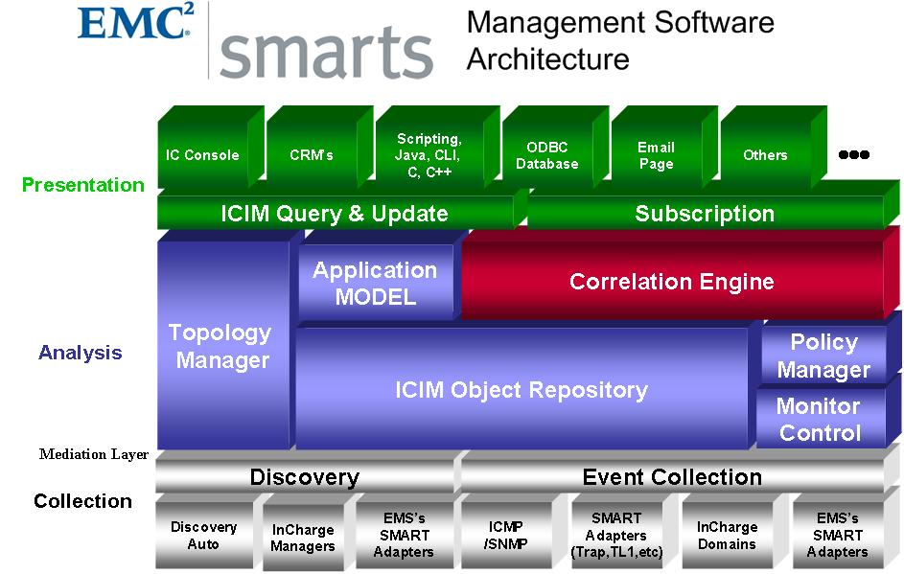
The architecture is generic by design to apply equally well to multiple domains beyond the network. Domain extensions are already in place for storage, servers, and applications and all domains are evolving to support changing technologies and user requirements.

4. Please provide Service Management metrics reported/measured by product, categorized by the following:
- Technical IT infrastructure, i.e. CPU, IO, MTTR
- Financial impact of service

Our PM products capture relevant network metrics such as bandwidth utilization, memory utilization, dropped packets, and errors. Our Server PM product extends this monitoring to server infrastructures and captures CPU and memory utilization, process breakdowns, I/O rates, and errors. Our reporting and dashboard products present this information in multiple forms for driving decisions. Intelligent thresholding capabilities are in all performance products to generate performance events for additional processing in our event management products.

Our strategic roadmap includes significant expansion of domain coverage, third-party instrumentation integration, and richer performance data analysis. This is scheduled for phased delivery over the next 24 months.

While we do not offer financial management capabilities in the strict sense, our business impact products (BIM and Dashboards) effectively convey the impact of infrastructure and application anomalies upon business services. Our technology also allows customers to prioritize services for more effective incident triage. Financial implications can be calculated based on the intelligent analysis and escalation we provide.

5. Please provide figures on units sold, delivered, customers serviced, etc.
Need more information to answer this question, not sure what you’re looking for.

6.Product pricing:
- High and low ranges
- Average initial purchase
Our pricing is based on number of managed devices. The initial starting price for our base product package (100 managed devices) is $50,000. The average selling price for EMC Smarts is $350,000.

7. Please provide project implementation planning guidelines.
EMC Smarts solutions need to run on a stand-alone server attached to the network being managed. The number of servers needed will depend on the total number of managed ports and interfaces. (After numerous deployments, Smarts has developed ratios that help estimate the number of managed ports and interfaces manageable by a single server.)

The successful deployment of EMC Smarts products requires knowledge of the operational environment and the management tools already in place. One can integrate EMC Smarts with third-party applications and prior installations of EMC Smarts applications without disturbing the existing environment.

Recommended EMC Smarts design and deployment practices include:
Before Beginning
- Possess an understanding of the EMC Smarts architecture and capabilities.
- Obtain contact information for the deployment team.
- Get nondisclosure requirements and negotiate an agreement.
- Develop schedules and set milestones for early deliverable.
Basic Information
- Describe the organization’s requirements and expectations.
- Obtain network diagrams.
- Describe the organization’s network and application priorities.
- Determine the number of managed devices and applications in the environment.
- Estimate potential growth in quantity of managed devices.
- Get the organization’s testing/acceptance requirements.
- Describe the organization’s requirements for installing new software.
- List the products that currently monitor the network and will be integrated with EMC Smarts.
- Describe the network security.
- List any other network requirements or features that may affect EMC Smarts.
EMC Smarts Design
- Determine the configuration of the Service Assurance Deployment.
- Determine the hardware required to support the Service Assurance Deployment.
- Determine the location of the EMC Smarts Broker.
- Determine the location of the License Server.
- Determine the location of the EMC Smarts Global Manager(s).
- Determine whether Service Assurance Manager must be configured with failover.
- Determine if acceptance test are required.
Designing Topology Operations
- Review topology synchronization issues.
- Plan topology synchronizations.
- Plan topology groups.
Planning for Notifications
- Determine which notifications are important for InCharge operators.
- Configure Notification Lists.
- Design Trap Processing.
EMC Smarts Client and User Design
- Choose appropriate EMC Smarts clients for users.
- Define functional groups for users.
- Define how you will implement user security.
- Define User Profiles.
- Define notification lists.
- Design console operations access.
- Design console layouts.
- Design client and server tools.
- Associate notification lists, console operations, console layouts, tools, and users with user profiles.
Business Impact Manager Design
- Define relevant business processes.
- Create a business topology.
- Assign weights to the elements of the topology.
- Choose a method for importing information.

We are also willing to provide installation and deployment guides, if necessary.

8. Describe your Service Management product roadmaps – including market segmentation and underlying assumptions like required customer process maturity – for the next 2 years.
- Benefits of your Service Management solutions to IT and to the business.
- Organizational profiles of businesses that will best be able to take advantage of your Service Management offering(s). Include factors such as size of business by gross revenue, market, industry, technology deployed, and processes implemented.
Our roadmap revolves around operational process automation. While several processes (in the ITIL framework, for example) benefit, our strengths in automated analysis most closely align with the incident management process. The initial stage of incident management is triage, where the primary goals are to isolate the root cause of an incident, prioritize inbound incidents based on business impact, and to assign resolution to the proper responder.

EMC Smarts provides superior triage automation because our solutions span domains and perform root-cause analysis with unrivalled accuracy. The EMC Smarts ICIM object model supports the entire service chain from infrastructure through applications and up to business services. By mapping this entire chain in a unified, standards-based model, we can leverage our analysis technology uniformly across all facets of interest. It allows us to effectively determine dependencies and their impact to higher levels in the chain.

As we combine the EMC Smarts modeling and analytical prowess with other technology members of the EMC family, broader, more ambitious automation is our vision. With technologies from fellow EMC powerhouses such as VMware, Rainfinity, and Documentum, virtualization, grid computing, and business process workflow are in place to address HOW to adapt IT environments to business needs. Smarts provides intelligent analysis to determine WHEN and WHY to make these adaptations. The combination is a unique capability to deliver a high level of service automation.

The three PowerPoint presentations in this Zip file articulate more of our service management vision and strategy:
High-level benefits of our solutions include:
- Operational cost savings via automated process execution.
- Improved service reliability due to reduced downtime and enhancements to the problem management process. A richer perspective of problems and incidents helps eliminate chronic problems from the ongoing operation.
- Significant reduction in MTTR within the incident management process because the triage phase is heavily automated.
- Application context provides the intelligence needed to understand business service impact and prioritize attention accordingly.
- New Application Discovery Manager product is a linchpin to a robust configuration management architecture, along with the already-superb Smarts network discovery and EMC’s dominant storage discovery.

Our principal target customer organizational profile is IT Operations. Our alignment with ITIL makes our solutions attractive to Operations groups pursuing ITIL for process discipline. The process defines the discipline and the technology solutions automate process execution and enforce the discipline.

Our target base does not necessarily align with any single vertical industry, although financial services and telecommunications service providers tend to dominate our customer base. We attribute this weighted distribution to two main factors:

- These customers tend to have more complex environments. Our solutions are designed to simplify complexity, so the more complex the environment, the better the fit for EMC Smarts solutions.
- These customers also tend to possess a higher level of operational maturity than most others. Because of the complexity, scale, and direct relationship between IT behavior and revenue/profit, they made they made the decision long before most that technology is a critical competitive requirement. Failures in this technology have devastating impact so these institutions developed the discipline to optimize the reliability and performance of their technology investments.

With the growth of process structure such as ITIL, IT organizations are finally maturing to a level necessary for survival. Many who have not graduated to the sufficient level of enlightenment will likely face punitive outsourcing, so the incentive to improve is strong.
We have found that the majority of Fortune 100 enterprises and virtually all service providers have now embraced effective process discipline. The largest environments now mimic the financial services firms in complexity, scale, and financial impact recognition, so our success in these large customers has been growing. Smaller companies are also on this track, albeit behind most of the large enterprises. As they mature, they are more receptive to the value proposition of EMC Smarts.
We will be happy to discuss and explain in more detail.

9. Describe your company’s market presence, including the following:
- Number of customers
- Service management revenue for fiscal year 2005
- Recent acquisitions, partnerships and technology developments related to service management
- Third-party indicators of market leadership (for instance, analyst rankings or awards)

