The following information will help us profile your company in our Service Management Analysis. We reserve the right to publish all answers returned in print and on our Web site. If your company has additional material in the way of research, white papers and demonstrations that you feel would be helpful, please include it. If your have questions contact Bruce Boardman via email bboardman@nwc.com. Companies that decline to answer questionnaire may still be included in the article, at the author’s discretion.
Please RSVP by March 27

June 22 Service Management Survey

1. Please provide at least two reference customer contacts for interview.
- Interviews will take place between NWC and the customer without the vendor.
- The interview will be used to understand Service Management issues, challenges and strategies
- We can shield the contact’s identity by saying, for example, “an IT manager for a 10,000 employee manufacturing firm.”

2. Describe your Service Management features architecture regarding:
- Automation
- Integration
- Processing

Service Management features

Managed Objects Business Service Management (BSM) solution lets IT organizations more effectively monitor, manage, and model their enterprise infrastructures by providing a service perspective to existing management tools that enables significant improvements in service quality, cost savings, and increased IT responsiveness.
Managed Objects BSM works by consolidating IT management (events, trouble tickets, etc.), asset and configuration data sources into a single command and control console. By leveraging Managed Objects’ unique object-based intelligence and multi-vendor integration, enterprise-wide IT management information is correlated into dashboard views that graphically show the state of health for each IT service (figure 1).
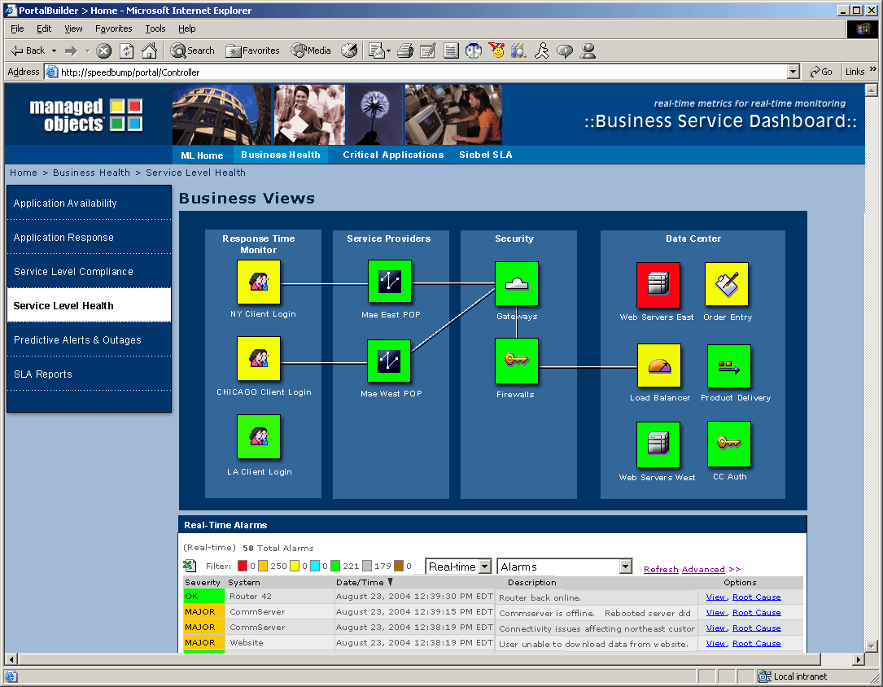
With its intuitive and interactive interface, Managed Objects let’s companies know in real-time when there’s trouble with a mission-critical e-commerce system – or any other business application. More importantly, because Managed Objects provides complete command and control capability, drilling down to find and fix individual IT components is a point-and-click operation.
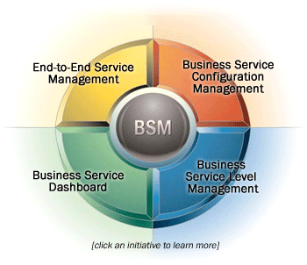
Managed Objects BSM consists of a suite of applications each running on a centralized platform that provides common services across each application (figure 2). BSM applications can be
Figure 1: Business Service Dashboard
Figure 2: Managed Objects BSM Solution
implemented individually or as part of a larger solution to solve critical needs for more effective IT management, faster adoption of ITIL best practices, and delivery of higher quality IT services.
Each of the applications integrated into the Managed Objects BSM platform provides specific capabilities to fulfill specific IT service management needs. Here’s a brief overview of those capabilities:

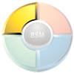
End-to-End Service Manager — Effective enterprise availability and performance management across an entire IT infrastructure has always been a daunting, resource-intensive task. With End-to-End Service Manager, IT operations can monitor and manage their complete end-to-end environment in real-time leveraging business service views that logically group physical infrastructure elements into a single pane of glass that puts the entire IT environment into the context of the services that IT delivers to the business.
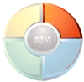
Business Service Configuration Manager — Business Service Configuration Manager (BSCM) integrates IT service topology information with virtually any configuration or asset data source. In addition, BSCM maps complex IT service relationships to Managed Objects to build and visualize a Configuration Management Data Base (vCMDB™). Leveraging a unique federated CMDB approach, Managed Objects’ BSCM provides real-time alerts when changes occur anywhere within the IT service configuration. What’s more, BSCM represents new software technology that facilitates faster adoption of BSM and process maturity models like ITIL.
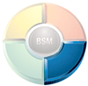
Business Service Level Manager — Business Service Level Manager (BSLM) enables organizations to measure and report on IT service level quality allowing them to more effectively deliver high quality IT services to the business – in terms that are meaningful to the business. Because BSLM works with Service Level Agreements (SLAs) in real-time or historically, IT organizations can accurately ensure that committed levels of IT service quality are met.

Business Service Dashboards — By consolidating essential IT service quality metrics, key performance indicators (KPIs), and business process health into one interactive view, management dashboards provide a real-time and historical window into overall business performance. With a dashboard window of real-time service quality, managers not only know the health of their business, they can ensure the right processes are tracked as well - all ensuring complete regulatory compliance.
Managed Objects BSM provides an effective service-centric system for managing the services IT delivers to the business. These essential capabilities work together to provide IT organizations with the centralized command and control facilities necessary to discover, prioritize, and fix IT issues in the context of specific business needs.
BSM also serves as an excellent solution to model IT configuration changes so that potential problems or change impacts can be isolated and remediated before actual changes are made to the production environment. Configuration modeling can significantly reduce risk and improve service quality. Further, by leveraging BSM to report on IT service delivery in a business context, IT is able to engender a common dialog between itself and the lines of business it supports - thereby, better aligning itself with the business.
More in-depth information on Managed Objects BSM technology is available from the Managed Objects BSM Technical White Paper (attached). Please refer to the following pages:
- Service Perspective: Pages 7 and 17
- Managed Objects IT management integration capabilities: Pages 8 and 10

3. Please provide an annotated architectural diagram in jpeg or bitmap format.

Managed Objects Architecture

Managed Objects BSM is built upon a 3-tier architecture to deliver effective IT service management and configuration modeling capabilities — Integration, Intelligence and Visualization (figure 3).

The BSM architecture builds on a foundation integration layer in which Managed Objects consolidates virtually any IT management, asset, or configuration data source into a single easy to use command and control console. By leveraging Managed Objects’ unique object-based intelligence layer, enterprise-wide IT management information is correlated into business service views that graphically show the state of health for each critical IT services.

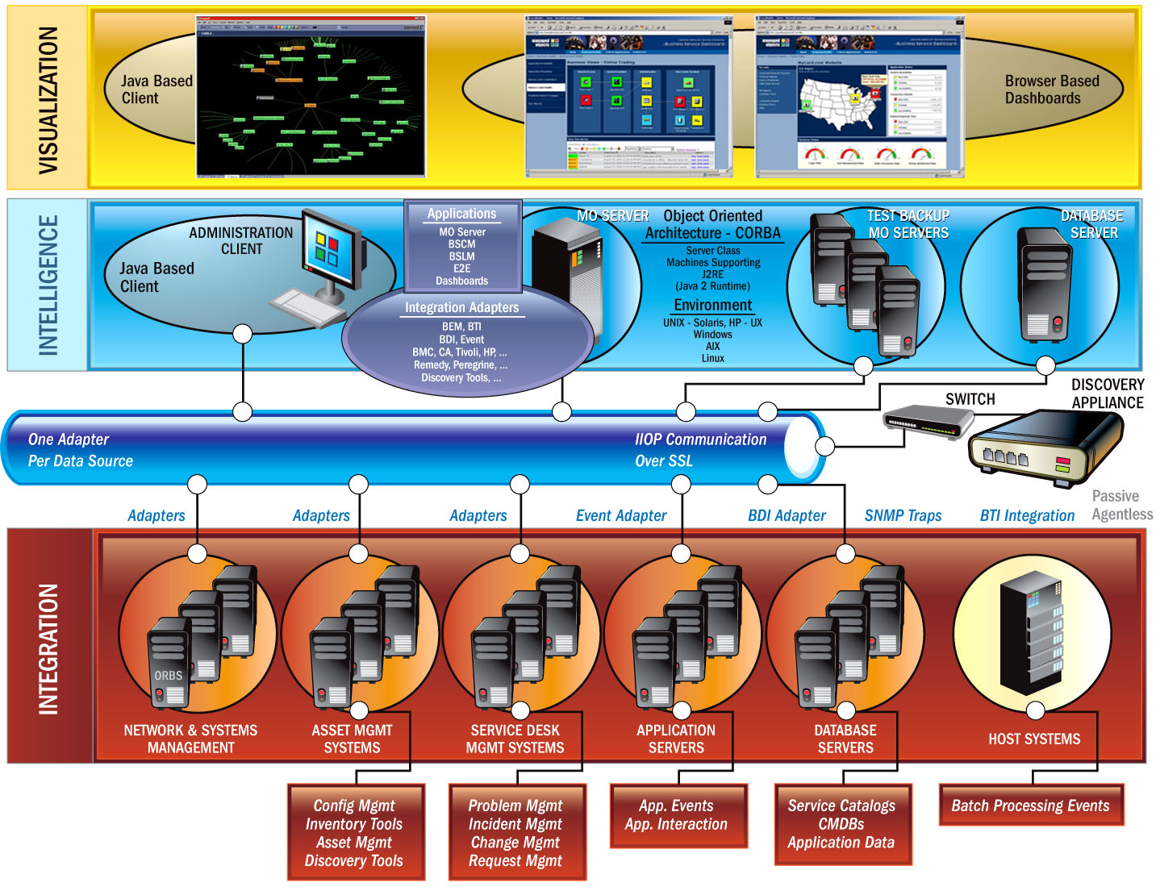
vCMDB
Figure 3: Managed Objects 3-Tier Architecture

The Managed Objects Intelligence layer provides the backbone of the BSM architecture. It’s here that common services like normalization, aggregation, and correlation occur. Other services critical to effective IT operations management are also handled here. Functions like relationship mapping and root cause / impact analysis originate here. Finally, automations for problem determination, notification, and remediation are also handled within the intelligence layer.
Visualization is accomplished through either a comprehensive administrative Business Service Console™ (BSC) or through an intuitive dashboard interface called the Business Service Dashboard™ (BSD). Either way, Managed Objects let’s you know in real-time when there’s trouble with your key business applications. More importantly, because Managed Objects provides complete command and control capability, drilling down to find and fix individual IT components is rapid and straightforward.
More in-depth information on Managed Objects BSM technology is available from the Managed Objects BSM Technical White Paper (attached). Please refer to the following pages:
- Integration: Pages 8 and 10
- Managed Objects Object Model: Pages 6 and 16
- Visualization: Pages 7 and 17

4. Please provide Service Management metrics reported/measured by product, categorized by the following:
- Technical IT infrastructure, i.e. CPU, IO, MTTR
- Financial impact of service

Service Management Metrics

Effective service management requires access to a number of different metrics -- and while some of these are related to the properties or state of an individual component (like a server, data base, or a network), a large part of what’s needed relies upon data pertaining to the actual services that IT provides to the business – services like order processing, online trading, or even email. Managed Objects BSM solution leverages over 60 adapters to integrate and aggregate multi-vendor information to formulate a federated CMDB repository (the Managed Objects vCMDB™).

Within this repository are five essential categories of data that relate to physical as well as logical infrastructure properties and state. To get a better idea of exactly which types of data are integrated, normalized, and correlated by Managed Objects, take a look at the following table which describes not only the data that is managed by Managed Objects, but also the source from which information is gathered.

Because Managed Objects uses a true federated model, links to data residing in IT management, asset, or configuration systems are used by Managed Objects rather than expensive ETL transformations. By linking to physical data, not only are maintenance issues avoided, but so are scalability issues associated with a centralized data repository.

Data Elements Managed by Managed Objects | Federated Source
Service Definition
- Service models (Service specification, associated CIs) | BSM system
- Service views (Role-based views of services supported by IT) | BSM system
- Calendaring (scheduled maintenance, peak availability windows) | SLA system, IT management system
- Quality targets (SLA and SLO metrics, availability targets, performance targets) | SLA system, IT management system
- Pricing and charging (shared resource charging scheme, transaction cost) | BSM system
- Associated CIs (names, relationships, locations) | BSM system, Asset database, IT management system
State
- Service performance rules (mapping of CI availability and performance requirements to the service) | IT management system, BSM system
- Service performance metrics (response time as perceived by the user) | IT management system, BSM system
- CI performance metrics | IT management system, BSM system
- Service availability (up or down service status as perceived by user) | IT management system, BSM system
- CI availability (up or down status of components in a configuration) | IT management system, BSM system
- Service performance (business performance as measured by KPI target compliance) | BSM system, ERP system
CI Attributes
- Physical properties (manufacturer, model number, serial number, cost, date-in-service, maintenance level) | Asset database, BSM system
- Logical properties (dates, numbers and associated documentation for: incidents, problems, changes, RFCs and SLAs) | Help desk, incident, problem, SLA or change management system, BSM system
Relationships
- Service relationship map (services and sub-services – service-to-service, or service-to-CI) | Discovery tool, IT management system, asset database, BSM system
- CI relationship map (CI-to-CI for each service and sub-service) | Discovery tool, IT management system, asset database, BSM system
CMDB Governance
- Audit Control metrics (historical change records, warranty expiration) | IT management system, BSM system, asset system
- Regulatory compliance requirements (change process documentation and compliance data) | IT management system, BSM system

All of the above metrics are easily reported on by Managed Objects. More on how Managed Objects reports are produced can be found in the Technical White Paper (attached) – see page 21.

5. Please provide figures on units sold, delivered, customers serviced, etc.

Product Units Summary

- Units sold: Over 200
- Units delivered: Over 200
- Customers serviced: Over 120

6.Product pricing:
- High and low ranges
- Average initial purchase

Pricing:
- High range: $1M+
- Low range: $200K
- Average initial purchase: Approximately $500K

7. Please provide project implementation planning guidelines.

Project implementation planning guidelines:

System requirements for implementing Managed Objects can be found on page 24 of the Technical Overview White Paper (attached).

Initial implementations of Managed Objects can be rolled-out within a typical large enterprise within a matter of days. Usually, an IT organization begins by defining one or two critical services that are to be modeled and managed by Managed Objects. Once targeted services are defined, the next step is to integrate necessary IT management information associated with those services to help populate and visualize an accurate picture of the physical infrastructure that comprises the targeted services.

By taking this “top-down” approach to service management implementation, companies can avoid costly “boil the ocean” bottom-up approaches which often require discovery of vast amounts of IT infrastructure components and the compilation of a relationship map across all of the discovered assets. In contrast, a top-down approach allows companies to implement service management in a phased approach – starting with those services that are most important to the business. Once these services are understood, it’s a relatively simple matter of relating targeted services to only those IT components that are directly associated.

Managed Objects object-oriented integration platform gives companies a fast and easy way to integrate nearly any source of IT management, asset, configuration, or even business data. The result is a normalized format for all the multi-vendor IT management data associated with an enterprise’s IT components. It’s the first step toward Business Service Management, and it can provide real value. After all, getting disparate management data down to a single screen – and a single service -- means IT doesn’t have to juggle multiple management consoles or have to figure out which service an IT component failure is associated with. Many companies have also been able to use the information gathered in integration to reduce redundant management licenses and more efficiently use their resources.

In this way, Managed Objects parses normalized streams of events from multi-vendor IT management systems and aggregates these into the logical IT services with which they are associated. Both physical IT components as well as logical IT services are represented as objects within Managed Objects. As such, each physical and logical entity within Managed Objects has property and state value which are each determined by correlating underlying multi-vendor IT management information. As well, Managed Objects maintains the relationships across physical and logical entities within its domain. In this way, Managed Objects understands in real-time when an IT component outage significantly impacts an associated IT service – such as in the case of an application server failure.

8. Describe your Service Management product roadmaps – including market segmentation and underlying assumptions like required customer process maturity – for the next 2 years.
- Benefits of your Service Management solutions to IT and to the business.
- Organizational profiles of businesses that will best be able to take advantage of your Service Management offering(s). Include factors such as size of business by gross revenue, market, industry, technology deployed, and processes implemented.

Product Roadmap

While the internal and external pressures put upon any large IT organization may look much like they did ten or even twenty years ago, the IT reactions from those pressures have evolved significantly. Today’s G2000 organization is focused on leveraging IT process maturity in combination with new service-centric technologies to deliver higher quality IT services to the business (figure 4).

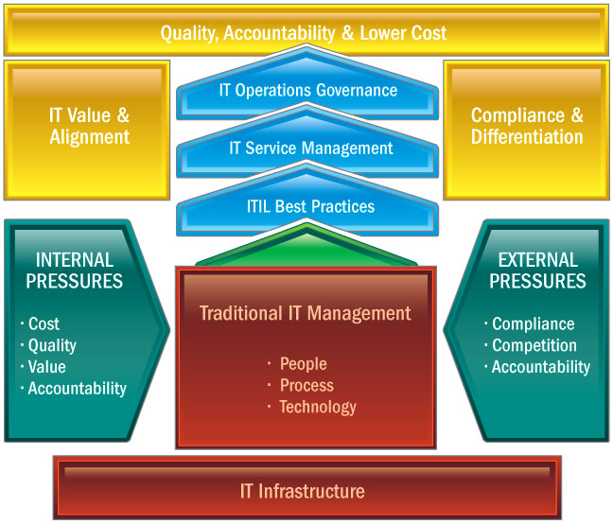
Quality, Cost, & Responsiveness
Figure 4: Forces Shaping IT Management

This has resulted in tremendous growth in adoption of key initiatives like ITIL and ITSM – both of which align well with BSM. At a fundamental level Managed Objects BSM is all about using a service perspective to manage services IT delivers to the business. Through its BSM solution, Managed Objects has grown its product-line to include a number of capabilities that facilitate and accelerate the adoption of ITIL and ITSM. With out-of-the-box capabilities for integrating multi-vendor IT management data, automating BSM deployment through auto-discovery / relationship mapping, and visualizing a service perspective, Managed Objects remains a leading provider of BSM technology.

Towards this end, Managed Objects will continue to provide state-of-the-art BSM capabilities, and will continue to deliver new technologies to more quickly and more effectively adopt ITIL and IT Service Management initiatives. As companies, move more towards a service-based management structure, Managed Objects will allow IT organizations to more effectively align themselves to business pressures by allowing them to better monitor, measure, and manage their IT infrastructures utilizing a service-based perspective – rather than simple IT component-based management methods.

To accomplish these objectives, Managed Objects will be increasingly proactive and automated, in line with “adaptive infrastructure” models – including bare metal resource provisioning and dynamic load reallocation within the parameters of defined change management policies.

In addition, while Managed Objects already provides a solution that complies with existing SOA “standards”, the Managed Objects BSM solution will be enhanced in future releases to deliver new support for emerging standards in SOA and web services as larger numbers of companies adopt this emerging architecture.

9. Describe your company’s market presence, including the following:
- Number of customers
- Service management revenue for fiscal year 2005
- Recent acquisitions, partnerships and technology developments related to service management
- Third-party indicators of market leadership (for instance, analyst rankings or awards)

Market Presence:
- Number of customers: 124
- Revenue: Managed Objects is a privately held company and as such, does
not publish revenue numbers.
- Recent partnerships: Ericsson, CSC, Fujitsu, Maryville
- Analyst Feedback: See attached reports from Gartner & Forrester
Research
- Raising the Bar for ITIL and CMDB Implementations – Forrester Research – Page 2 has a particularly good description of how Managed Objects provides “BSM for the rest of us”.
- IT Asset Management, ITIL, and the CMDB: Paving the Way for BSM – Forrester Research – Page 7 includes a good description on how companies should use a “top-down” approach when implementing BSM
- Market Update: SLM / BSM Technologies – Forrester Research – Page 7 has a good description of Managed Objects as a “Market Leader”.
- Poll Reveals Buying Preferences for Business Service Management, Availability and Performance Monitoring – Gartner – Page 2 shows that the combined markets of BSM and SLM are being given much higher priority (38% total) than other Monitoring or Management markets. Page 4 shows that most companies (52%) will seek out third-party, independent, BSM-focused vendors like Managed Objects, when implementing a BSM or SLM project.

- Awards: 2005 Network World All Stars Awards (http://www.networkworld.com/allstar/2005/) for: Fidelity Investments, and Defense Information Systems Agency (DISA)
- Additional Award: Deloitte’s 2005 Technology Fast 50 for Virginia

