


Request for Information (RFI)
On
Mobile E-mail

RFI Deadline: August 22, 2007
Publication Date: October, 2007

Drafted by Sean Ginevan
Contributing Technology Editor, Network Computing
E-mail: SGinevan@nwc.com

Introduction 3
Instructions 3
A. Business Overview 4
Objectives 5
Mobile E-mail Vendors Questions 6

Introduction

This RFI (Request for Information) is proprietary to Network Computing, Information Week and CMP Media, LLC. It is drafted and disseminated for the sole purpose of generating information on Mobile E-mail for publication in Network Computing.com and/or InformationWeek in October, 2007. Participating vendors must agree that any information returned to Network Computing in response to this RFI may be published in print and electronic form on our Web site, www.networkcomputing.com. Information obtained for this RFI may also be reprinted in whole or in part within InformationWeek or on the InformationWeek website at www.informationweek.com

Instructions

The following questions are designed to provide direct comparisons among major vendors within the mobile e-mail space. We have endeavored to provide as much detail about our proposed scenario below in “Business Overview.” However, if you feel that any points need clarification, please contact the author, Sean Ginevan, via e-mail at SGinevan@nwc.com. If points are clarified we will send those clarifications to all participating vendors to ensure that everyone is operating with the same information. The answers obtained from this RFI, in addition to previous completed testing, will be used to provide all analysis for this article.

If you respond to the RFI, please note that all responses must be received by August 22, 2007 for inclusion in this review. We suggest you read through the entire RFI before answering questions. You can reference answers to other questions in the RFI using the section title. Please do not reference materials outside the RFI; incorporate them into your answers.

Essay-type questions include word-count limits. Any submission beyond the limit may be ignored.

Business Overview

NWC Inc. is a medium sized company specializing in the development and manufacturer of specialty Widgets and Sprockets. The company has three major offices; a headquarters in suburban Washington, DC and branch offices in Syracuse, NY and Kansas City, MO. The company also has just opened a European sales office in Dublin, Ireland.

NWC Inc.’s mobile strategy has been limited thus far. Cellular phones and plans have been subsidized for executives, sales staff and critical operations (on call) staff. However the company has been slow to move into any other mobile service beyond voice. Executives at NWC Inc. have read numerous articles on the benefits of mobile e-mail but have been concerned about costs as well as complexity for supporting a new mobile e-mail initiative.

NWC Inc. has decided to start with a 100 user deployment, focusing on executives, top-tier sales staff and select operations employees in each of our worldwide offices. The company has standardized on Microsoft Exchange and has recently completed an upgrade to Exchange 2007. NWC Inc. has its e-mail servers distributed between Washington, DC; Syracuse, NY; and Kansas City, MO for increased scale and reliability.

While our focus is on an initial 100 user deployment, NWC Inc. wants to eventually scale to include the entire IT operations, sales and management staffs for a total of about 1000 people. The ability to scale up to larger deployments, particularly as the company grows, is important.
NWC Inc is also interested in applications beyond mobile e-mail. Our CIO has read numerous articles about how enterprises are creating applications beyond mobile e-mail. The company is thus curious with how our mobile e-mail software provider can also help us mobilize applications or whether we would have to partner with another vendor. Our CIO is also very security conscious, so we want to understand what the device management and security posture is for the vendors

Objectives

NWC Inc's initial goal is to provision select staff across our worldwide offices with a mobile e-mail solution to more effectively communicate with our more nomadic employees. While our initial goal is to focus on mobile e-mail, we want to ensure that whatever solution we choose has a robust enough security and device management framework in place. We also want to make sure that we can expand into other types of applications. Our goal is to be strategic, rather than tactical, in developing our mobility strategy. We are flexible in device platform selection and we're looking to vendors to provide us with insight as to pros and cons with our available selections (Windows Mobile, BlackBerry, Symbian, etc).

Targets:
- Initial deployment date is: Sept 5th, 2007
  - Mobile e-mail gateway installed in all locations
  - Handsets configured and loaded with software
  - 2 weeks troubleshooting
  - Employee training if needed
- Live on Sept 24th, 2007

Selection Criteria
During our analysis period, we will be reviewing all the RFI’s looking for the best solutions that fit our needs. We will most likely have additional clarifying questions that will need to be answered. We will be using the following list of items (in alphabetical order) to perform our assessment.

- Client software cost (if any)
- Depth of client support
- Depth of management features
- Depth of security features
- Mobile e-mail client features
- Mobile e-mail client ease of use
- Geographical Coverage (i.e. Where service(s) can be used)
- Middleware software cost (if any)
- Service contract cost

Mobile E-mail Vendors Questions

Server Support
Please define what e-mail platform(s) your mobile e-mal platform supports. Examples would include Microsoft Exchange, Lotus Notes, etc.
Answer Guidance
Reason For Question
While NWC Inc uses an Exchange environment, we want to understand if the vendor supports platforms outside of Microsoft Exchange.

Mandatory Response Format:
Word count: Summary not exceeding one page

Information Anywhere suite extends enterprise email and database synchronization. It supports Microsoft Exchange and Lotus Domino to more than 150 mobile devices and smart phones. Information Anywhere (via its OneBridge mobile email component) delivers email and PIM data (contacts, calendar, tasks and notes) to mobile workers anytime, anywhere – regardless of the device, connection method or email system.

Specifically, Information Anywhere suite supports the following data sources:
- Microsoft Exchange 5.5/2000/2003/2007
- Lotus Domino R5/R6/R7/R8 (includes custom Lotus Notes database support)
- Any OLE DB database and access to enterprise Web services remotely from mobile device

Client Support
Please define what client platform(s) your product supports. Examples would include Microsoft Windows Mobile, Symbian, etc. If your product supports non smartphone platforms (e.g. J2ME or BREW), please note this. Please note if your product uses its own e-mail client or integrates with the handheld’s native e-mail client.
If possible, please provide screenshots of the e-mail client on each platform supported by your product.

Answer Guidance
Reason For Question
NWC Inc has office locations around the globe. Windows Mobile is the most popular within the United States however our European counterparts prefer Symbian, so we are curious to know what we can support. Screenshots help us to get a feeling for the look & feel of your product and if there are major differences in the user experience between handset platforms.

Mandatory Response Format:
Word count: Summary not exceeding one page excluding screenshots.

Information Anywhere suite supports more than 150 mobile devices and smartphones, including Windows Mobile (Pocket PC, Pocket PC Phone, and Smartphone), Palm OS, Symbian (Nokia and Sony Ericsson) and OMA Data Sync clients.

The following section highlights the specific mobile device operating systems that are supported.
- Windows Mobile 6.0 (Standard, Professional and Classic), Windows Mobile 5.0 (Smartphone, Pocket PC), Smartphone 2003/2002, Pocket PC 2003/2002
- Symbian OS versions 7, 8, and 9. Device support includes Nokia, Series 60 (2nd and 3rd Edition), Series 80, Sony Ericsson, and UIQ 2.0, 2.1, and 3.0.
- Palm OS 3.5 or greater – Recommended device memory is 8 MB or more. Devices with less memory may not function properly for PIM synchronization or when using Bluetooth, IR, or GSM due to limited heap space. Device security functionality is only supported on Palm OS 4.0 or greater.
- OMA Data Sync (formerly SyncML) 1.01/1.1.1 clients

To see our complete supported devices list, visit: www.ianywhere.com/supporteddevices.

When possible, Information Anywhere suite links into the existing native applications on a mobile device. For example on Windows Mobile and Symbian OS devices, Information Anywhere uses the native email infrastructure but we have created an optimized mail box to enhance the user experience. However, there are times when the native email application is too limited so Sybase iAnywhere has created our own email application, specifically for Palm OS devices.

See example email client screen shots on the following page.

Windows Mobile:
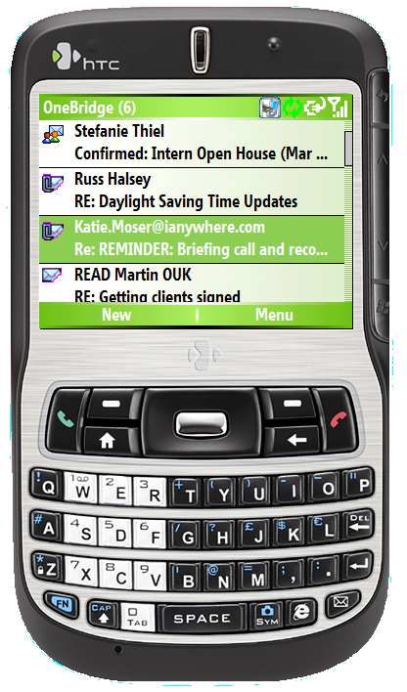

Symbian OS:
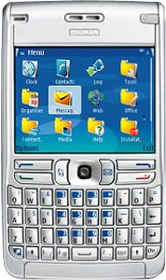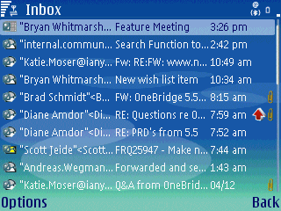

Palm OS:
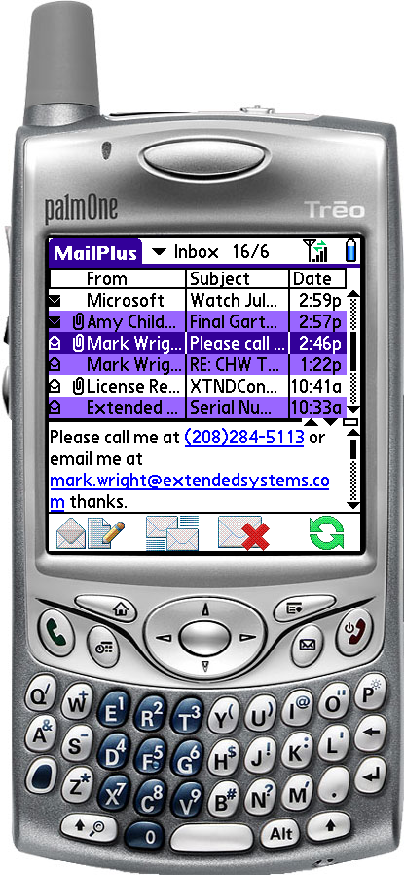

Client Features
Please detail the features available from your client (e.g. send/receive e-mail, create calendar appointments, synchronize Outlook contacts, corporate directory lookup, etc.). If necessary, please reference screenshots from the previous section to provide better detail of the available features.

Answer Guidance
Reason For Question
The breadth and depth of client features available for each product is one of the grading criteria. We are thus looking for detail in this category.

Mandatory Response Format:
Word count: Not to exceed three pages

Client Messaging Features
Email
- Smart Forwarding: Allows users to remotely forward emails and attachments stored on the groupware server without downloading them to their device.
- Attachments: Allows users to receive and view file attachments.
- MailPlus Client: An enhanced Palm OS mail client adding several key features that allows users to synchronize attachments, respond to meeting requests and synchronize follow-up flags. Attachments are viewed with “Docs2Go” (included).
- Mailbox for Symbian: An enhanced, user-friendly mail client for Symbian devices that allows users to synchronize attachments and respond to meeting requests.
- Read/Unread flags: When a user reads email on the device, it is marked as “read” on the server. Users can also mark items as unread, if desired.
- Drag-and-drop files: Allows mobile users to transfer Office documents from desktop to mobile device.
- Auto-truncation: Automatically trims the text when it is set to a certain character limitation by the user and to reduce the amount of data sent to the device. Users can also choose to “get more” of a truncated email message.
- Smart text: Allows user to directly dial a phone number or compose an email from a phone number or email inside the text of an email.
- Adobe Acrobat support: Ability for users to view Adobe Acrobat files on all device platforms.

Corporate Directory Lookup
• Easily find a colleague’s contact information within the corporate address book without having to download the entire address book.
• Integrated within the email and contact applications for Windows Mobile 6 and 5.

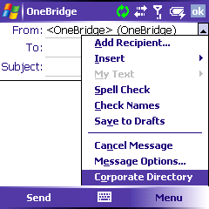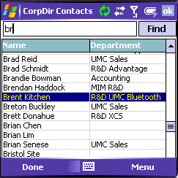

Contacts
- Global Address List (GAL): Both private and corporate address books can be combined so that users can view all their contacts.
- Smart mapping: Transfers all important telephone numbers from the groupware server to devices regardless of the availability of fields.

Calendar
- Recurring appointments: Full support for repeating appointments (repeating patterns are preserved on both the device and server). Supports exceptions to a repeating appointment.
- Native Meeting requests: Allows users to accept and decline meeting requests from their device.
- Time Zones: Supports time zones. Users can change time zones and refresh their data.

Folder Support
- Inbox subfolder support: Ability for users to subscribe to the subfolders and filter the information that they want to view on their mobile device.
- Exchange Public folders: Ability to synchronize Exchange Public folders.

Tasks and Notes
- Can be synchronized, opened and edited.

Custom Notes Databases
- Supports mobile access to any native Lotus Notes database.

Mobile Instant Messaging (available as a separate add-on component)
Information Anywhere Mobile IM provides enterprises with an easy to use, secure solution for extending instant messaging (IM) and presence to mobile devices. It offers mobile workers a single application for accessing leading enterprise and public IM solutions from a range of mobile devices, enabling increased productivity with the ability to communicate and collaborate in real-time.
- Support for leading enterprise instant messaging systems including IBM Lotus Sametime, Microsoft Office Live Communications Server, Jabber XCP, Jabber Wildfire and Reuters Messaging.
- Support for public instant messaging networks via XMPP, which includes support for Google Talk and Jabber.
- Comprehensive cross-platform support for Windows Mobile, RIM BlackBerry, Symbian and Palm OS mobile devices.
- Provides access to multiple instant messaging systems with a single client.
- Compatible with IM security and management solutions such as Akonix, FaceTime and IMLogic.
Pricing
Please define server and/or client pricing for your product for both our initial deployment (100 users) and final deployment (1000 users) based on any volume discounts available.

Answer Guidance
Reason For Question
Price is a grading criteria and we have asked vendors to submit information for this area accordingly.

Mandatory Response Format:
Word count: Summary not exceeding two pages. Pricing charts are allowed for submission to this question.

Sybase iAnywhere charges a 1-time client access license with no separate or additional server charge.

Mobile Email Pricing
The initial deployment of 100 users for mobile email would be $12,900 ($129 per user).

The final deployment (adding 900 more users for a total of 1,000 users) would be $98,100.

Information Anywhere suite pricing
Information Anywhere is available on a component basis which offers customers the ability to acquire only the specific functionality they need today with the flexibility to acquire additional functionality in the future as their needs evolve or their deployment grows. Typical deployments and pricing are:
Price Per User
100 Users 1000 Users
Basic Management: $69 per user $40 per user
Email & PIM $129 " $109 "
Secure Email & PIM $158 " $139 "
Secure, Managed Email & PIM: $199 " $165 "

For pricing on additional components (such as Application Enablement) or other types of deployments, contact Sybase iAnywhere.

In addition, there are specific bundle pricing promotions if additional products within Information Anywhere suite are also purchased.

Current promotions
Mobile Email and Security components
Until December 31, 2007, purchase the mobile email and security for handheld devices components for the combined price of $158 USD per user.

Mobile Email, Security & Management components
Purchase Mobile Email, Security and Management components for the combined promotional price of $199 USD per user.

Mobile IM component
Until December 31, 2007, existing Information Anywhere customers can purchase Information Anywhere Mobile IM for $49 USD per user.

Note: Promotional offer available worldwide (excluding countries where the products are not available).
Support Costs
Please define service contract costs for your product for both our initial deployment (100 users) and final deployment (1000 users) based on any volume discounts available.

Answer Guidance
Reason For Question
Price is a grading criteria and we have asked vendors to submit information for this area accordingly.

Mandatory Response Format:
Word count: Summary not exceeding two pages. Pricing charts are allowed for submission to this question.

iAnywhere Flat Fee Support Pricing
There are two support options that NWC, Inc. might consider purchasing along with the client access licenses. These options allow a certain number of contacts at the company to call our support team and vary on the number of cases and response time. Additional support plans for larger deployments are also available.

Bronze Plan
Price: $1000
Cases: 10
Contacts: 1
Response time: Priority 1 – < 1 day; Priority 2 – < 2 days; Priority 3/4 – < 5 days
24x7 support: No

Silver Plan
Price: $4000
Cases: Unlimited
Contacts: 2
Response time: Priority 1 – < 4 hours; Priority 2 – < 5 hours; Priority 3/4 – < 6 hours
24x7 support: Yes for Priority 1 issues; other priorities are business day only

Software Assurance
Update Subscription Plans (USPs) are priced separately by product and entitle the customer to receive major and minor new feature software releases made available by Sybase during the one-year term of the USP. Pricing for USPs is based on the individual product and is per copy of the product. The cost is based on a percentage of license fees and can be renewable each year.

Mobile Email USP Pricing
The initial deployment of 100 users for mobile email would be $2,300 ($23 per user).

The final deployment (adding 900 more users for a total of 1,000 users) would be $18,000 ($20 per user).

Data Plans
We understand that some vendors require special data plans for their mobile e-mail product. With so many data plans available, please detail which data plan (if any) is required for your product from the following carriers: AT&T, Sprint, Verizon Wireless, Vodafone, T-Mobile (Europe)

Answer Guidance
Reason For Question
Data plans are a major point of confusion for NWC Inc.’s CEO. Some carriers charge differently if a particular mobile e-mail product is used than if another is used. We are looking for guidance from our vendors to determine which data plan(s) we will need to ensure that our mobile e-mail solution works.

Mandatory Response Format:
Word count: Summary not exceeding two pages. Charts are allowed as a response to this question.

Information Anywhere suite does not require a carrier-based data plan since it functions over any IP-based connection, including Wi-Fi, cable/cradle, Bluetooth, infrared, etc. For customers not in a campus environment, a basic carrier data plan is recommended. There is no additional carrier-based fees as there would be in a NOC-based model (e.g., Good, RIM).
Communications Model
Please detail how messages are relayed from our corporate e-mail servers to a client handheld (i.e. via a NOC, direct connection to the handheld, etc). Please explain why this model is best compared to your competitors (i.e. if a direct connection is used, explain why this is better than a NOC relay).

Answer Guidance
Reason For Question
We are curious as to what the technical differences are between each product; these differences may sway our overall impression for each product.

Mandatory Response Format:
Word count: Not to exceed three pages including a high level summary and a technical description. A maximum of two pages of graphical diagrams are ok to enhance your technical description and will not impact the overall word count. (I.e. five pages maximum).

Information Anywhere suite is a “behind-the-firewall” enterprise solution. The sync server is the core component that manages all synchronization sessions. It communicates with multiple components distributed in various locations throughout an enterprise.

The email component allows users to update their data anytime and anywhere via the most suitable connection. During the transfer, data is compressed and encrypted. The software supports any wired or wireless connection.
- Desktop connector runs on Windows-based PCs (Windows 95/98/2000/NT/XP/2003) and some Citrix Clients for synchronization via serial or USB cradle
- Wireless connection over any TCP/IP connection, e.g. GSM, GPRS, Infrared, Bluetooth or W-LAN
- The IT administrator can create actions/triggers based on the connectivity – for example an IT manager can ensure that software is deployed to cradled devices but not over GPRS

Information Anywhere provides various delivery methods that meet individual user's needs for real-time data. Users can choose to have data delivered via Live Connect (push technology), scheduled synchronization (at defined time intervals), or on-demand synchronization. The Live Connect technology guarantees automated data delivery without user interaction through a variety of configurable modes. Live Connect always-on delivers data through IP-based push technology; Live Connect polling method delivers data in pre-defined time intervals. The administrator can also define different modes for different time ranges – for example, during normal working hours, weekdays, weekends and throughout the evening. Live Connect Push model works over any network connectivity option (e.g., cradle, Wi-Fi).

Live Connect modes
• Always-on mode - Provides real-time configuration to push out the most up-to-date information.
• Power-save mode - Provides up-to-date information at a scheduled interval to increase battery life.
• Disable mode - Provides optimal battery consumption while allowing users to sync on demand.

Distributed installations
For easier integration in complex networks and for improved scalability, Information Anywhere mobile email supports the deployment and configuration of remote components throughout the enterprise. For example, adapters can be installed on a server or distributed close to the data source, based on what is optimal for the enterprise deployment.

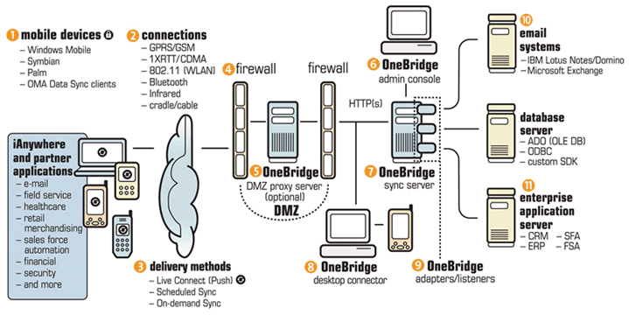

Benefits over NOC Model

Sybase iAnywhere provides an on-premise solution for extending corporate email to mobile devices. As an on-premise solution, Information Anywhere empowers IT to have control of the networks, security and data on their system.is providing a true enterprise solution that IT departments can more effectively control.

With a NOC model, companies would need to understand the risks of outsourcing their mission-critical mobile email to third party. IT managers have no ability to control the security or data flow on the NOC, and are completely dependent on the service provider (RIM/Good) to keep systems up and running. This provides a dangerous single point of failure that compromises a company’s ability to maintain 24x7 secure mobile email to its workers.
Security
Please detail how messages are secured during transport. Please detail how messages are secured on the client handheld.

Answer Guidance
Reason For Question
Security is a crucial concern not just for NWC Inc. but in many surveys is a leading concern for enterprises considering mobile deployments. We would thus like to determine the security features available for each product.

Mandatory Response Format:
Word count: Not to exceed three pages including a high level summary and a technical description. A maximum of two pages of graphical diagrams are ok to enhance your technical description and will not impact the overall word count. (I.e. five pages maximum).

Remote access via a wide variety of devices makes data security ever more complex. Information Anywhere suite ensures maximum security consistent with industry standards and offers the highest security for all data during transfer. This is achieved, among other methods, through a combination of authentication, symmetric and asymmetric encryption with no data staging at any time.

Authentication
Information Anywhere supports two-tier user authentication, allowing security administrators to fine tune network and groupware access. The first-tier authentication can be transparent if an administrator chooses to use single sign-on.

It also supports a feature called extended sessions that allows administrators to securely persist an authenticated session for a defined period of time. This feature helps reduce processing time. The first tier allows the user to authenticate against Active Directory, Lotus Domino, Microsoft Exchange, Windows NT Domain, Radius, LDAP, and database. The second tier allows the user to authenticate against Microsoft Exchange, Lotus Domino or database. If the first and second tier authentication mechanisms are the same and the same user ID and password are used for both, it allows the user to enter their user ID and password only once. Information Anywhere supports connection-based authentication.

For example:
• Use Radius for connections made outside the firewall.
• Use Active Directory for connections on the corporate network.

Over-the-Air Encryption
Information Anywhere integrates several technologies to meet the needs of customers with heightened security standards such as government agencies and financial institutions.
• Communications between the client and server are encrypted with a 128-bit AES and 1024-bit RSA algorithm for the best combination of security and performance.
• The encryption modules used – RSA Security BSAFE Crypto-C Micro Edition – are FIPS 140-2 Level I compliant.
• If an encrypted connection like a VPN is used, Information Anywhere encryption can be disabled.

Remote Device Wipe
By using the Live Connect technology and management capabilities, Information Anywhere has the ability to kill or hard-reset a mobile device in the event that the device is lost or stolen.

Advanced Device Protection
For enhanced device-side security, enterprises can deploy Security Manager. This security solution provides administrator-defined password policy, on-device encryption and data fading, among other security capabilities. Data fading is the ability for administrators to define certain actions if a mobile device doesn't contact the server within a defined period of time, including hard resetting the device, forcing the device into administrative lock-down, or deleting files.

Password Protection
Password protection is the first step toward securing data on mobile devices. Security Manager offers IT the ability to centrally define, control and enforce end user password requirements.
- Power on password capability requires a user to enter a password each time the device is cycled on
- Device “lock down” after a predefined number of failed password entry attempts
- Device reset, encrypted data deletion or complete device disablement may be enforced by IT after failed password entry attempts
- Alphanumeric and/or character based passwords may be used
- Variable frequency of password change requirements
- Remote password retrieval by IT is possible in the case of a forgotten password

On-device Data Encryption
Security Manager gives users and IT piece of mind by offering the ability to encrypt data that resides on devices. In the case of a lost or stolen device, data is protected through strong encryption, rendering the device unusable. Through the Security Manager console, IT can select what data to encrypt and when it should be encrypted. Removable storage medium, such as compact flash cards and SD cards, can also be encrypted.
- Full 128 bit encryption for both device and over-the-air transmission
- Option to encrypt PIM data, company specific data, or data stored on external media

Data Fading
Security Manager allows an IT administrator to lock, wipe or reset a device that has not communicated with the corporate network or Information Anywhere server after a predetermined number of days.
- Automatically renders a device unusable, eliminating manual IT intervention for lost or stolen devices
- Options setting fully configurable by IT

Policy Management
Security policies are easily managed and enforced from a central location, simplifying management of a diverse set of frontline users, applications and devices.
- Security policies are created and controlled by IT from a central console
- Policy changes are automatically updated on the device during a connection with the Information Anywhere server
- Ensures anti-virus definition files and firewalls are configured correctly and operating normally

Over-the-air Client Deployment
Security Manager enables over-the-air deployment, allowing administrators and end-users to simply and easily leverage existing wireless connections to automatically download and install the Security Manager client software on mobile devices.
- Client can be deployed wirelessly, eliminating the need for desktop sync
- Download client via a clickable URL is sent to the user via an SMS message
- Device specific client creation wizard creates the smallest installation size image, saving download time and disk space

Security – Part 2
NWC Inc’s Exchange server is located behind the corporate firewall. We are reluctant to open any holes into our firewall to allow for mobile clients to gain access. Please detail how your product can integrate into our DMZ (i.e. use of a proxy, via middleware server’s integration to Exchange via OWA, etc). Please also detail what firewall ports NWC Inc would need to open, if any, in order to facilitate communication between mobile clients, your mobile e-mail server and Exchange.

Answer Guidance
Reason For Question
Security is a crucial concern not just for NWC Inc. but in many surveys is a leading concern for enterprises considering mobile deployments. We would thus like to determine the security features available for each product.

Mandatory Response Format:
Word count: Not to exceed three pages including a high level summary and a technical description. A maximum of two pages of graphical diagrams are ok to enhance your technical description and will not impact the overall word count. (I.e. five pages maximum).

Proxy Infrastructure
With the Information Anywhere DMZ Proxy, the sync server connects outbound to the proxy server. With this architecture, no inbound ports are required between the enterprise DMZ and the internal network. The Information Anywhere DMZ Proxy checks connections from mobile devices, authenticates the user and validates protocol packets before allowing traffic through the firewall to the Server. Proxy Server can differentiate between multiple departments or company servers using a specific company ID. The Proxy Server does not stage data.

The Information Anywhere Sync Server includes a DMZ Proxy component that can be installed within a corporate DMZ or Firewalling Gateway to bolster security for devices connecting to the Sync Server from outside the corporate network. The DMZ Proxy is a proxy server, or an application-specific firewall for Sync Server. The use of DMZ Proxy software makes utilizing filtering/firewalling significantly less complex to set up, while enhancing security and ease of use for such functions as auditing (for intrusion detection or usage monitoring). The DMZ Proxy understands the Information Anywhere protocol. It makes it possible to disallow any connections from the Internet to the private network. The DMZ Proxy examines and authenticates each connection and checks Information Anywhere protocol packets for validity.

The Information Anywhere Sync Server can be configured to define which DMZ Proxy to establish connections to, which port to be used to connect to a host, and what protocol to use (HTTP or HTTPS). If configured to do so, the Information Anywhere Sync Server connects to the DMZ Proxy from the corporate LAN, thus eliminating the need to allow connections from the DMZ or internet to the LAN for Information Anywhere traffic.

Information Anywhere (OneBridge component) Proxy Infrastructure
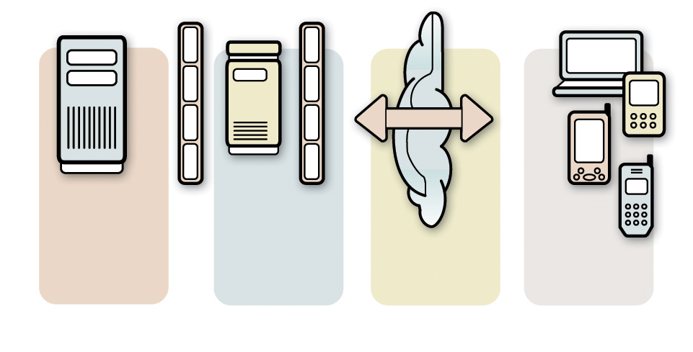
OneBridge
Infrastructure
OneBridge
DMZ Proxy
Devices
HTTPS
Port 443
HTTP
Port 80
Management
Please detail the handheld management features available from your product or from products available from your company. If no product is available, please detail if any products are available from partner vendors. If management features are available as a separate product, please detail the change in the price defined above, if any.

Answer Guidance
Reason For Question
When companies start to load corporate data (like e-mail) onto their handhelds, it’s imperative that these handhelds be able to be managed from the IT department. We are curious to know if we will need to implement a separate management solution or if we can leverage management features from our mobile e-mail investment.

Mandatory Response Format:
Word count: Not to exceed three pages

Information Anywhere suite provides comprehensive mobile device management capabilities to proactively manage and secure all the devices, applications, data and communications on the frontlines. Specifically designed to address mobile management needs, Information Anywhere provides IT a set of capabilities that allow applications to be centrally distributed, installed, tracked and maintained, regardless of the bandwidth available. It can also automatically manage routine systems management tasks, while supporting and securing all the device types enterprises require, including laptops, PDAs and smart phones. Information Anywhere uniquely combines security and systems management functionality from a single console.
Information Anywhere’s mobile device management capabilities include:
- Software Management
- Process Automation
- Inventory Management
- Data & Content Management
- Connection Management
- Frontline Device Support
Software Management
Software Manager makes it easy to centrally distribute, install, maintain and support frontline applications, no matter where users are located or what kind of device they’re using. Information Anywhere enables the electronic distribution, installation and maintenance of applications and administrators can control software installations, including version management, rollback and criteria checking. Administrators can track the installation and usage of licenses against those purchased, and use detailed reports to gather information on the last time an application was accessed.
Process Automation
Using Session Manager, complex, multi-step systems and application management processes can be automated to make processes faster, easier and more reliable. Session Manager can be customized to automate electronic file distribution, file and directory management, notifications, and system registry management tasks without having to learn a programming language. It provides efficient file transfers, fault-tolerant communications, incremental updates, and checkpoint restart for your desktop, laptop, and handheld devices.
Inventory Management
Information Anywhere gives visibility into the front lines so exactly what software and device each worker is using is known. Administrators can perform comprehensive inventory scans of hardware and software and any changes are automatically detected and generate alerts for review and action. It tracks software installation and usage data on PCs, laptops, and handhelds allowing comparisons to be made against software purchases and license agreements, based on installed count, expiration date or both. Further, help desk personnel have access to asset information for rapid issue resolution.
Data & Content Management
Information Anywhere can synchronize file-based information from any source and format, including HTML, database files, documents and other electronic content. Document files are securely delivered to frontline users using a forced or subscription model, and old documents are automatically replaced. Document owners have control over content, enabling easy addition, deletion and updating.
Connection Management
Information Anywhere uses a variety of optimization techniques to enable intelligent decisions about how to best utilize connectivity to the front lines. Scheduling allows system administrators to control the content, timing, parameters and method of communication allowing the completion of work at the most efficient times. Reacting to changes in the state of a device, Information Anywhere can trigger connections, logging or local processes when key characteristics change. Comprehensive bandwidth management, including checkpoint restart, byte-level differencing, and dynamic bandwidth throttling, helps to support applications across all network types.
Application Support
Please detail how NWC Inc. can leverage your company to help us mobilize applications
Answer Guidance
Reason For Question
Mobile e-mail is a good way to get our foot in the door to create a larger mobile applications strategy. We are interested in ways we can create CRM, field force automation and other mobile applications for our company. We are thus interested in understanding how we can

Mandatory Response Format:
Word count: Not to exceed four pages. Please detail products available from your company and how they help create mobile applications. Please also detail any mobile application companies you are partnered with.
Information Anywhere suite delivers the ability to extend enterprise systems to mobile devices easily. It optimizes and automates many of the difficult tasks associated with mobile applications, greatly reducing the amount of time it takes to develop a mobile enterprise application. Application developers no longer have to be concerned with the properties of the network, how to synchronize the data, how to integrate to enterprise systems or how to deploy and support the application. Information Anywhere solves all of these problems so developers can focus on building functionality and value into their mobile solutions.
Information Anywhere provides a robust development suite for accelerating application development on mobile devices. With a broad range of development features, it provides tools for every level of
application development experience, including enterprise developers, independent application developers, or IT teams charged with deploying and maintaining applications.
Sybase iAnywhere enables enterprises to develop and deploy rich business applications on
mobile devices. Its enterprise mobile architecture delivers both a high degree of reliability and extensive backend integration to legacy enterprise applications. For mobile workers, it allows flexibility and investment protection by enabling enterprises to extend additional business applications to their existing devices.
Information Anywhere suite specifically extends corporate applications, including SAP ERP, BMC Remedy Service Desk, Business Objects, Crystal Reports, Lotus Notes, JDBC databases, OLE DB databases, Web Services or Web applications, directly to mobile devices. This includes the ability to create custom applications ideally suited to customer-facing situations.

Information Anywhere’s application enablement toolkit allows for custom development by providing built-in delivery technologies such as synchronization, push and transactional-based processing. It also provides various ways to connect to existing enterprise systems such as web services, OLE DB/ ODBC and an SDK to connect to legacy systems.

Data Synchronization
Information Anywhere suite has the ability to synchronize multiple enterprise data sources with mobile device databases. The flexible solution allows companies to choose what data sources and information needs to be synchronized. Information Anywhere introduces better control of data synchronization from within mobile applications. Sync libraries are provided to the developer so that the whole process of replicating data from a mobile device to a server data store can be embedded into the mobile application.
- No need to make any changes to database structure to enable sync.
- Information Anywhere Sync Engine tracks changes in mobile databases and handle conflict resolution
- Quickly and efficiently synchronizes offline data with server-side databases

Web Services/Remote Method Invocation
Information Anywhere provides the ability to wrap any service and expose it as a local module for most mobile application development environments (Microsoft Visual Studio, .NET Compact Framework, RIM JDK). This allows other connected operations besides just “sync”.
- Remotely execute a complex workflow operation
- Interactively submit or request data
- Easily execute advanced transactions
- Securely transmit data over wireless networks

Push Service
Information Anywhere provides IP-based push technology called Live Connect that enables server-side changes to be delivered immediately to devices. Live Connect technology also monitors battery life to deliver data optimally. Components called listeners monitor changes on the server. APIs are also available to create custom listeners to any enterprise backend.
- Offers both always-on and power-save modes
- Register any third-party client application for push
- Does not rely on expensive SMS for any notification of push

Browser Applications
Information Anywhere suite provides a platform for delivering Web-based content and applications to a wide variety of mobile devices rapidly and cost-effectively – with minimal recoding. Web developers can leverage their existing skill sets and open standards to develop and deploy fully interactive Web applications with sync-and-go or wireless capabilities. So no matter where end users are, they’ll be able to tap into the information, applications and Web services they need to make more effective business decisions, more quickly than ever before. Just as importantly, you can develop, deploy, and maintain mobile Web applications rapidly and with the lowest total cost of ownership (TCO) possible.
Information Anywhere allows companies to mobilize enterprise applications such as portals, customer relationship management (CRM), field service, logistics, data collection, inspection, help desk, and business intelligence. Literally any paper-based or desktop-based application or process can be extended to handheld devices, tablet computers or laptops with Information Anywhere, resulting in faster and more accurate data collection, improved field productivity and better decision-making.
Geographic Coverage
Please detail the countries your product works in.

Answer Guidance
Reason For Question
As NWC Inc looks to expand globally, we want to understand where your mobile e-mail product will work.

Mandatory Response Format:
Word count: Not to exceed one page, a chart is acceptable to answer this coverage

Sybase iAnywhere is a global company with offices throughout the world. Our main R&D offices are located in North America (Boise, Idaho and Alpharetta, GA) as well as a dedicated R&D team focused on the Symbian mobile platform in Bristol, England. In addition, we have sales and support teams located throughout North America and Europe and Asia-Pacific.
Competitive Analysis
Please detail how your product compares, and what advantages it has, against your competition. Consider competing companies to be those on the right hand side of Gartner’s mobile e-mail magic quadrant.

Answer Guidance
Reason For Question
We want to understand how vendors see themselves and how their product stacks up against competing products.

Mandatory Response Format:
Word count: Not to exceed five pages.

Sybase iAnywhere is the largest, independent mobile infrastructure software provider in the industry.
Sybase iAnywhere offers the most comprehensive support for extending enterprise email systems and IM platforms across the broadest range of mobile devices.

Information Anywhere suite is the only device, network/carrier and backend database independent solution in the market. All of our primary competitors are now aligned with a specific device type or operating system. This alignment does not benefit enterprise organizations that are looking for a flexible, scalable mobile enterprise solution today and into the future.
Key Differentiators:
- Secure push email solution
  - Interoperability between the Information Anywhere components for email and security ensures that solutions are compatible (with same R&D development and testing processes)
- Heterogeneous, cross-platform solution
  - Supports dominant email systems (Microsoft Exchange and Lotus Domino),
150 mobile devices on all major operating systems, any connection (wired/wireless)
- Scalability and flexibility
  - Information Anywhere can support up to 1,000 users per server and those
can be clustered to scale to up to 10,000+
  - Behind-the-firewall, distributable architecture
  - Separate adapters and components make the solution
- More than email and PIM
  - Support for mobile messaging, security, management
  - Ability to extend other enterprise applications using the same platform

According to Gartner’s mobile email magic quadrant report:
Sybase shows a stronger vision of enterprise mobility than any other vendor and takes a wider approach than just providing e-mail: to provide enterprises with a software infrastructure that holistically covers e-mail, applications, security and management, to support an overall enterprise mobility strategy.

According to The 451 Group’s mobile application vendors report:
As always, we note that Sybase (NYSE: SY) iAnywhere (NYSE: SY) remains the absolute top dog in this particular space, but iAnywhere has the resources of parent Sybase, as well as the resources of the entire 'Unwired Enterprise' effort of the company behind it.

In fact, the one truly competent major software vendor in the space is Sybase. The company has delivered extensive mobile-aware platforms at every level – from its core Fortune 500-level database platforms to development tools any business of any size can use to drive mobile applications.

More details about Information Anywhere suite
Information Anywhere suite is a secure, scalable mobile software platform that addresses the converging IT requirements of enterprises today. By combining email, collaboration, mobile device management, enterprise-to-edge security and back-office application extension capabilities, Information Anywhere suite enables organizations to empower employees to do the work they need to do anywhere, at anytime, on any device. Built from the inception to address the unique characteristics of frontline environments, Information Anywhere suite ensures that mobilized applications are as secure, reliable and available as those that are running within the data center. Backed by more than 20 years of expertise in solving mobile deployment challenges, Information Anywhere allows organizations to integrate, extend and leverage investments in their existing IT infrastructure when developing a mobile strategy.
Information Anywhere suite’s award-winning technologies are interoperable, resulting in a common design and quality assurance, and optimized communication streams. This compatibility between technologies removes the burden from IT of ensuring the software works together. Information Anywhere also supports heterogeneous environments, allowing organizations to choose the right technologies for their business requirements, rather than being locked into a single device, platform or vendor approach. In addition, Information Anywhere suite’s unique Always Available architecture enables users to access email, data and applications on frontline systems and devices anytime—whether or not they have a “live” connection to enterprise systems. Always Available solutions eliminate downtime and empower users to be more productive with accurate and timely information and business tools.

Information Anywhere suite’s capabilities include:

Heterogeneous Mobile Email and Instant Messaging
Information Anywhere suite provides a powerful out-of-the-box solution for mobile delivery of email and PIM (calendar, contacts, tasks) data to mobile workers any time, anywhere—regardless of the device, connection method or groupware application. Unlike other mobile email solutions that may be limited to a single email application or device, Information Anywhere Suite provides access to Microsoft Exchange and Lotus Domino from hundreds of mobile devices. Leveraging OneBridge technology, Information Anywhere eliminates device compromises, connecting essentially any back-end data source by GPRS, CDMA, WiFi, Bluetooth, cable or cradle to virtually any intelligent device including smartphone, Windows Mobile, Palm or Symbian device. Information Anywhere suite also provides interoperability with its mobile email, management and security capabilities, relieving the compatibility issues that can be encountered when implementing disparate solutions. In addition, Information Anywhere Mobile IM provides enterprises with an easy-to-use, secure solution for extending instant messaging (IM) and presence to mobile devices. It offers mobile workers a single application for accessing leading enterprise and public IM solutions from a range of mobile devices, enabling increased productivity with the ability to communicate and collaborate in real time.

Mobile Device Management
Information Anywhere suite allows companies to centrally manage and support multiple device types, applications, data and communications at the frontlines of business, regardless of the bandwidth available. Powered by Afaria technology, it creates a bridge of system control, user support and information flow between the frontlines and the enterprise. With no need for field worker involvement, devices are optimized for maximum productivity, data is always available, and IT has the visibility and control to enforce the policies required to achieve significant business breakthroughs. In addition, Information Anywhere uniquely combines management and security from a single console, providing the best protection against security threats and compliance issues.

Mobile Device Security
With Information Anywhere suite, companies can secure their data, devices, applications and users where they are at their most vulnerable—on the frontlines. Information Anywhere suite empowers IT with a comprehensive, policy-based, enterprise-ready security solution designed specifically with the frontline environment in mind, supporting laptops, handhelds and smartphones. It addresses the spectrum of frontline security needs, including protecting against unauthorized access and other security vulnerabilities, wiping data and/or disabling access to lost or stolen devices, and encrypting data transmissions. Built on Sybase iAnywhere’s Afaria technology, Information Anywhere suite is differentiated by the tight coupling of its mobile management and security technologies from a single console to best enforce security procedures, and offering unique managed security features including Guardian Angels, Enterprise-to-Edge Protection and Enterprise Policy Management.

Mobile Enterprise Application Enablement
Developers and IT professionals can leverage Information Anywhere suite to build custom mobile solutions that extend existing enterprise information sources (including databases, application and messaging servers and Intranets) and applications (including SAP, Business Objects and Remedy) directly to mobile devices. Information Anywhere provides the core integration, synchronization, messaging and mobile data management capabilities required to exchange information between frontline workers and enterprise systems—enabling better decision making, improved efficiency and increased profits.

