Please complete in full in BLOCK letters. Attach one recent COLOUR passport photograph for each proposal insured, print the name and sign on the back of each.

PERSONAL PARTICULARS
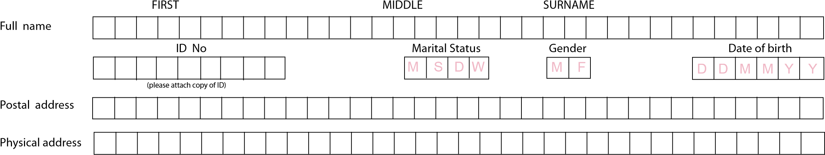
E-mail address __________________________________________________________________________________________________________________________
CODE NUMBER
Mobile. no (Wo rk)

PARTICULARS OF OCCUPATION
Employer’s Name ________________________________________________________________________________ Date of employment
Employer’s Physical Address _______________________________________________________________________________________________________________
_____________________________________________________________________________________________________________________
ATTACH
PHOTOGRAPH
HERE
)
do not use staple or pin
(
Policy Date
Membership No.
D D M M Y Y
CORPORATE HEALTH
(
)
Application Form

PARTICULARS OF DEPENDANTS
Full name |  | Date of birth |  |  |  |  |  | Gender |  | Relationship | Living with you
(01) |  |  |  |  |  |  |  | M | F | Spouse | Y | N
(02) |  |  |  |  |  |  |  | M | F |  | Y | N
(03) |  |  |  |  |  |  |  | M | F |  | Y | N
(04) |  |  |  |  |  |  |  | M | F |  | Y | N
(05) |  |  |  |  |  |  |  | M | F |  | Y | N
(06) |  |  |  |  |  |  |  | M | F |  | Y | N
(07) |  |  |  |  |  |  |  | M | F |  | Y | N
Name of previous medical Insurer _____________________________________________________________________________________________________________
Period of Insurance _________________________________________________________________________________________________________________________
Continued overleaf

Medical history of applicant and dependent’s
4
UAP INSURANCE SOUTH SUDAN LIMITED
UAP Plaza, Hai Cinema, Opposite Al-Sabah Children Hospital
PO Box 201, Juba, South Sudan, Website http://www.uap-group.com
Tel +211 959 000000, +211 977 296555
 | All questions must be answered (blank spaces on lines are not acceptable) | Member 00 | Dependant 01 (Spouse) | Dependant 02 | Dependant 03 | Dependant 04 | Dependant 05 | Dependant 06 | Dependant 07
a) | physical defect or illness whatsoever even in slight form? | YES  NO | YES  NO | YES  NO | YES  NO | YES  NO | YES  NO | YES  NO | YES  NO
b) | If so, is such illness or physical defect likely to necessitate an operation ? Please give details. | YES  NO | YES  NO | YES  NO | YES  NO | YES  NO | YES  NO | YES  NO | YES  NO
2) | Have you consulted your doctor OR what illness accidents or operations have you or your dependants had in the past, no matter how trivial ? State YES or NO. If YES, please specify (add an additional sheet if necessary) and state date of last consultation. | YES  NO | YES  NO | YES  NO | YES  NO | YES  NO | YES  NO | YES  NO | YES  NO
3) | Please state if you or your dependants at any time have been subject to any chronic/recurring illness  e.g asthma, diabetes, hypertension, convulsions/epilepsy gastric or duodenal ulcers, gallstones, heart disease, neurological disease, psychiatric illness, rheumatic fever, kidney disease, back pain/spinal disease, sinusitis,  cancer, others (please specify) | YES  NO | YES  NO | YES  NO | YES  NO | YES  NO | YES  NO | YES  NO | YES  NO
4a) | State any allergies
b) | Do you or your dependants smoke? | YES  NO | YES  NO | YES  NO | YES  NO | YES  NO | YES  NO | YES  NO | YES  NO
5) | Are you or your dependants currently using medication for medical or other reasons? If so, please specify.
6) | Are there any other circumstances in your current or past medical history not mentioned above, which may result in hospitalization in future?
7) | Female members only  i) Has any member of your family ever delivered a child through caeserean operation.
 | ii) Is any member currently pregnant?
8) | State name, address and phone number of your medical practitioner to whom reference may be made.
____________________________________________________________ ID Number _____________________________________________
Relationship ____________________________________________________________________________________________________________________________ Declaration
I hereby apply to join the above mentioned plan. I understand that any mis-statement or the non-diclosure of any material information in this form will jeopardise my membership. I warrant that the answers in this form are true, correct and complete and I acknowledge that such answers are all material. I hereby authorise the hospital, medical or dental practitioners who have treated me or any of my dependants to disclose to the Company the records relating to such current or previous hospitalisations / medical treatment and to allow the Company to receive extracts from such records and undertake to assist in obtaining such information.
Dated this Day of __________________________________ 20__________________
Member’s Signature.______________________________________________________

