Cover is provided under six sections. Cover under Section A must be taken if this type of policy is to be issued, but Sections B and G are optional.
OFFICE COMPACT PROPOSAL FORM

SECTION A - OFFICE CONTENTS are insured against:-
Fire, Explosion, Lightning, Earthquake, Riot, Strike, Malicious Damage, Storm, Flood, Burst Pipes and Impact by Aircraft, Road Vehicles, Horses or Cattle, theft or attempted theft involving break-in. IN ADDITION this Section provides the following useful extensions:
(i)
- Temporary removal of Contents, up to 15% of the Contents sum Insured.
- Loss of rent if the premises are Untenantable as a result of an insured peril, upto 10% of the Contents sum insured.
- Out of pocket expenses if the premises are untenantable as a result of an insured peril, upto 5% of the Contents sum insured.

SECTION B - ALL RISKS

SECTION C - LEGAL LIABILITY TO THE PUBLIC
Provides cover for all sums which the insured shall be legally liable to pay as damages for accidental bodily injury and/or damage to property of third parties including law costs and expenses incurred with the written consent of the Company.

SECTION D - LOSS OF MONEY
Provides cover for loss of money In direct transit or on premises including damage to safes or strongroom caused by theft or any attempt threat.

SECTION E - LOSS OF DOCUMENTS
arising out of such loss, theft, destruction or damage.

SECTION F - GROUP PERSONAL ACCIDENT
Indemnity to the employer against legal liability in respect of assessments and awards for bodily injury by accident or disease caused to employees in course of their employment, and occurring / made during the period of Insurance, subject to the terms and conditions, exceptions and warranties, of the Policy.

Note. The above is a brief summary of the cover available, and is subject to the terms, conditions and exclusions of the company’s standard form of policy a copy of which may be inspected upon request

PROPOSER
- Full Name_________________________________________________________________________________________
Last Middle First
- a) Postal Address: PO Box_____________________________ Tel No._________________ E-mail __________________

  - Address of property to be insured House No. (Estate/Town/District)_______________________________________
  - Situation of your property : Plot No._________________________________________________________________
- PIN No. ___________________________________________________________________________________________
- Tel. No. Res. _______________________________ Mobile ________________________Office ____________________
- Postal Address _______________________ Code _____________________________ Email ______________________
- Trade or Business/Occupation________________________________________________________________________
- Period for which Insurance is required: from ________________________________ to__________________________
- Is the Building of which the Office forms part constructed of Brick, Stone or Concrete and roofed with Concrete,
Asphalt, Metal, Asbestos, Slate or Tiles? Yes No
lf not, give full details _______________________________________________________________________________ _________________________________________________________________________________________________
- a) Is the Building of which the Office forms part occupied solely as offices? Yes No If Not, give details of other occupiers __________________________________________________________________
  - If you occupy the Premises otherwise than as Office/Consulting Room, e.g. Stock Room, please give details including the value of stock, samples kept on the premises etc.
_________________________________________________________________________________________________
_________________________________________________________________________________________________
- How long have you conducted business
i) In these premises? __________________________________________________________________________ ii) Elsewhere? ________________________________________________________________________________
- Are you currently insured or have you ever proposed for insurance in respect of any of the risks proposed?
Yes No

If “Yes”, give full details: Insurer ___________________________________________________________________

Policy Nos _____________________________________________________________________________________

Risks_________________________________________________________________________________________
- Has any Insurer declined to insure you, required special terms to insure you, cancelled or refused to renew your insurance, or increased your premium on renewal? Yes No
If ‘Yes’ , give full details
_________________________________________________________________________________________________
_________________________________________________________________________________________________

_________________________________________________________________________________________________

- Have you ever sustained loss by any of the contingencies for which you require insurance? Yes No

If ‘Yes’, give full details ______________________________________________________________________________

- a) Do you maintain a proper set of Accounts Books? Yes No
  - Where are they kept out of business hours? _________________________________________________________
  - Are your accounts audited at least annually? Yes No
If ‘Yes’, please give full details

    - Name of auditor/accountant __________________________________________________________________

    - Address____________________________________________________________________________________

3
- Have you or any of your partners or directors ever been bankrupt or made a
compromise with creditors? Yes No
If ’Yes’, give full details

________________________________________________________________________________________________
________________________________________________________________________________________________
________________________________________________________________________________________________

- The following Sections are available. Please indicate which covers you require:

SECTION A: FIRE AND PERILS AND BURGLARY.
SECTION B: ALL RISKS.
SECTION C: LEGAL LIABILITY TO THE PUBLIC.
SECTION D: LOSS OF MONEY.
SECTION E: LOSS OF DOCUMENTS.
SECTION F: GPA
SECTION A - CONTENTS
This Section is obligatory
a) State the Sum to be insured in respect of the CONTENTS of | (a) | USD. ________________________
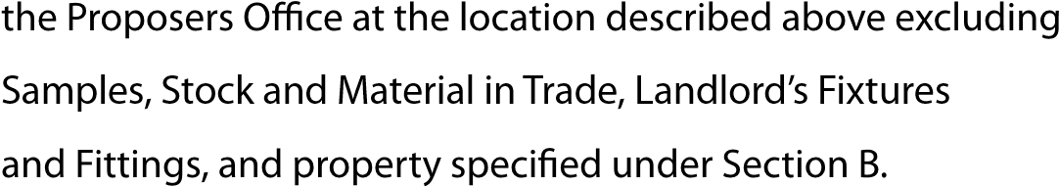
  - This Section excludes individual items valued at more than (b) USD. ________________________
USD. 1500 unless specified. Please list any items on a separate sheet of paper. If none, insert “None”.
  - If more than one location is to be insured, please give details separately in respect of each.

SECTION B - ALL RISKS - SPECIFIED OFFICE EQUIPMENT
Please give detailed description and state separately the full value of each item.

Item No. | Full Description Make Model | Serial No. | Value (USD)
SECTION C - PUBLIC LIABILITY
Please state the indemnity Limit required (Minimum USD. I, 000)

SECTION D - LOSS OF MONEY
Please insert the maximum amounts of money for which cover is required at any one time.

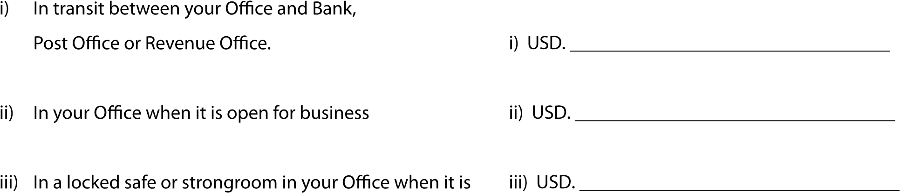
closed for business
iv) In locked cashbox in locked drawer or locked cabinet in iv) USD. _________________________________

(Money means - Cash Current Coins, Bank Notes, Postal Orders, Money Orders, Cheques, Postage, Government Revenue Stamps & Local Authorities Service Charge Stamps.)
5

SECTION E - LOSS OF DOCUMENTS
Please state the sum to be insured USD. ____________________________________________________________________ SECTION F - GROUP PERSONAL ACCIDENT
1. Does any law or regulation governing the conduct or maintenance of premises apply to your premises? |  |  | Yes No  If so, name such laws and regulations.  __________________________________________  __________________________________________  __________________________________________  (ii) Have you carried out all obligations imposed on you by such laws and regulations?  Yes No
2. Do you handle or us radio isotopes radioactive substances, or other sources of ionising radiations? |  |  | Yes No  If yes, give details  __________________________________________  __________________________________________
3. Do you have any employee with pre-existing medical condition? |  |  | Yes/No____________________________________ __________________________________________
Names/number of employees | Description of occupation | Estimated Annual  Salaries/ Wages  And Other Earnings  On Which Premium Is Based |  | use only Rate | Premium | tions

Declaration
I/We submit this proposal to the UAP Insurance Sudan Limited, and I/we do hereby declare that the above answers and statements are true, and that I/We withheld no material information regarding this proposal. I/we agree that this Declaration and the answers above given, as well as any proposal or declaration or statement made in writing by me/us or anyone acting on my/our behalf shall form the basis of the contract between me/us and the Company, and I/we further agree to accept indemnity subject to the conditions in, and endorsed on, the Company’s policy. I/we also declare that the sums expressed in Sections A and B represent not less than the full value of property, as above mentioned.
Date of completion of the proposal form__________________________________________________________________
Name of the person completing the proposal form__________________________________________________________
Proposers Signature___________________________________________________________________________________
The liability of the Company does not commence until acceptance of the proposal has been intimated by the Company, or

